1b. Write down code to solve this problem for arbitary number of parameters, but make sure your routine is stable to solve the problem for high values of

%%%%%code for problem 1b%%%%%
%%%wrote the following function and saved as cake1b.m file%%%%%
function F = cake1b(w)
beta = 0.95;
R = 0.25;
sigma = .45;
betaR = (beta * R)^(1/sigma);
T = length(w);
F = ones(T, 1);
wbar = 100;
w = [wbar; w; 0];
for t= 2:(T+1)
F(t-1) = betaR*(R*w(t-1)-w(t)) - (R*w(t)-w(t+1));
end
%%%%%%placed the following in the command window%%%%%%
plot(1:T+2,w, ':ks');
legend('W')
xlabel('time')
ylabel('W')
title('Plot of W')
pause(.001)
w0 = ones(10, 1);
options=optimset('Display','off');
[w,fval,exitflag] = fsolve(@cake1b,w0,options)

%%%output: 14 end
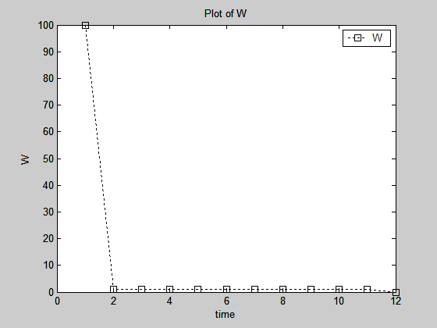
1c. Modify your code to incorporate a new law of motion

%%%%%code for problem 1b%%%%%
%%%wrote the following function and saved as cake1c.m file%%%%%
function F = cake1c(w)

beta = 0.95;
R = 0.25;
sigma = 0.45;
betaR = (beta * R)^(1/sigma);
T = length(w);
F = ones(T, 1);
wbar = 100;
w = [wbar; w; 0];
y=1;
for t= 2:(T+1)
F(t-1) = betaR*(y+R*w(t-1)-w(t)) - (y+R*w(t)-w(t+1));
End
%%%%%%placed the following in the command window%%%%%%
plot(1:T+2,w, ':ks');
legend('W')
xlabel('time')
ylabel('W')
title('Plot of W')
pause(.001)
w0 = ones(10, 1);
options=optimset('Display','off');
[w,fval,exitflag] = fsolve(@cake1c,w0,options)

2c) Write down code to calculate the optimal decision rule and value function.

function res=cake2(x)

% PARAMETERS
delta = 0.5; % Exogenous return from savings
beta = 0.5; % Discount rate

% Coefficients for the functional form for the value function v(k)= A + B log(k)
A = x(1);
B = x(2);

%----------------------------------------------------------------
% INITIALIZE VARIABLES AND FUNCTIONS
%----------------------------------------------------------------
% Define grid points for cake
nump = 25; % Number of grid points
whigh = 5; % Highest point in the grid
wlow = whigh/nump; % Lowest point in the grid
w = linspace(wlow,whigh,nump)'; % State space
tol = 1e-5; % Tolerance criterium

% Guess for the initial value function and policy function
v1 = zeros(nump,1); % Initialize value function
wprime = zeros(nump,1); % Initialize savings policy function
c = zeros(nump,1); % Initialize consumption policy function

%----------------------------------------------------------------
% COMPUTE VALUE FUNCTION
%----------------------------------------------------------------
% For every point in the grid solve the FOC and compute consumption
% -U'(delta*w-w')+beta*V'(w')

wprime = (delta*beta*B/(1+beta*B))*w;

c = delta*w-wprime;

% Compute the value function associated to the optimal policy

v1 = log(c) + beta* (A + B*log(wprime));

% Compute the value function associated to the guessed coefficients

v0 = A + B*log(w);

%----------------------------------------------------------------
% COMPUTE THE RESIDUAL FUNCTION AND PLOT CONVERGENCE
%----------------------------------------------------------------

res = max(abs(v1-v0));

% Plot convergence of the value function

plot(w,v1,':rs',w,v0);
legend('v1','v0')
axis([wlow whigh -10 3])
title('Plot of 2.c')
pause(.1)

%%%%%in command window type the following%%%%

>[coefficients,residual,conv,options]= fminsearch('cake2',[-8,3])

OUTPUT
coefficients =

-5.5452 2.0000

residual =

1.7864e-005

conv =

1

options =

iterations: 42
funcCount: 80
algorithm: 'Nelder-Mead simplex direct search'
