1.
OUTPUT
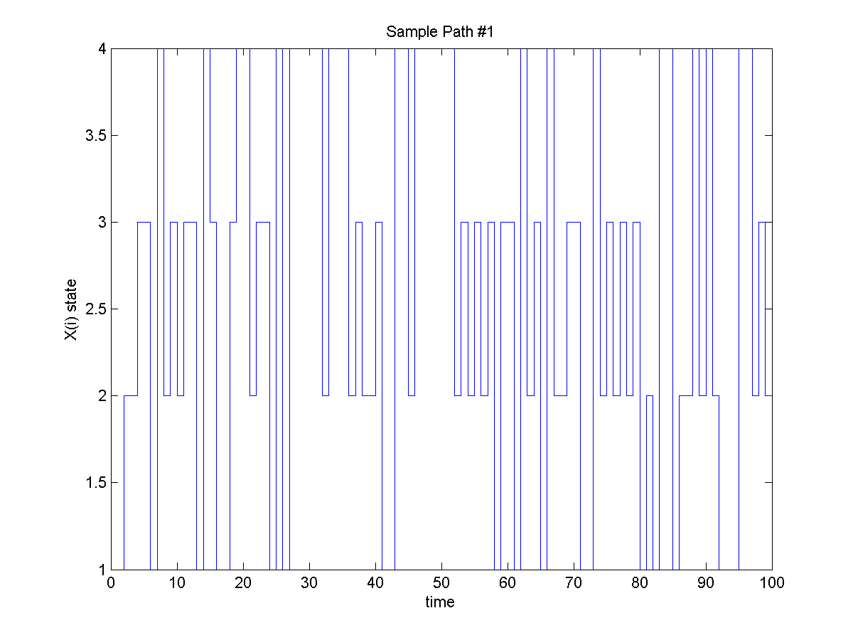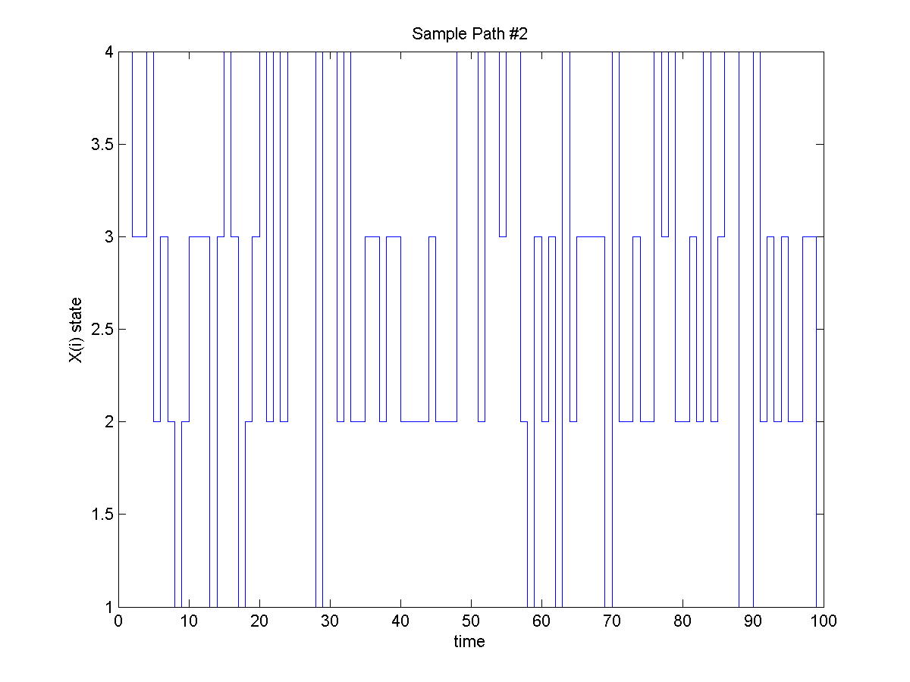
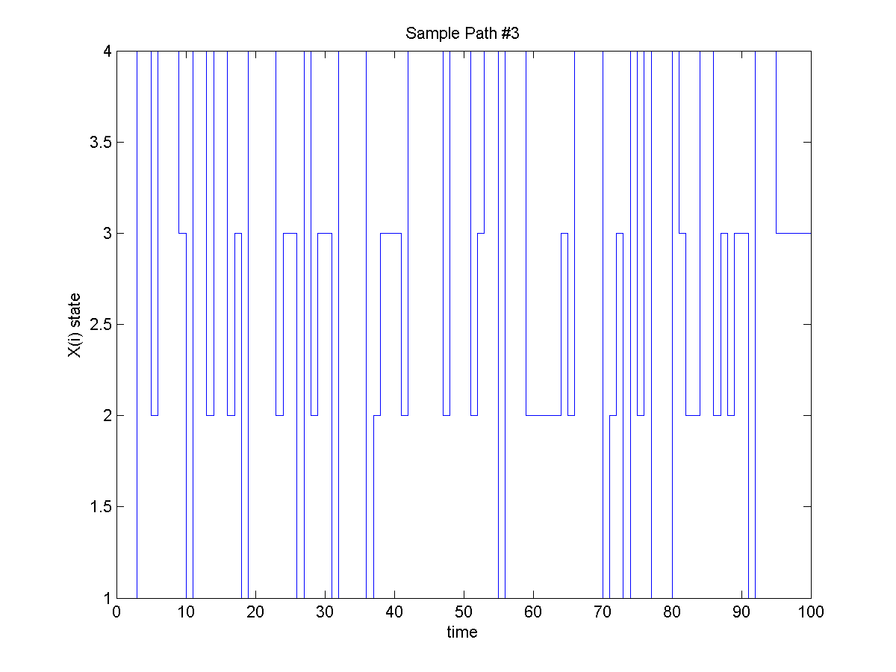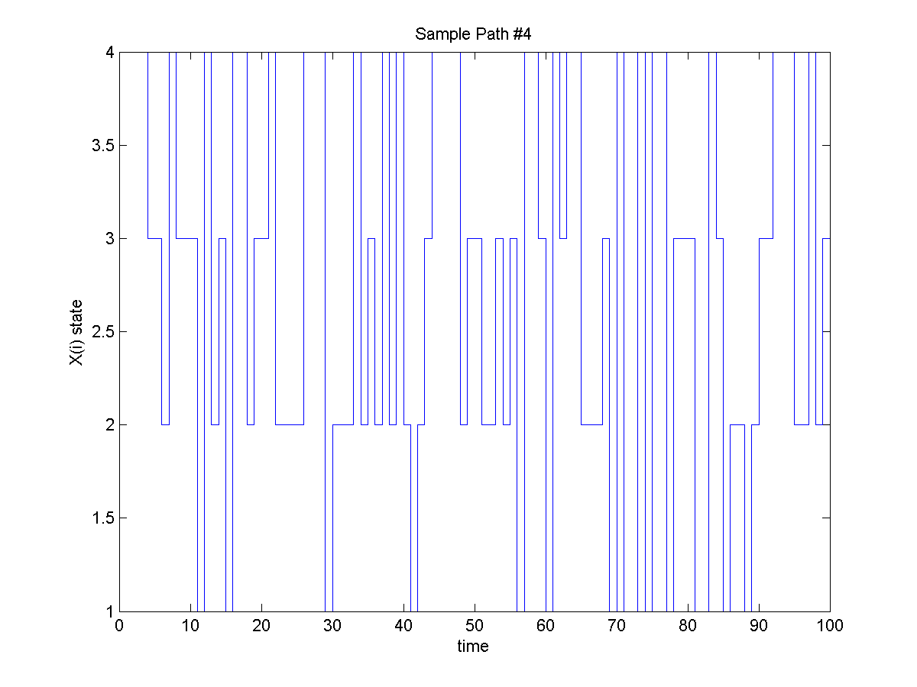
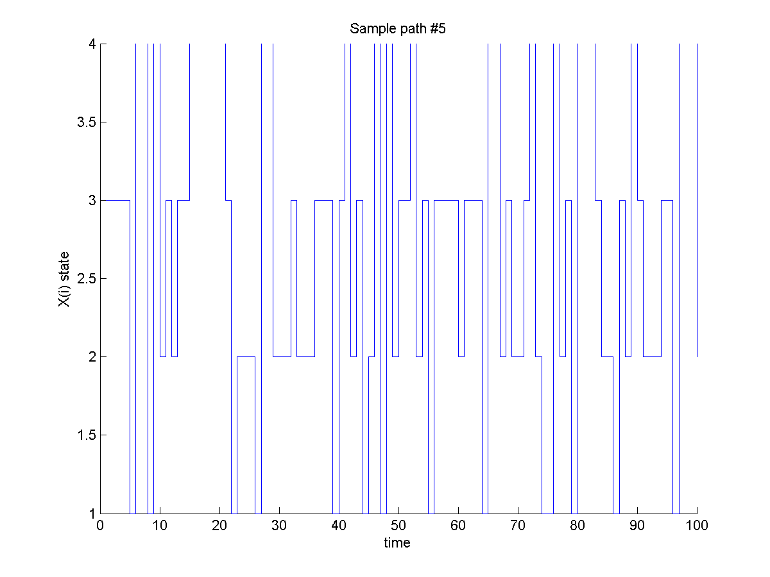
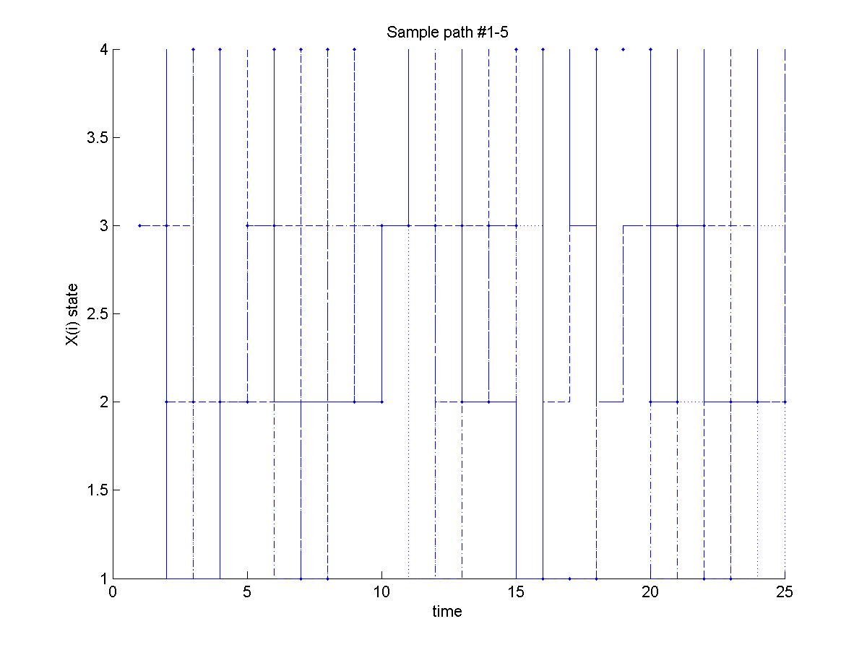

CODE
clear all
clc

trans = [0.2 0.2 0.1 0.5;
0.1 0.3 0.4 0.2;
0.3 0.2 0.3 0.2;
0.1 0.3 0.1 0.5];
n=25;
state = zeros(4,n);
state(:,1) = 0.25*ones;
path = zeros(n);
for i=1:5;
for j=1:n;
x = rand;
position = find(x<cumsum(state(:,j)));
path(j,i) = min(position);
state(:,j+1)=trans(path(j,i),:)';
end;
end
for n1 = 1:5;
figure(n1)
hold on;
stairs(path(:,n1));
xlabel('time')
ylabel('X(i) state')
title(['Sample path #' int2str(n1)]);
saveas(figure(n1),['Sample path ' int2str(n1) '.png'])
end;

figure(6)
hold on;
stairs(path(:,1),':');
stairs(path(:,2),'-');
stairs(path(:,3),'--');
stairs(path(:,4),'-.');
stairs(path(:,5),'--.');
xlabel('time')
ylabel('X(i) state')
title(['Sample path #1-5']);
saveas(figure(6),['Sample paths 1-5.png'])
2.
OUTPUT
Trail, when n=100
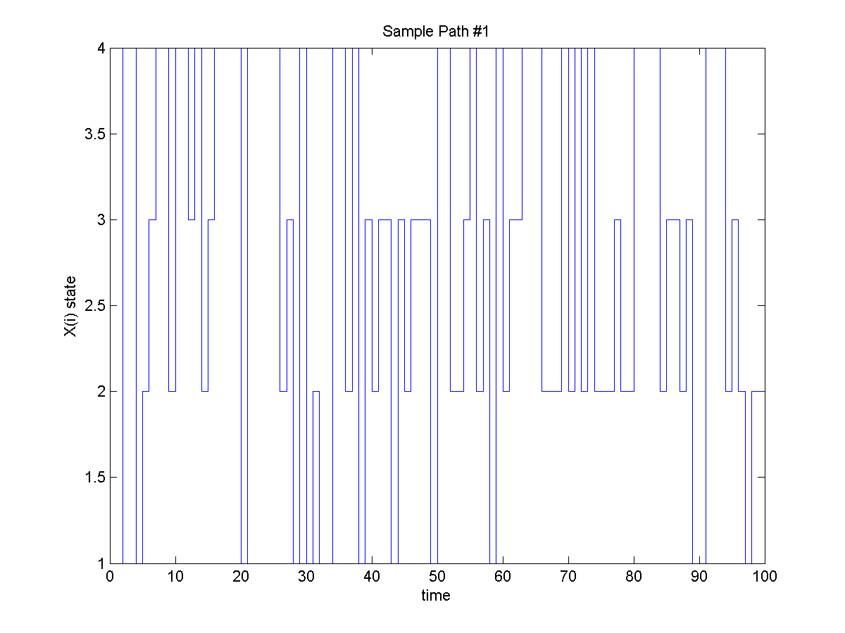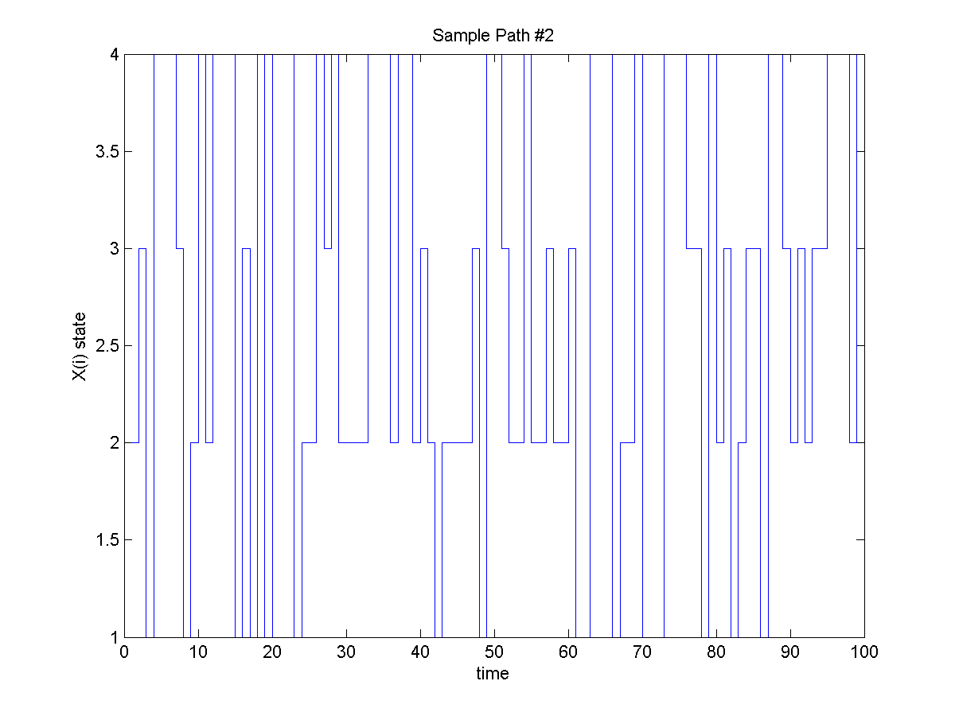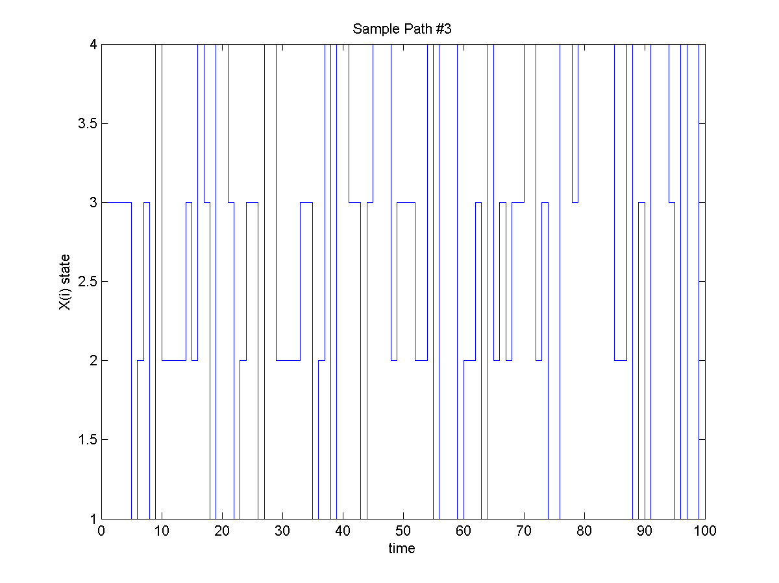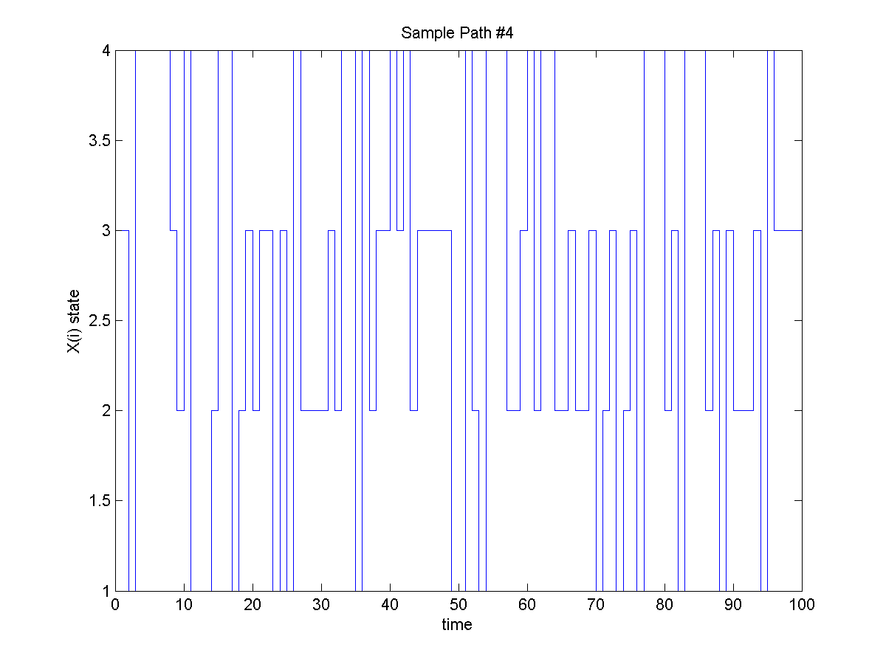

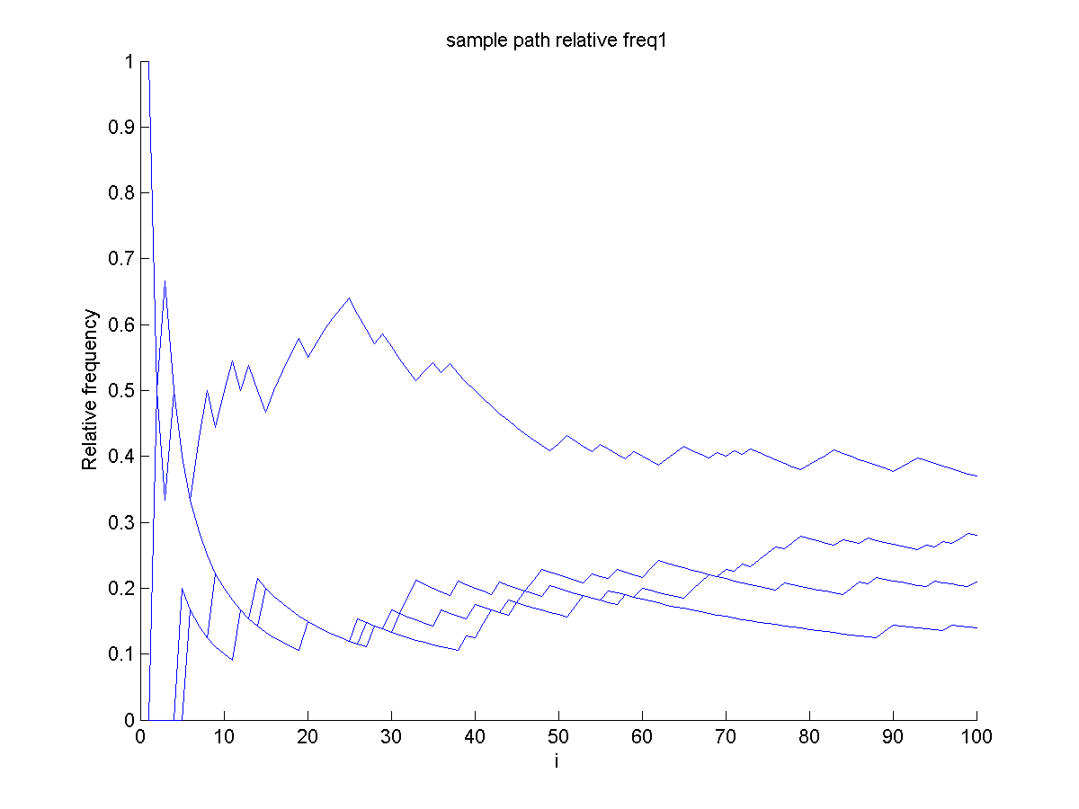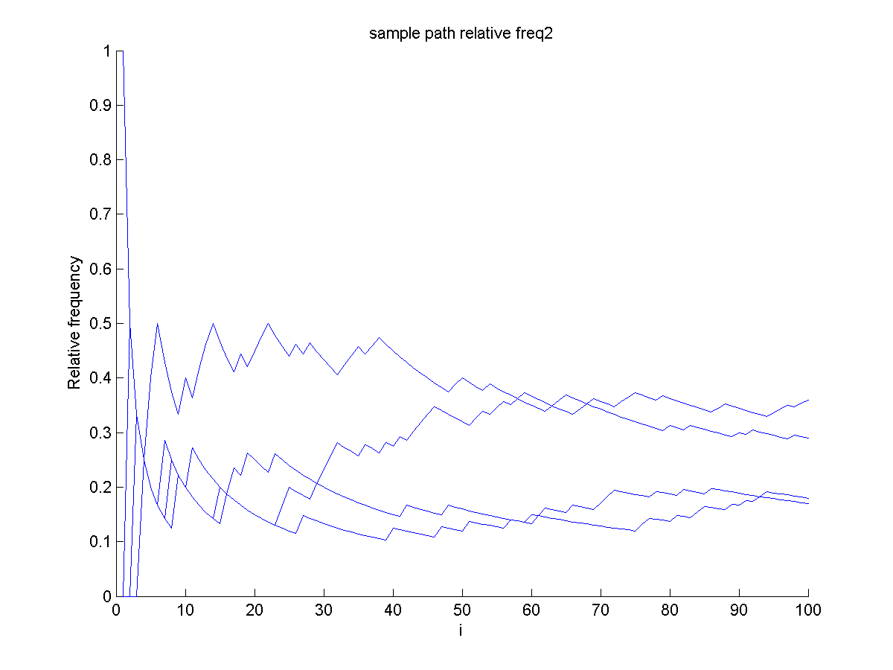
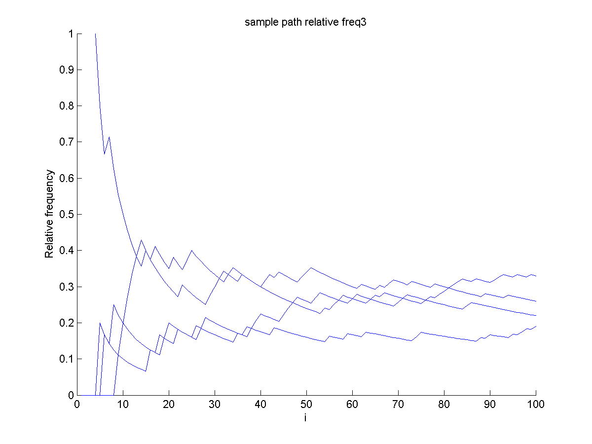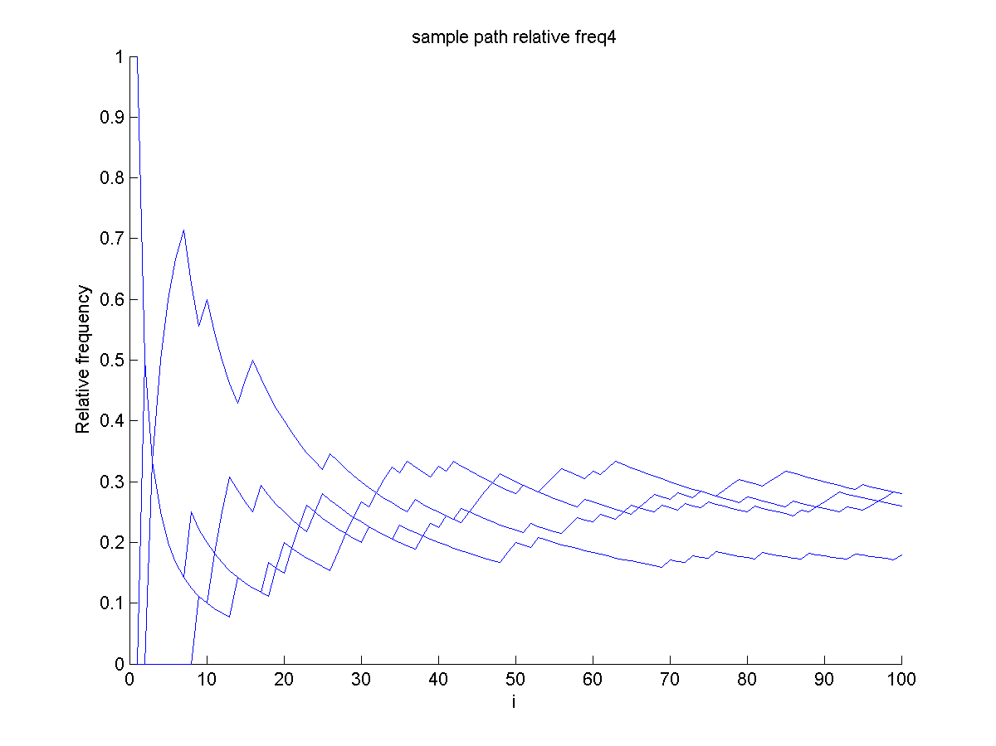

Compare the vectors of the relative frequencies at i=100 with the dominant eigen vector of the transition matrix

When state =1
v1_eigen =

0.1607 0.2616 0.2231 0.3546

v2_Rel_Freq =

0.2200 0.3200 0.2500 0.2100

When state =2
v1_eigen =

0.1607 0.2616 0.2231 0.3546

v2_Rel_Freq =

0.1200 0.2800 0.1800 0.4200

When state =3
v1_eigen =

0.1607 0.2616 0.2231 0.3546

v2_Rel_Freq =

0.1800 0.2300 0.2400 0.3500

When state =4

v1_eigen =

0.1607 0.2616 0.2231 0.3546

v2_Rel_Freq =

0.1200 0.2900 0.2600 0.3300

OUTPUT
Trail, when n=9000

v1_eigen =

0.1607 0.2616 0.2231 0.3546

When state =1
v2_Rel_Freq =

0.1653 0.2603 0.2211 0.3532

When state =2
v2_Rel_Freq =

0.1579 0.2586 0.2297 0.3539

When state =3
v2_Rel_Freq =

0.1573 0.2650 0.2283 0.3493

When state =4
v2_Rel_Freq =

0.1508 0.2723 0.2281 0.3488

CODE
clear all
clc
trans = [0.2 0.2 0.1 0.5;
0.1 0.3 0.4 0.2;
0.3 0.2 0.3 0.2;
0.1 0.3 0.1 0.5];
n=100;
state = zeros(4,n);
path=zeros(n);
for i=1:4;
rand1 = rand/2;
rand2 = rand/2;
state(:,1)=[rand1 0.5-rand1 rand2 0.5-rand2];
for j=1:n;
x = rand;
y = find(x<cumsum(state(:,j)));
path(j,i) = min(y);
state(:,j+1)=trans(path(j,i),:)';
for k=1:4;
count(j,i,k)=length(find(path(1:j,i)==k))/j;
end;
end;
end;
for i=1:4;
figure(i);
stairs(path(:,i));
xlabel('time')
ylabel('X(i) state')
title(['Sample Path #' int2str(i)]);
saveas(figure(i),['Sample path prob2 ' int2str(i) '.png'])
end;

x1 = [1:1:100];
for i=1:4;
figure(i+4);
hold on
plot(x1,count(:,i,1));
plot(x1,count(:,i,2));
plot(x1,count(:,i,3));
plot(x1,count(:,i,4));
xlabel('i');
ylabel('Relative frequency');
title(['sample path relative freq' int2str(i)]);
saveas(figure(i+4),['sample path relative freq ' int2str(i) '.png'])
hold off
end;

for i=1:4;
[v,d] = eig(trans');
v1_eigen = v(1:4,1)/sum(v(1:4,1))
v2_Rel_Freq = [count(n,i,1), count(n,i,2), count(n,i,3), count(n,i,4)]
end;

