1.
OUTPUT
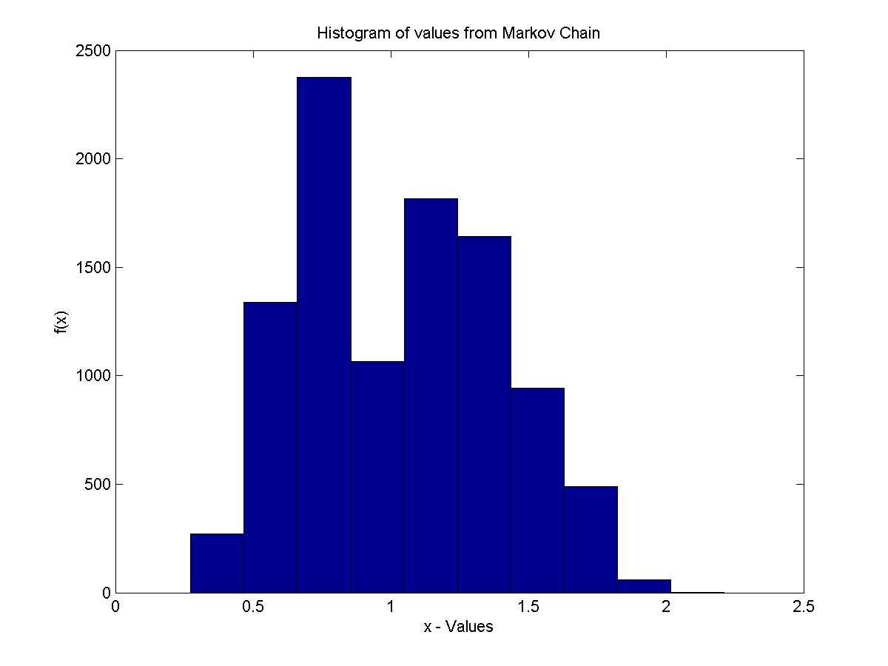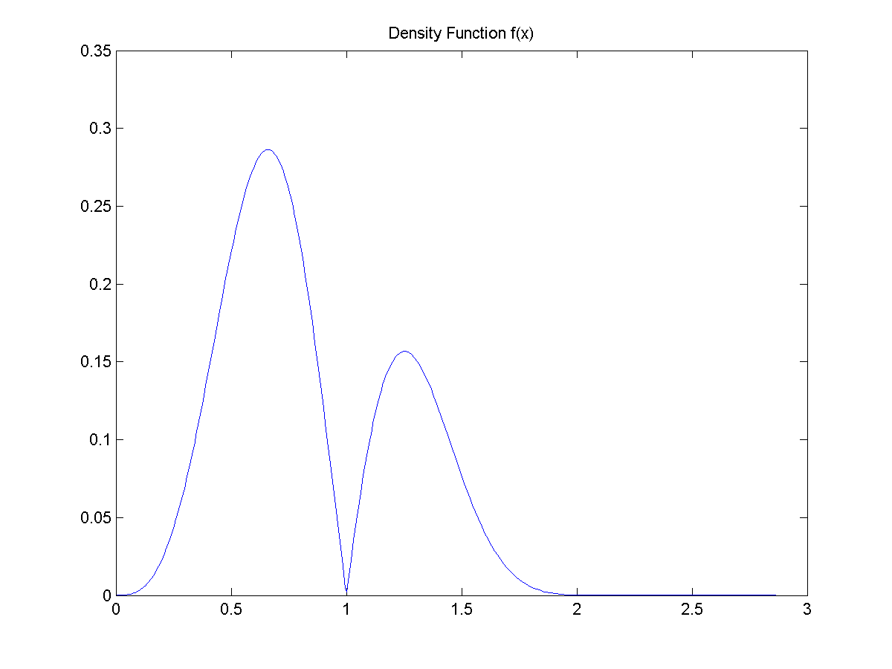
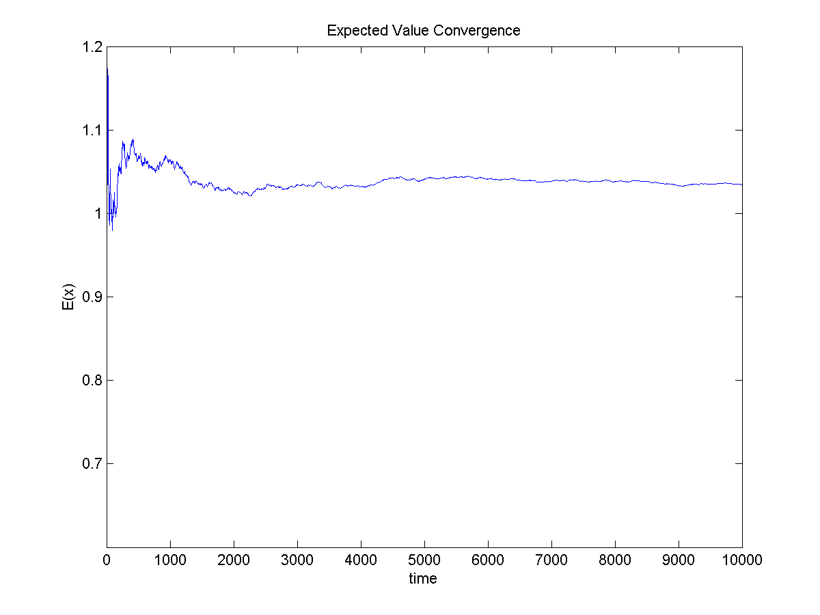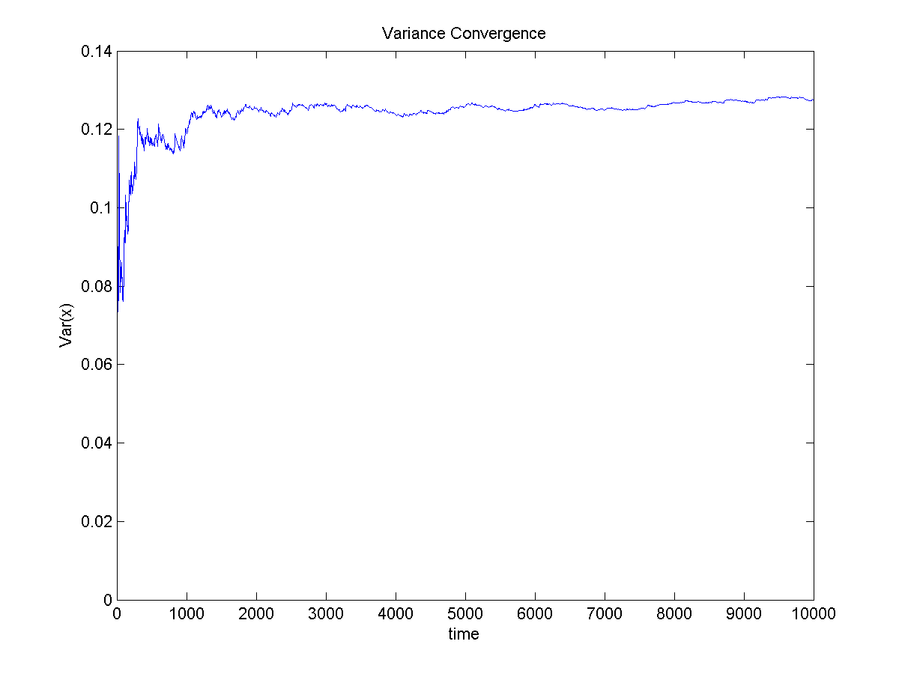

exp_x1 =

1.0190

var_x1 =

0.1315

CODE
clear all
clc

alpha=3;
beta=0.8;

x = -log(rand);

for i=1:10000;
y = -1*beta*log(rand);
u1 = rand;
fun1 = fun4_prob1(x,y,alpha,beta);
if u1 <=fun1
x=y;
else
x=x;
end;
x_1(i)=x;
exp_x(i) = mean(x_1);
var_x(i) = var(x_1);
end;
figure(1)
hist(x_1);
xlabel('x - Values')
ylabel('f(x)')
title(['Histogram of values from Markov Chain']);
saveas(figure(1),['Histogram MC-Values prob1.png'])

exp_x1 = mean(x_1)
var_x1 = var(x_1)

figure(2)
func=@(x) x*x*abs(sin(pi*x))*exp(-abs(x)^3);
fplot(func,[0,3]);
title(['Density Function f(x)']);
saveas(figure(2),['Density Function prob1.png'])

figure(3)
plot(exp_x)
xlabel('time')
ylabel('E(x)')
title(['Expected Value Convergence']);
saveas(figure(3),['Expected Convergence prob1.png'])

figure(4)
plot(var_x)
xlabel('time')
ylabel('Var(x)')
title(['Variance Convergence']);

saveas(figure(4),['Variance Convergence prob1.png'])

2.
OUTPUT

CODE
clear all
clc

n=10000;

for i=2:n
u1= rand;
x(1) = rand;
z=random('normal',5,2);

if u1<=fun1_prob2(x(i-1),z);
x(i)=z;
else
x(i)=x(i-1);
end;

mean1(i) = mean(x);
var1(i) =var(x);

end

figure(1)
hist(x);
title(['Histogram of values ']);
saveas(figure(1),['Histogram prob2.png'])

figure(2)
plot(x);
title(['Evolution of']);
saveas(figure(2),['Histogram MC-Values prob2.png'])

figure(3)
plot(mean1);

figure(4)
plot(var1);

mean1(n)
var1(n)

3.
OUTPUT Checkboard
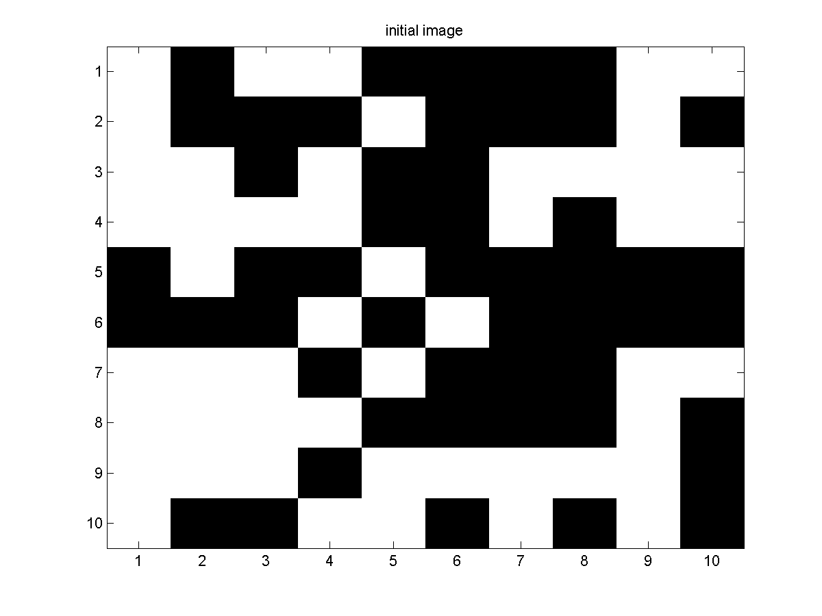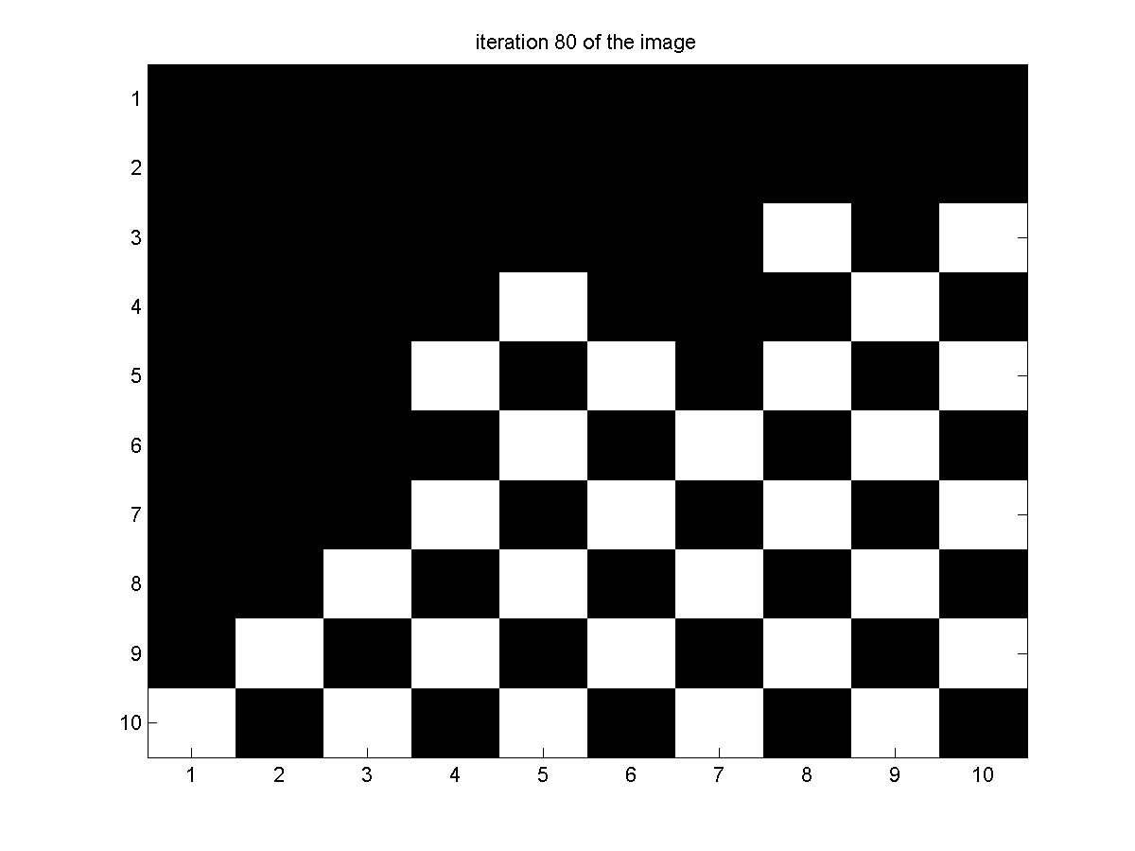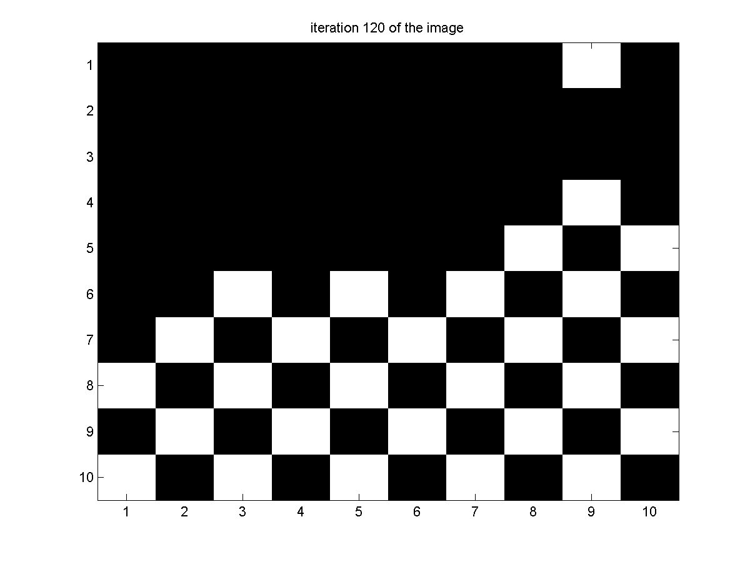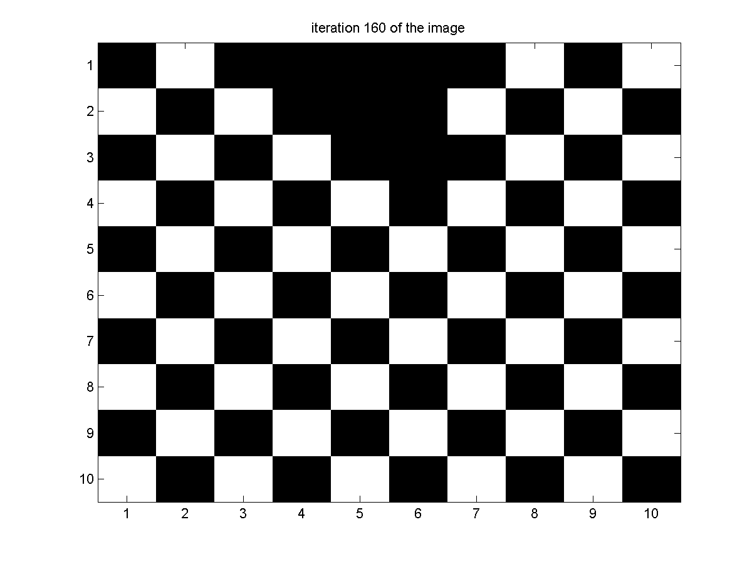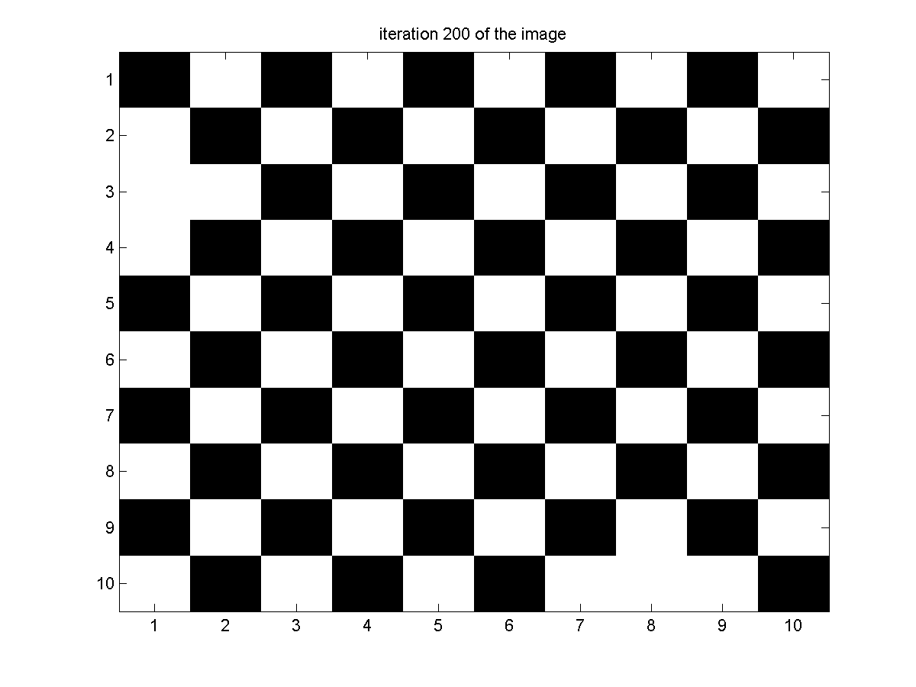

Black Board
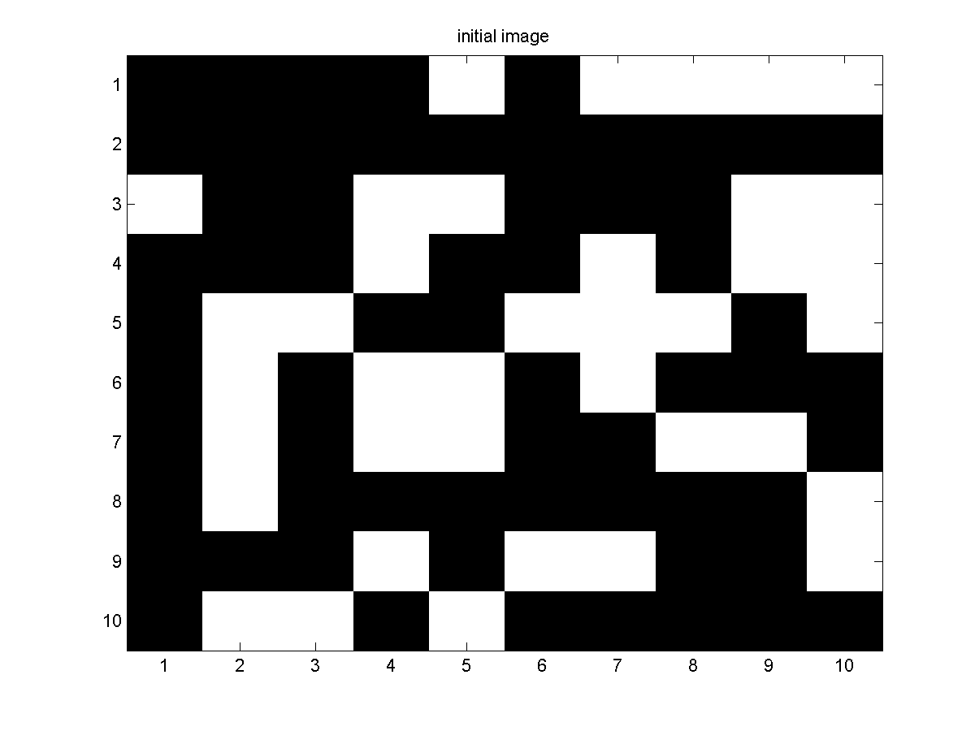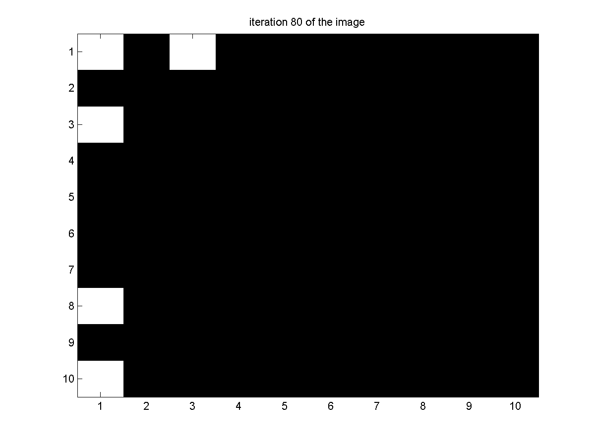

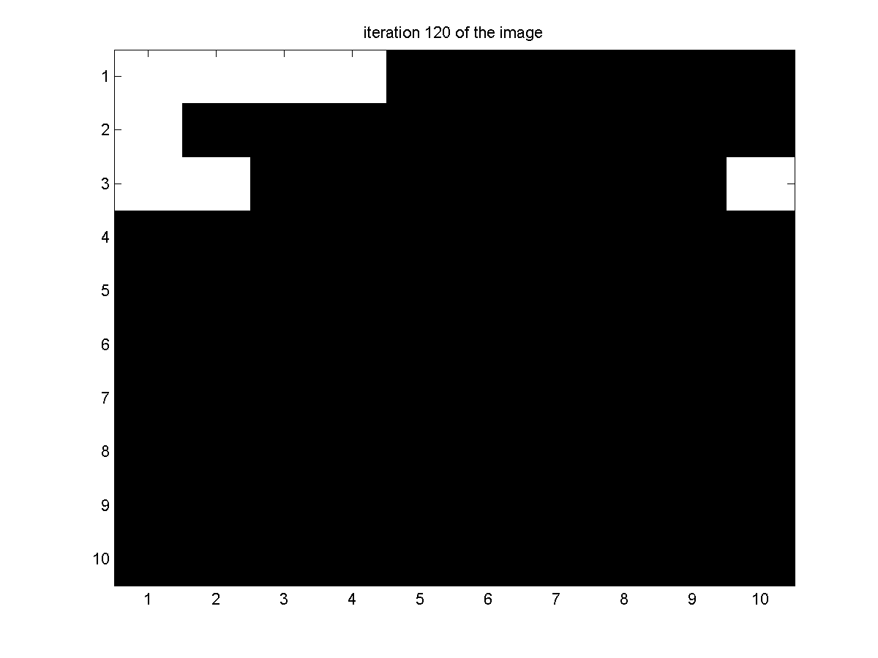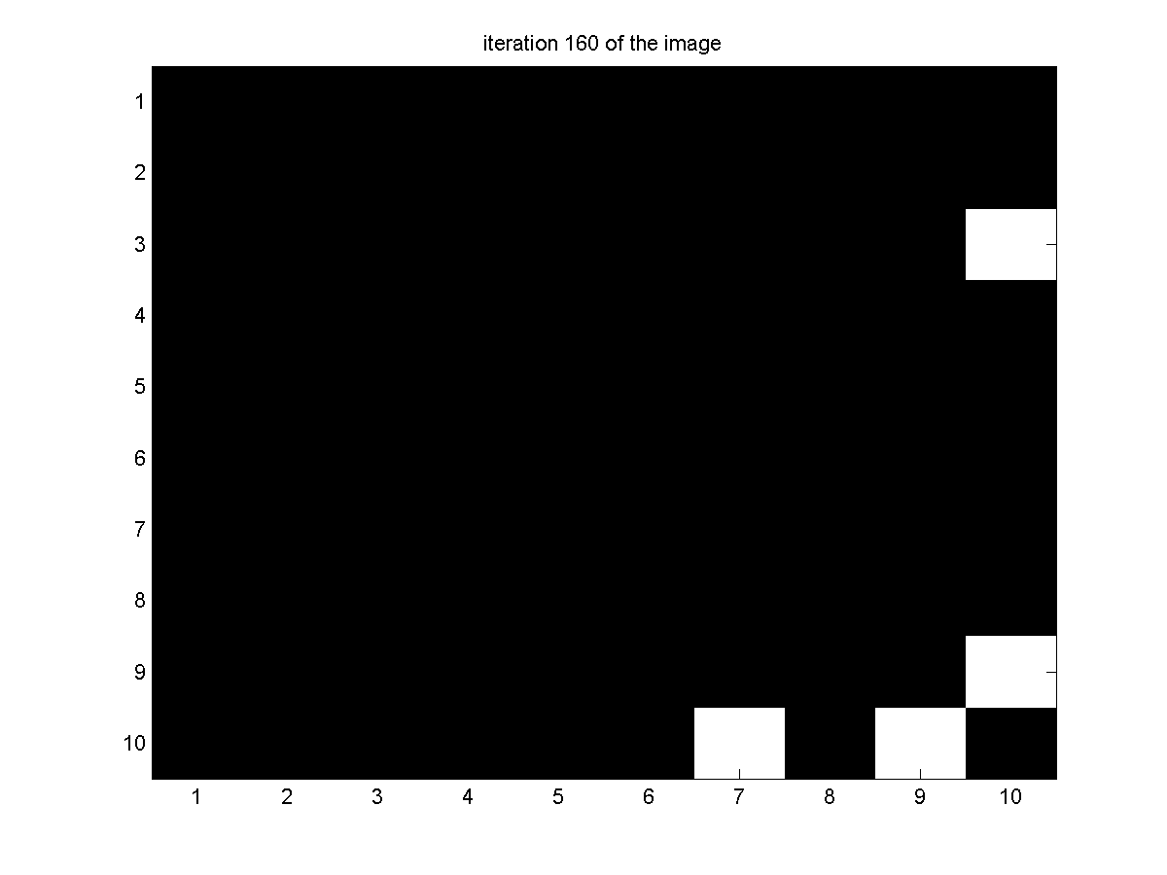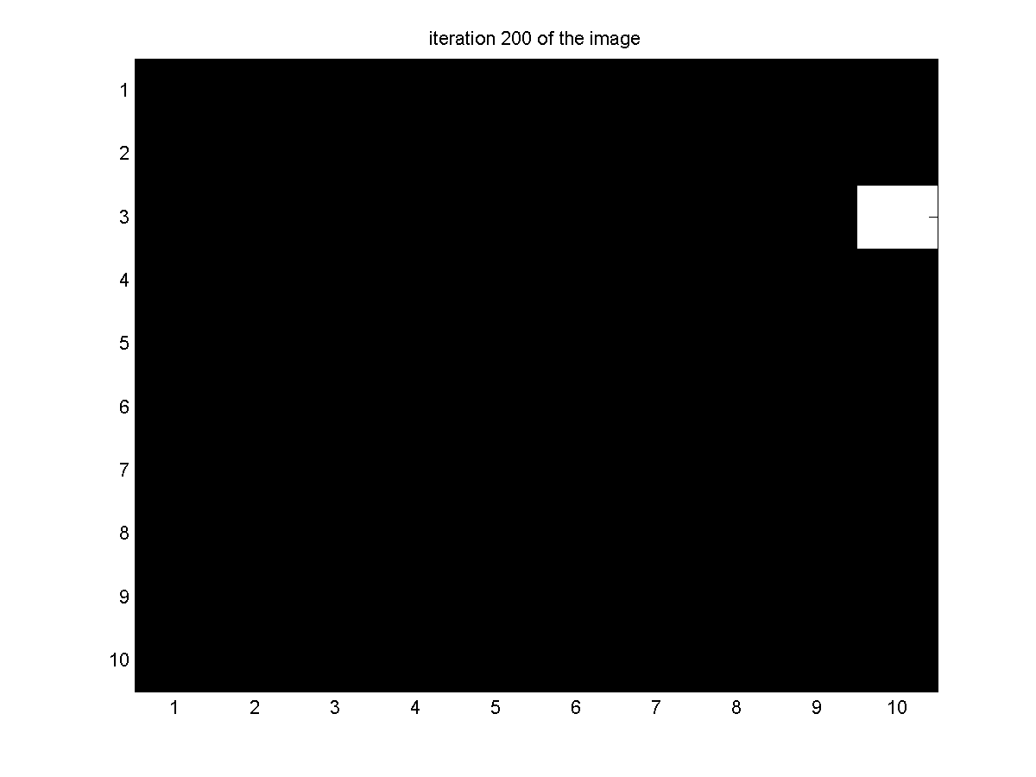

White board
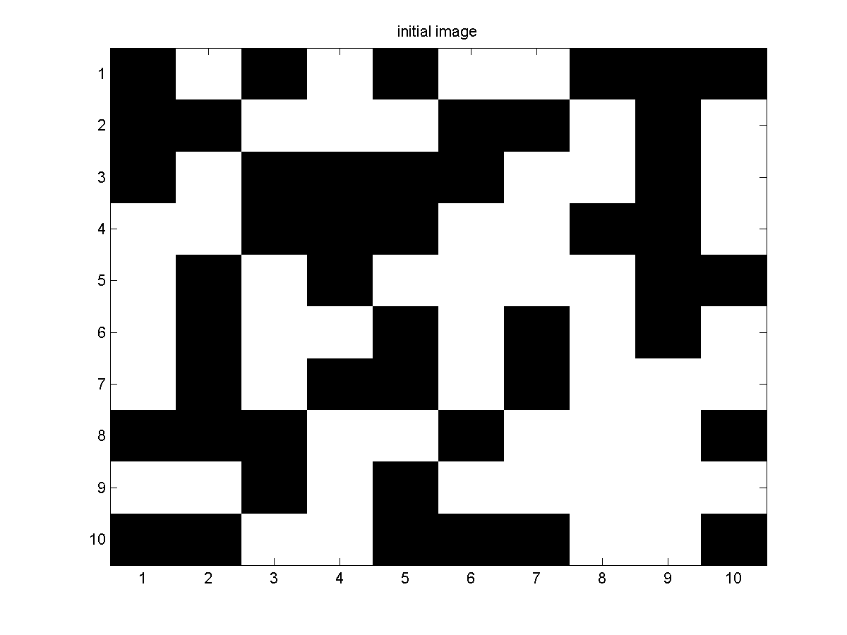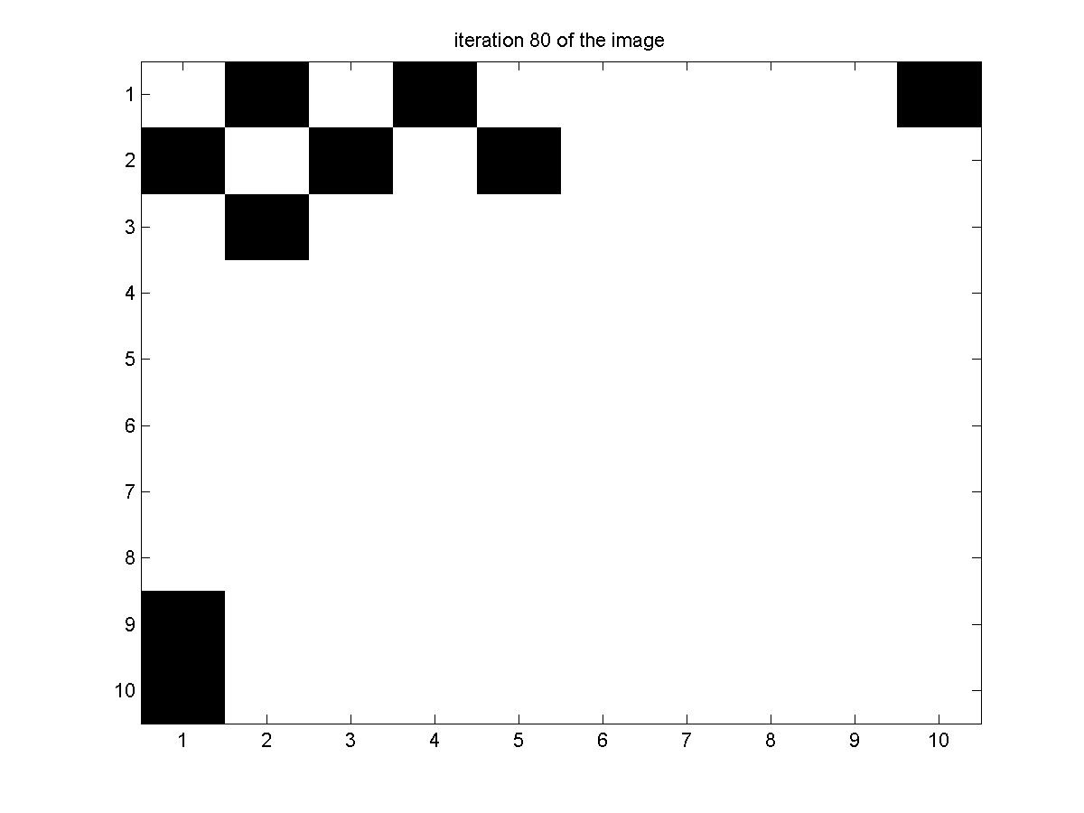
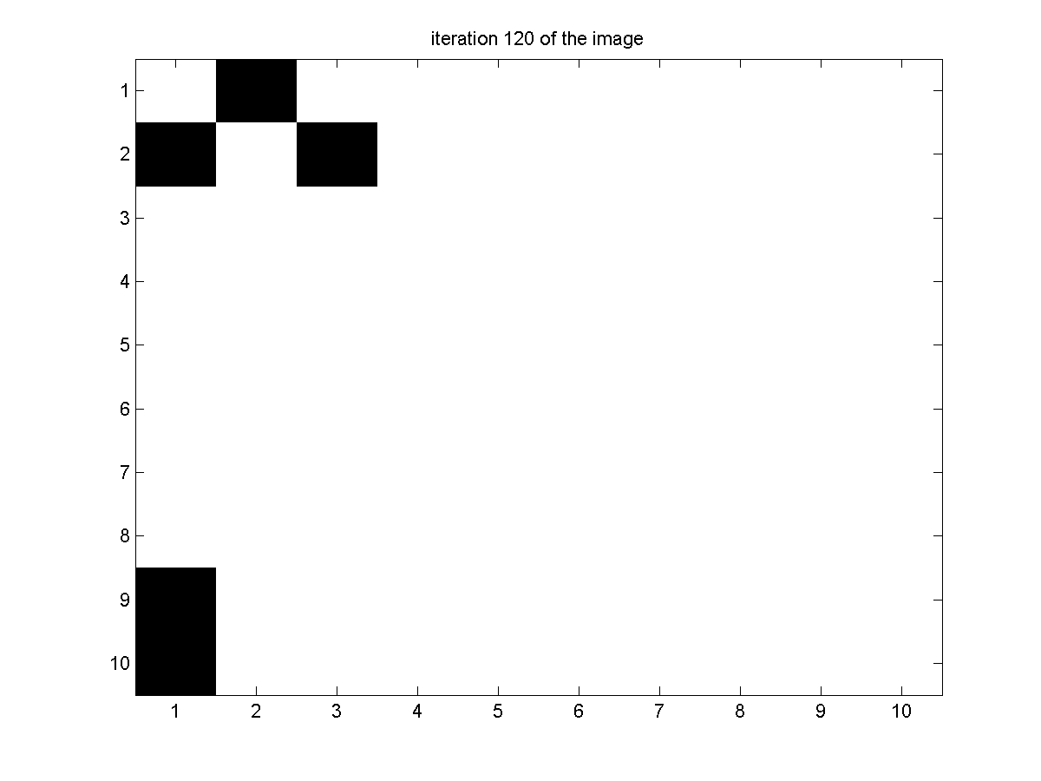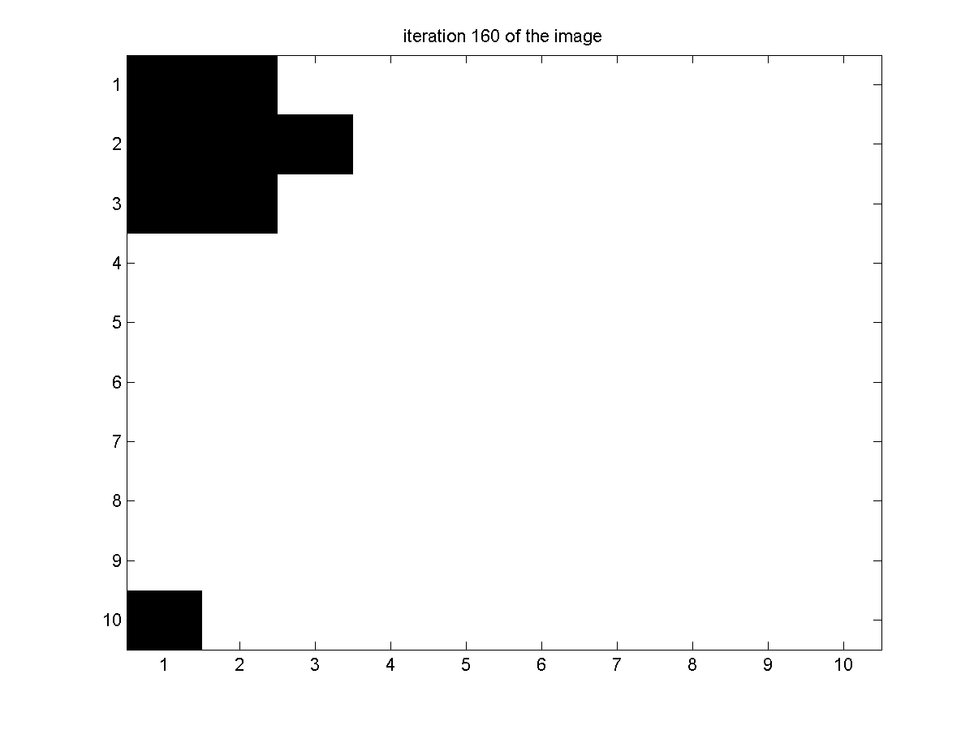
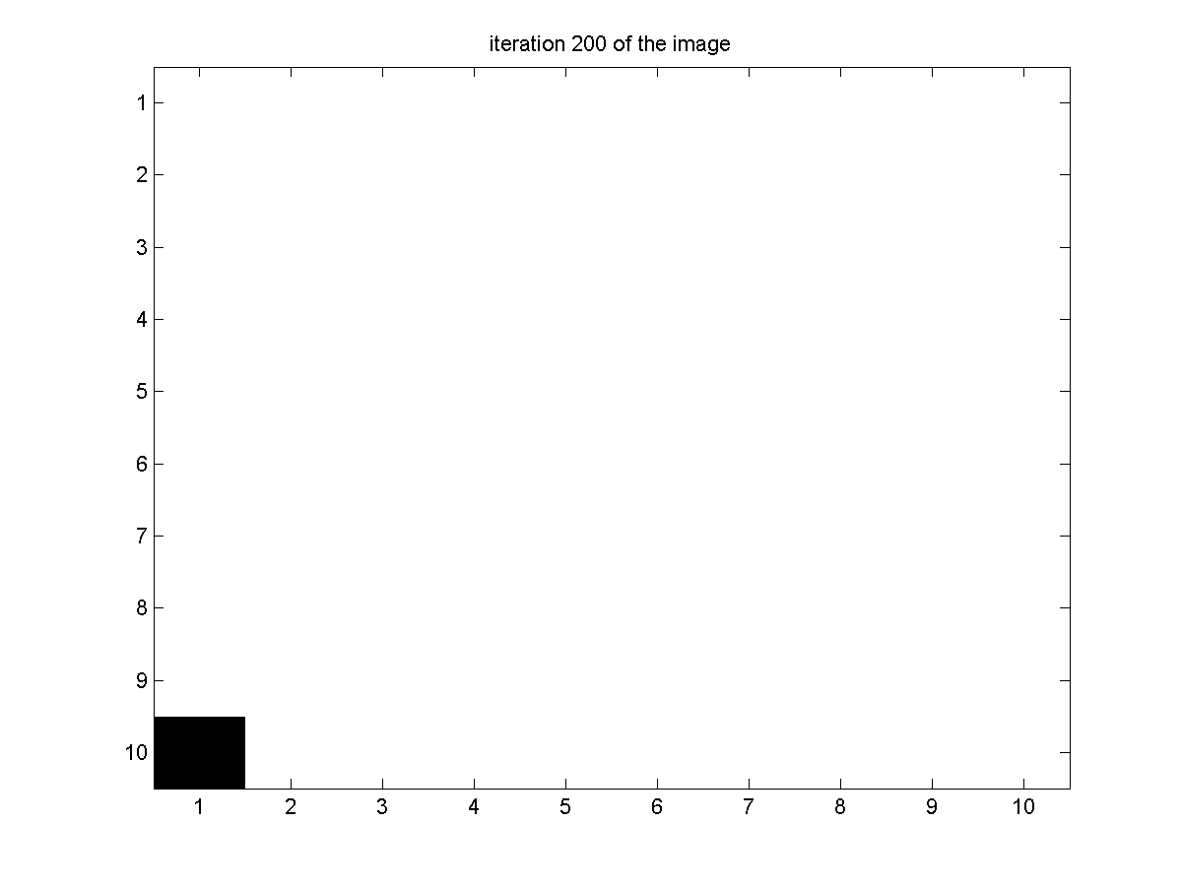
CODE
clear all
clc

n=12;
x=rand(n,n,1);

for j=1:n;
for k=1:n
if x(j,k,1)<=0.5
x(j,k,1) = -1;
else
x(j,k,1) = 1;
end;
end;
end;

figure(1)
imagesc(x(2:n-1,2:n-1,1));
colormap('gray');
title('initial image');
saveas(figure(1),['Initial Image prob3.png']);

n1=200;
for i=2:n1;
x(:,:,i)= x(:,:,i-1);
for j=2:n-1;
for k=2:n-1
alpha1=x(j+1,k,i-1) + x(j-1,k,i-1)+x(j,k+1,i-1)+x(j,k-1,i-1);
p=exp(-x(j,k,i-1)*alpha1)/(exp(alpha1)+exp(-alpha1));
if p<=rand;
x(j,k,i)=x(j,k,i-1);
else
x(j,k,i)=-x(j,k,i-1);
end
end;
end
end;

figure(2)
imagesc(x(2:n-1,2:n-1,(floor(n1/5))*2));
colormap('gray');
title(['iteration ' int2str(floor(n1/5)*2) ' of the image']);
saveas(figure(2),['iteration ' int2str(floor(n1/5)*2) ' prob3.png']);

figure(3)
imagesc(x(2:n-1,2:n-1,floor(n1/5)*3));
colormap('gray');
title(['iteration ' int2str(floor(n1/5)*3) ' of the image']);
saveas(figure(3),['iteration ' int2str(floor(n1/5)*3) ' prob3.png']);

figure(4)
imagesc(x(2:n-1,2:n-1,floor(n1/5)*4));
colormap('gray');
title(['iteration ' int2str(floor(n1/5)*4) ' of the image']);
saveas(figure(4),['iteration ' int2str(floor(n1/5)*4) ' prob3.png']);

figure(5)
imagesc(x(2:n-1,2:n-1,floor(n1/5)*5));
colormap('gray');
title(['iteration ' int2str(floor(n1/5)*5) ' of the image']);
saveas(figure(5),['iteration ' int2str(floor(n1/5)*5) ' prob3.png']);

4.
OUTPUT
I1.txt
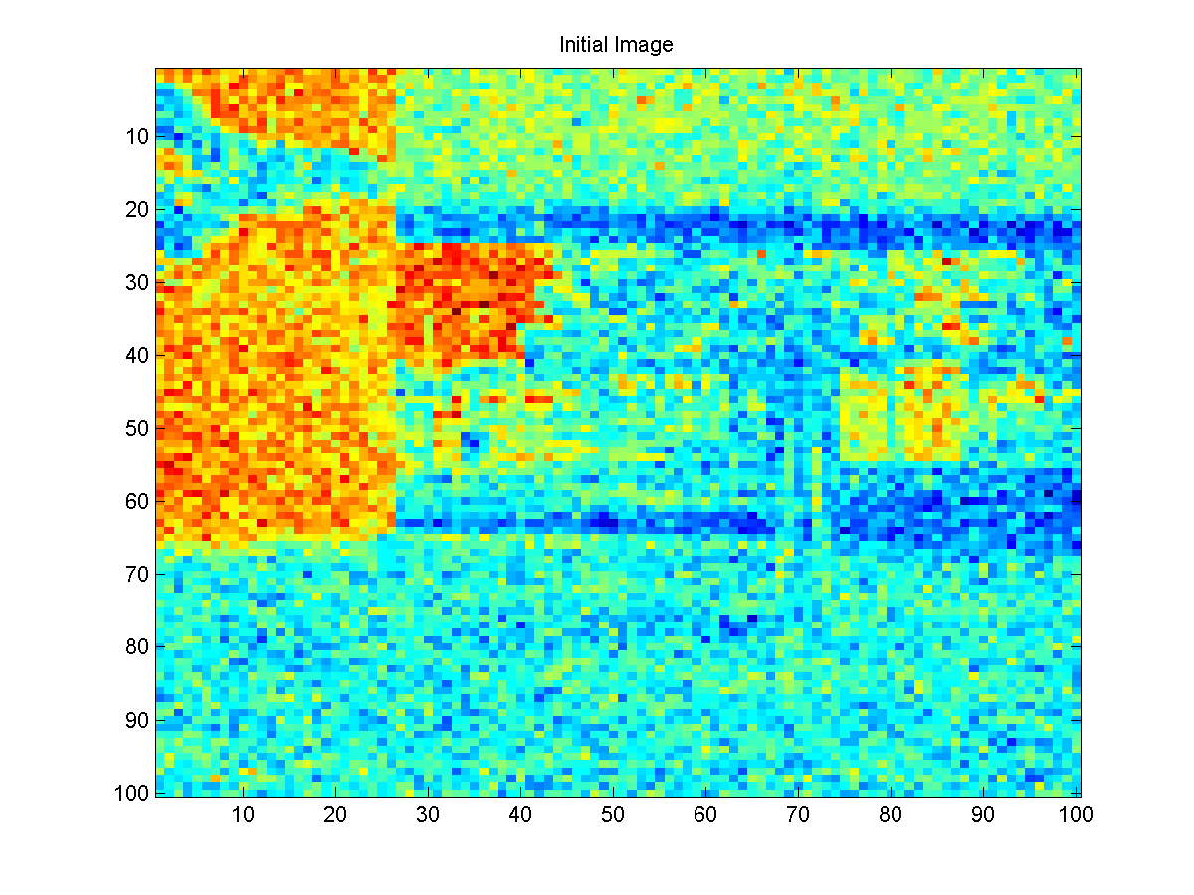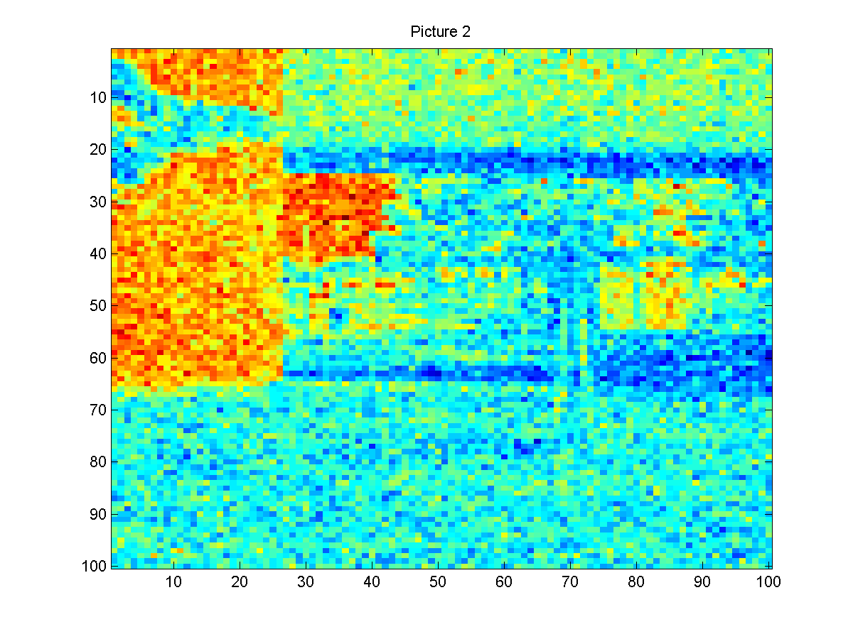
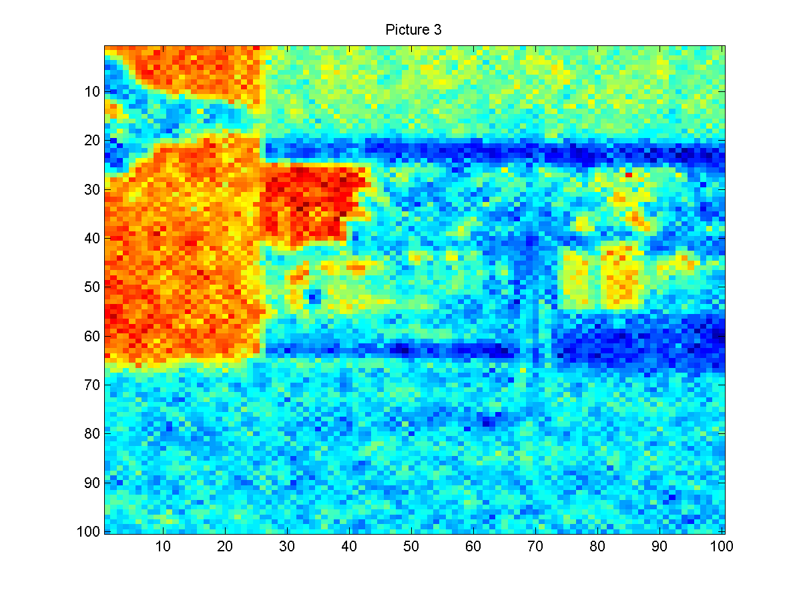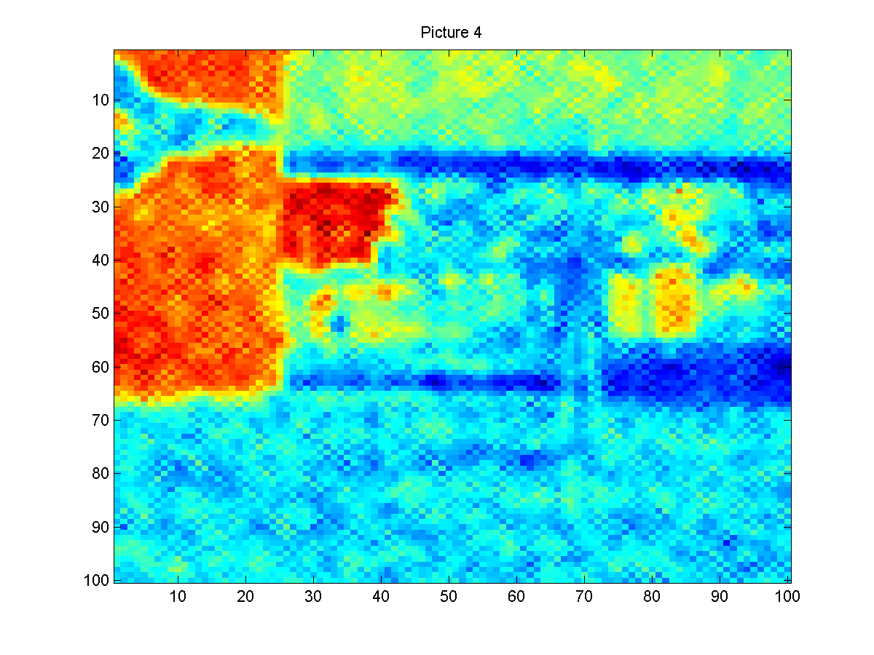
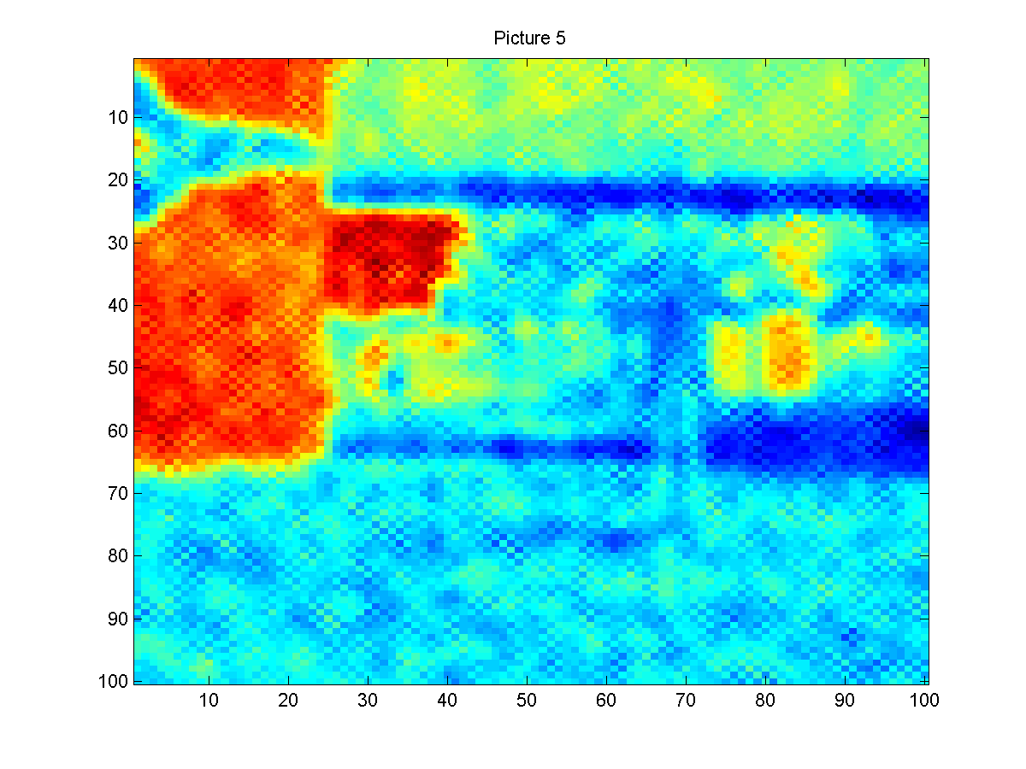

I2.txt
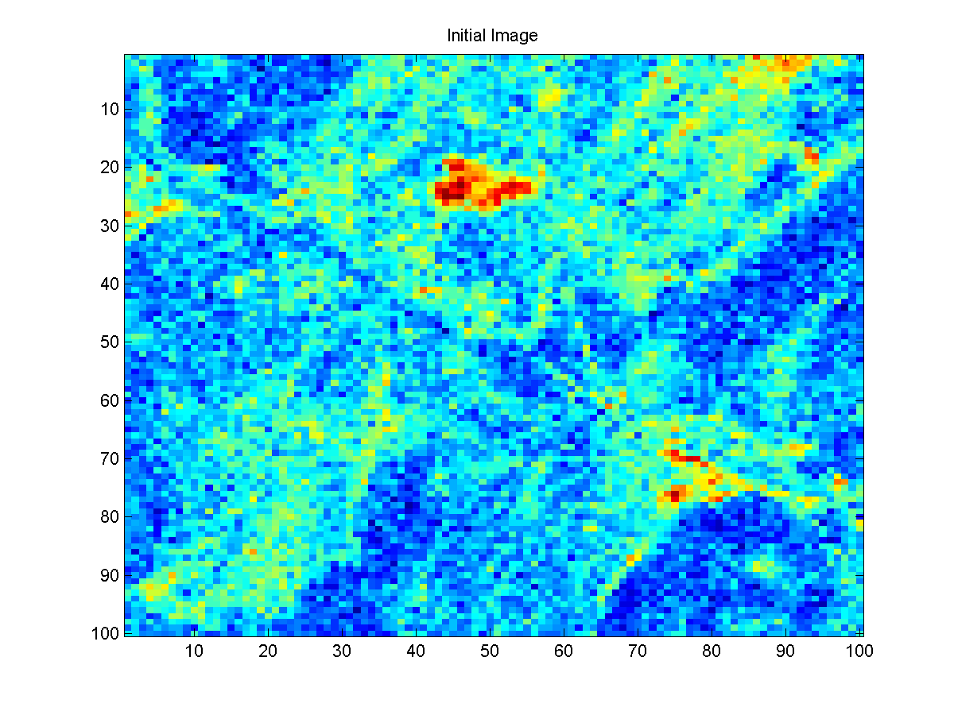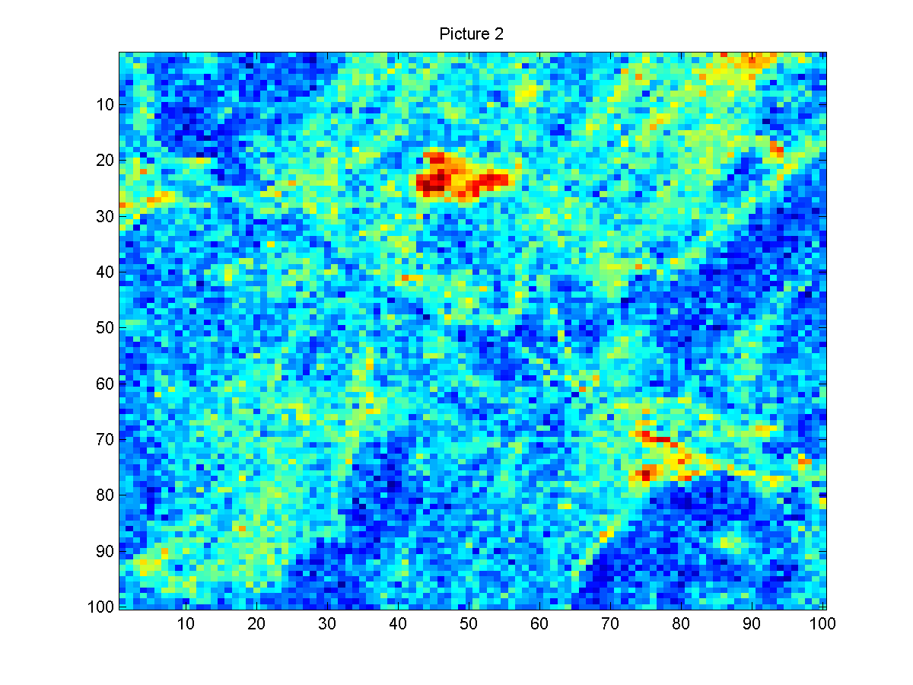
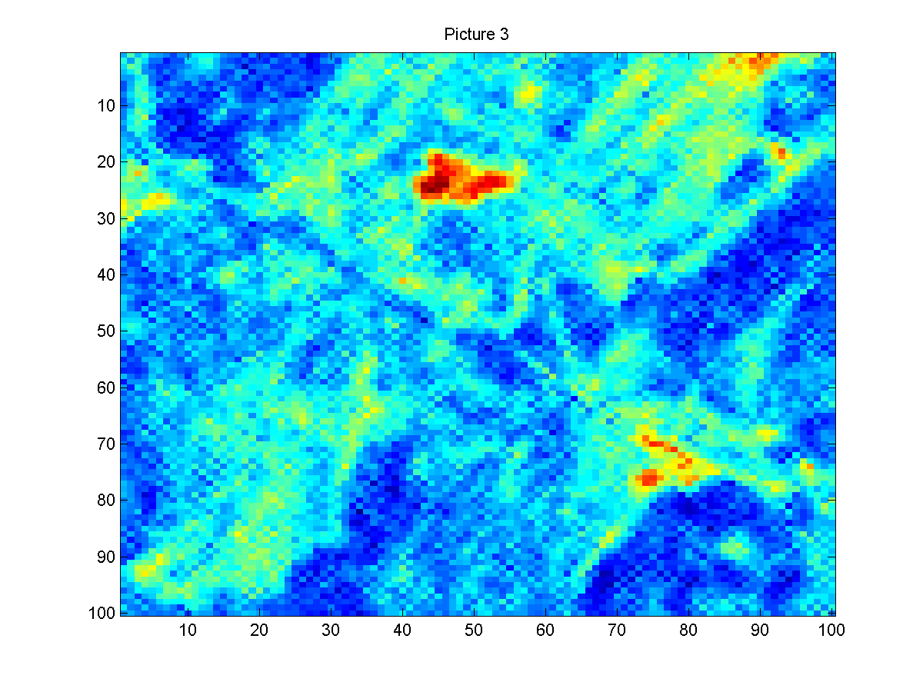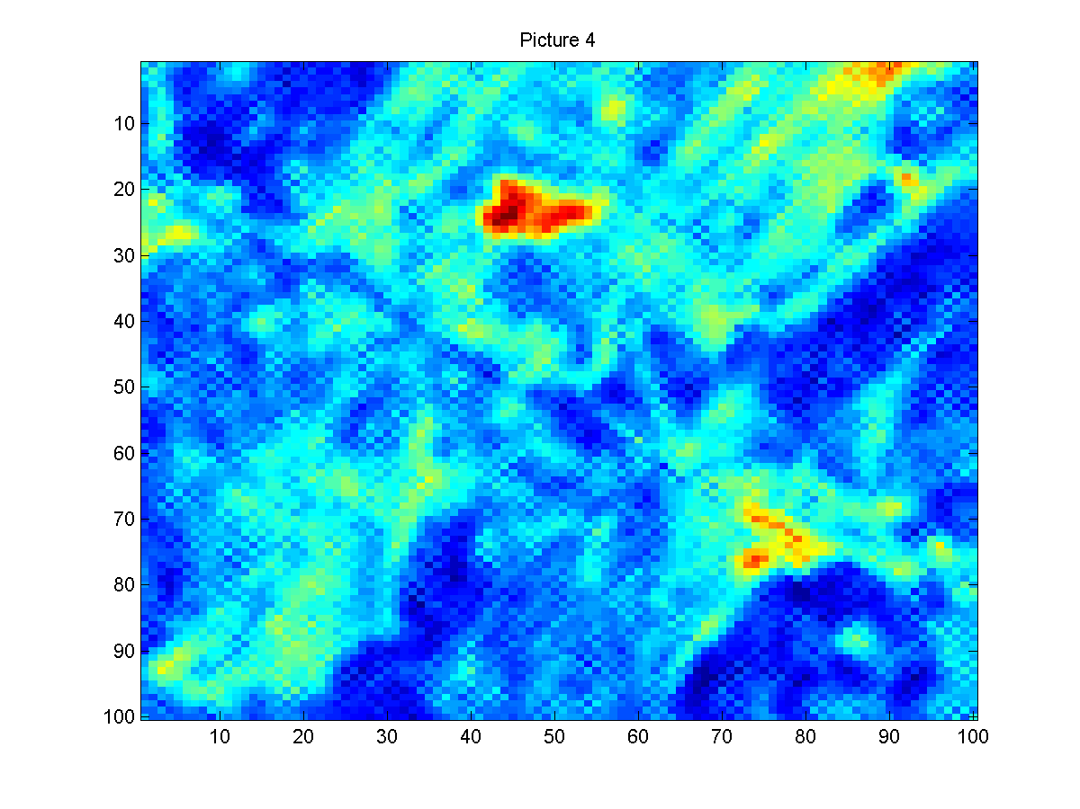
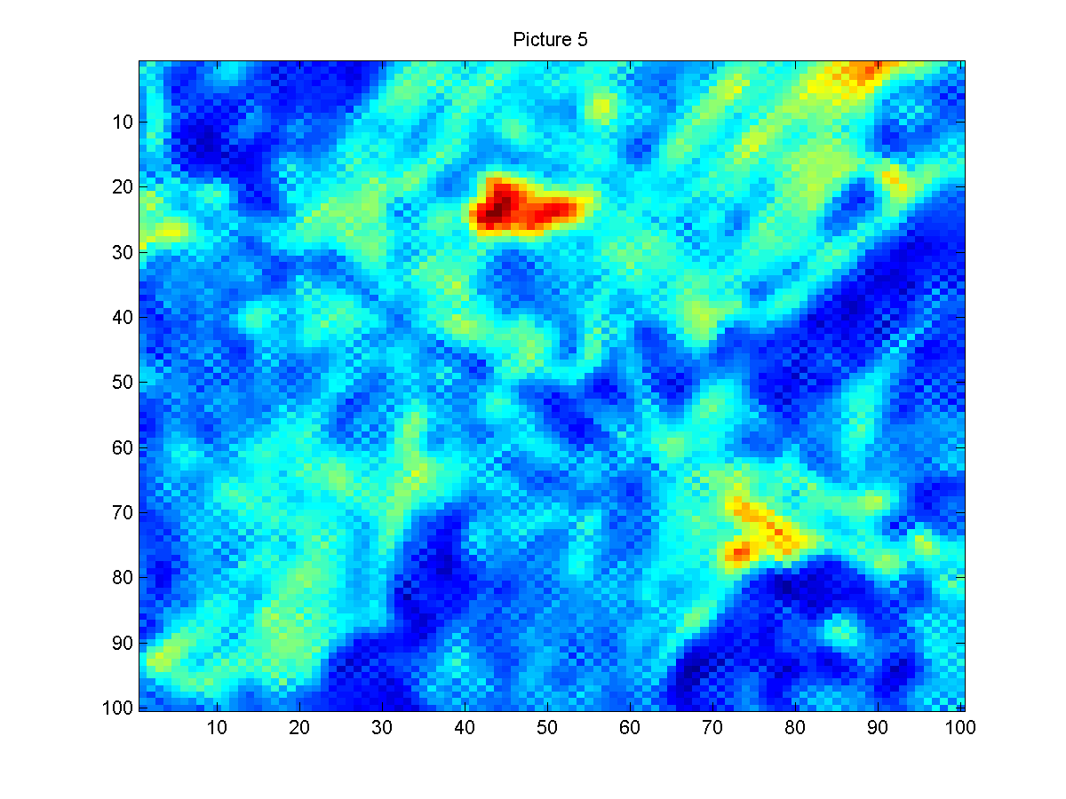

I3.txt
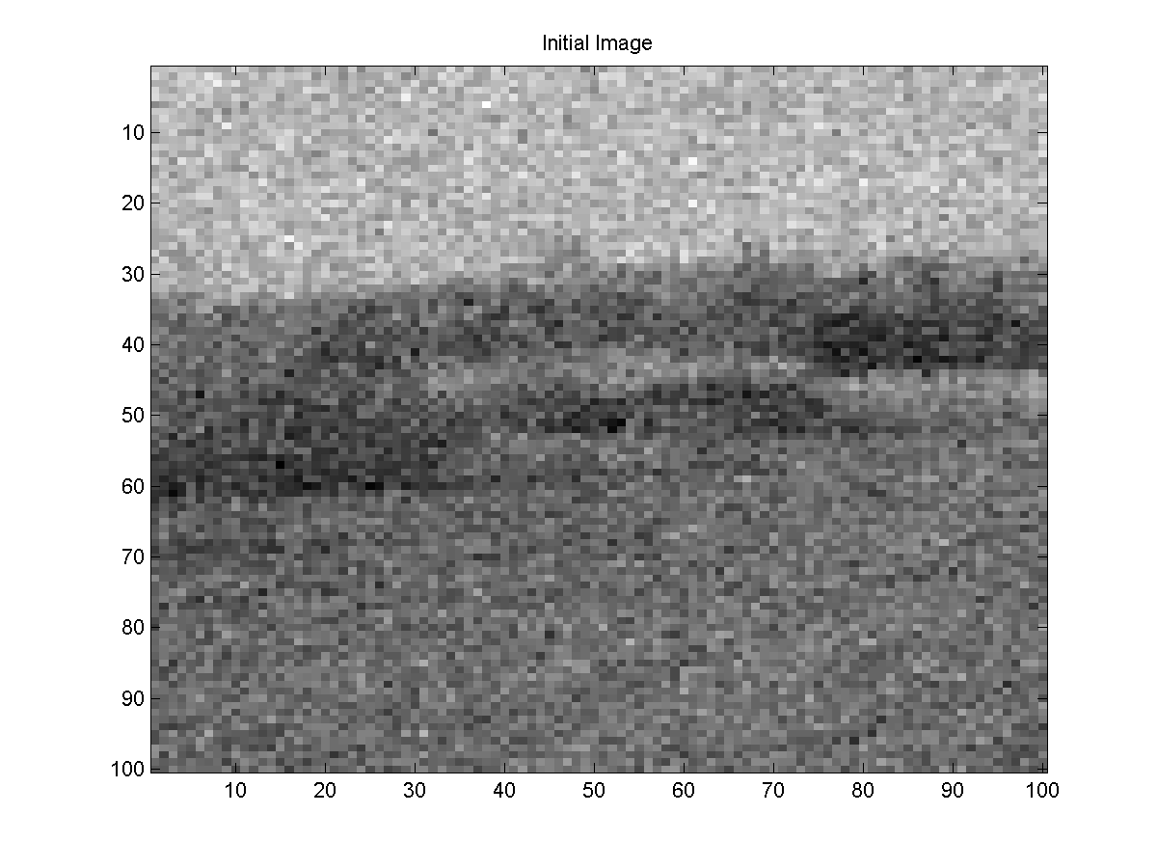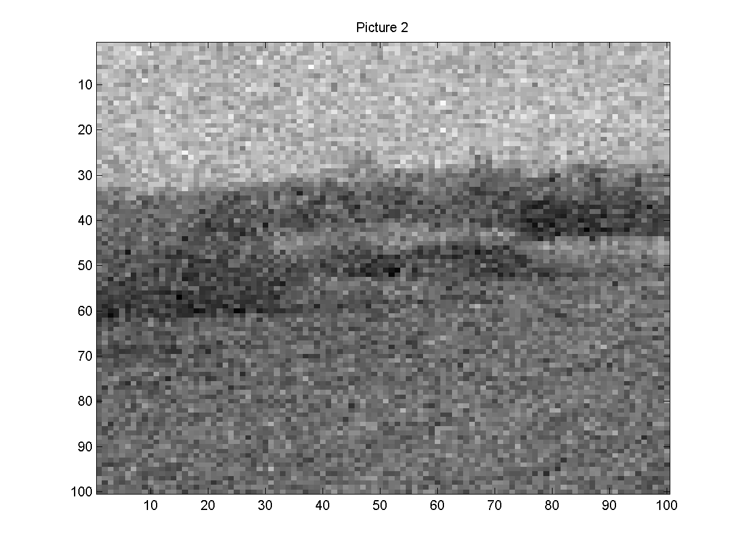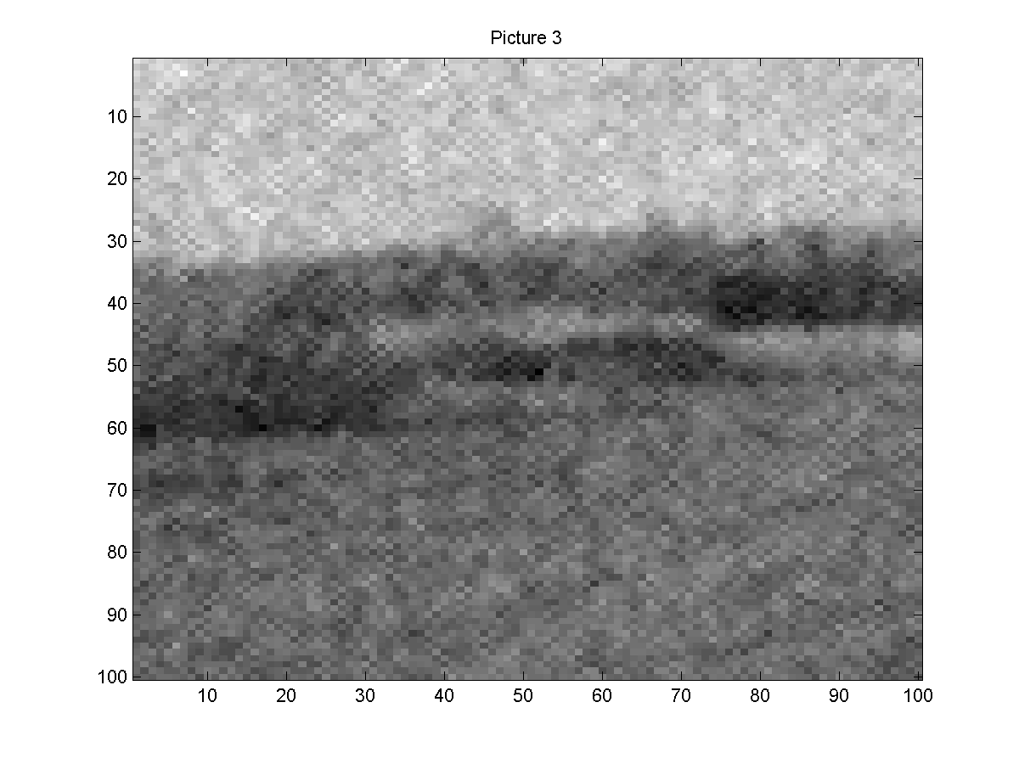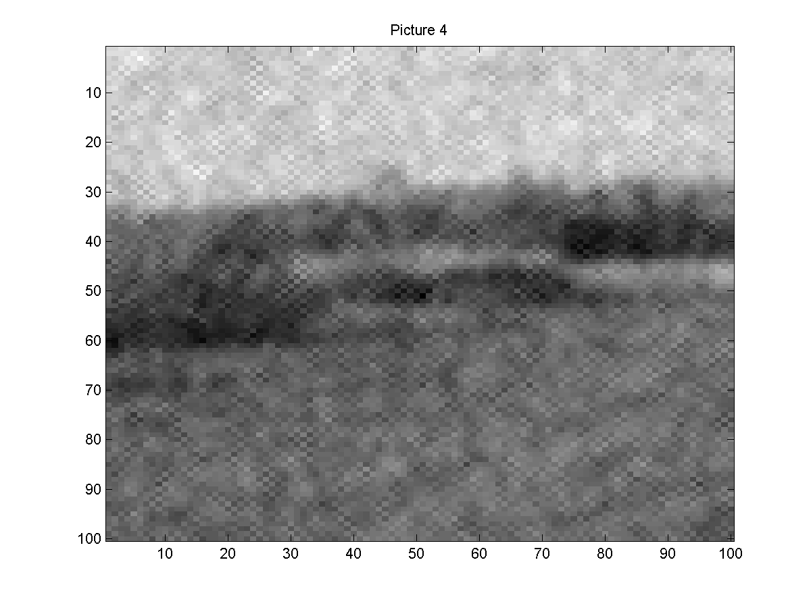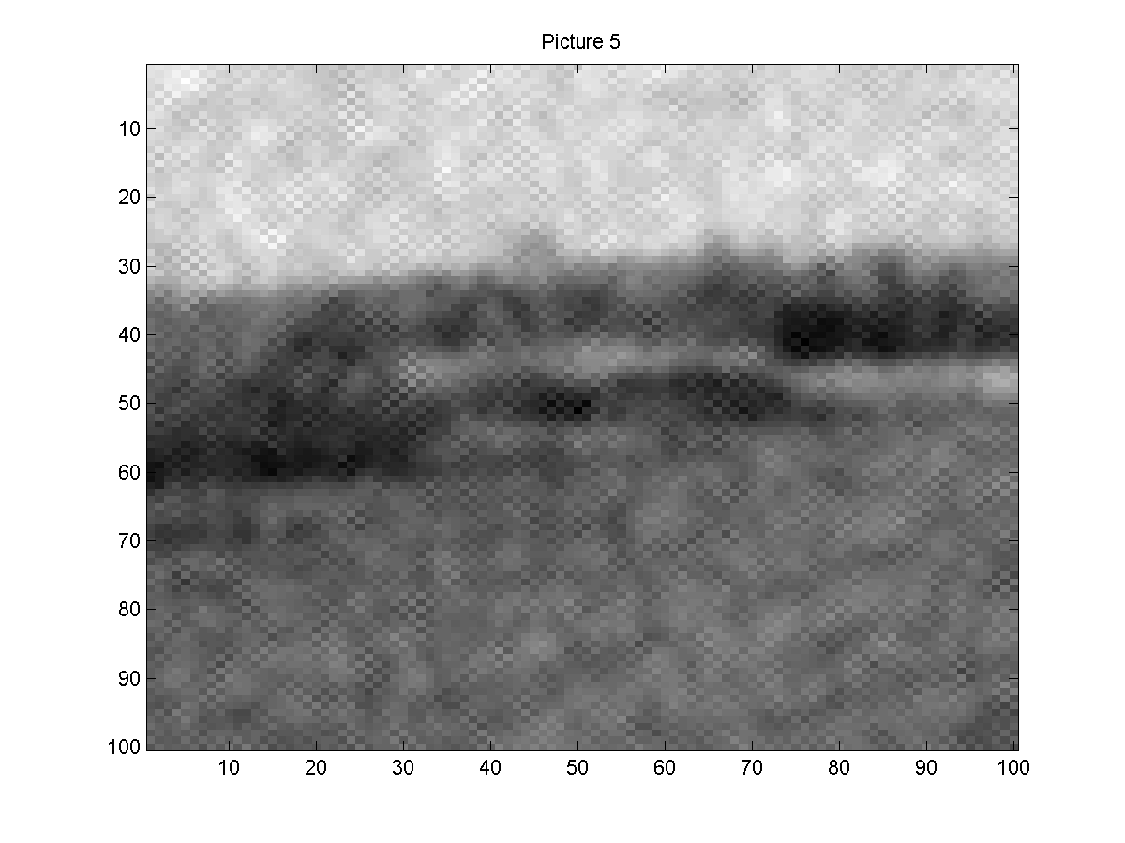

I4.txt
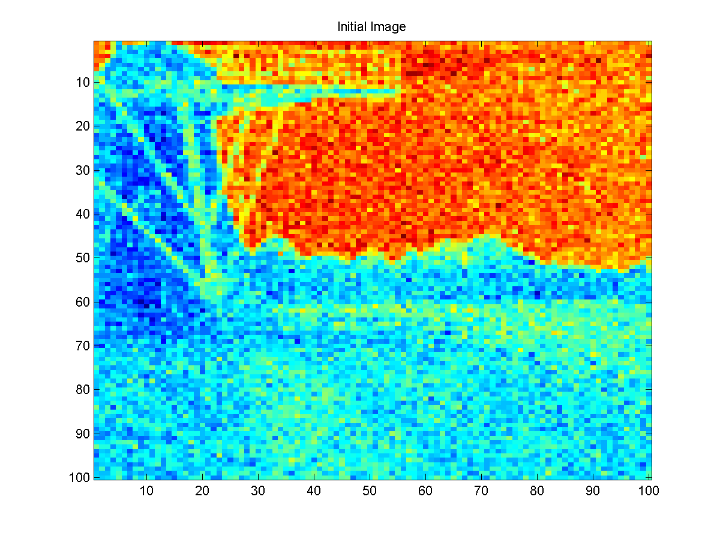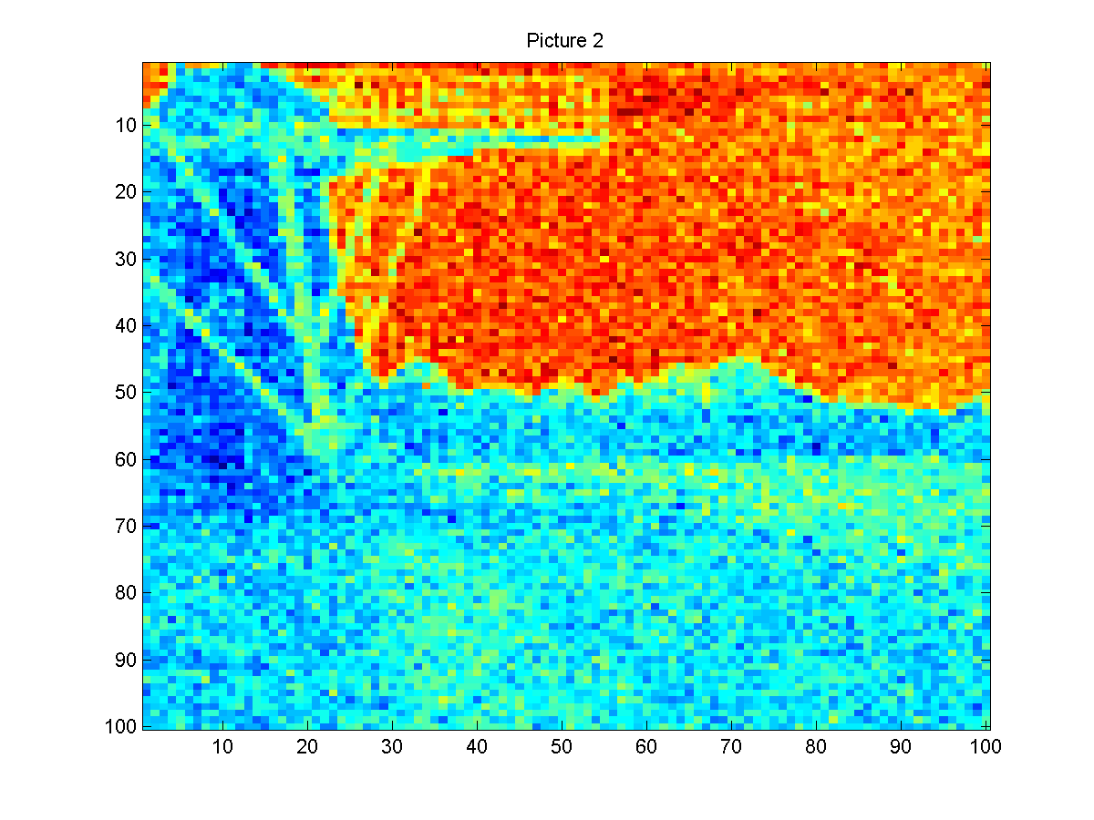
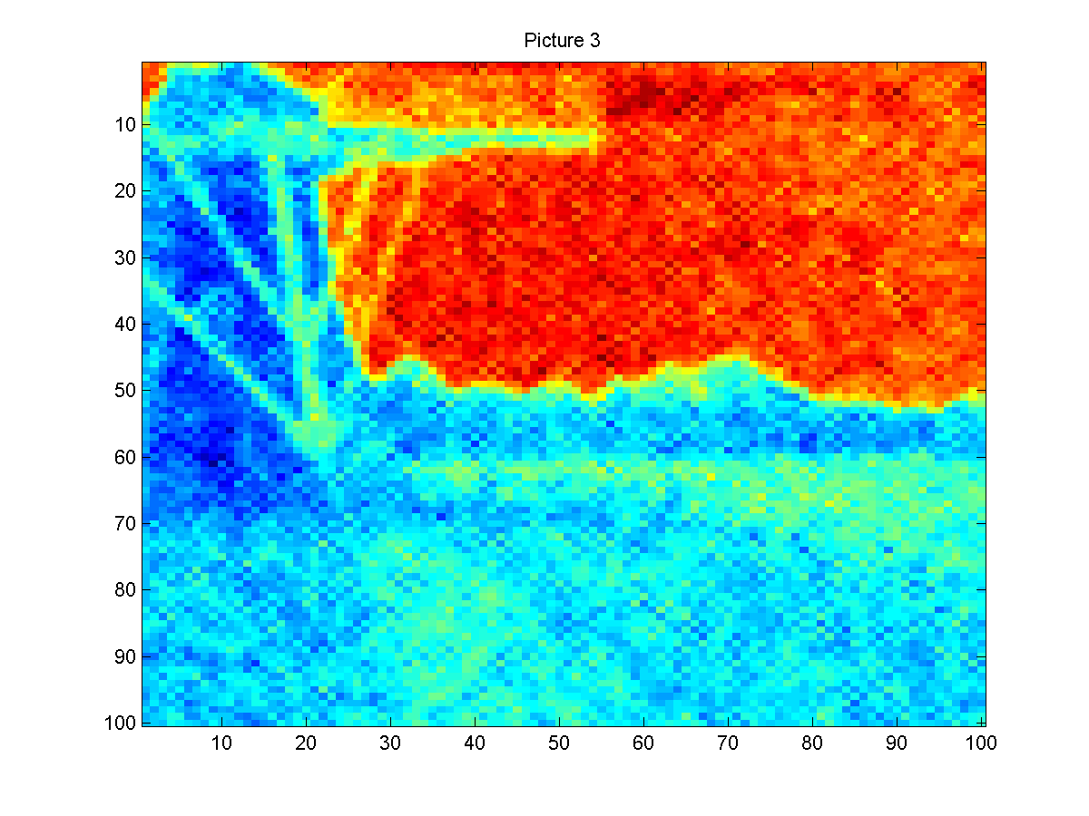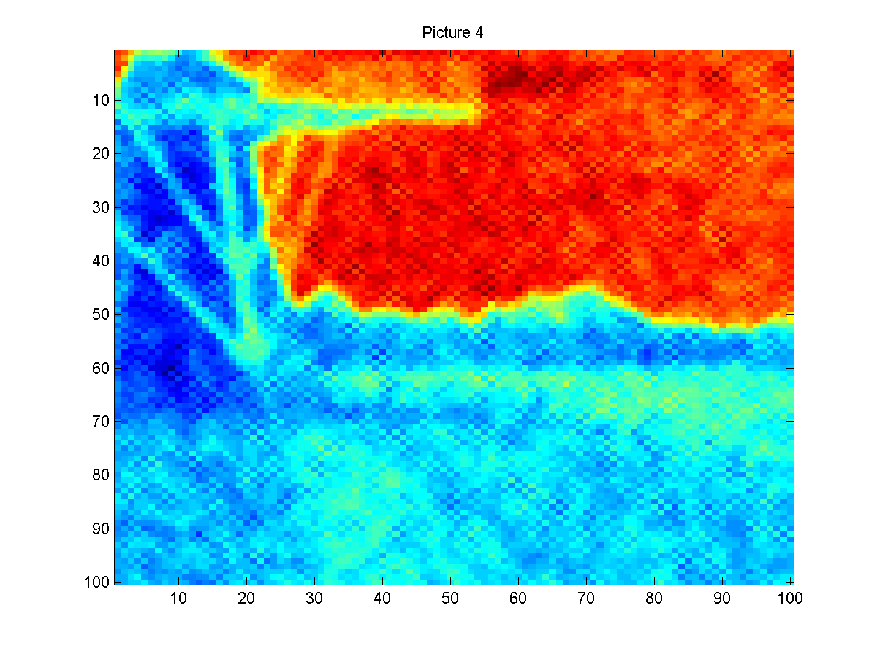
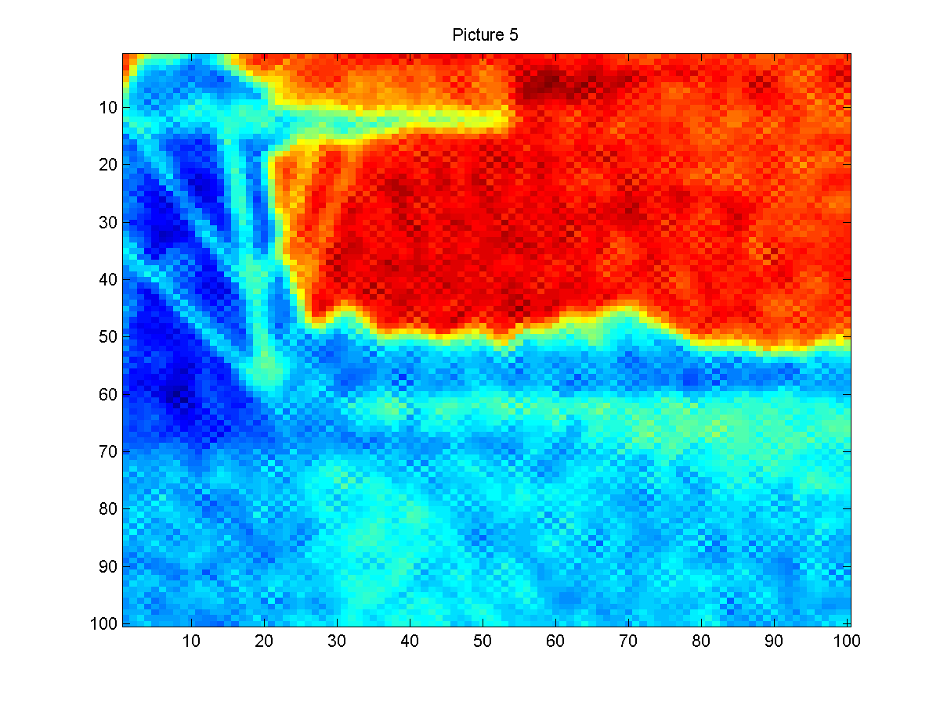
CODE

clear all
clc

load('I4.txt');
x(:,:,1)=I4;
[n1,n1]=size(I4);
loop=5;

figure(1)
imagesc(x(:,:,1));
title('Initial Image');
saveas(figure(1),['Initial Image prob4-4.png']);

for i=2:loop;
x(:,:,i)= x(:,:,i-1);
for j=1:n1;
for k=1:n1;
[n2,n2,n3]=size(x);
if (j==1) && (k==1)
mid=(x(j,k+1,i-1)+x(j+1,k,i-1))/2;
end;

if (j==1) && (k==n2)
mid=(x(1,k-1,i-1)+x(j+1,k,i-1))/2;
end;

if (j==n2) && (k==1)
mid=(x(j-1,k,i-1)+x(j,k+1,i-1))/2;
end;

if (j==n2) && (k==n2)
mid=(x(j,k-1,i-1)+x(j-1,k,i-1))/2;
end;

if (j==1 && k~=1 && k~=n2)
mid=(x(j+1,k,i-1)+x(j,k-1,i-1)+x(j,k+1,i-1))/3;
end;

if (j==n1 && k~=1 && k~=n2)
mid=(x(j-1,k,i-1)+x(j,k-1,i-1)+x(j,k+1,i-1))/3;
end;

if (j~=1 && j~=n2 && k==1)
mid=(x(j-1,k,i-1)+x(j+1,k,i-1)+x(j,k+1,i-1))/3;
end;

if (j~=1 && j~=n2 && k==n2)
mid=(x(j-1,k,i-1)+x(j+1,k,i-1)+x(j,k-1,i-1))/3;
end;

if (j~=1 && j~=n2) && (k~=1 && k~=n2)
mid=(x(j-1,k,i-1)+x(j+1,k,i-1)+x(j,k+1,i-1)+x(j,k+1,i-1))/4;
end;

norm1=random('normal',mid,sqrt(0.1),1,1);
x(j,k,i)=norm1;
end;
end;
figure(i)
imagesc(x(:,:,i-1));
title(['Picture ' int2str(i)]);
saveas(figure(i),['Picture ' int2str(i) ' prob4-4.png']);
end;

