1.
OUTPUT
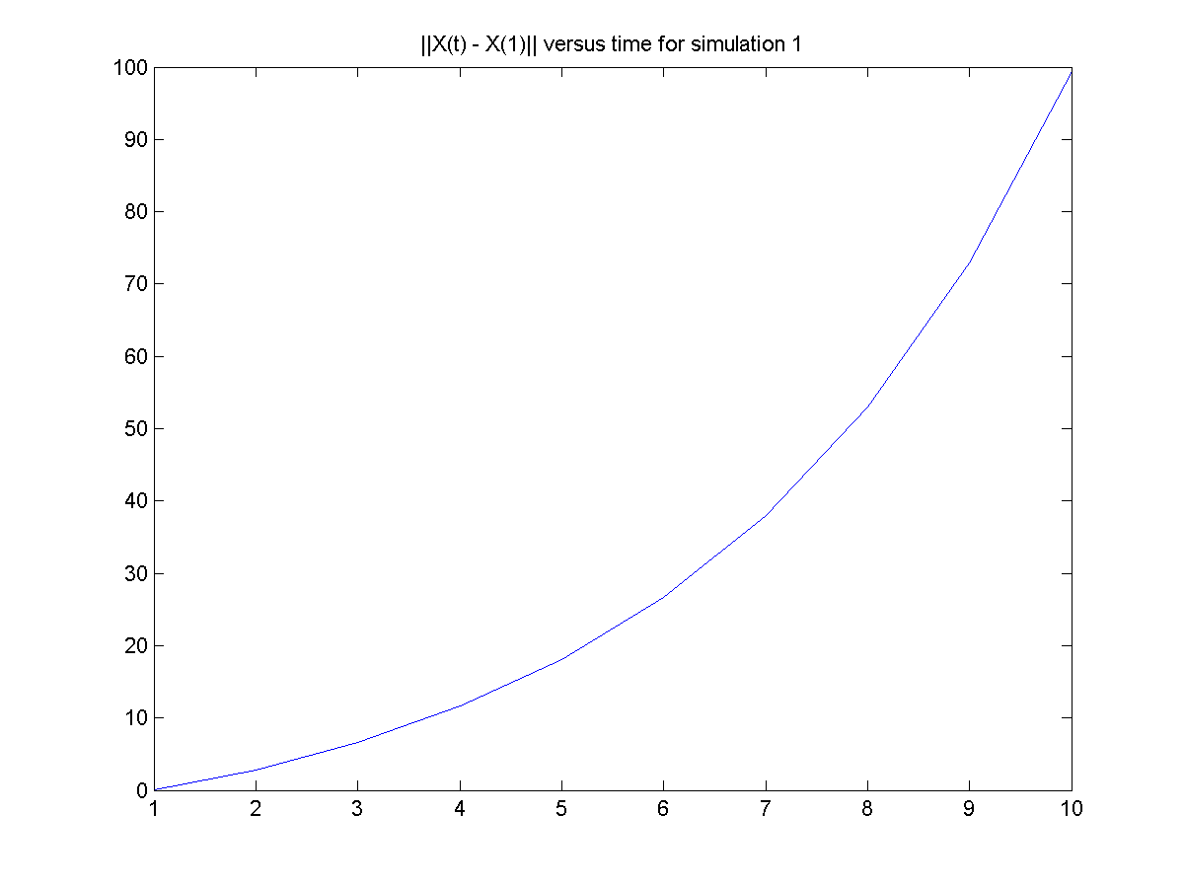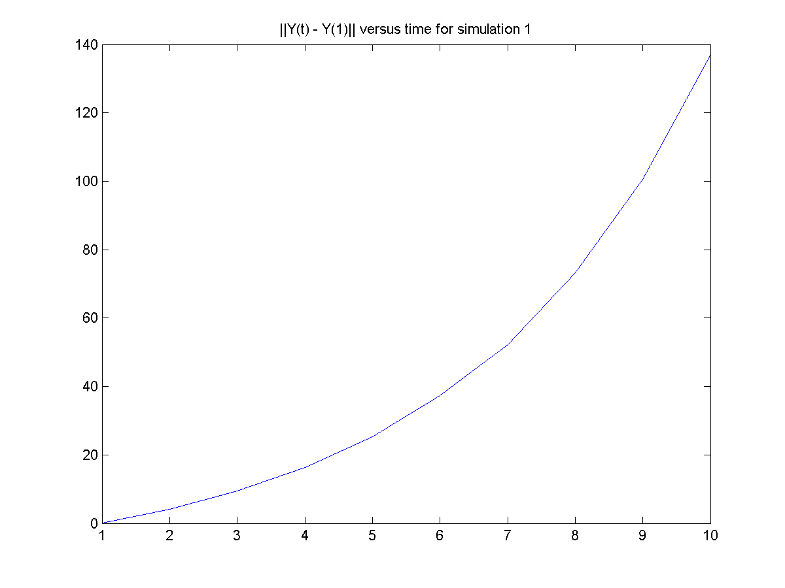

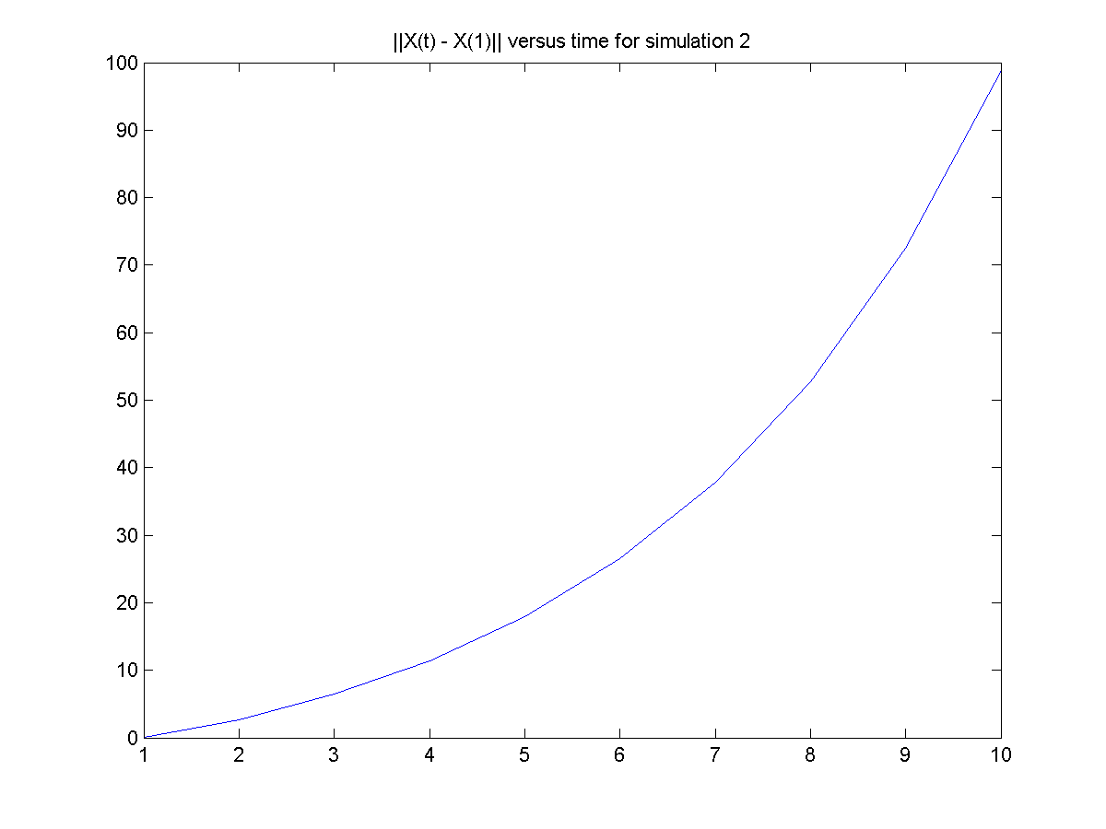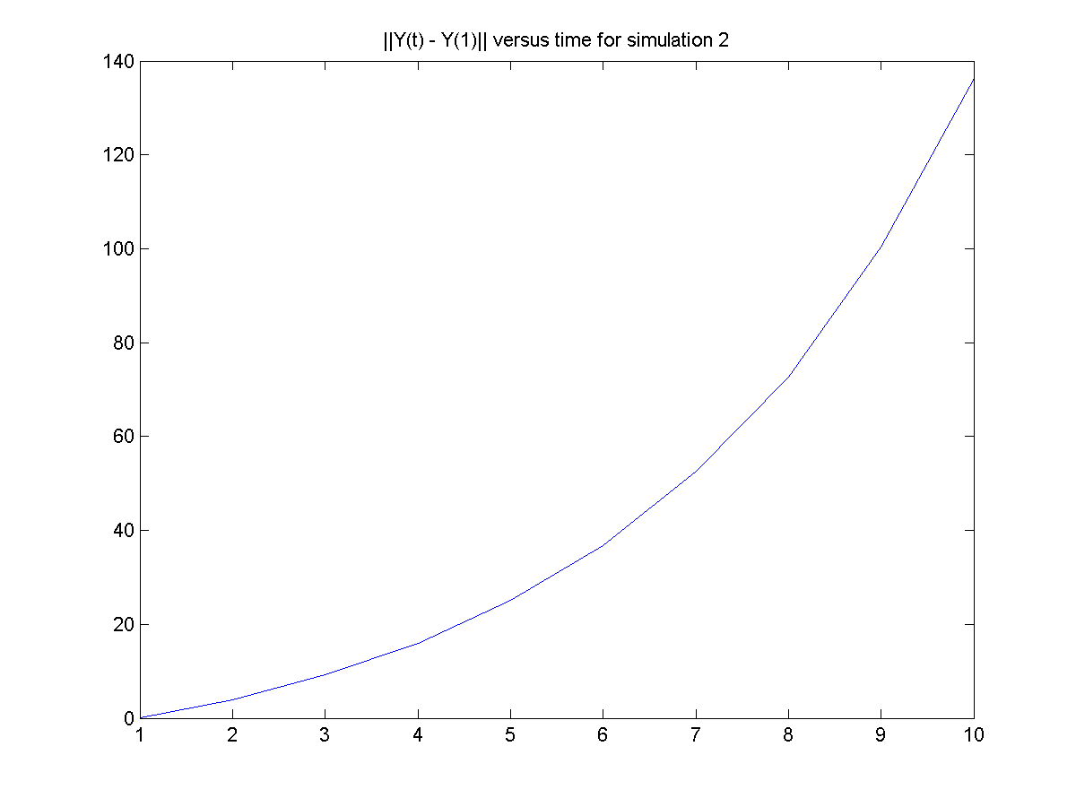
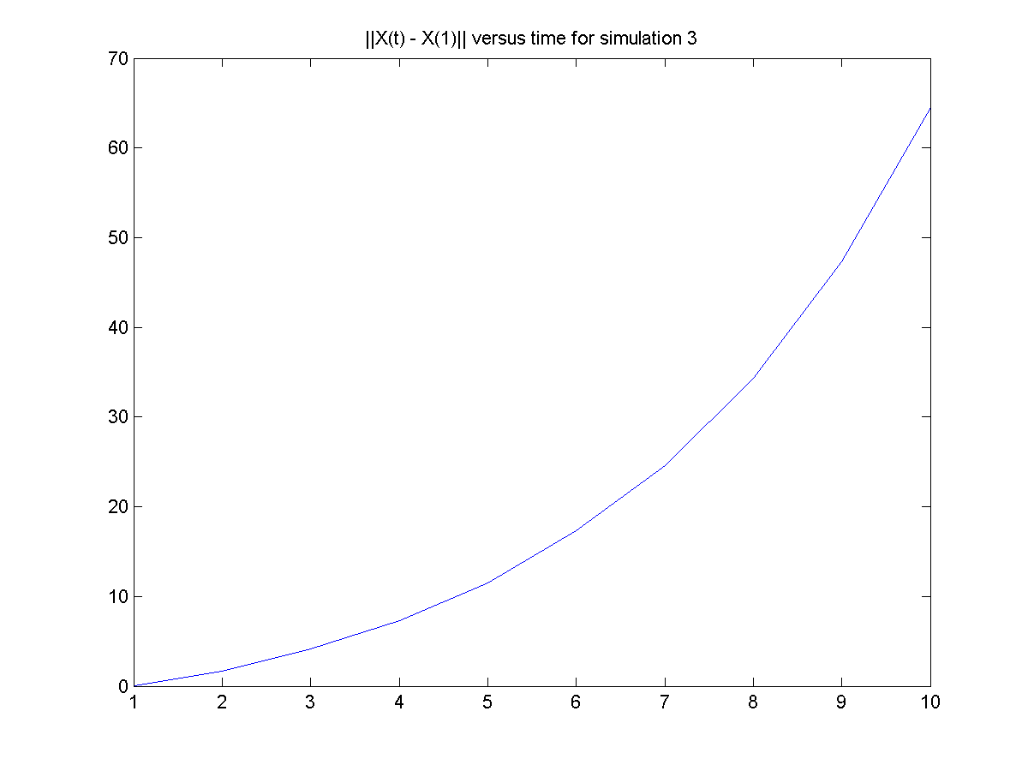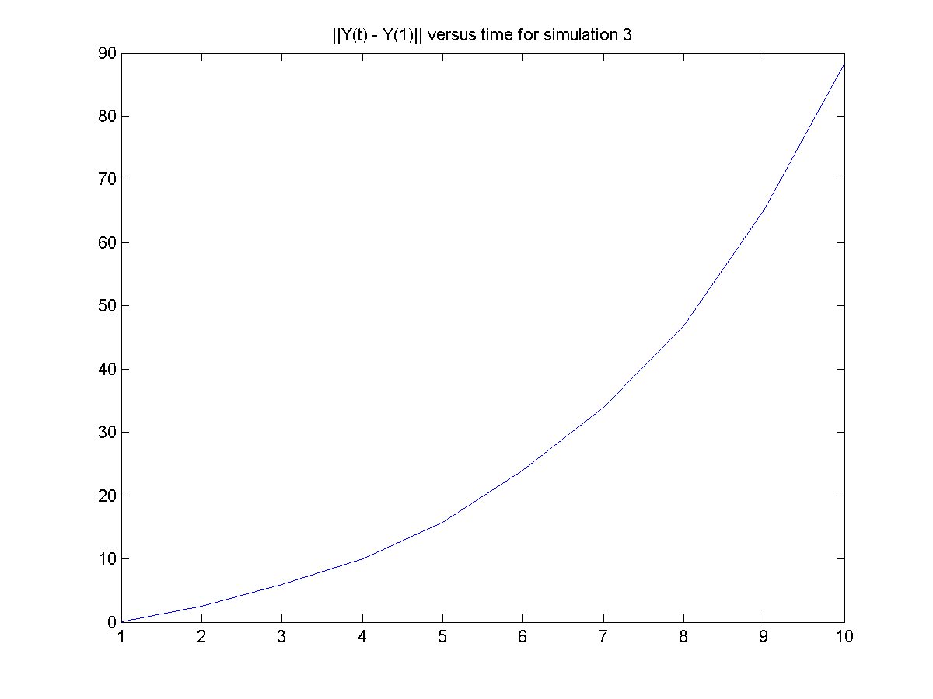

CODE
clear all
clc

for k=1:3
A=[1,.1,.2;.3,1,.1;.2,.1,1];
B=[1,.5,.2;.5,1,.1];
tau=[.1,0,0;0,.1,0;0,0,.1];

x0=random('normal',3,1,3,1);

n1=10;

for i=1:n1
u1=random('normal',0,1,3,1);
x=x0;
x=A*x0 + tau*u1;
u2 = random('normal',0,0.2,2,1);
y=B*x + u2;

for j=1:3;
X1(i,j)=x(j);
end

for j=1:2;
Y1(i,j)=y(j);
end
x0=x;
end;

for i=1:n1
normx1(i)=norm(X1(i,:)-X1(1,:));
normy1(i)=norm(Y1(i,:)-Y1(1,:));
end;

figure(1)
plot(normx1);
title(['||X(t) - X(1)|| versus time for simulation ' int2str(k)]);
saveas(figure(1),['Simulated process- ' int2str(k) ' of x prob 1.png']);

figure(2)
plot(normy1);
title(['||Y(t) - Y(1)|| versus time for simulation ' int2str(k)']);
saveas(figure(2),['Simulated process- ' int2str(k) ' of y prob 1.png']);

end

2.
OUTPUT
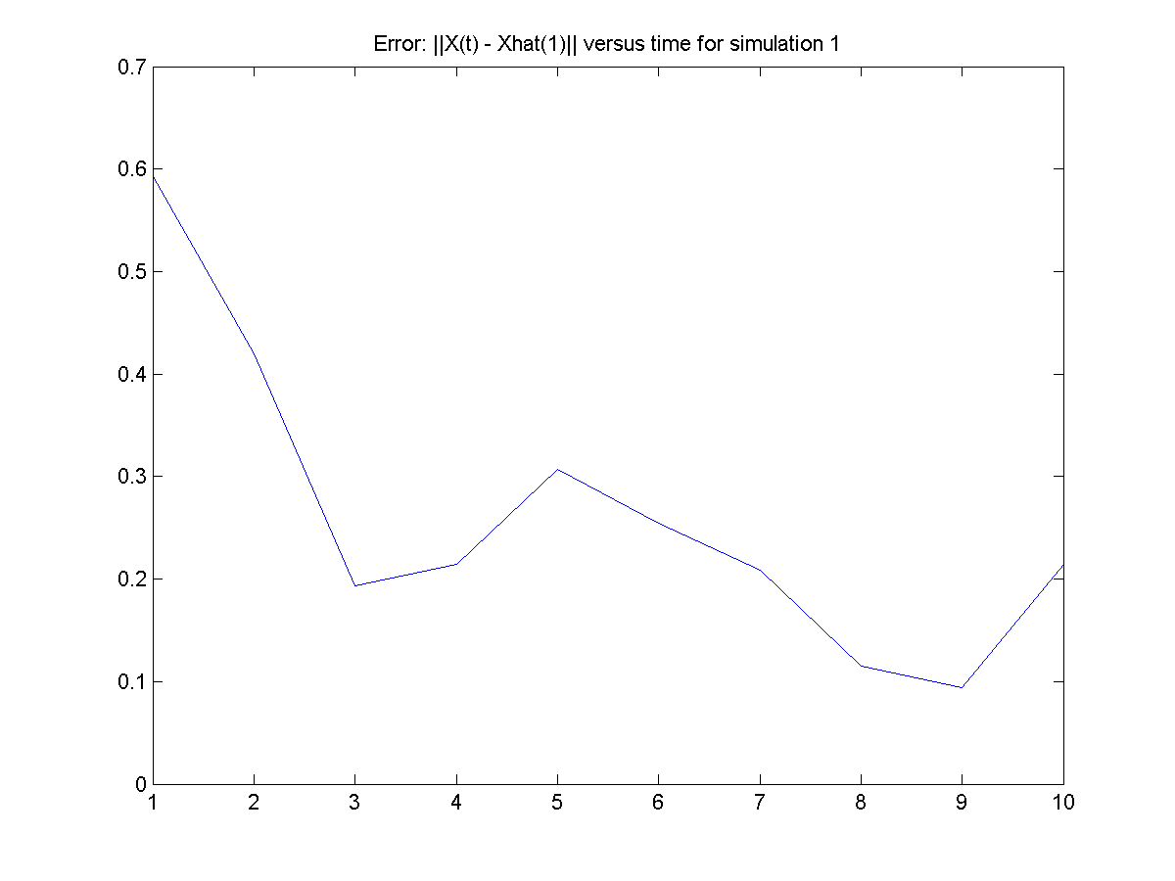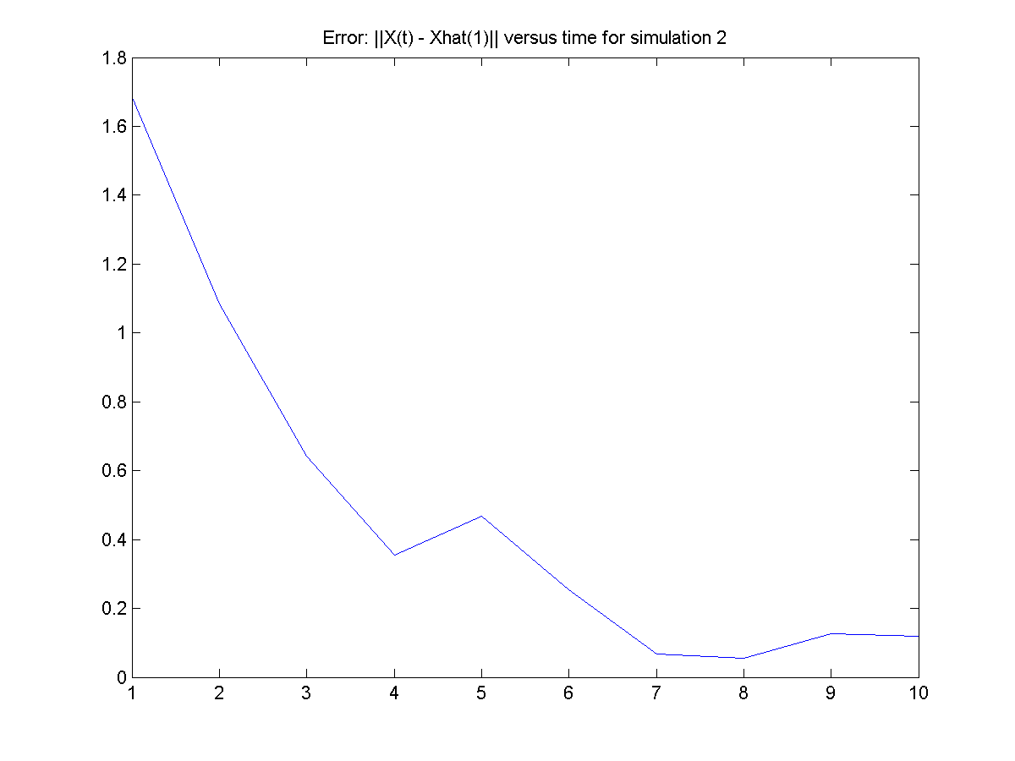

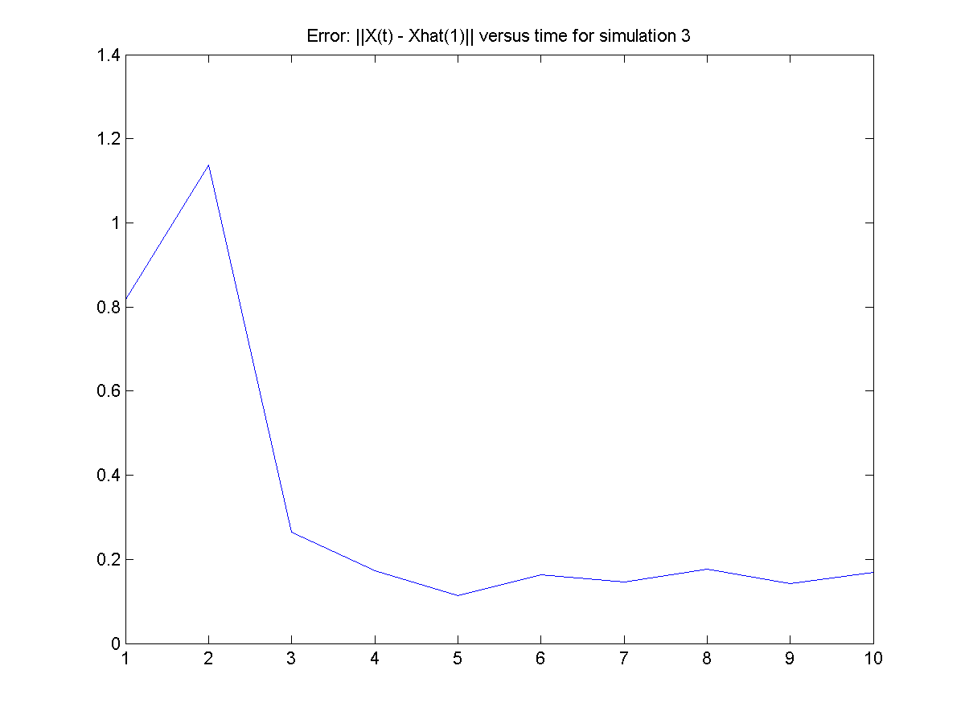

CODE

clear all
clc

for k=1:3
A=[1,.1,.2;.3,1,.1;.2,.1,1];
B=[1,.5,.2;.5,1,.1];
tau=[.1,0,0;0,.1,0;0,0,.1];
x0=random('normal',3,1,3,1);
Q=[1,0,0;0,1,0;0,0,1];
V=[0.2,0;0,0.2];
n1=10;

for i=1:n1
u1=random('normal',0,1,3,1);
x=A*x0 + tau*u1;
u2 = random('normal',0,0.2,2,1);
y=B*x + u2;

for j=1:3;
X1(i,j)=x(j);
end

for j=1:2;
Y1(i,j)=y(j);
end
x0=x;
end;

M_0=[3;3;3];
P_0=[3,0,0;0,3,0;0,0,3];
M_1=zeros(3,1);
P_1=zeros(3,3);

for i=1:n1
M=A*M_0;
P = A*P_0*A' + tau*Q*tau';
Pinv1=inv(V+B*P*B');
M_1 = M + P*B'*Pinv1*(Y1(i,:)'-B*M);
P_1 = P-P*B'*Pinv1*B*P;
M1(i,:)=M_1;
P_0 = P_1;
M_0=M_1;
end
for i=1:n1
sim1(i)=norm(X1(i,:)-M1(i,:));
end;
figure(1)
plot(sim1);
title(['Error: ||X(t) - Xhat(1)|| versus time for simulation ' int2str(k)]);
saveas(figure(1),['Simulated process- ' int2str(k) ' of x prob 2.png']);
end

3.
OUTPUT
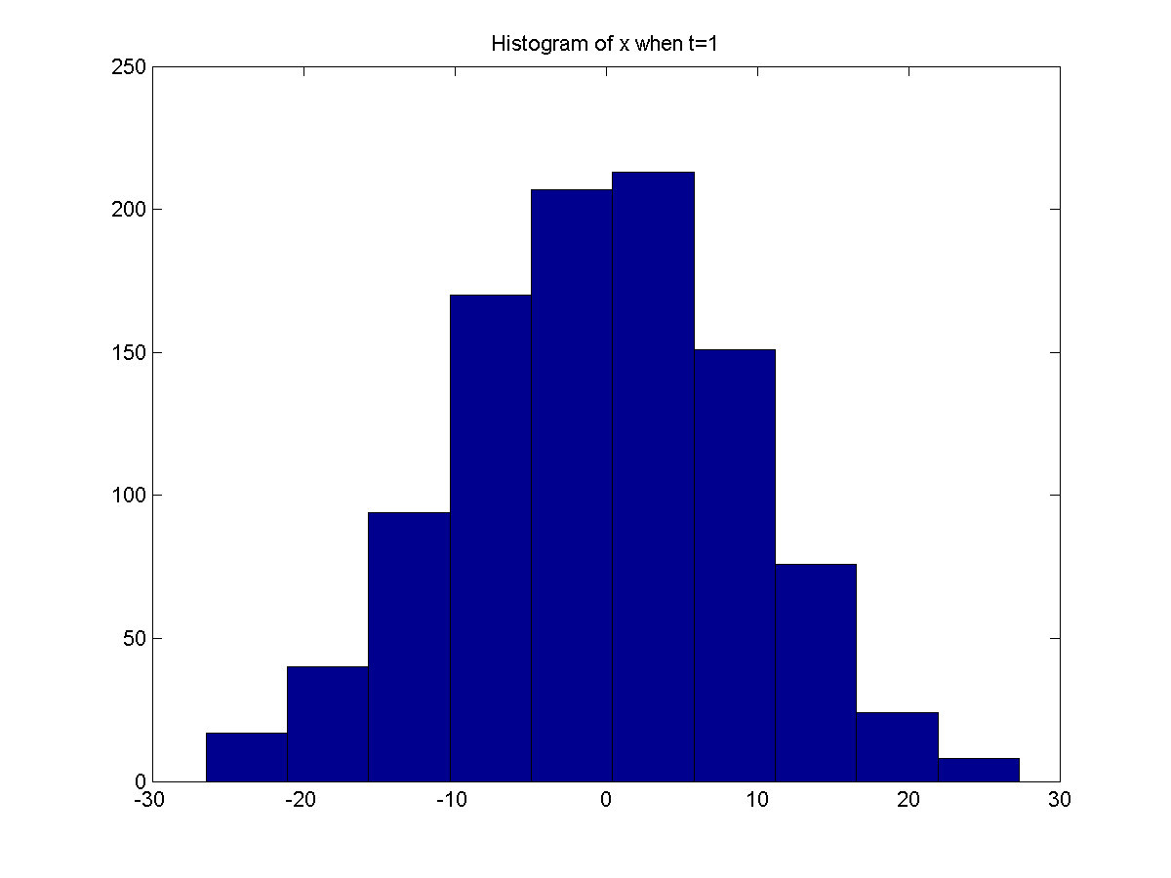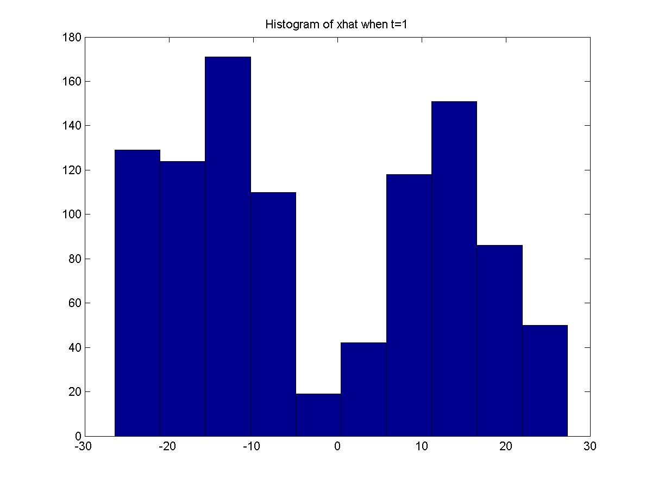
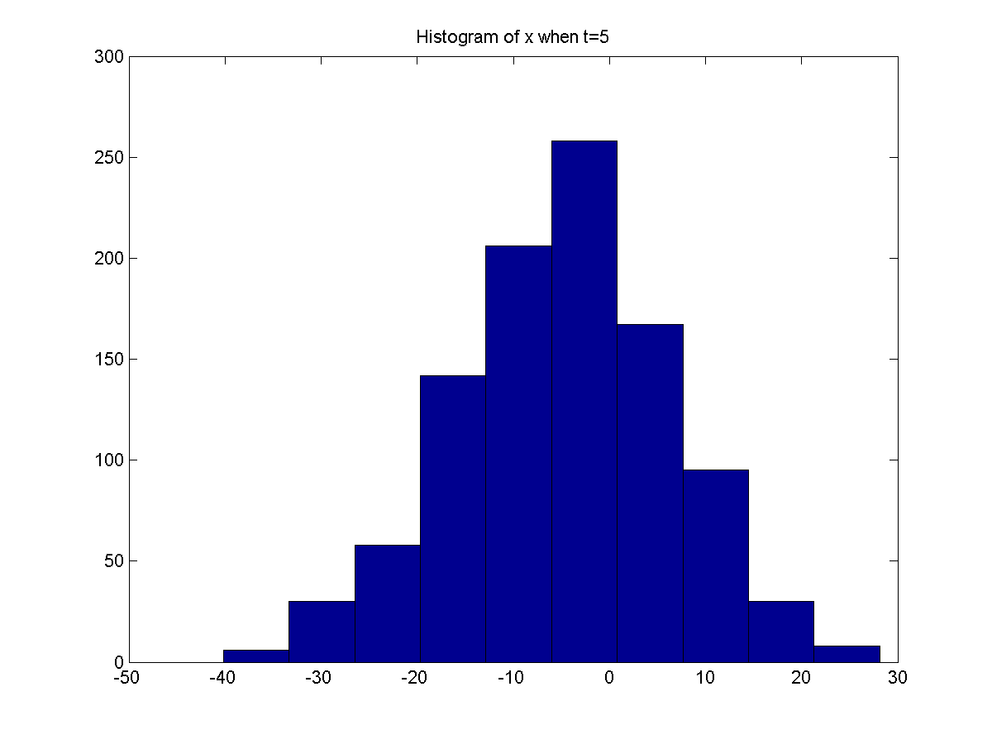
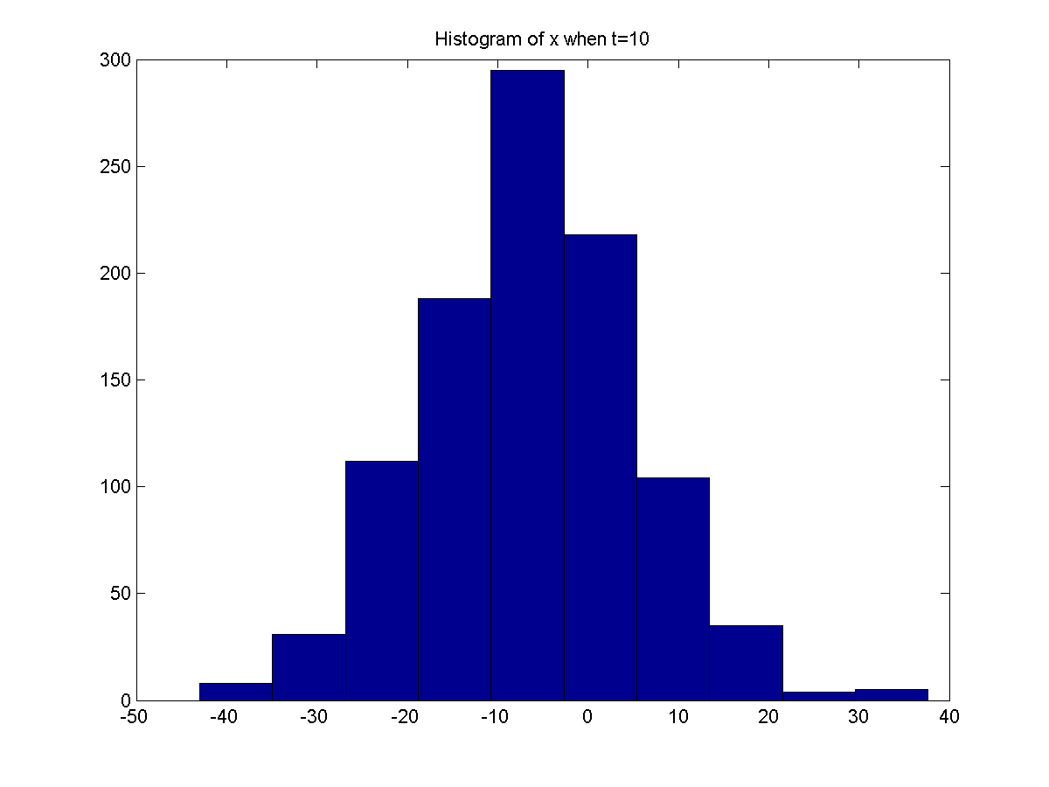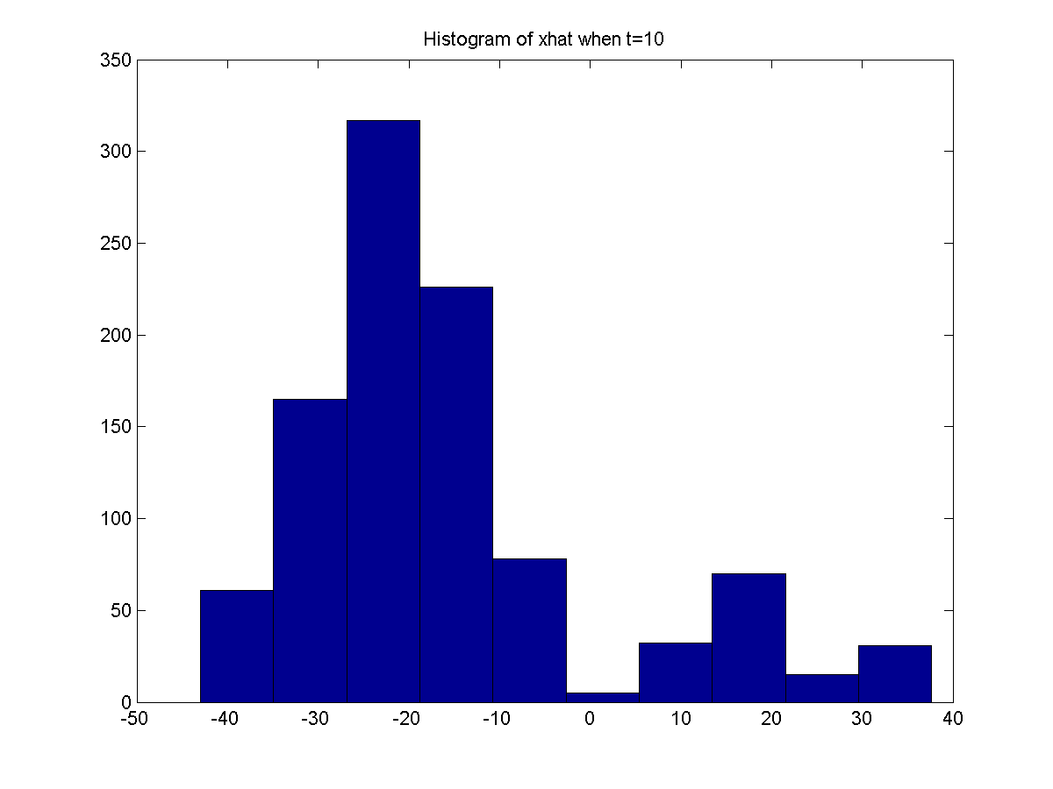
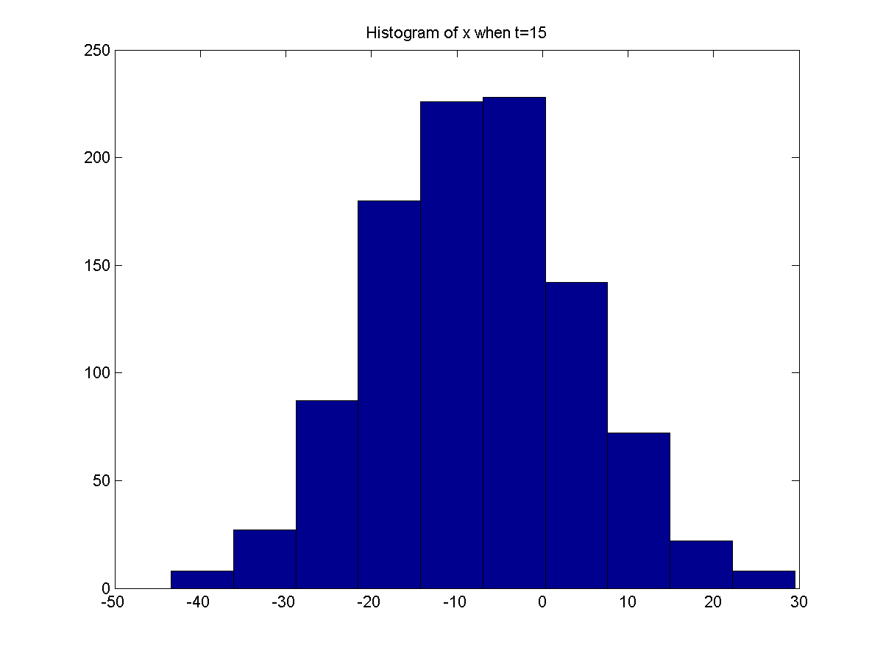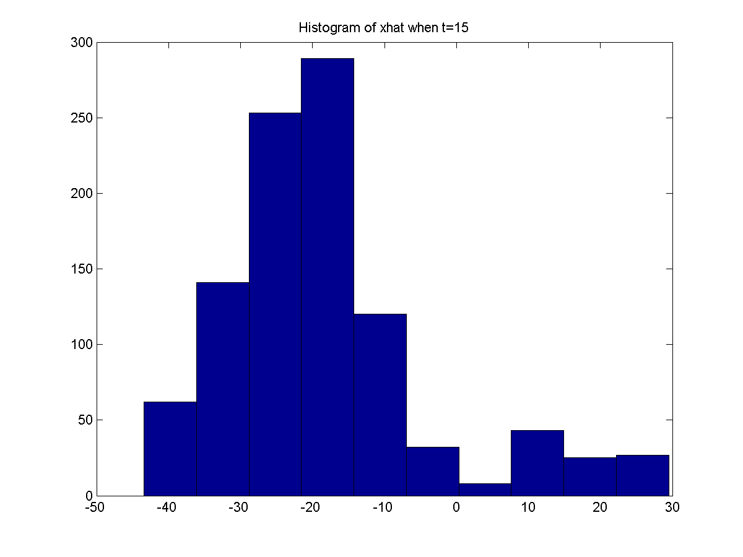

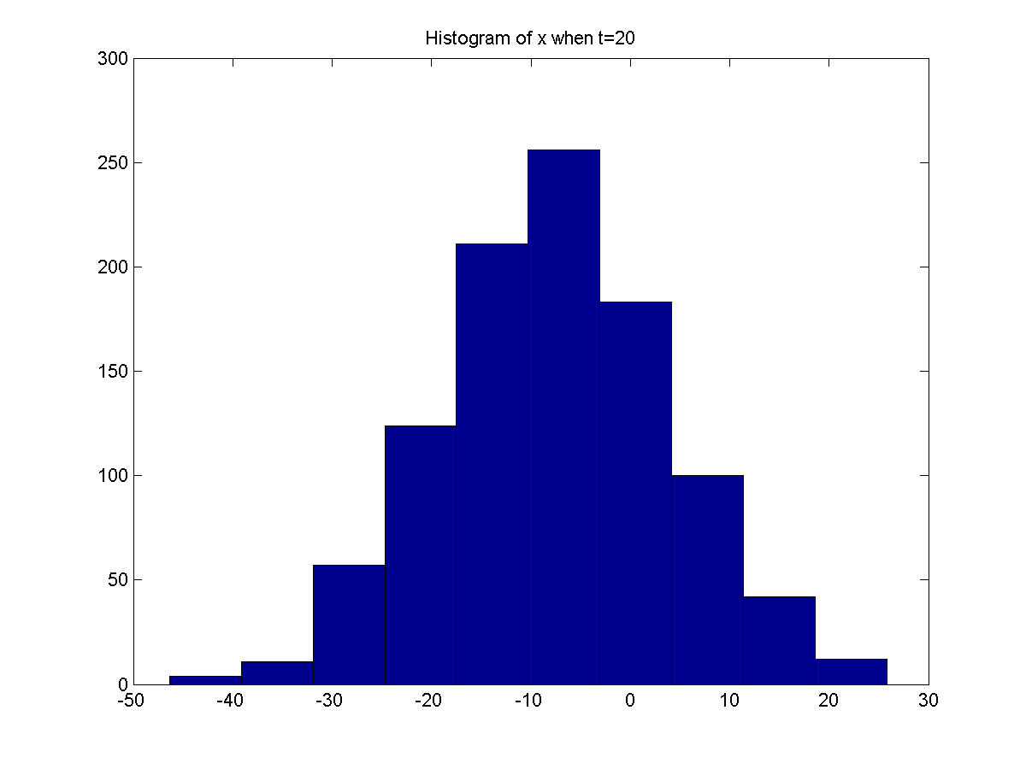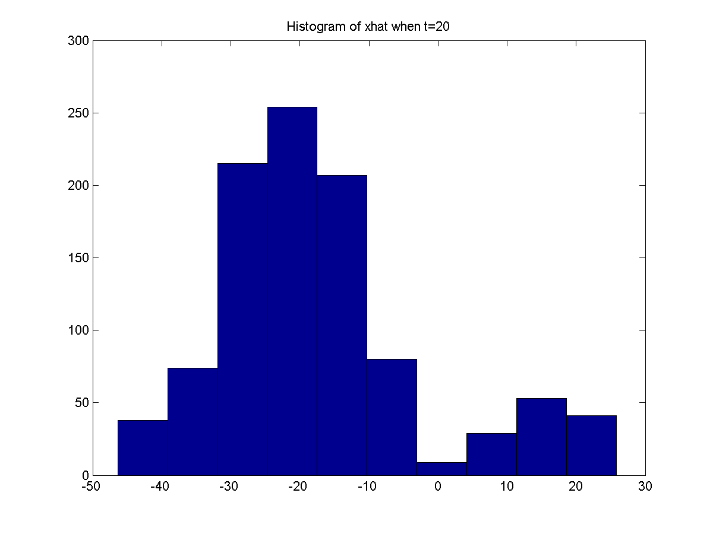

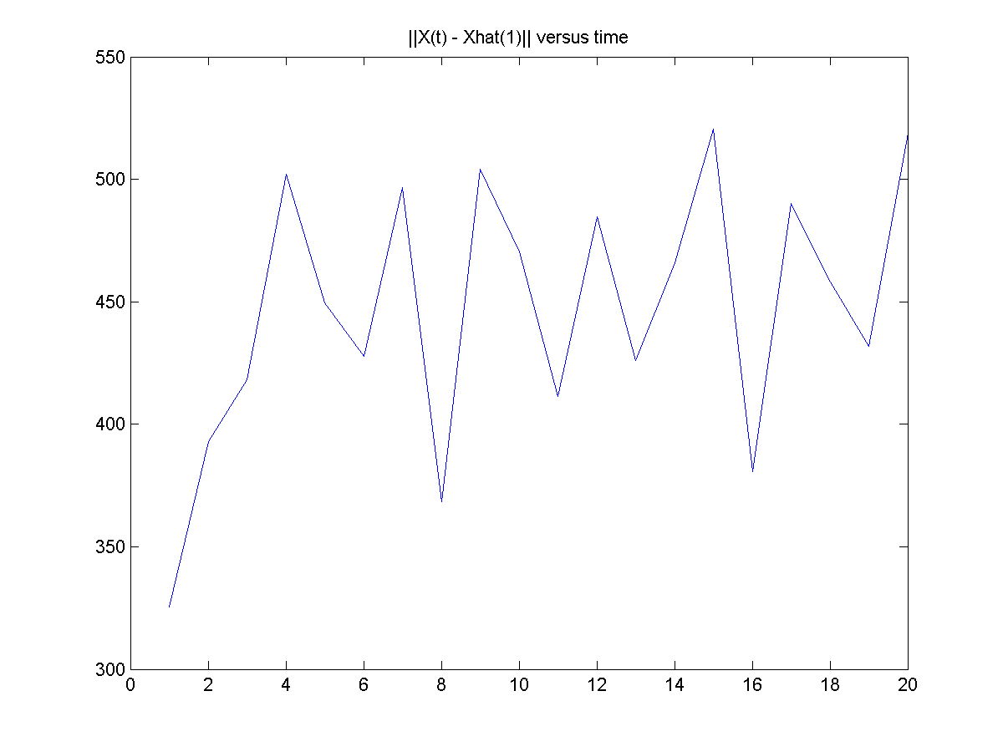

CODE

clear all
clc

n=1000;
x(1,:)=random('normal',0,10,1,n);
u1=random('normal',0,10,1,n);

for i=1:20
u1=random('normal',0,10,1,n);
x(i+1,:)=0.5*x(i,:)+(25*x(i,:)/(1+x(i,:).^2)) + 8*cos(1.2*i)+u1;
v1=random('normal',0,1,1,n);
wt1(i,:)=((x(i,:).^2)/20) + v1;
wt(i,:)=wt1(i,:)/(sum(wt1(i,:)));

for j=1:n
x_0=find(rand<cumsum(wt(i,:)));
x_1 = min(x_0);
xhat(i,j)=x(i,x_1);
end
end
normx1(i)=norm(x(i,:)-mean(xhat(i,:)));
for i=1:20
sum1=0;
for j=1:n
sum1 = sum1 +x(i,j)*wt1(i,j)/(sum(wt1(i,:))/n);
end
avg1(i) = sum1/n;
end

figure(1)
hist(x(1,:));
title(['Histogram of x when t=1']);
saveas(figure(1),['Histogram when (t=1) x prob 3.png']);

figure(2)
hist(xhat(1,:));
title(['Histogram of xhat when t=1']);
saveas(figure(2),['Histogram when xhat, (t=1) x prob 3.png']);

figure(3)
hist(x(5,:));
title(['Histogram of x when t=5']);
saveas(figure(3),['Histogram when (t=5) x prob 3.png']);

figure(4)
hist(xhat(5,:));
title(['Histogram of xhat when t=5']);
saveas(figure(2),['Histogram when xhat, (t=5) x prob 3.png']);

figure(5)
hist(x(10,:));
title(['Histogram of x when t=10']);
saveas(figure(5),['Histogram when (t=10) x prob 3.png']);

figure(6)
hist(xhat(10,:));
title(['Histogram of xhat when t=10']);
saveas(figure(6),['Histogram when xhat, (t=10) x prob 3.png']);

figure(7)
hist(x(15,:));
title(['Histogram of x when t=15']);
saveas(figure(7),['Histogram when (t=15) x prob 3.png']);

figure(8)
hist(xhat(15,:));
title(['Histogram of xhat when t=15']);
saveas(figure(8),['Histogram when xhat, (t=15) x prob 3.png']);

figure(9)
hist(x(20,:));
title(['Histogram of x when t=20']);
saveas(figure(9),['Histogram when (t=20) x prob 3.png']);

figure(10)
hist(xhat(20,:));
title(['Histogram of xhat when t=20']);
saveas(figure(10),['Histogram when xhat, (t=20) x prob 3.png']);

figure(11)
plot(normx1);
title(['||X(t) - Xhat(1)|| versus time']);
saveas(figure(11),['Error plot prob 3.png']);

