1.
OUTPUT
a)
mean_x =

579.5333

mean_y =

3.0873

rou =

0.8429

b) Table for the estimates for the standard errors for B

B | 25 | 50 | 100 | 200 | 500 | 1000 | 2000 | 5000
standard errors X | 48.6809 | 31.3001 | 37.166 | 47.3164 | 31.5315 | 38.4516 | 36.1316 | 33.3599
standard errors Y | 0.2113 | 0.1878 | 0.1661 | 0.1322 | 0.1995 | 0.2106 | 0.2033 | 0.1437

c) Histograms: At B=2000, can see that histogram correlation coefficients using the random sample and boostrap replicates are very similar.
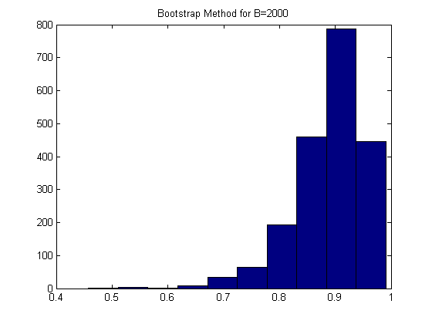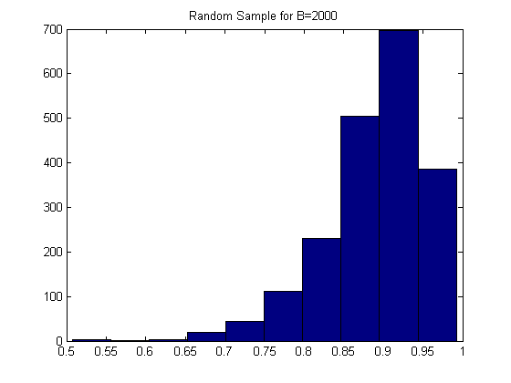

CODE
clear all
clc
LawSchoolData;
[m,n] = size(X);

n1=15; % obtain a random start
num = ceil(rand*5);
for i=num:num:n1*num;
x1(ceil(i/num),:) = X(i,:);
end;
% part a
mean_x = mean(x1(:,1))
mean_y = mean(x1(:,2))
rou = corr(x1(:,1),x1(:,2))
sd_x = std(x1(:,1));
sd_y = std(x1(:,2));
% part and c
B= [25 50 100 500 1000 2000 5000];
m=size(B);
for i=1:m;
for j=1:B(i);
u1 = randint(1,n1,[1,n1]);
for k=1:n1;
x2(k,:) = x1(u1(k),:);
end;
sd_m1x(j)=std(x2(:,1));
sd_m1y(j)=std(x2(:,2));
rou_m1(j)=corr(x2(:,1),x2(:,2));
end;
sd_m2_x=mean(sd_m1x);
sd_m2_y=mean(sd_m1y);
rou_m2=mean(rou_m1);

for j2=1:B(i);
u2 = randint(1,n1,[1,n1]);
for k2=1:n1;
x3(k2,:) = x1(u2(k2),:);
end;
sd_m2x(j2)=std(x3(:,1));
sd_m2y(j2)=std(x3(:,2));
rou_m2(j2)=corr(x3(:,1),x3(:,2));
end;
sd_m2x(end)
sd_m2y(end)

if B(i)==2000
figure(1)
hist(rou_m1);
title('Bootstrap Method for B=2000');
figure(2)
hist(rou_m2);
title('Random Sample for B=2000');
end;
end;
2.
OUTPUT
a)

B | 25 | 50 | 100 | 200 | 500 | 1000 | 2000
standard errors | 2.1495 | 2.0274 | 1.9761 | 1.9535 | 2.0757 | 2.0858 | 1.9777

b)
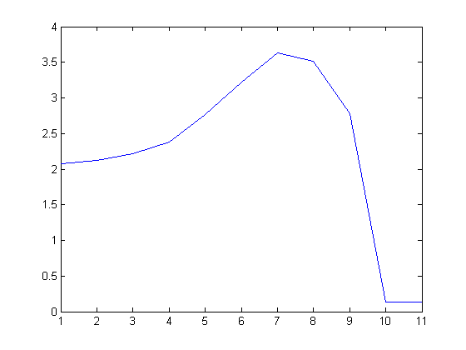

CODE

3.

