1.
OUTPUT

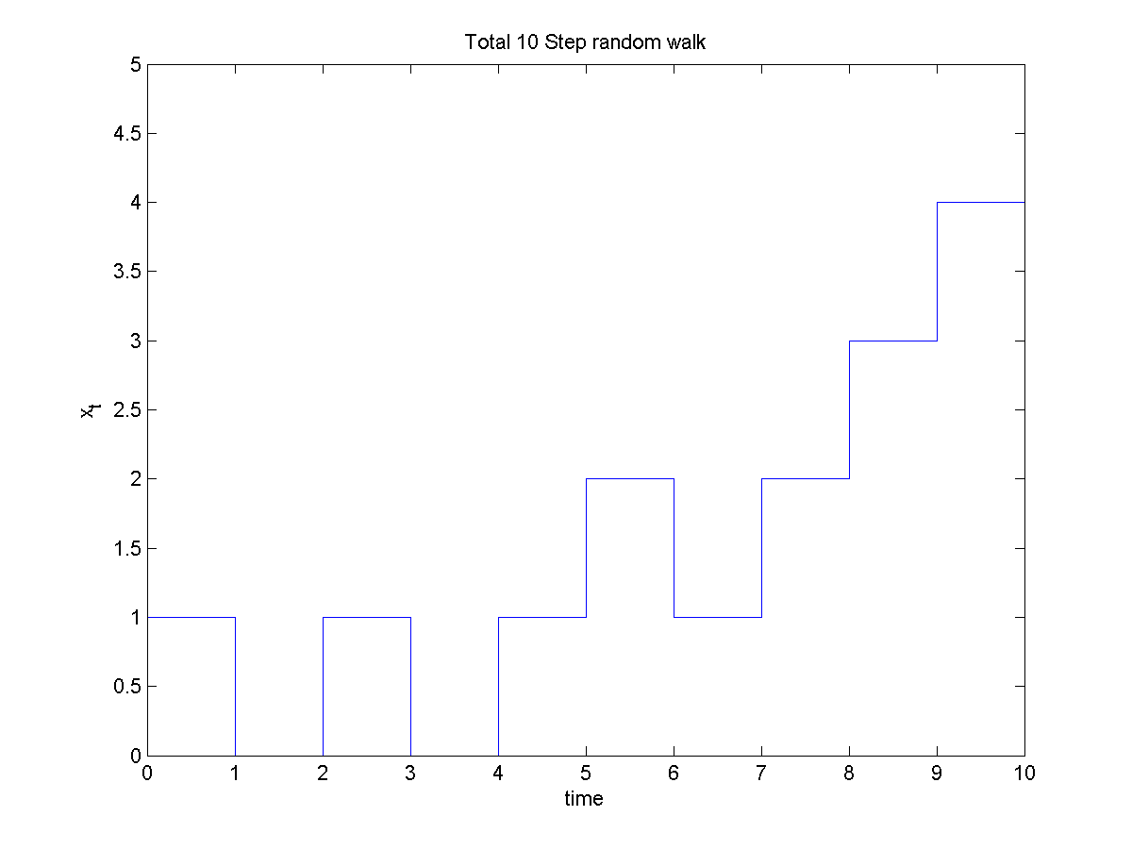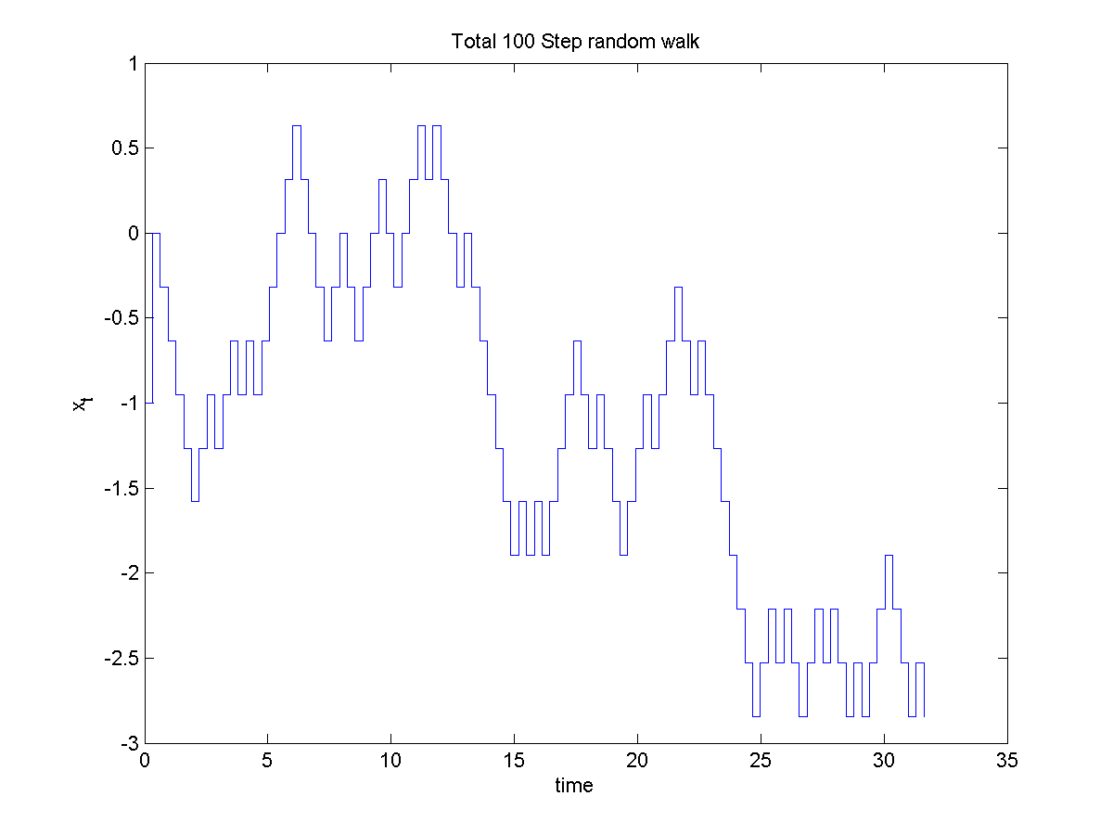

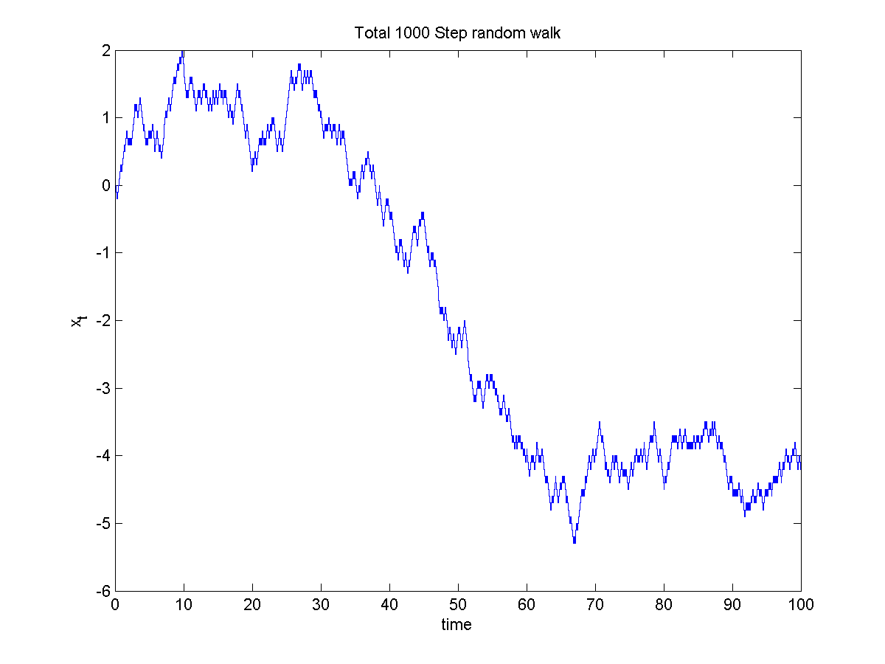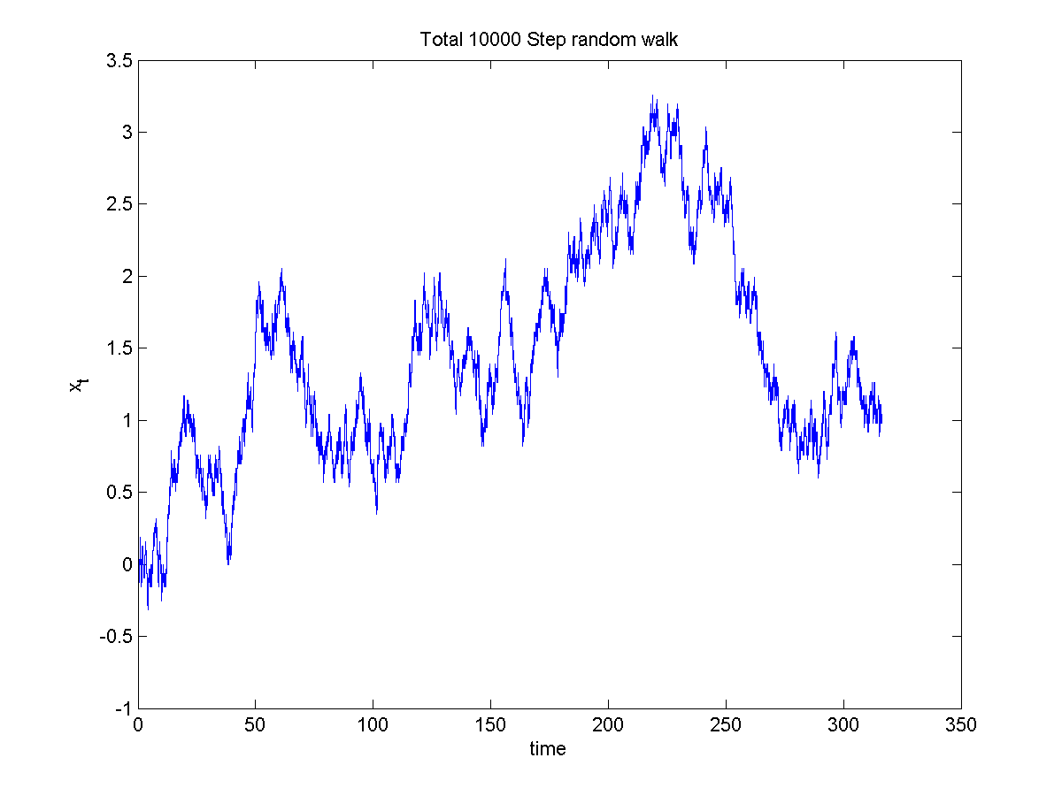

CODE
%prob1
clear all

T_1 = [1, 0.1, 0.01, 0.001];
n1=size(T_1);

for j=1:4;
alpha_1 = 1.0;
T = T_1(j);
s_1 = sqrt(T)*alpha_1;
n=10/T;
t_1 = (0:s_1:n*s_1);

random_u = random('uniform',0,1,1,n+1);
score = zeros(1,n+1);

for k=1:n+1;
if random_u(k) <=0.5;
score(k) = -1;
else
score(k) = 1;
end;
end;

sum_1 = score(1,n+1);

for m=2:n+1;
sum_1(m) = sum(score(1:m))*s_1;
end;

figure(j);
stairs(t_1,sum_1);
xlabel('time')
ylabel('x_t')
title(['Total ' int2str(n) ' Step random walk']);
hold off;
saveas(figure(j),['Total Step random walk ' int2str(n) '.png'])
end;

2.
OUTPUT

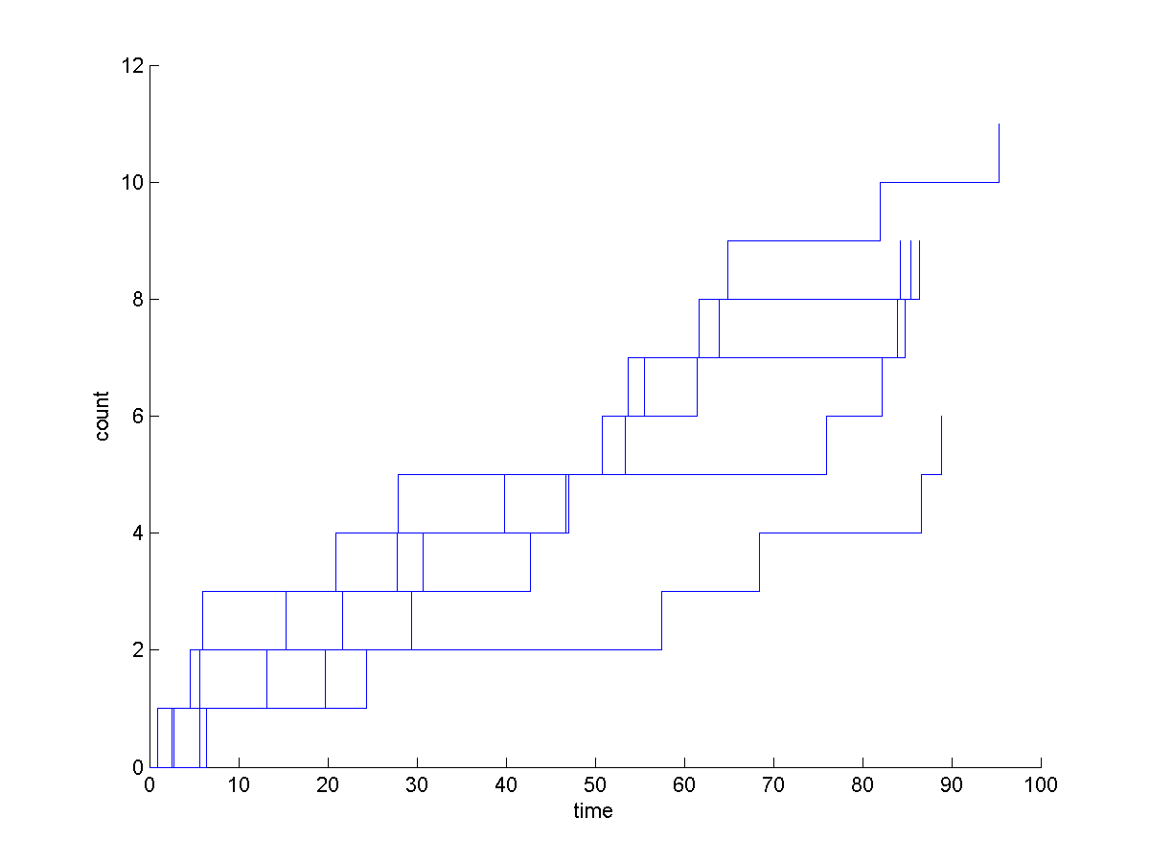

CODE
%prob1
clear all

%prob2

for n=1:5
hold on
function1;
end;

function y=function1
intensity=.1;
time(1)=0;
i=2;

while intensity>0
n_1(i-1)=(-1/intensity)*log(rand);
time(i)=n_1(i-1)+time(i-1);
if time(i)<=100
i=i+1;
else
break
end
end

for n=1:i-1
f_1(n)=time(n);
end

n=[0:1:i-2];
figure(1);
stairs(f_1,n);
xlabel('time')
ylabel('count')
saveas(figure(1),['HW1 prob 2.png'])

3.
OUTPUT

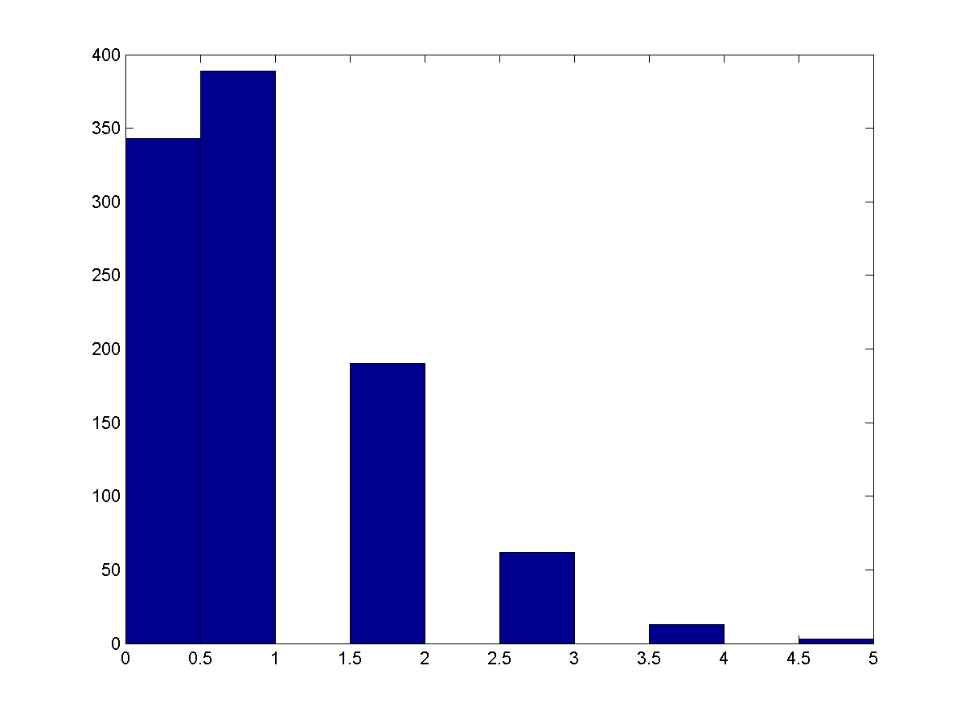

CODE
%prob3

intensity = 0.1;

for i=1:1000;
u_1 = random('uniform',0,1,i);
d_1 =-log(u_1)/intensity;
time1 = zeros(1,i);

for j=2:i;
time1(j) = time1(j-1) + d_1(j-1);
end;

sum_1=0;

for k=1:i;
if time1(k)>=10 && time1(k)<=20;
sum_1=sum_1 + 1;
else
sum_1 = sum_1;
end;
end;

ht(i) = sum_1;
end;
figure(1)
hist(ht);
saveas(figure(1),['HW1 prob 3.png'])

