Jaime Frade

STA5166

HW1: Reproduce graphs from the lecture using R.

**Summary**

I stored x1 as a random standard normal variable to generate 1000. Each of the four plots listed below exhibit the characteristics of this random normal variable.

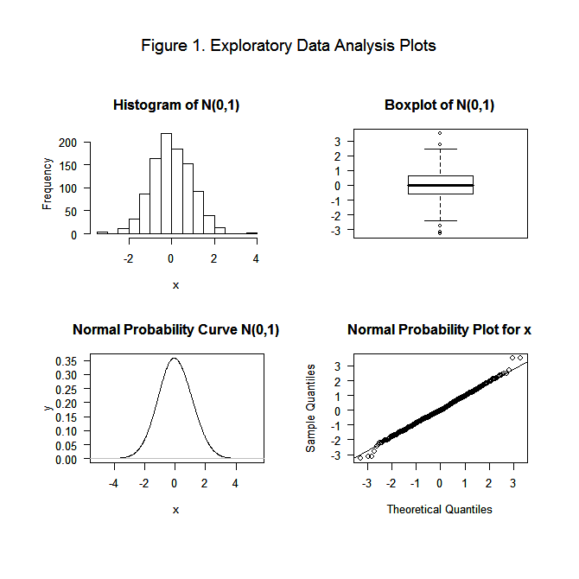

**Summary**: I obtained the following variance and summary statistics regarding quartiles.

>var(x1)

[1] 0.8780359

> summary(x1)

Min. 1st Qu. Median Mean 3rd Qu. Max.

-3.27900 -0.59400 -0.02774 0.01245 0.65280 3.52800

File name: HW1eda.txt

x1<-rnorm(1000,0,1)

eda1<-function(x){par(mfrow=c(2,2), oma=c(4,2,6,2), mar=c(5,5,4,2), hist(x,las=1, main = "Histogram of N(0,1)"),

boxplot(x,las=1, main = "Boxplot of N(0,1)"),iqr<-summary(x)[5]-summary(x)[2],

plot(density(x, width=2*iqr), xlab="x",ylab="y", type="l", las=1, main="Normal Probability Curve N(0,1)"),

qqnorm(x,las=1, main="Normal Probability Plot for x" ),qqline(x),par(mfrow=c(2,2),oma=c(4,2,6,2),mar=c(5,5,4,2)),

mtext(side=3,line=2,cex=1.2,outer=T, "Figure 1. Exploratory Data Analysis Plots" ))}

eda1(x1)

CODE

>source("C:/Documents and Settings/Jaime/Desktop/FALL07/STA5166/hw1eda1.txt")

>var(x1)

>summary(x1)