> data=scan("C:/Documents and Settings/Jaime/Desktop/FALL07/STA5166/BHH2-Data/datahw3.dat")
Read 112 items
> data
[1] 9 10 8 9 8 8 8 7 6 9 10 11 9 10 11 11 11 11 10 11 12 13 12 13 12
[26] 14 15 14 12 13 13 12 13 13 13 13 13 10 8 9 8 6 7 7 6 5 6 5 6 4
[51] 5 4 4 2 4 5 4 5 6 5 5 6 5 6 7 8 8 8 7 9 10 9 10 9 8
[76] 9 8 7 7 8 7 7 7 8 8 8 8 7 6 5 6 5 6 7 6 6 5 6 6 5
[101] 4 3 4 4 5 5 6 5 6 7 6 5
> Mean1wout = mean(c(8,6))
> Mean2with = mean(c(3,4))
> diff_means = Mean2with-Mean1wout
> y = c(rep(NA, (109)))
> x = c(rep(NA, (109)))
> for(i in 1:109){ y[i] = mean(data[i:i+1])}
> y
[1] 10 8 9 8 8 8 7 6 9 10 11 9 10 11 11 11 11 10 11 12 13 12 13 12 14
[26] 15 14 12 13 13 12 13 13 13 13 13 10 8 9 8 6 7 7 6 5 6 5 6 4 5
[51] 4 4 2 4 5 4 5 6 5 5 6 5 6 7 8 8 8 7 9 10 9 10 9 8 9
[76] 8 7 7 8 7 7 7 8 8 8 8 7 6 5 6 5 6 7 6 6 5 6 6 5 4
[101] 3 4 4 5 5 6 5 6 7
> sort(y)
[1] 2 3 4 4 4 4 4 4 4 4 5 5 5 5 5 5 5 5 5 5 5 5 5 5 5
[26] 6 6 6 6 6 6 6 6 6 6 6 6 6 6 6 6 6 7 7 7 7 7 7 7 7
[51] 7 7 7 7 7 8 8 8 8 8 8 8 8 8 8 8 8 8 8 8 8 9 9 9 9
[76] 9 9 9 9 10 10 10 10 10 10 10 11 11 11 11 11 11 12 12 12 12 12 13 13 13
[101] 13 13 13 13 13 13 14 14 15
> for(j in 1:109){ x[j] = y[j+2] - y[j]}
> x
[1] -1 0 -1 0 -1 -2 2 4 2 -1 -1 2 1 0 0 -1 0 2 2 0 0 0 1 3 0
[26] -3 -1 1 -1 0 1 0 0 0 -3 -5 -1 0 -3 -1 1 -1 -2 0 0 0 -1 -1 0 -1
[51] -2 0 3 0 0 2 0 -1 1 0 0 2 2 1 0 -1 1 3 0 0 0 -2 0 0 -2
[76] -1 1 0 -1 0 1 1 0 0 -1 -2 -2 0 0 0 2 0 -1 -1 0 1 -1 -2 -2 0
[101] 1 1 1 1 0 0 2 NA NA
> sort(x)
[1] -5 -3 -3 -3 -2 -2 -2 -2 -2 -2 -2 -2 -2 -1 -1 -1 -1 -1 -1 -1 -1 -1 -1 -1 -1
[26] -1 -1 -1 -1 -1 -1 -1 -1 -1 -1 0 0 0 0 0 0 0 0 0 0 0 0 0 0 0
[51] 0 0 0 0 0 0 0 0 0 0 0 0 0 0 0 0 0 0 0 0 0 0 0 0 0
[76] 0 0 1 1 1 1 1 1 1 1 1 1 1 1 1 1 1 1 2 2 2 2 2 2 2
[101] 2 2 2 3 3 3 4
> diff_means
[1] -3.5
> 1/109
[1] 0.009174312

> brandA = c(2,4,2,1,9,9,2,2)
> brandB = c(8,3,5,3,7,7,4)
>
> y = t.test(brandA, brandB)
> y

Welch Two Sample t-test

data: brandA and brandB
t = -1.0122, df = 11.923, p-value = 0.3316
alternative hypothesis: true difference in means is not equal to 0
95 percent confidence interval:
-4.449587 1.628159
sample estimates:
mean of x mean of y
3.875000 5.285714

> x = y$estimate
> diff = diff(x)
> n1=0
> h1=0
> y1= c(2,4,2,1,9,9,2,2, 8,3,5,3,7,7,4)
> c1=c(rep("A", 8), rep("B", 7))
> diff= 5.285714-3.875
> for(i in 1:10000){
+ c2=sample(c1)
+ x1=y1[c2=="A"]; x2=y1[c2=="B"]
+ m1 = mean(x1); m2 = mean(x2)
+ d1 = m2-m1
+ h1=c(h1,d1)
+ if(d1 >= diff)n1=n1+1
+ }
> n1
[1] 1883
> hist(h1, main="Randomization Distribution")
> pvalue= n1/10000
> pvalue
[1] 0.1883

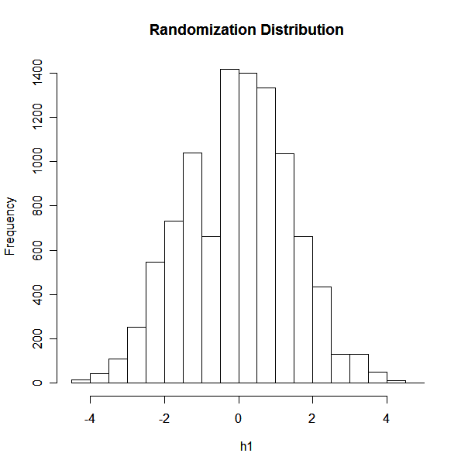

> designA = c(1.8, 1.9, 1.1, 1.4)
> designB = c(1.9, 2.1, 1.5, 1.5)
>
> y = t.test(designA , designB)
> y

Welch Two Sample t-test

data: designA and designB
t = -0.8402, df = 5.756, p-value = 0.4343
alternative hypothesis: true difference in means is not equal to 0
95 percent confidence interval:
-0.7885191 0.3885191
sample estimates:
mean of x mean of y
1.55 1.75

> n1=0
> h1=0
> y1= c(1.8, 1.9, 1.1, 1.4, 1.9, 2.1, 1.5, 1.5)
> c1=c(rep("A", 4), rep("B", 4))
> diff=1.55-1.75
> for(i in 1:10000){
+ c2=sample(c1)
+ x1=y1[c2=="A"]; x2=y1[c2=="B"]
+ m1 = mean(x1); m2 = mean(x2)
+ d1 = m2-m1
+ h1=c(h1,d1)
+ if(d1 <= diff)n1=n1+1
+ }
> n1
[1] 2289
> hist(h1, main="Randomization Distribution")
> pvalue= n1/10000
> pvalue
[1] 0.2289
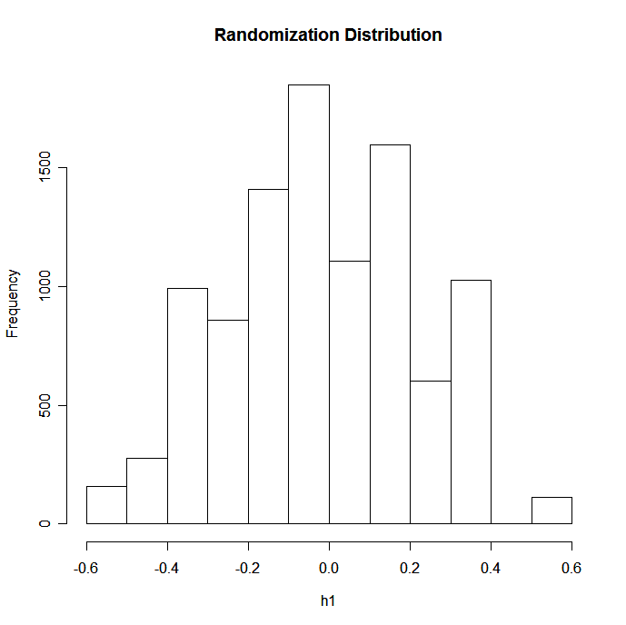

> dietA = c(166,174,150,166,165,178)
> dietB = c(158,159,142,163,161,157)
>
> y = t.test(dietA , dietB)
> y

Welch Two Sample t-test

data: dietA and dietB
t = 1.9735, df = 9.436, p-value = 0.07842
alternative hypothesis: true difference in means is not equal to 0
95 percent confidence interval:
-1.359600 21.026267
sample estimates:
mean of x mean of y
166.5000 156.6667

> n1=0
> h1=NULL
> y1= c(166,174,150,166,165,178, 158,159,142,163,161,157)
> c1=c(rep("A", 6), rep("B", 6))
> diff=156.6667-166.5
> for(i in 1:10000){
+ c2=sample(c1)
+ x1=y1[c2=="A"]; x2=y1[c2=="B"]
+ m1 = mean(x1); m2 = mean(x2)
+ d1 = m2-m1
+ h1=c(h1,d1)
+ if(d1 <= diff)n1=n1+1
+ }
> n1
[1] 496
> hist(h1, main="Randomization Distribution")
> pvalue= n1/10000
> pvalue
[1] 0.0496

