Chapter 3.2 (三。二)

Summary:
Will try to test the hypothesis to see if there exists a significant difference between the mean values of levels of asbestos fiber in the air of the industrial plant with and without S-142 chemical. From the comparative trail in the plant, the four consecutive readings had a mean difference of -3.5. The null hypothesis is that with or without S-142, the asbestos levels will not change, the alternative is that with S-142, the level will decrease since the mean difference is negative. To test this, used as a reference the past observations of asbestos levels without S-142. From the dataset, obtained a probability that 1/109 (=0.0091743119) that there exists a mean difference less that the comparative trail. Since this probability is less that 5%, we reject the null hypothesis and accept the salesman claim that S-142 is beneficial to reduce the level of asbestos levels in the air of the industrial plant.

CODE

data=scan("C:/Documents and Settings/Jaime/Desktop/FALL07/STA5166/BHH2-Data/datahw3.dat")
data
n1=0
Mean1wout = mean(c(8,6))
Mean2with = mean(c(3,4))
diff_means = Mean2with-Mean1wout
y = c(rep(NA, (109)))
x = c(rep(NA, (109)))
for(i in 1:111){ y[i] = (data[i]+data[i+1])/2}
for(j in 1:109){ x[j] = y[j+2] - y[j];
if(x[j]<= diff_means) n1=n1+1}
x
sort(x)
n1
diff_means
n1/109

OUTPUT

> data=scan("C:/Documents and Settings/Jaime/Desktop/FALL07/STA5166/BHH2-Data/datahw3.dat")
Read 112 items
> data
[1] 9 10 8 9 8 8 8 7 6 9 10 11 9 10 11 11 11 11 10 11 12 13 12 13 12
[26] 14 15 14 12 13 13 12 13 13 13 13 13 10 8 9 8 6 7 7 6 5 6 5 6 4
[51] 5 4 4 2 4 5 4 5 6 5 5 6 5 6 7 8 8 8 7 9 10 9 10 9 8
[76] 9 8 7 7 8 7 7 7 8 8 8 8 7 6 5 6 5 6 7 6 6 5 6 6 5
[101] 4 3 4 4 5 5 6 5 6 7 6 5
> n1=0
> Mean1wout = mean(c(8,6))
> Mean2with = mean(c(3,4))
> diff_means = Mean2with-Mean1wout
> y = c(rep(NA, (109)))
> x = c(rep(NA, (109)))
> for(i in 1:111){ y[i] = (data[i]+data[i+1])/2}
> for(j in 1:109){ x[j] = y[j+2] - y[j];
+ if(x[j]<= diff_means) n1=n1+1}
> x
[1] -1.0 -0.5 -0.5 -0.5 -0.5 -1.5 0.0 3.0 3.0 0.5 -1.0 0.5 1.5 0.5 0.0
[16] -0.5 -0.5 1.0 2.0 1.0 0.0 0.0 0.5 2.0 1.5 -1.5 -2.0 0.0 0.0 -0.5
[31] 0.5 0.5 0.0 0.0 -1.5 -4.0 -3.0 -0.5 -1.5 -2.0 0.0 0.0 -1.5 -1.0 0.0
[46] 0.0 -0.5 -1.0 -0.5 -0.5 -1.5 -1.0 1.5 1.5 0.0 1.0 1.0 -0.5 0.0 0.5
[61] 0.0 1.0 2.0 1.5 0.5 -0.5 0.0 2.0 1.5 0.0 0.0 -1.0 -1.0 0.0 -1.0
[76] -1.5 0.0 0.5 -0.5 -0.5 0.5 1.0 0.5 0.0 -0.5 -1.5 -2.0 -1.0 0.0 0.0
[91] 1.0 1.0 -0.5 -1.0 -0.5 0.5 0.0 -1.5 -2.0 -1.0 0.5 1.0 1.0 1.0 0.5
[106] 0.0 1.0 1.0 -1.0
> x
[1] -1.0 -0.5 -0.5 -0.5 -0.5 -1.5 0.0 3.0 3.0 0.5 -1.0 0.5 1.5 0.5 0.0
[16] -0.5 -0.5 1.0 2.0 1.0 0.0 0.0 0.5 2.0 1.5 -1.5 -2.0 0.0 0.0 -0.5
[31] 0.5 0.5 0.0 0.0 -1.5 -4.0 -3.0 -0.5 -1.5 -2.0 0.0 0.0 -1.5 -1.0 0.0
[46] 0.0 -0.5 -1.0 -0.5 -0.5 -1.5 -1.0 1.5 1.5 0.0 1.0 1.0 -0.5 0.0 0.5
[61] 0.0 1.0 2.0 1.5 0.5 -0.5 0.0 2.0 1.5 0.0 0.0 -1.0 -1.0 0.0 -1.0
[76] -1.5 0.0 0.5 -0.5 -0.5 0.5 1.0 0.5 0.0 -0.5 -1.5 -2.0 -1.0 0.0 0.0
[91] 1.0 1.0 -0.5 -1.0 -0.5 0.5 0.0 -1.5 -2.0 -1.0 0.5 1.0 1.0 1.0 0.5
[106] 0.0 1.0 1.0 -1.0
> sort(x)
[1] -4.0 -3.0 -2.0 -2.0 -2.0 -2.0 -1.5 -1.5 -1.5 -1.5 -1.5 -1.5 -1.5 -1.5 -1.5
[16] -1.0 -1.0 -1.0 -1.0 -1.0 -1.0 -1.0 -1.0 -1.0 -1.0 -1.0 -1.0 -0.5 -0.5 -0.5
[31] -0.5 -0.5 -0.5 -0.5 -0.5 -0.5 -0.5 -0.5 -0.5 -0.5 -0.5 -0.5 -0.5 -0.5 -0.5
[46] 0.0 0.0 0.0 0.0 0.0 0.0 0.0 0.0 0.0 0.0 0.0 0.0 0.0 0.0 0.0
[61] 0.0 0.0 0.0 0.0 0.0 0.0 0.0 0.0 0.0 0.0 0.5 0.5 0.5 0.5 0.5
[76] 0.5 0.5 0.5 0.5 0.5 0.5 0.5 0.5 0.5 1.0 1.0 1.0 1.0 1.0 1.0
[91] 1.0 1.0 1.0 1.0 1.0 1.0 1.0 1.5 1.5 1.5 1.5 1.5 1.5 2.0 2.0
[106] 2.0 2.0 3.0 3.0
> n1
[1] 1
> diff_means
[1] -3.5
> n1/109
[1] 0.009174312

Chapter 3.4 (三。四)

Assumptions:
Ratings are both approximately normal distributed. Two samples, A and B, are independent. Ratings in each brand are i.i.d.

Summary:
To test the hypothesis that , against the . I used a t-test to check if the difference in means is not equal to zero. The p-value obtained 0.3316. Therefore there is not sufficient evidence to reject the null hypothesis. The assumptions were needed to conduct test.

Using a randomization distribution, I also tested the above hypothesis. Here, I did not make assumptions about the distributions of the ratings. The mean of brand A: (3.875) and brand B: (5.285714), to obtain a difference of 1.4107.

There exist 6435 possible permutations of 8 ratings of brand A and 7 ratings of brand B. Assuming that the null hypothesis, then there exist no difference in the ratings of brand A and brand B. Can arrange and for each calculate the differences that are less than 1.4107. Count the number of occurrences and this will lead to a calculation of the p-value.

The p-value obtained after a large number of observations should be approximately equal to the p-value obtained from the t-test above. I obtained the p-value: 0.3551. This also leads to the conclusion that one cannot reject the null hypothesis.

CODE

brandA = c(2,4,2,1,9,9,2,2)
brandB = c(8,3,5,3,7,7,4)

y = t.test(brandA, brandB)
y
n1=0
h1=0
y1= c(2,4,2,1,9,9,2,2,8,3,5,3,7,7,4)
c1=c(rep("A", 8), rep("B", 7))
d1 = c(rep(0,10000))
diff= 5.285714-3.875
for(i in 1:10000){
c2=sample(c1);
x1=y1[c2=="A"];
x2=y1[c2=="B"];
m1 = mean(x1);
m2 = mean(x2);
d1[i] = m2-m1;
h1=c(h1,d1[i]);
if(abs(d1[i]) >= 1.4107)n1=n1+1
}
n1
hist(h1, main="Randomization Distribution")
pvalue= n1/10000
pvalue

OUTPUT

> brandA = c(2,4,2,1,9,9,2,2)
> brandB = c(8,3,5,3,7,7,4)
>
> y = t.test(brandA, brandB)
> y

Welch Two Sample t-test

data: brandA and brandB
t = -1.0122, df = 11.923, p-value = 0.3316
alternative hypothesis: true difference in means is not equal to 0
95 percent confidence interval:
-4.449587 1.628159
sample estimates:
mean of x mean of y
3.875000 5.285714

> n1=0
> h1=0
> y1= c(2,4,2,1,9,9,2,2,8,3,5,3,7,7,4)
> c1=c(rep("A", 8), rep("B", 7))
> d1 = c(rep(0,10000))
> diff= 5.285714-3.875
> for(i in 1:10000){
+ c2=sample(c1);
+ x1=y1[c2=="A"];
+ x2=y1[c2=="B"];
+ m1 = mean(x1);
+ m2 = mean(x2);
+ d1[i] = m2-m1;
+ h1=c(h1,d1[i]);
+ if(abs(d1[i]) >= 1.4107)n1=n1+1
+ }
> n1
[1] 3551
> hist(h1, main="Randomization Distribution")
> pvalue= n1/10000
> pvalue
[1] 0.3551

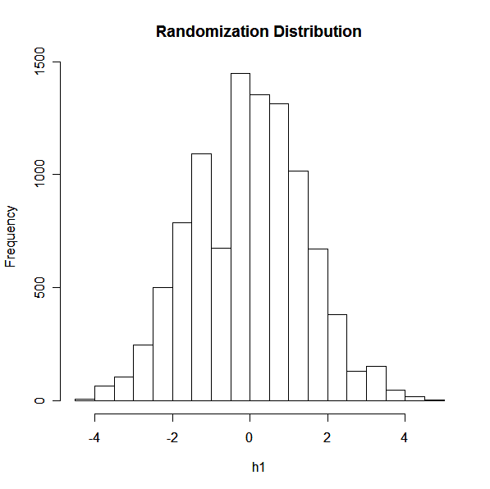
Chapter 3.7 (三。七)

Assumptions:
Results are both approximately normal distributed. Two samples, designs A and B, are independent. Results in each design are i.i.d.

Summary:
Will try to test the hypothesis to see if there exists a significant difference between the mean values for the power attainable for the two designs. The null hypothesis assumes there is no difference in the mean values. I used a t-test to check if the difference in means is not equal to zero. The p-value obtained 0.4343. Therefore there is not sufficient evidence to reject the null hypothesis. The assumptions were needed to conduct test.

Using a randomization distribution, I also tested the above hypothesis. Here, I did not make assumptions about the distributions of the ratings. The mean of design A: (1.55) and brand B: (1.75), to obtain a difference of 0.2

The p-value obtained after a large number of observations should be approximately equal to the p-value obtained from the t-test above. I obtained the p-value: 0.4454. This also leads to the conclusion that one cannot reject the null hypothesis.

CODE

designA = c(1.8, 1.9, 1.1, 1.4)
designB = c(1.9, 2.1, 1.5, 1.5)
y = t.test(designA , designB)
y
n1=0
h1=NULL
y1= c(1.8, 1.9, 1.1, 1.4, 1.9, 2.1, 1.5, 1.5)
c1=c(rep("A", 4), rep("B", 4))
diff=1.75-1.55
d1 = rep(0, 10000)
for(i in 1:10000){
c2=sample(c1);
x1=y1[c2=="A"]; x2=y1[c2=="B"]
m1 = mean(x1); m2 = mean(x2);
d1[i] = m2-m1;
h1=c(h1,d1[i]);
if(abs(d1[i]) >= diff)n1=n1+1
}
n1
hist(h1, main="Randomization Distribution")
pvalue= n1/10000
pvalue

OUTPUT

> designA = c(1.8, 1.9, 1.1, 1.4)
> designB = c(1.9, 2.1, 1.5, 1.5)
>
> y = t.test(designA , designB)
> y

Welch Two Sample t-test

data: designA and designB
t = -0.8402, df = 5.756, p-value = 0.4343
alternative hypothesis: true difference in means is not equal to 0
95 percent confidence interval:
-0.7885191 0.3885191
sample estimates:
mean of x mean of y
1.55 1.75

> n1=0
> h1=NULL
> y1= c(1.8, 1.9, 1.1, 1.4, 1.9, 2.1, 1.5, 1.5)
> c1=c(rep("A", 4), rep("B", 4))
> diff=1.75-1.55
> d1 = rep(0, 10000)
> for(i in 1:10000){
+ c2=sample(c1);
+ x1=y1[c2=="A"]; x2=y1[c2=="B"]
+ m1 = mean(x1); m2 = mean(x2);
+ d1[i] = m2-m1;
+ h1=c(h1,d1[i]);
+ if(abs(d1[i]) >= diff)n1=n1+1
+ }
> n1
[1] 4454
> hist(h1, main="Randomization Distribution")
> pvalue= n1/10000
> pvalue
[1] 0.4454

=============================
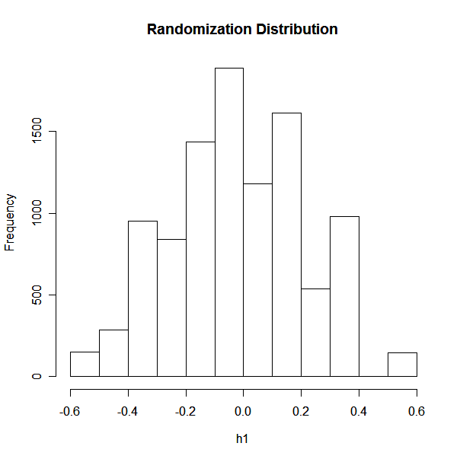

hapter 3.13 (三。十三)

Assumptions:
Results of production from each diet are both approximately normal distributed. Two samples, designs A and B, are independent. Results in each diet are i.i.d.

Summary:
Will try to test the hypothesis to see if there exists a significant difference between the mean values for the power attainable for the two designs. The null hypothesis assumes there is no difference in the mean values. I used a t-test to check if the difference in means is not equal to zero. The p-value obtained 0.07842. Therefore there is not sufficient evidence to reject the null hypothesis. The assumptions were needed to conduct test.

Using a randomization distribution, I also tested the above hypothesis. Here, I did not make assumptions about the distributions of the ratings. The mean of diet A: (166.5) and brand B: (156.6667), to obtain a absolute value of the difference of 9.83

The p-value obtained after a large number of observations should be approximately equal to the p-value obtained from the t-test above. I obtained the p-value: 0.0913. This also leads to the conclusion that one cannot reject the null hypothesis.

A 95% confidence interval for the mean difference: [-9.399669, 29.05967]

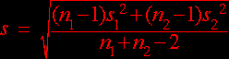

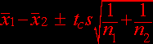

Here, the 95% confidence interval for the difference in mean hen production between diet A and diet B numbers above. Thus, not only do we estimate the difference to be 9.83 mg/dl, but we are 95% confident it is no less than lower bound or greater than upper bound.

CODE

dietA = c(166,174,150,166,165,178)
dietB = c(158,159,142,163,161,157)

y = t.test(dietA , dietB)
y
n1=0
h1=NULL
y1= c(166,174,150,166,165,178, 158,159,142,163,161,157)
c1=c(rep("A", 6), rep("B", 6))
diff=156.6667-166.5
for(i in 1:10000){
c2=sample(c1)
x1=y1[c2=="A"]; x2=y1[c2=="B"]
m1 = mean(x1); m2 = mean(x2)
d1 = m2-m1
h1=c(h1,d1)
if(d1 <= diff)n1=n1+1
}
n1
hist(h1, main="Randomization Distribution")
pvalue= n1/10000
pvalue

9.83-qt(0.975,10)* sqrt((5*var(dietA)+5*var(dietB))/10)
9.83+qt(0.975,10)* sqrt((5*var(dietA)+5*var(dietB))/10)

OUTPUT

> dietA = c(166,174,150,166,165,178)
> dietB = c(158,159,142,163,161,157)
>
> y = t.test(dietA , dietB)
> y

Welch Two Sample t-test

data: dietA and dietB
t = 1.9735, df = 9.436, p-value = 0.07842
alternative hypothesis: true difference in means is not equal to 0
95 percent confidence interval:
-1.359600 21.026267
sample estimates:
mean of x mean of y
166.5000 156.6667

> n1=0
> h1=NULL
> y1= c(166,174,150,166,165,178, 158,159,142,163,161,157)
> c1=c(rep("A", 6), rep("B", 6))
> diff=166.5 - 156.6667
> d1 = rep(0,10000)
> for(i in 1:10000){
+ c2=sample(c1);
+ x1=y1[c2=="A"];
+ x2=y1[c2=="B"];
+ m1 = mean(x1);
+ m2 = mean(x2);
+ d1[i] = m2-m1;
+ h1=c(h1,d1[i]);
+ if(abs(d1[i])>=9.83)n1=n1+1
+ }
> n1
[1] 913
> hist(h1, main="Randomization Distribution")
> pvalue= n1/10000
> pvalue
[1] 0.0913
> 9.83-qt(0.975,10)* sqrt((5*var(dietA)+5*var(dietB))/10)
[1] -9.399669
> 9.83+qt(0.975,10)* sqrt((5*var(dietA)+5*var(dietB))/10)
[1] 29.05967

