4.2

a) What is this design called? What characteristics does it have?

The problem is a Latin-Square experimental design
The study consists of 6 treatments (A-F) of “Volunteers,” 6 blocks (I-VI) of “Positions on arm,” and 6 blocks (#1-6) of “Subjects.”

b) How can such a design be randomized? Why?

1. Randomly select one of the standard 6X6 Latin Square
2. Randomly permute the rows and columns of chosen square.
3. Randomly assign the 6 treatments to the 6 letters of treatments( A-F)

c.
> Prob4.2=read.table(file="E:/FSU-FALL07-School/Fall07-school/STA5166/BHH2-Data/prb0402.dat", header=TRUE)

##change variables to characters
> new2 <- edit(Prob4.2)

> fit1=aov(y~position +subject+treatment, data=new2)
> fit1
Call:
aov(formula = y ~ position + subject + treatment, data = new2)

Terms:
position subject treatment Residuals
Sum of Squares 219.917 5407.917 250.250 1708.667
Deg. of Freedom 5 5 5 20

Residual standard error: 9.243015
Estimated effects may be unbalanced
>
> summary(fit1)
Df Sum Sq Mean Sq F value Pr(>F)
position 5 219.9 44.0 0.5148 0.7619
subject 5 5407.9 1081.6 12.6600 1.248e-05 ***
treatment 5 250.3 50.1 0.5858 0.7107
Residuals 20 1708.7 85.4
---
Signif. codes: 0 '***' 0.001 '**' 0.01 '*' 0.05 '.' 0.1 ' ' 1

d)
>par(mfrow=c(1,1))
>plot(fit1$fitted, fit1$resid)

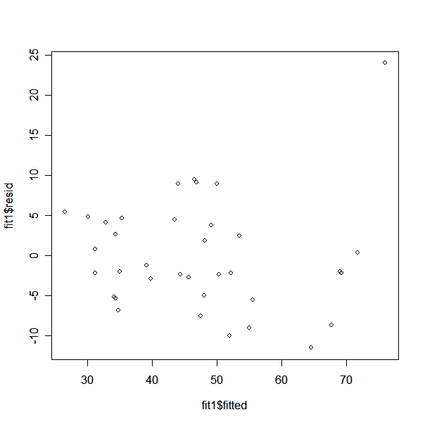

Made the assumption that the experiment is randomized and the residuals follow the i.i.d Normal distrubtion, N(0,)

e)
>par(mfrow=c(2,2))
?source("C:\\Documents and Settings\\Jaime\\Desktop\\FALL07\\STA5166\\hw1eda1-2.txt")
>eda1(fit1$resid)

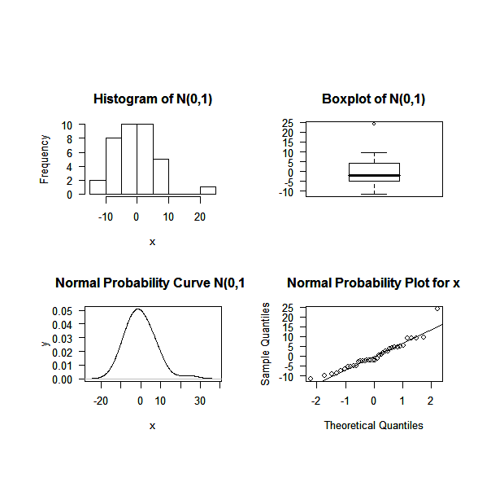

There exists one value that does not fit, however, overall the residuals likely follow N(0,) distribution.

See source (hw1eda1-2.txt)
x1<-rnorm(1000,0,1)

eda1<-function(x){par(mfrow=c(2,2), oma=c(4,2,6,2), mar=c(5,5,4,2), hist(x,las=1, main = "Histogram of N(0,1)"),
boxplot(x,las=1, main = "Boxplot of N(0,1)"),iqr<-summary(x)[5]-summary(x)[2],
plot(density(x, width=2*iqr), xlab="x",ylab="y", type="l", las=1, main="Normal Probability Curve N(0,1)"),
qqnorm(x,las=1, main="Normal Probability Plot for x" ),qqline(x))}

