Problem 4

a) Plot the data. What kind of experimental design is this?
Divided the run into 8 blocks which includes 4 treatments each.
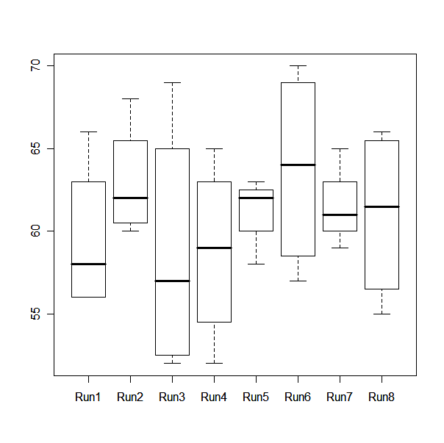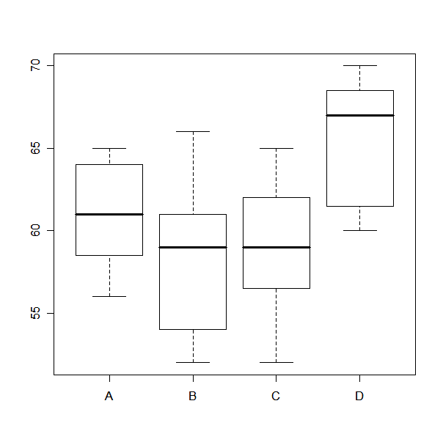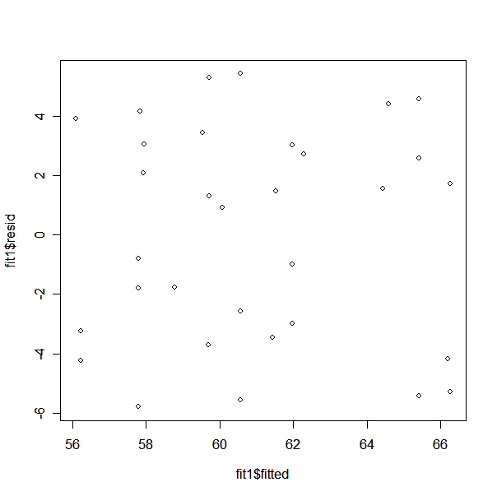

CODE
#renumber runs 8 blocks of (1-4)
Prob4.4=read.table(file="E:/FSU-FALL07-School/Fall07-school/STA5166/BHH2-Data/prb0404-3.txt", header=TRUE)
Prob4.4
plot(Prob4.4$run, Prob4.4$result)
plot(Prob4.4$variant, Prob4.4$result)
fit1=aov(result~ factor(run) + variant, data=Prob4.4)
plot(fit1$fitted, fit1$resid)

b) Make the ANOVA and a graphical ANOVA

ANOVA
Call:
aov(formula = result ~ variant + factor(run), data = Prob4.4)

Terms:
variant factor(run) Residuals
Sum of Squares 254.3750 59.1457 406.3543
Deg. of Freedom 3 7 21

Residual standard error: 4.398886
Estimated effects may be unbalanced

Df Sum Sq Mean Sq F value Pr(>F)
variant 3 254.38 84.79 4.3820 0.01519 *
factor(run) 7 59.15 8.45 0.4367 0.86800
Residuals 21 406.35 19.35
---
Signif. codes: 0 '***' 0.001 '**' 0.01 '*' 0.05 '.' 0.1 ' ' 1
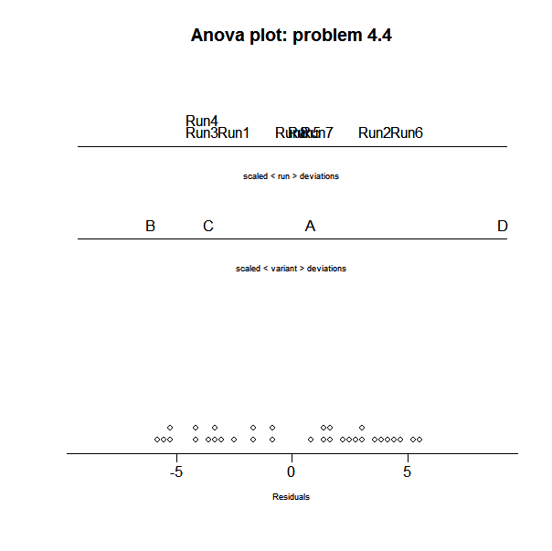

c) Estimate the mean, with confidence interval, for the four possible process conditions.

A B C D
61.00 58.25 59.00 65.50

CODE- R
variant1 = Prob4.4$variant
mean1 = tapply(result, variant1, mean)
mean1

I needed to use Splus for this.

95 % simultaneous confidence intervals for specified
linear combinations, by the Sidak method

critical point: 2.7098
response variable: result

intervals excluding 0 are flagged by '****'

Estimate Std.Error Lower Bound Upper Bound
A 61.1 1.86 56.1 66.2 ****
B 57.5 1.84 52.5 62.5 ****
C 59.2 1.61 54.9 63.6 ****
D 65.9 1.83 60.9 70.8 ****

95 % simultaneous confidence intervals for specified
linear combinations, by the Bonferroni method

critical point: 2.7316
response variable: result

intervals excluding 0 are flagged by '****'

Estimate Std.Error Lower Bound Upper Bound
A 61.1 1.86 56.0 66.2 ****
B 57.5 1.84 52.5 62.5 ****
C 59.2 1.61 54.8 63.6 ****
D 65.9 1.83 60.9 70.9 ****

CODE- Splus
>Prob4.4=read.table(file="E:/FSU-FALL07-School/Fall07-school/STA5166/BHH2-Data/prb0404-3.txt", header=TRUE)
>Prob4.4

>fit1=aov(result~ run + variant, data=Prob4.4)
>fit1

> multicomp(fit1, comparisons = "none", focus = "variant")
> multicomp(fit1, comparisons = "none", focus = "variant", method =”Bon”)

d) Plot the residuals in time order.

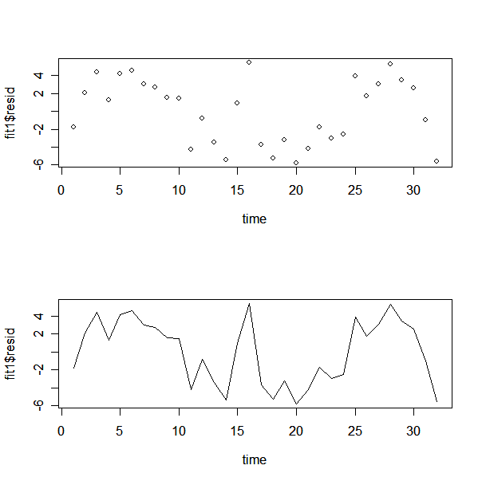

CODE
time =c(1:32)
par(mfrow=c(2,1))
plot(time, fit1$resid)
plot(time, fit1$resid, type = "l")

e) Plot the eight averages of the sets of four runs in time order and comment.

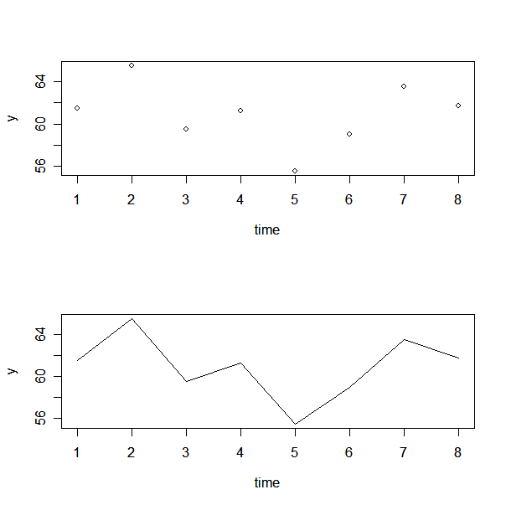

CODE
time = c(1:8)
y = c(1:8)
result = Prob4.4$result
for (i in 0:7){
y[i+1] = (result[i*4+1]+ result[i*4+2] + result[i*4+3]+ result[i*4+4])/4
}
y
length(y)
par(mfrow=c(2,1))
plot(time, y)
plot(time, y, type = "l")

COMMENT
Because variation is always present, can’t expect to hold a variable exactly constant over time. This is illustrated in the graphs. Analyzing each of the time plots, the process is not stable and there are data points that are out of control, or outside of 3 standard deviations of the average. (μ±3σ/$\sqrt{n}$)

Any $\bar{x}$that does not fall between the control limits is evidence that the process is out of control.

