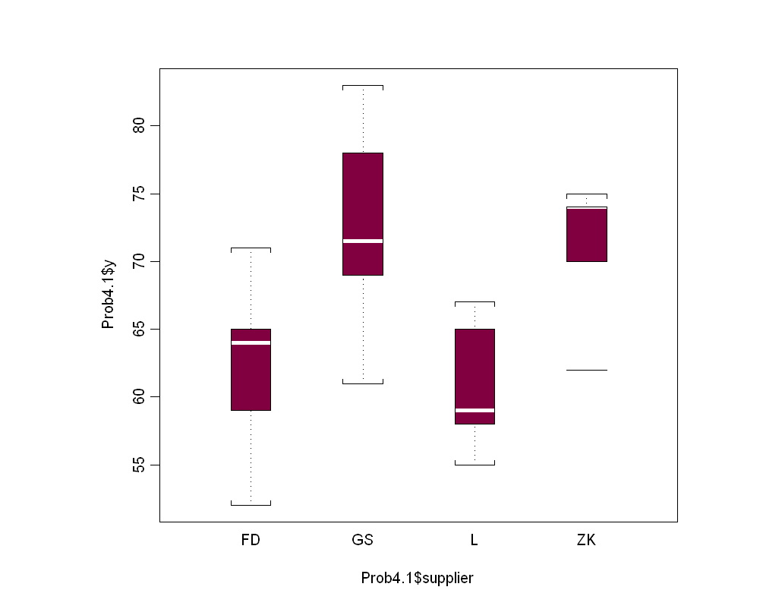

*** Analysis of Variance Model ***

Short Output:
Call:
aov(formula = y ~ site + supplier, data = prb0401, na.action = na.exclude)

Terms:
site supplier Residuals
Sum of Squares 568.7083 665.1250 163.1250
Deg. of Freedom 5 3 15

Residual standard error: 3.297726
Estimated effects are balanced

Df Sum of Sq Mean Sq F Value Pr(F)
site 5 568.7083 113.7417 10.45900 0.000180808
supplier 3 665.1250 221.7083 20.38697 0.000015031
Residuals 15 163.1250 10.8750

95 % simultaneous confidence intervals for specified
linear combinations, by the Bonferroni method

critical point: 3.0363
response variable: y

intervals excluding 0 are flagged by '****'

Estimate Std.Error Lower Bound Upper Bound
FD-GS -9.830 1.9 -15.60 -4.05 ****
FD-L 2.000 1.9 -3.78 7.78
FD-ZK -9.000 1.9 -14.80 -3.22 ****
GS-L 11.800 1.9 6.05 17.60 ****
GS-ZK 0.833 1.9 -4.95 6.61
L-ZK -11.000 1.9 -16.80 -5.22 ****

95 % simultaneous confidence intervals for specified
linear combinations, by the Bonferroni method

critical point: 3.4837
response variable: y

intervals excluding 0 are flagged by '****'

Estimate Std.Error Lower Bound Upper Bound
A-B -8.75 2.33 -16.90 -0.627 ****
A-C -4.50 2.33 -12.60 3.620
A-D 4.75 2.33 -3.37 12.900
A-E -9.25 2.33 -17.40 -1.130 ****
A-F -3.00 2.33 -11.10 5.120
B-C 4.25 2.33 -3.87 12.400
B-D 13.50 2.33 5.38 21.600 ****
B-E -0.50 2.33 -8.62 7.620
B-F 5.75 2.33 -2.37 13.900
C-D 9.25 2.33 1.13 17.400 ****
C-E -4.75 2.33 -12.90 3.370
C-F 1.50 2.33 -6.62 9.620
D-E -14.00 2.33 -22.10 -5.880 ****
D-F -7.75 2.33 -15.90 0.373
E-F 6.25 2.33 -1.87 14.400

Prob4.4=read.table(file="E:/FSU-FALL07-School/Fall07-school/STA5166/BHH2-Data/prb0404-3.txt", header=TRUE)
plot(Prob4.4$run, Prob4.4$result)
plot(Prob4.4$variant, Prob4.4$result)

fit1=aov(result~ variant + run, data=Prob4.4)
multicomp(fit1, method="Bon", plot=T)

*** Analysis of Variance Model ***

Short Output:
Call:
raov(formula = result ~ variant + run, data = prb0404.3, na.action =
na.exclude)

Terms:
variant run Residuals
Sum of Squares 254.3750 59.1457 406.3543
Deg. of Freedom 3 7 21

Residual standard error: 4.398886
Estimated effects may be unbalanced

Df Sum of Sq Mean Sq Est. Var.
variant 3 254.3750 84.79167 8.18018
run 7 59.1457 8.44939 -2.72520
Residuals 21 406.3543 19.35020 19.35020

95 % simultaneous confidence intervals for specified
linear combinations, by the Bonferroni method

critical point: 2.9121
response variable: result

intervals excluding 0 are flagged by '****'

Estimate Std.Error Lower Bound Upper Bound
A-B 3.62 2.87 -4.73 12.000
A-C 1.90 2.39 -5.06 8.870
A-D -4.74 2.81 -12.90 3.430
B-C -1.71 2.50 -8.99 5.560
B-D -8.36 2.65 -16.10 -0.628 ****
C-D -6.65 2.53 -14.00 0.735

