Problem 4.1 (四。一)

a) What kind of an experimental design is this? Randomized Block Design

b) Make a graphical analysis and an ANOVA.
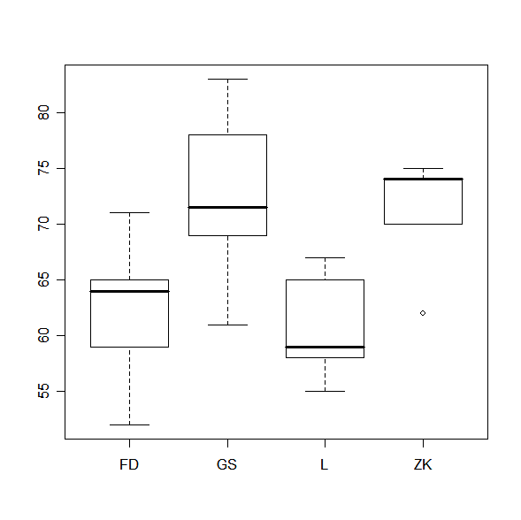
Analyzing each of the paint suppliers, the mean is different for each of them as illustrated above.

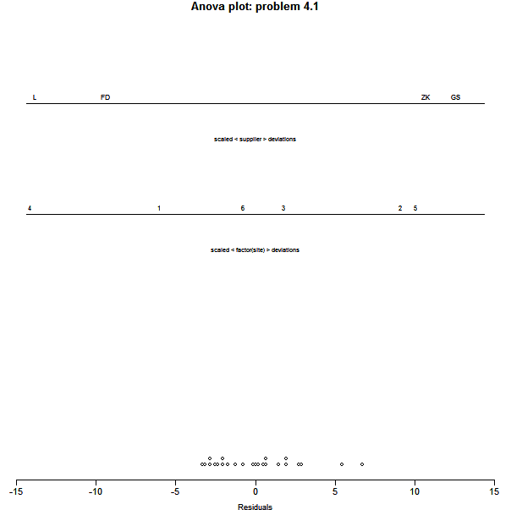

ANOVA output
> summary(fit1)
Df Sum Sq Mean Sq F value Pr(>F)
supplier 3 665.13 221.71 20.387 1.503e-05 ***
site 5 568.71 113.74 10.459 0.0001808 ***
Residuals 15 163.13 10.88
---
Signif. codes: 0 '***' 0.001 '**' 0.01 '*' 0.05 '.' 0.1 ' ' 1

Analyzing the residuals, assume no effect since no pattern and wide spread.

CODE
>Prob4.1=read.table(file="E:/FSU-FALL07-School/Fall07-school/STA5166/BHH2-Data/prb0401.dat", header=TRUE)
>Prob4.1
>par(mfrow=c(1,1))
>plot(Prob4.1$supplier, Prob4.1$y)
>fit1= aov(y~supplier + factor(site), data=Prob4.1)
>fit2= aov(y~supplier, data=Prob4.1)
>summary(fit1)
>attributes(fit1)
>par(mfrow=c(1,1))
>plot(fit1$fitted.values, fit1$residuals)

##LOAD BBH2 package
>par(mfrow = c(1, 1), cex = 0.7)
>anovaPlot(fit1, main = "Anova plot: problem 4.1",labels = TRUE, cex.lab = 0.6)

c) Obtain confidence limits for the supplier averages

Using R
General Linear Hypotheses

Multiple Comparisons of Means: Tukey Contrasts

Linear Hypotheses:
Estimate
GS - FD == 0 9.8333
L - FD == 0 -2.0000
ZK - FD == 0 9.0000
L - GS == 0 -11.8333
ZK - GS == 0 -0.8333
ZK - L == 0 11.0000

Simultaneous Confidence Intervals for General Linear Hypotheses

Multiple Comparisons of Means: Tukey Contrasts

Fit: aov(formula = y ~ supplier, data = Prob4.1)

Estimated Quantile = 2.799

Linear Hypotheses:
Estimate lwr upr
GS - FD == 0 9.83333 0.05797 19.60869
L - FD == 0 -2.00000 -11.77536 7.77536
ZK - FD == 0 9.00000 -0.77536 18.77536
L - GS == 0 -11.83333 -21.60869 -2.05797
ZK - GS == 0 -0.83333 -10.60869 8.94203
ZK - L == 0 11.00000 1.22464 20.77536

95% family-wise confidence level

Simultaneous Tests for General Linear Hypotheses

Multiple Comparisons of Means: Tukey Contrasts

Fit: aov(formula = y ~ supplier, data = Prob4.1)

Linear Hypotheses:
Estimate Std. Error t value p value
GS - FD == 0 9.8333 3.4925 2.816 0.0641 .
L - FD == 0 -2.0000 3.4925 -0.573 1.0000
ZK - FD == 0 9.0000 3.4925 2.577 0.1080
L - GS == 0 -11.8333 3.4925 -3.388 0.0175 *
ZK - GS == 0 -0.8333 3.4925 -0.239 1.0000
ZK - L == 0 11.0000 3.4925 3.150 0.0303 *
---
Signif. codes: 0 '***' 0.001 '**' 0.01 '*' 0.05 '.' 0.1 ' ' 1
(Adjusted p values reported -- bonferroni method)
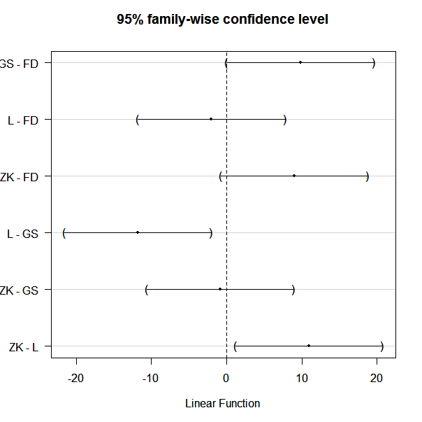

CODE: (R)
##load package mvtnorm
##load package multcomp
##load package multtest

fit2= aov(y~supplier, data=Prob4.1)
summary(fit2)
int= glht(fit2, linfct = mcp(supplier = "Tukey"))
int
print(confint(int))
plot(confint(int))
summary(int, test = adjusted( "bonferroni"))

Using Splus
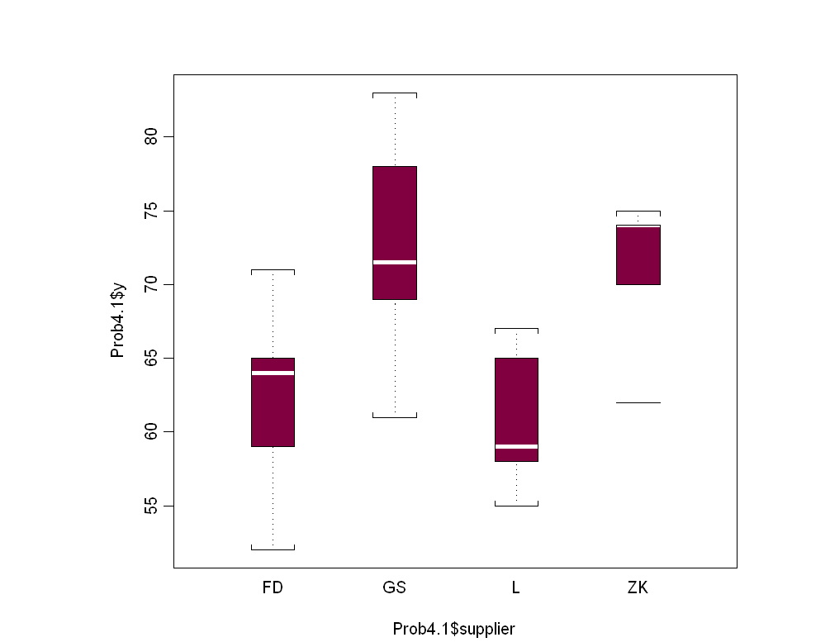

*** Analysis of Variance Model ***
Short Output:
Call:
aov(formula = y ~ site + supplier, data = prb0401, na.action = na.exclude)
Terms:
site supplier Residuals
Sum of Squares 568.7083 665.1250 163.1250
Deg. of Freedom 5 3 15

Residual standard error: 3.297726
Estimated effects are balanced

Df Sum of Sq Mean Sq F Value Pr(F)
site 5 568.7083 113.7417 10.45900 0.000180808
supplier 3 665.1250 221.7083 20.38697 0.000015031
Residuals 15 163.1250 10.8750

95 % simultaneous confidence intervals for specified
linear combinations, by the Bonferroni method

critical point: 3.0363
response variable: y

intervals excluding 0 are flagged by '****'

Estimate Std.Error Lower Bound Upper Bound
FD-GS -9.830 1.9 -15.60 -4.05 ****
FD-L 2.000 1.9 -3.78 7.78
FD-ZK -9.000 1.9 -14.80 -3.22 ****
GS-L 11.800 1.9 6.05 17.60 ****
GS-ZK 0.833 1.9 -4.95 6.61
L-ZK -11.000 1.9 -16.80 -5.22 ****

CODE: (Splus)

Prob4.1=read.table(file="E:/FSU-FALL07-School/Fall07-school/STA5166/BHH2-Data/prb0401.txt", header=TRUE)
plot(Prob4.1$supplier, Prob4.1$y)

fit1=aov(y~ supplier + factor(site), data=Prob4.1)
fit1
multicomp(fit1, method="Bon", plot=T)

d) Make checks that might indicate departures from assumptions.
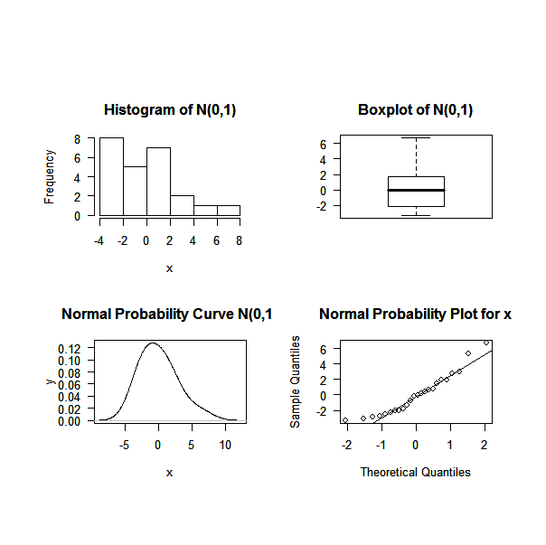
From the plot above, the residuals do not strictly follow Normal distributions, N(0,). This may indicate departures from the assumptions. Made the assumption that the experiment is randomized and the residuals follow the i.i.d Normal distribution. A transformation may be needed.

Using S-Plus
A possible transformation was found to be: =1.77, with R2 = 0.068

CODE
par(mfrow=c(2,2))
##may need my fuction see other script
source("C:\\Documents and Settings\\Jaime\\Desktop\\FALL07\\STA5166\\hw1eda1-2.txt")

eda1(fit1$resid)

CODE Splus
>turkey(fit1.suppliers, suppliers.df)
>comp.plot(fit1.suppliers, suppliers.df)

SOURCE
x1<-rnorm(1000,0,1)

eda1<-function(x){par(mfrow=c(2,2), oma=c(4,2,6,2), mar=c(5,5,4,2), hist(x,las=1, main = "Histogram of N(0,1)"),
boxplot(x,las=1, main = "Boxplot of N(0,1)"),iqr<-summary(x)[5]-summary(x)[2],
plot(density(x, width=2*iqr), xlab="x",ylab="y", type="l", las=1, main="Normal Probability Curve N(0,1)"),
qqnorm(x,las=1, main="Normal Probability Plot for x" ),qqline(x))}

e) Do you think the data contains bad values?

1 2 3 4 5 6
0.12500000 5.37500000 0.62500000 -3.12500000 -0.12500000 -2.87500000
7 8 9 10 11 12
-0.04166667 -2.79166667 0.45833333 -2.29166667 2.70833333 1.95833333
13 14 15 16 17 18
-2.04166667 -0.79166667 -2.54166667 6.70833333 0.70833333 -2.04166667
19 20 21 22 23 24
1.95833333 -1.79166667 1.45833333 -1.29166667 -3.29166667 2.95833333

There data contains a big value, 6.70833333. This may contain bad value.

CODE
>fit1$resid

f) What can you say about the relative resistance to wear of the four paints?

Estimate Std.Error Lower Bound Upper Bound
FD-GS -9.830 1.9 -15.60 -4.05 ****
FD-L 2.000 1.9 -3.78 7.78
FD-ZK -9.000 1.9 -14.80 -3.22 ****
GS-L 11.800 1.9 6.05 17.60 ****
GS-ZK 0.833 1.9 -4.95 6.61
L-ZK -11.000 1.9 -16.80 -5.22 ****

Sites and Suppliers were both found to be significant, the data indicates that a least one mean is different. Analyzing the Bonferroni intervals, the differences FD-GS, FD-ZK, GS-L, and L-ZK.

g) Do you think this experimental arrangement was helpful?
Df Sum Sq Mean Sq F value Pr(>F)
supplier 3 665.13 221.71 20.387 1.503e-05 ***
site 5 568.71 113.74 10.459 0.0001808 ***
Residuals 15 163.13 10.88
---
Signif. codes: 0 '***' 0.001 '**' 0.01 '*' 0.05 '.' 0.1 ' ' 1

CODE
> summary(fit1)

From these results, we can see that using Sites as blocks make a significant effect on the experiment. Therefore, using this type of design was helpful.

Problem 4.2 (四。二)

a) What is this design called? What characteristics does it have?

The problem is a Latin-Square experimental design
The study consists of 6 treatments (A-F) of “Volunteers,” 6 blocks (I-VI) of “Positions on arm,” and 6 blocks (#1-6) of “Subjects.”

b) How can such a design be randomized? Why?

1. Randomly select one of the standard 6X6 Latin Square
2. Randomly permute the rows and columns of the chosen square.
3. Randomly assign the 6 treatments to the 6 letters of treatments ( A-F)

c) Make an ANOVA. (Ignored graphical ANOVA)

ANOVA results

Call:
aov(formula = y ~ position + subject + treatment, data = new2)

Terms:
position subject treatment Residuals
Sum of Squares 219.917 5407.917 250.250 1708.667
Deg. of Freedom 5 5 5 20

Residual standard error: 9.243015
Estimated effects may be unbalanced

Df Sum Sq Mean Sq F value Pr(>F)
position 5 219.9 44.0 0.5148 0.7619
subject 5 5407.9 1081.6 12.6600 1.248e-05 ***
treatment 5 250.3 50.1 0.5858 0.7107
Residuals 20 1708.7 85.4
---
Signif. codes: 0 '***' 0.001 '**' 0.01 '*' 0.05 '.' 0.1 ' ' 1

CODE
>Prob4.2=read.table(file="E:/FSU-FALL07-School/Fall07-school/STA5166/BHH2-Data/prb0402.dat", header=TRUE)
>fit1=aov(y~factor(position) + factor(subject)+treatment, data=Prob4.2)
>fit1
>summary(fit1)

d)
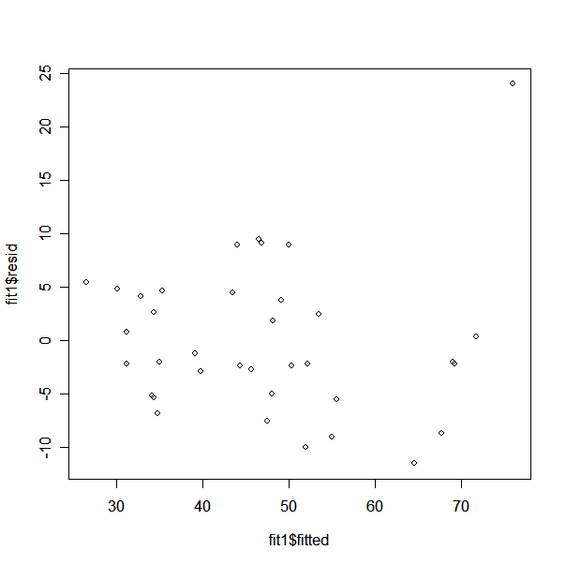

Made the assumption that the experiment is randomized and the residuals follow the i.i.d Normal distribution, N(0,)

CODE
>par(mfrow=c(1,1))
>plot(fit1$fitted, fit1$resid)

e)
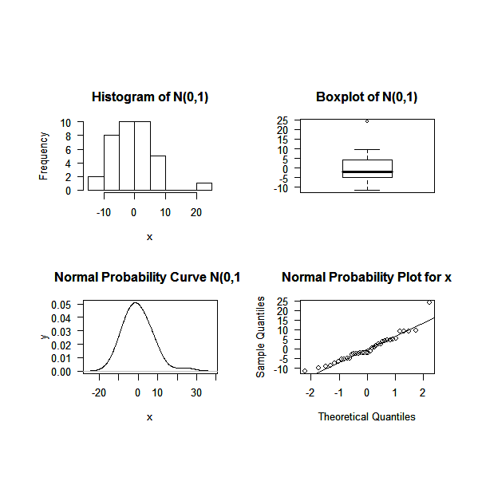
There exists one value that does not fit, however, overall the residuals likely follow N(0,) distribution.

CODE

>par(mfrow=c(2,2))
>source("C:\\Documents and Settings\\Jaime\\Desktop\\FALL07\\STA5166\\hw1eda1-2.txt")
>eda1(fit1$resid)

SOURCE (see problem 1: hw1eda1-2.txt)

Problem 4

a) Plot the data. What kind of experimental design is this?
Divided the run into 8 blocks which includes 4 treatments each.
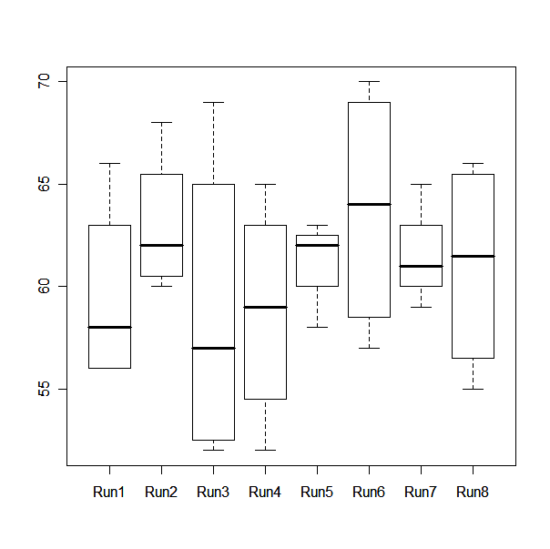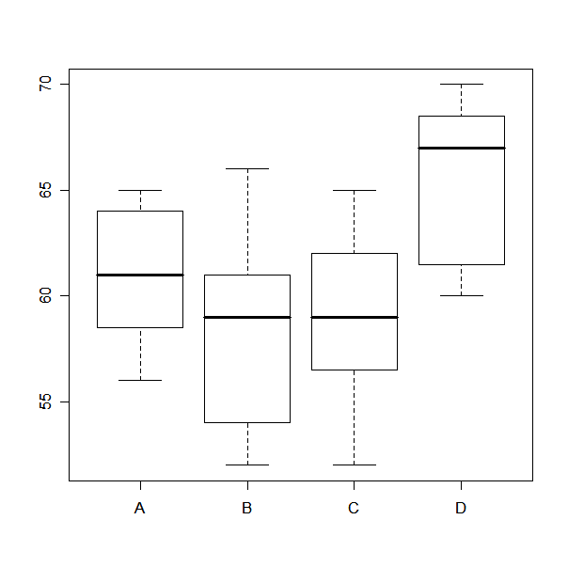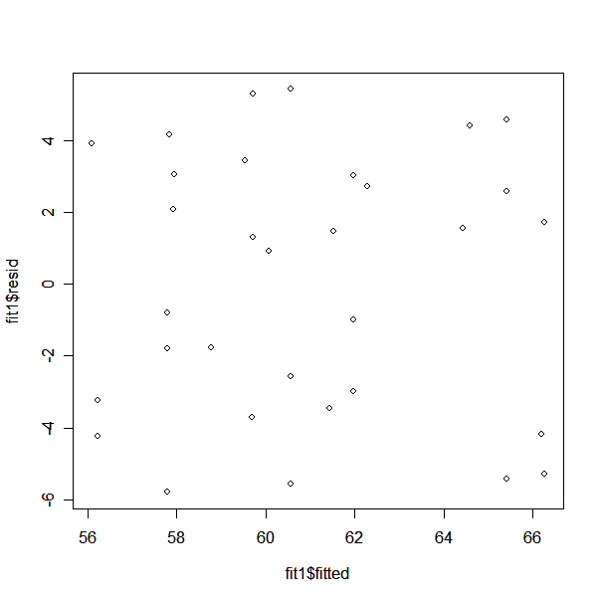

CODE
#renumber runs 8 blocks of (1-4)
Prob4.4=read.table(file="E:/FSU-FALL07-School/Fall07-school/STA5166/BHH2-Data/prb0404-3.txt", header=TRUE)
Prob4.4
plot(Prob4.4$run, Prob4.4$result)
plot(Prob4.4$variant, Prob4.4$result)
fit1=aov(result~ factor(run) + variant, data=Prob4.4)
plot(fit1$fitted, fit1$resid)

b) Make the ANOVA and a graphical ANOVA

ANOVA
Call:
aov(formula = result ~ variant + factor(run), data = Prob4.4)

Terms:
variant factor(run) Residuals
Sum of Squares 254.3750 59.1457 406.3543
Deg. of Freedom 3 7 21

Residual standard error: 4.398886
Estimated effects may be unbalanced

Df Sum Sq Mean Sq F value Pr(>F)
variant 3 254.38 84.79 4.3820 0.01519 *
factor(run) 7 59.15 8.45 0.4367 0.86800
Residuals 21 406.35 19.35
---
Signif. codes: 0 '***' 0.001 '**' 0.01 '*' 0.05 '.' 0.1 ' ' 1
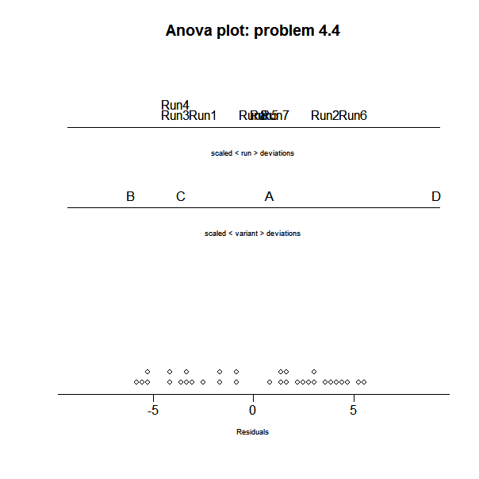

c) Estimate the mean, with confidence interval, for the four possible process conditions.

A B C D
61.00 58.25 59.00 65.50

CODE- R
variant1 = Prob4.4$variant
mean1 = tapply(result, variant1, mean)
mean1

I needed to use Splus for this.

95 % simultaneous confidence intervals for specified
linear combinations, by the Sidak method

critical point: 2.7098
response variable: result

intervals excluding 0 are flagged by '****'

Estimate Std.Error Lower Bound Upper Bound
A 61.1 1.86 56.1 66.2 ****
B 57.5 1.84 52.5 62.5 ****
C 59.2 1.61 54.9 63.6 ****
D 65.9 1.83 60.9 70.8 ****

95 % simultaneous confidence intervals for specified
linear combinations, by the Bonferroni method

critical point: 2.7316
response variable: result

intervals excluding 0 are flagged by '****'

Estimate Std.Error Lower Bound Upper Bound
A 61.1 1.86 56.0 66.2 ****
B 57.5 1.84 52.5 62.5 ****
C 59.2 1.61 54.8 63.6 ****
D 65.9 1.83 60.9 70.9 ****

CODE- Splus
>Prob4.4=read.table(file="E:/FSU-FALL07-School/Fall07-school/STA5166/BHH2-Data/prb0404-3.txt", header=TRUE)
>Prob4.4

>fit1=aov(result~ run + variant, data=Prob4.4)
>fit1

> multicomp(fit1, comparisons = "none", focus = "variant")
> multicomp(fit1, comparisons = "none", focus = "variant", method =”Bon”)

d) Plot the residuals in time order.

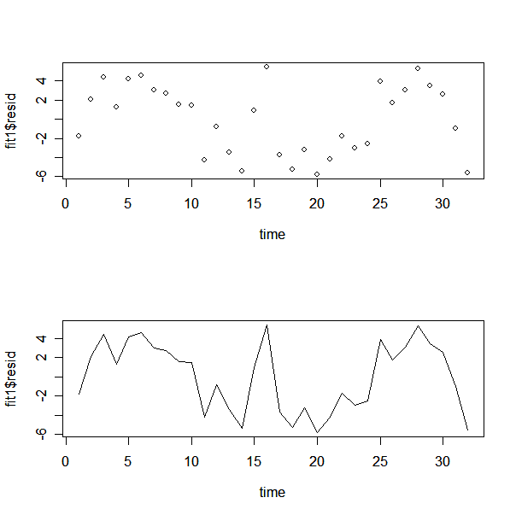

CODE
time =c(1:32)
par(mfrow=c(2,1))
plot(time, fit1$resid)
plot(time, fit1$resid, type = "l")

e) Plot the eight averages of the sets of four runs in time order and comment.

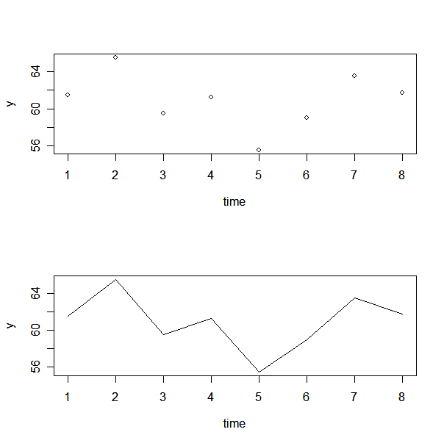

CODE
time = c(1:8)
y = c(1:8)
result = Prob4.4$result
for (i in 0:7){
y[i+1] = (result[i*4+1]+ result[i*4+2] + result[i*4+3]+ result[i*4+4])/4
}
y
length(y)
par(mfrow=c(2,1))
plot(time, y)
plot(time, y, type = "l")

COMMENT
Because variation is always present, can’t expect to hold a variable exactly constant over time. This is illustrated in the graphs. Analyzing each of the time plots, the process is not stable and there are data points that are out of control, or outside of 3 standard deviations of the average. (μ±3σ/$\sqrt{n}$)

Any $\bar{x}$that does not fall between the control limits is evidence that the process is out of control.

