a) This is a randomized Bloack experimental design

b)
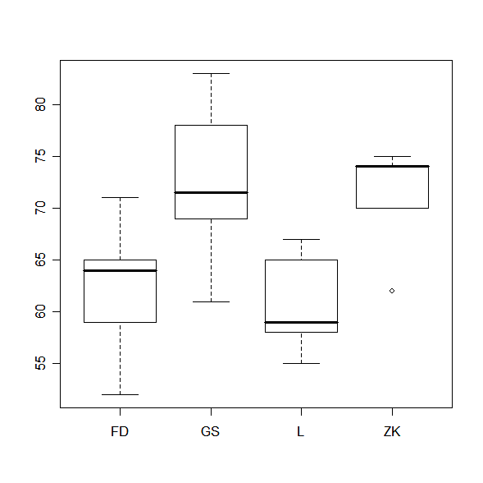
Analyzing each of the paint suppliers, the mean is different for each of them as illustrated above.

> fit1= aov(y~supplier + site, data=Prob4.1)
Warning message:
variable 'site' converted to a factor in: model.matrix.default(mt, mf, contrasts)
> fit2= aov(y~supplier, data=Prob4.1)
> summary(fit1)
Df Sum Sq Mean Sq F value Pr(>F)
supplier 3 665.13 221.71 20.387 1.503e-05 ***
site 5 568.71 113.74 10.459 0.0001808 ***
Residuals 15 163.13 10.88
---
Signif. codes: 0 '***' 0.001 '**' 0.01 '*' 0.05 '.' 0.1 ' ' 1

attributes(fit1)
par(mfrow=c(1,1))
plot(fit1$fitted.values, fit1$residuals)

Analyzing the residuals, assume no effect since no pattern and wide spread.

Using S-Plus

Using R
##load package mvtnorm
##load package multcomp
##load package multtest
int= glht(fit2, linfct = mcp(supplier = "Tukey"))
int
print(confint(int))
plot(confint(int))
summary(int, test = adjusted( "bonferroni"))

#this gives same output as glht
##with site
summary(simtest(y~supplier + site, data = Prob4.1, whichf="supplier",type = "Tukey"))
summary(simint(y~supplier+site, data = Prob4.1,whichf="supplier",type = "Tukey"))

##without site (I think this is right)
summary(simtest(y~supplier, data = Prob4.1, whichf="supplier",type = "Tukey"))
summary(simint(y~supplier, data = Prob4.1,whichf="supplier",type = "Tukey"))

> int= glht(fit2, linfct = mcp(supplier = "Tukey"))
> int

General Linear Hypotheses

Multiple Comparisons of Means: Tukey Contrasts

Linear Hypotheses:
Estimate
GS - FD == 0 9.8333
L - FD == 0 -2.0000
ZK - FD == 0 9.0000
L - GS == 0 -11.8333
ZK - GS == 0 -0.8333
ZK - L == 0 11.0000

> print(confint(int))

Simultaneous Confidence Intervals for General Linear Hypotheses

Multiple Comparisons of Means: Tukey Contrasts

Fit: aov(formula = y ~ supplier, data = Prob4.1)

Estimated Quantile = 2.799

Linear Hypotheses:
Estimate lwr upr
GS - FD == 0 9.83333 0.05797 19.60869
L - FD == 0 -2.00000 -11.77536 7.77536
ZK - FD == 0 9.00000 -0.77536 18.77536
L - GS == 0 -11.83333 -21.60869 -2.05797
ZK - GS == 0 -0.83333 -10.60869 8.94203
ZK - L == 0 11.00000 1.22464 20.77536

95% family-wise confidence level

