Problem chapter 9.2

#=================parta
##each pair of observations occurs in the same block one time, lambda=1

#=================partb
##Efficiency factor
##E = [(lambda)(t)]/[rk]
lambda=1 ##how many times each pair is repeated
t = 7 ##number of treatments, total of columns
r = 4 ##number of item w/in columns
k = 4 ##number of items w/in each row
E = ((lambda)*(t))/(r*k)

E = 2*7/4*4 =14/16

#=================partC

#y_ij = \mu _ \beta_j + \tau_i + \epsilon_ij i=1, 2, 3 , 4, 5, 6, 7 (number of colms) j = 1-7 (number of rows)
#
#\beta_j = jth block as block effect
#\tau_i = ith treatment
#\mu is general mean
#\epsilon = experimental error, mean=0 variance \sigma^2 normal iid
#

#==========part c
fit1= aov(Data~factor(Run)+factor(Voltage), data=BIBProb2)
fit1
Call:
aov(formula = Data ~ factor(Run) + factor(Voltage), data = BIBProb2)

Terms:
factor(Run) factor(Voltage) Residuals
Sum of Squares 47866.28 275795.04 9315.78
Deg. of Freedom 6 7 14

Residual standard error: 25.79559
Estimated effects may be unbalanced

#==========part d

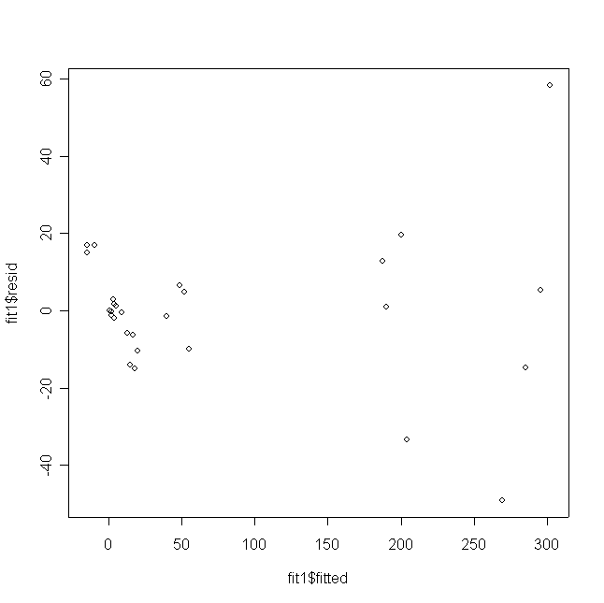
#==========part e
> lndata = log(BIBProb2$Data)
> lndata
[1] 3.6425737 1.6937791 0.6729445 -0.5978370 5.3946270 2.0360120
[7] 0.9321641 -0.4004776 5.6015652 5.3016618 1.8309802 -0.2744368
[13] 5.8864928 5.1388526 3.8161727 1.1693814 5.3941729 4.0384794
[19] 2.2321626 -0.4942963 5.7059801 4.0134960 2.3427669 1.9726912
[25] 5.2511209 2.1679102 1.9344158 0.7929925
>
> BIBProb2_2= data.frame(lndata, data=BIBProb2)
> BIBProb2_2
lndata data.Data data.Run data.Voltage
1 3.6425737 38.19 1 32
2 1.6937791 5.44 1 40
3 0.6729445 1.96 1 44
4 -0.5978370 0.55 1 58
5 5.3946270 220.22 2 24
6 2.0360120 7.66 2 36
7 0.9321641 2.54 2 44
8 -0.4004776 0.67 2 48
9 5.6015652 270.85 3 24
10 5.3016618 200.67 3 28
11 1.8309802 6.24 3 40
12 -0.2744368 0.76 3 48
13 5.8864928 360.14 4 24
14 5.1388526 170.52 4 28
15 3.8161727 45.43 4 32
16 1.1693814 3.22 4 44
17 5.3941729 220.12 5 28
18 4.0384794 56.74 5 32
19 2.2321626 9.32 5 36
20 -0.4942963 0.61 5 48
21 5.7059801 300.66 6 24
22 4.0134960 55.34 6 32
23 2.3427669 10.41 6 36
24 1.9726912 7.19 6 40
25 5.2511209 190.78 7 28
26 2.1679102 8.74 7 36
27 1.9344158 6.92 7 40
28 0.7929925 2.21 7 44
> fit2= aov(lndata~factor(data.Voltage)+ factor(data.Run), data=BIBProb2_2)
> fit2
Call:
aov(formula = lndata ~ factor(data.Voltage) + factor(data.Run),
data = BIBProb2_2)

Terms:
factor(data.Voltage) factor(data.Run) Residuals
Sum of Squares 123.09915 0.28622 0.23430
Deg. of Freedom 7 6 14

Residual standard error: 0.1293674
Estimated effects may be unbalanced
> summary(fit2)
Df Sum Sq Mean Sq F value Pr(>F)
factor(data.Voltage) 7 123.099 17.586 1050.7691 < 2e-16 ***
factor(data.Run) 6 0.286 0.048 2.8504 0.04985 *
Residuals 14 0.234 0.017
---
Signif. codes: 0 '***' 0.001 '**' 0.01 '*' 0.05 '.' 0.1 ' ' 1
> par(mfrow=c(1,1))
> plot(fit2$fitted, fit2$resid)

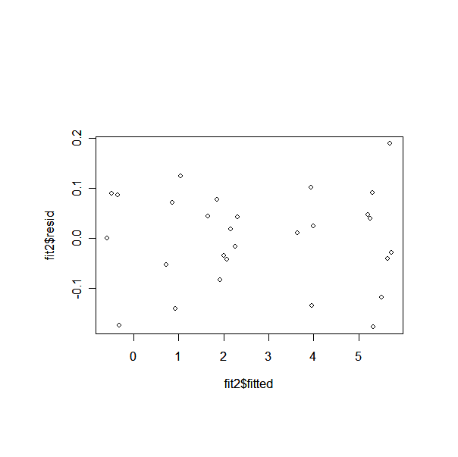
> fit_BIBprob2 = aov(Data~factor(Run)+factor(Voltage), data=BIBProb2 )
> fit_BIBprob2
Call:
aov(formula = Data ~ factor(Run) + factor(Voltage), data = BIBProb2)

Terms:
factor(Run) factor(Voltage) Residuals
Sum of Squares 47866.28 275795.04 9315.78
Deg. of Freedom 6 7 14

Residual standard error: 25.79559
Estimated effects may be unbalanced
>
> summary(fit_BIBprob2)
Df Sum Sq Mean Sq F value Pr(>F)
factor(Run) 6 47866 7978 11.989 8.065e-05 ***
factor(Voltage) 7 275795 39399 59.210 2.502e-09 ***
Residuals 14 9316 665
---
Signif. codes: 0 '***' 0.001 '**' 0.01 '*' 0.05 '.' 0.1 ' ' 1

#=================partD
par(mfrow=c(2,4))
##may need my fuction see other script
source("C:\\Documents and Settings\\Jaime\\Desktop\\FALL07\\STA5166\\hw1eda1-2.txt")

eda1(fit_BIBprob2$resid)

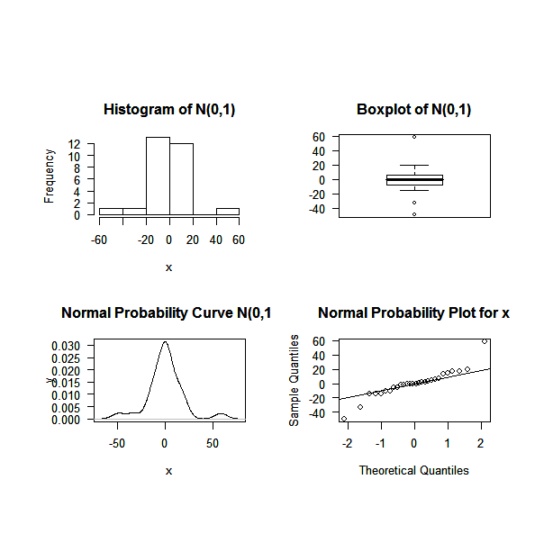
> fit_BIBprob2_2 = aov(lndata~factor(Run)+factor(Voltage), data=BIBProb2 )
> fit_BIBprob2_2
Call:
aov(formula = lndata ~ factor(Run) + factor(Voltage), data = BIBProb2)

Terms:
factor(Run) factor(Voltage) Residuals
Sum of Squares 19.41556 103.96981 0.23430
Deg. of Freedom 6 7 14

Residual standard error: 0.1293674
Estimated effects may be unbalanced
>
> summary(fit_BIBprob2_2)
Df Sum Sq Mean Sq F value Pr(>F)
factor(Run) 6 19.416 3.236 193.35 1.208e-12 ***
factor(Voltage) 7 103.970 14.853 887.48 < 2.2e-16 ***
Residuals 14 0.234 0.017
---
Signif. codes: 0 '***' 0.001 '**' 0.01 '*' 0.05 '.' 0.1 ' ' 1

#par(mfrow=c(4,4))
##may need my fuction see other script
source("C:\\Documents and Settings\\Jaime\\Desktop\\FALL07\\STA5166\\hw1eda1-2.txt")
eda1(fit_BIBprob2_2$resid)
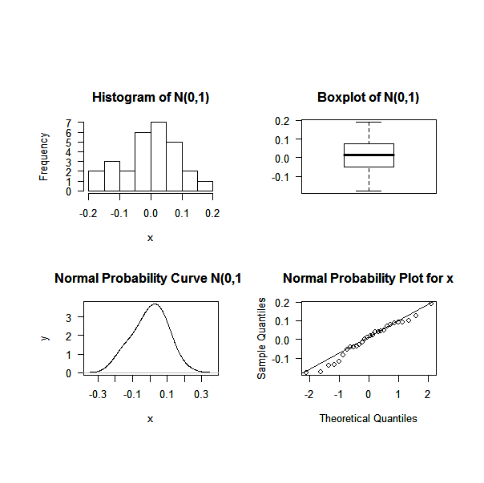

After the transformation, the residual plot looks more sparse, which means a constant variance.

Problem Chapter 5, #7

> Prob5_7=read.table(file="E:/FSU-FALL07-School/Fall07-school/STA5166/hw5/prb0507_2.dat", header=TRUE)
> Prob5_7
run Temp Phlevel Agicul y
1 1 -1 -1 -1 60
2 2 1 -1 -1 61
3 3 -1 1 -1 54
4 4 1 1 -1 75
5 5 -1 -1 1 58
6 6 1 -1 1 61
7 7 -1 1 1 55
8 8 1 1 1 75
>
> prob5.7= data.frame(apply(Prob5_7[,2:4],2, as.factor), y= Prob5_7[,5])
> fit1 = aov(y~Temp*Phlevel*Agicul, data=prob5.7)
> par(mfrow=c(1,1))
> plot.design(prob5.7)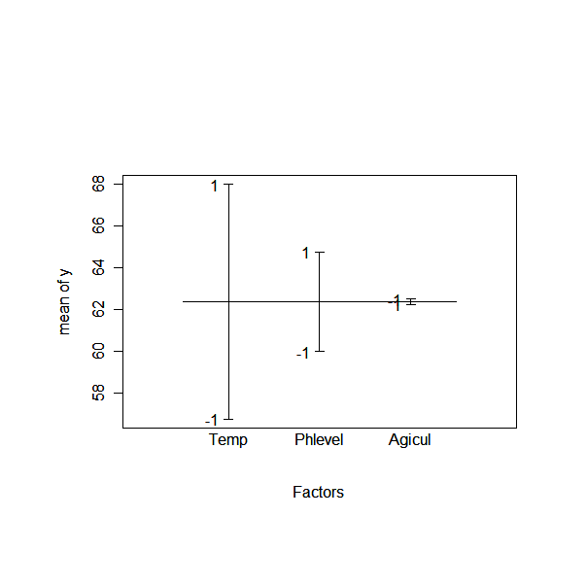
par(mfrow=c(2,2))
interaction.plot(prob5.7$Temp, prob5.7$Phlevel, prob5.7$y)
interaction.plot(prob5.7$Temp, prob5.7$Agicul, prob5.7$y)
interaction.plot(prob5.7$Phlevel, prob5.7$Agicul, prob5.7$y)

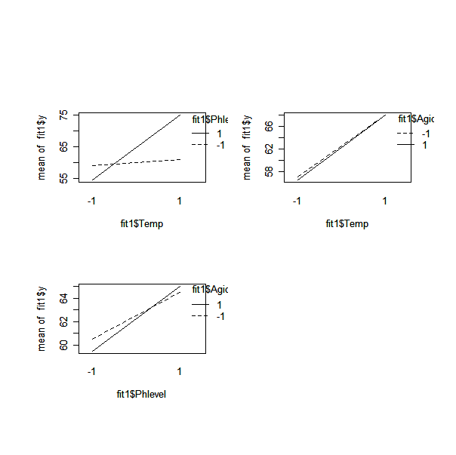
par(mfrow=c(1,1))
qqnorm(fit1$fitted)
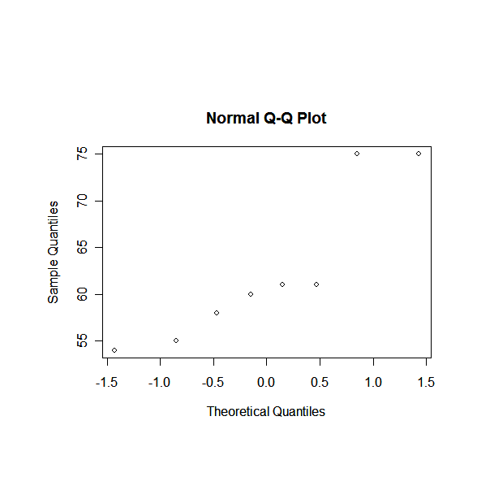
par(mfrow=c(2,2))
plot(prob5.7$Temp, prob5.7$y)
plot(prob5.7$Phlevel, prob5.7$y)
plot(prob5.7$Agicul, prob5.7$y)
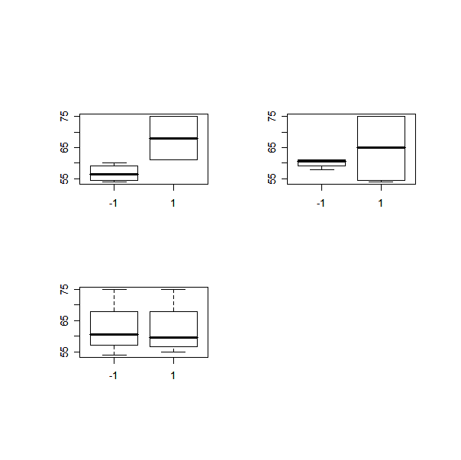
> fit2=aov(y~Temp+Phlevel, data=Prob5_7)
> fit2
Call:
aov(formula = y ~ Temp + Phlevel, data = Prob5_7)

Terms:
Temp Phlevel Residuals
Sum of Squares 253.125 45.125 173.625
Deg. of Freedom 1 1 5

Residual standard error: 5.892792
Estimated effects are balanced
> summary(fit2)
Df Sum Sq Mean Sq F value Pr(>F)
Temp 1 253.125 253.125 7.2894 0.04279 *
Phlevel 1 45.125 45.125 1.2995 0.30595
Residuals 5 173.625 34.725
---
Signif. codes: 0 '***' 0.001 '**' 0.01 '*' 0.05 '.' 0.1 ' ' 1
> fit3=aov(y~Temp+Phlevel+Temp:Phlevel, data=Prob5_7)
> fit3
Call:
aov(formula = y ~ Temp + Phlevel + Temp:Phlevel, data = Prob5_7)

Terms:
Temp Phlevel Temp:Phlevel Residuals
Sum of Squares 253.125 45.125 171.125 2.500
Deg. of Freedom 1 1 1 4

Residual standard error: 0.7905694
Estimated effects are balanced
> summary(fit3)
Df Sum Sq Mean Sq F value Pr(>F)
Temp 1 253.125 253.125 405.0 3.599e-05 ***
Phlevel 1 45.125 45.125 72.2 0.001052 **
Temp:Phlevel 1 171.125 171.125 273.8 7.812e-05 ***
Residuals 4 2.500 0.625
---
Signif. codes: 0 '***' 0.001 '**' 0.01 '*' 0.05 '.' 0.1 ' ' 1

Assumption: The estimated effects are assumed to be i.i.d with normal distribution, mean is zero. Results indicat the temperature has the strongest effect on yield. Ph levels as well as the interaction between this and temp also are significant.

Problem Chapter 5, #10
> prob5_10<-read.table("E:/FSU-FALL07-School/Fall07-school/STA5166/hw5/prb0510.dat",header=T)
> prob5_10
run temp conc rate yield
1 1 50 6 60 54
2 2 60 6 60 57
3 3 50 10 60 69
4 4 60 10 60 70
5 5 50 6 100 55
6 6 60 6 100 54
7 7 50 10 100 80
8 8 60 10 100 81
> prob5_10= data.frame(apply(prob5_10[,2:4],2, as.factor), yield= prob5_10[,5])
>
> fit1 = aov(yield~temp*conc*rate, data=prob5_10)
> summary(fit1)
Df Sum Sq Mean Sq
temp 1 2 2
conc 1 800 800
rate 1 50 50
temp:conc 1 8.247e-29 8.247e-29
temp:rate 1 2 2
conc:rate 1 72 72
temp:conc:rate 1 2 2
>
> plot.design(prob5_10)
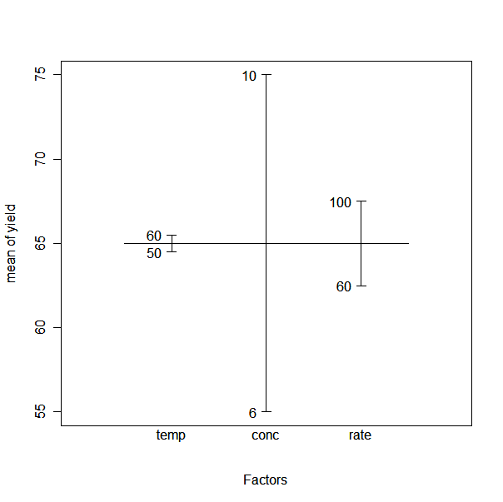

par(mfrow=c(2,2))
interaction.plot(prob5_10$temp,prob5_10$conc,prob5_10$yield)
interaction.plot(prob5_10$temp,prob5_10$rate,prob5_10$yield)
interaction.plot(prob5_10$conc,prob5_10$rate,prob5_10$yield)
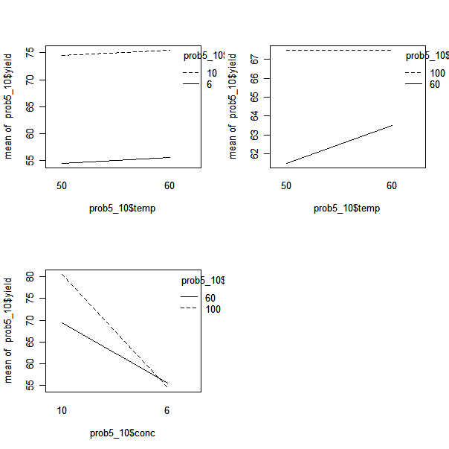
> model.tables(fit1, type="effects", se=F)
Tables of effects

temp
temp
50 60
-0.5 0.5

conc
conc
10 6
10 -10

rate
rate
100 60
2.5 -2.5

temp:conc
conc
temp 10 6
50 3.211e-15 -3.211e-15
60 -3.211e-15 3.211e-15

temp:rate
rate
temp 100 60
50 0.5 -0.5
60 -0.5 0.5

conc:rate
rate
conc 100 60
10 3 -3
6 -3 3

temp:conc:rate
, , rate = 100

conc
temp 10 6
50 -0.5 0.5
60 0.5 -0.5

, , rate = 60

conc
temp 10 6
50 0.5 -0.5
60 -0.5 0.5

>
>
> fit2<-lm(yield~factor(temp)*factor(conc)*factor(rate),data=prob5_10)
>
> summary(fit2)

Call:
lm(formula = yield ~ factor(temp) * factor(conc) * factor(rate),
data = prob5_10)

Residuals:
ALL 8 residuals are 0: no residual degrees of freedom!

Coefficients:
Estimate Std. Error t value
(Intercept) 8.000e+01 NA NA
factor(temp)60 1.000e+00 NA NA
factor(conc)6 -2.500e+01 NA NA
factor(rate)60 -1.100e+01 NA NA
factor(temp)60:factor(conc)6 -2.000e+00 NA NA
factor(temp)60:factor(rate)60 1.014e-15 NA NA
factor(conc)6:factor(rate)60 1.000e+01 NA NA
factor(temp)60:factor(conc)6:factor(rate)60 4.000e+00 NA NA
Pr(>|t|)
(Intercept) NA
factor(temp)60 NA
factor(conc)6 NA
factor(rate)60 NA
factor(temp)60:factor(conc)6 NA
factor(temp)60:factor(rate)60 NA
factor(conc)6:factor(rate)60 NA
factor(temp)60:factor(conc)6:factor(rate)60 NA

Residual standard error: NaN on 0 degrees of freedom
Multiple R-Squared: 1, Adjusted R-squared: NaN
F-statistic: NaN on 7 and 0 DF, p-value: NA

> fit2<-lm(yield~rate+conc:rate, data=prob5_10)
> summary(fit2)

Call:
lm(formula = yield ~ rate + conc:rate, data = prob5_10)

Residuals:
1 2 3 4 5 6 7 8
-1.5 1.5 -0.5 0.5 0.5 -0.5 -0.5 0.5

Coefficients:
Estimate Std. Error t value Pr(>|t|)
(Intercept) 80.500 0.866 92.953 8.03e-08 ***
rate60 -11.000 1.225 -8.981 0.000851 ***
rate100:conc6 -26.000 1.225 -21.229 2.91e-05 ***
rate60:conc6 -14.000 1.225 -11.431 0.000334 ***
---
Signif. codes: 0 '***' 0.001 '**' 0.01 '*' 0.05 '.' 0.1 ' ' 1

Residual standard error: 1.225 on 4 degrees of freedom
Multiple R-Squared: 0.9935, Adjusted R-squared: 0.9887
F-statistic: 204.9 on 3 and 4 DF, p-value: 7.821e-05

>
> fit3<-lm(yield~conc+rate+conc:rate, data=prob5_10)
> summary(fit3)

Call:
lm(formula = yield ~ conc + rate + conc:rate, data = prob5_10)

Residuals:
1 2 3 4 5 6 7 8
-1.5 1.5 -0.5 0.5 0.5 -0.5 -0.5 0.5

Coefficients:
Estimate Std. Error t value Pr(>|t|)
(Intercept) 80.500 0.866 92.953 8.03e-08 ***
conc6 -26.000 1.225 -21.229 2.91e-05 ***
rate60 -11.000 1.225 -8.981 0.00085 ***
conc6:rate60 12.000 1.732 6.928 0.00228 **
---
Signif. codes: 0 '***' 0.001 '**' 0.01 '*' 0.05 '.' 0.1 ' ' 1

Residual standard error: 1.225 on 4 degrees of freedom
Multiple R-Squared: 0.9935, Adjusted R-squared: 0.9887
F-statistic: 204.9 on 3 and 4 DF, p-value: 7.821e-05

The estimated effects are assumed to be i.i.d with normal distribution, mean is zero.
Results indicate the concentration, rate, and their interaction have the strongest effect on yield. All three effects have a positive effect on yield. Some interactions produce a negative effect on yield. Setting the temp to 60, concentration to -1%, and 100rmp will yield highest results.

Problem Chapter 5, #15

prob5_15<-read.table("E:/FSU-FALL07-School/Fall07-school/STA5166/hw5/prb0515.dat",header=T)
prob5_15

#prob5_15= data.frame(apply(prob5_15_1[,2:4],2, as.factor), y= prob5_15_1[,5])

par(mfrow=c(2,2))
interaction.plot(prob5_15$temp,prob5_15$conc,prob5_15$y)
interaction.plot(prob5_15$temp,prob5_15$time,prob5_15$y)
interaction.plot(prob5_15$conc,prob5_15$time,prob5_15$y)
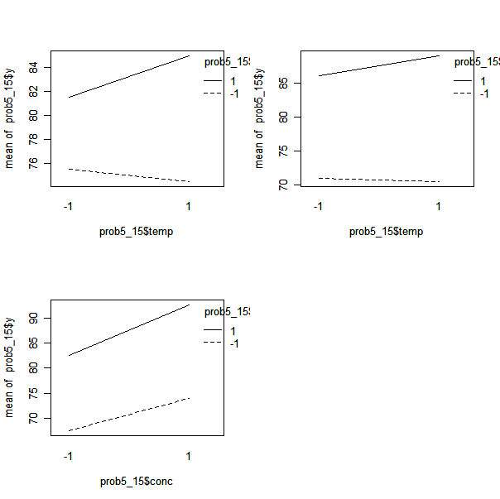

> fit1 = aov(y~factor(temp)*factor(conc)*factor(time), data=prob5_15)
> summary(fit1)
Df Sum Sq Mean Sq F value Pr(>F)
factor(temp) 1 6.25 6.25 0.2551 0.6271225
factor(conc) 1 272.25 272.25 11.1122 0.0103304 *
factor(time) 1 1122.25 1122.25 45.8061 0.0001424 ***
factor(temp):factor(conc) 1 20.25 20.25 0.8265 0.3898448
factor(temp):factor(time) 1 12.25 12.25 0.5000 0.4995759
factor(conc):factor(time) 1 12.25 12.25 0.5000 0.4995759
factor(temp):factor(conc):factor(time) 1 72.25 72.25 2.9490 0.1242610
Residuals 8 196.00 24.50
---
Signif. codes: 0 '***' 0.001 '**' 0.01 '*' 0.05 '.' 0.1 ' ' 1

> model.tables(fit1, type="effects", se=T)
Tables of effects

factor(temp)
factor(temp)
-1 1
-0.625 0.625

factor(conc)
factor(conc)
-1 1
-4.125 4.125

factor(time)
factor(time)
-1 1
-8.375 8.375

factor(temp):factor(conc)
factor(conc)
factor(temp) -1 1
-1 1.125 -1.125
1 -1.125 1.125

factor(temp):factor(time)
factor(time)
factor(temp) -1 1
-1 0.875 -0.875
1 -0.875 0.875

factor(conc):factor(time)
factor(time)
factor(conc) -1 1
-1 0.875 -0.875
1 -0.875 0.875

factor(temp):factor(conc):factor(time)
, , factor(time) = -1

factor(conc)
factor(temp) -1 1
-1 2.125 -2.125
1 -2.125 2.125

, , factor(time) = 1

factor(conc)
factor(temp) -1 1
-1 -2.125 2.125
1 2.125 -2.125

Standard errors of effects
factor(temp) factor(conc) factor(time) factor(temp):factor(conc)
1.750 1.750 1.750 2.475
replic. 8 8 8 4
factor(temp):factor(time) factor(conc):factor(time)
2.475 2.475
replic. 4 4
factor(temp):factor(conc):factor(time)
3.500
replic.

>qqnorm(fit1$fitted)
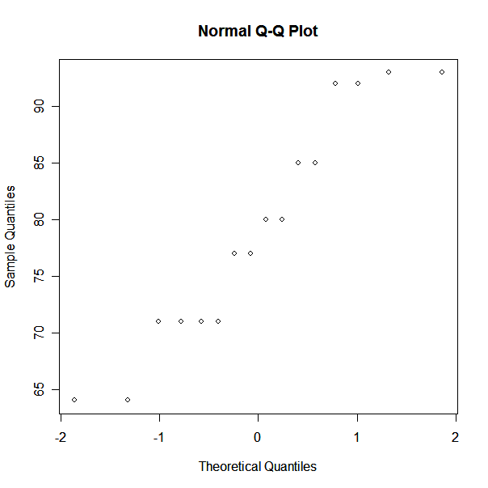

> fit2<-lm(y~factor(conc)+factor(time)+ factor(conc):factor(time),data=prob5_15)
>
> summary(fit2)

Call:
lm(formula = y ~ factor(conc) + factor(time) + factor(conc):factor(time),
data = prob5_15)

Residuals:
Min 1Q Median 3Q Max
-5.50 -2.75 -0.50 0.75 12.50

Coefficients:
Estimate Std. Error t value Pr(>|t|)
(Intercept) 67.500 2.529 26.690 4.7e-12 ***
factor(conc)1 6.500 3.577 1.817 0.09420 .
factor(time)1 15.000 3.577 4.194 0.00125 **
factor(conc)1:factor(time)1 3.500 5.058 0.692 0.50212
---
Signif. codes: 0 '***' 0.001 '**' 0.01 '*' 0.05 '.' 0.1 ' ' 1

Residual standard error: 5.058 on 12 degrees of freedom
Multiple R-Squared: 0.8209, Adjusted R-squared: 0.7761
F-statistic: 18.33 on 3 and 12 DF, p-value: 8.916e-05

>
>
>
> fit3<-lm(y~factor(conc)+factor(time),data=prob5_15)
>
> summary(fit3)

Call:
lm(formula = y ~ factor(conc) + factor(time), data = prob5_15)

Residuals:
Min 1Q Median 3Q Max
-5.875 -2.687 -0.750 1.375 13.375

Coefficients:
Estimate Std. Error t value Pr(>|t|)
(Intercept) 66.625 2.146 31.05 1.40e-13 ***
factor(conc)1 8.250 2.478 3.33 0.00543 **
factor(time)1 16.750 2.478 6.76 1.34e-05 ***
---
Signif. codes: 0 '***' 0.001 '**' 0.01 '*' 0.05 '.' 0.1 ' ' 1

Residual standard error: 4.956 on 13 degrees of freedom
Multiple R-Squared: 0.8137, Adjusted R-squared: 0.7851
F-statistic: 28.39 on 2 and 13 DF, p-value: 1.804e-05

#=================PART a
#The model contains a value that is not compatible with others.
#
#=================PART b
#ANOVA and plots

par(mfrow=c(1,1))
plot(prob5_15$y,fit1$resid)
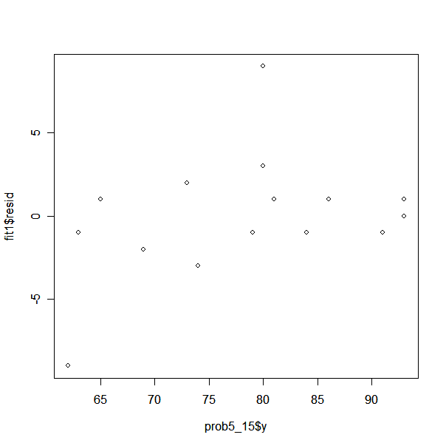
From above, possible points not fitting well in the data are at 62 and 80.

After taking out the data points, I rerun the full model.
> prob5_15_2<-read.table("E:/FSU-FALL07-School/Fall07-school/STA5166/hw5/prb0515_2.dat",header=T)
> prob5_15_2
temp conc time y
1 -1 -1 -1 80
2 1 -1 -1 65
3 -1 1 -1 69
4 1 1 -1 74
5 -1 -1 1 81
6 1 -1 1 84
7 -1 1 1 91
8 1 1 1 93
10 1 -1 -1 63
11 -1 1 -1 73
13 -1 -1 1 79
14 1 -1 1 86
15 -1 1 1 93
16 1 1 1 93
> fit1 = aov(y~factor(temp)*factor(conc)*factor(time), data=prob5_15_2)
> summary(fit1)
Df Sum Sq Mean Sq F value Pr(>F)
factor(temp) 1 4.57 4.57 1.7143 0.2383325
factor(conc) 1 160.10 160.10 60.0357 0.0002429 ***
factor(time) 1 971.52 971.52 364.3214 1.337e-06 ***
factor(temp):factor(conc) 1 22.53 22.53 8.4500 0.0270901 *
factor(temp):factor(time) 1 48.13 48.13 18.0500 0.0053889 **
factor(conc):factor(time) 1 72.20 72.20 27.0750 0.0020083 **
factor(temp):factor(conc):factor(time) 1 105.80 105.80 39.6750 0.0007463 ***
Residuals 6 16.00 2.67
---
Signif. codes: 0 '***' 0.001 '**' 0.01 '*' 0.05 '.' 0.1 ' ' 1

plot(prob5_15_2$y,fit1$resid)
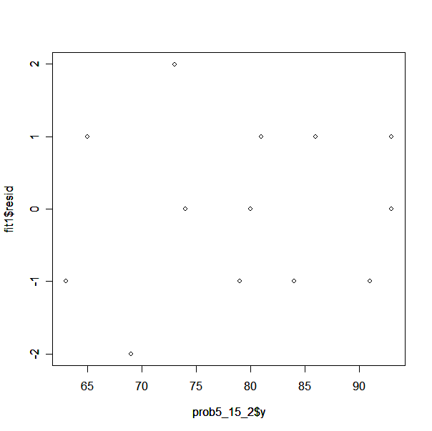
qqnorm(fit1$fitted)
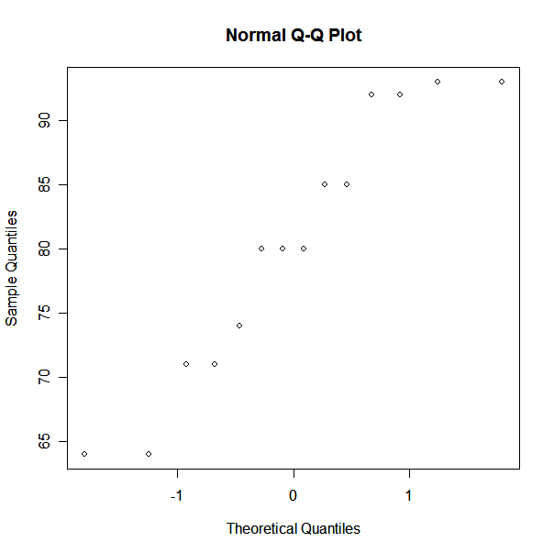

#===============part d
#From ANOVA all three effects produce positive effect on y.

source("C:\\Documents and Settings\\Jaime\\Desktop\\FALL07\\STA5166\\hw1eda1-2.txt")
par(mfrow=c(2,2))
eda1(fit1$fitted)
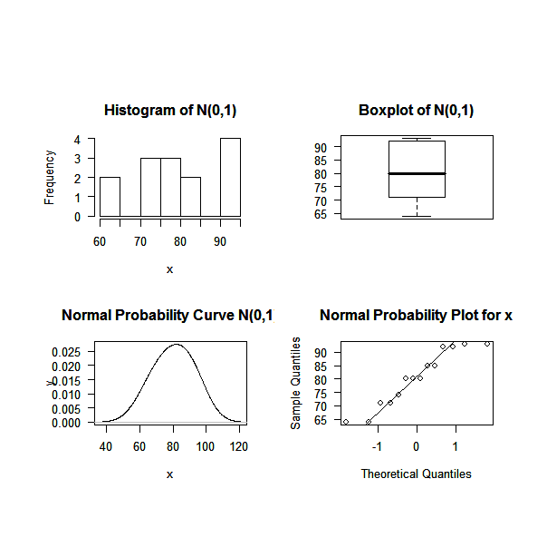

Problem Chapter 6, #13

Interaction term is I = (126)(1237) = 367. This is the defining relation I = 126 = 1237 = 367.

The main effect 1 confounded with other effects, 237, 26, implies I = 26=237=1367, resolution 3.

Alternative plan
I= 12346 and I = 12357
Interaction = 4567
Defining relation I = 12346 = 12357 = 4567, resolution 4
Main effects are not confounded with to term interaction as initial design.

Problem Chapter 6, #16

a) first design contains 2^(5-2) = 8 runs

b)
first design: I = 1234=135
second design generators : I = -1234 = -135 → -3 = 124 = -15

c) Resolution is 3 for second

d) The defining relation of the combined design is I = 245

e) Combined design resolution is 3

f) The second design has less confounding than first. The initial result showed factor 3 was confounded with 15 2-factor interaction. The combined design allows factor 3 to be estimated without confounding.

