Problem 2.7

Data: Regression through the orgin.

2.7.1 (see attached for computations by hand)

2.7.2 (see attached for computations by hand)

2.7.3 Snake River data (Output is calculated in R and see attached for computations by hand)

> install.packages("alr3")
> library(alr3)
> data(snake)
> names(snake)
[1] "X" "Y"
> attach(snake)

> fit2 = lm(Y ~ X-1)
> fit2

Call:
lm(formula = Y ~ X - 1)

Coefficients:
X
0.5204

> summary(fit2)

Call:
lm(formula = Y ~ X - 1)

Residuals:
Min 1Q Median 3Q Max
-2.4207 -1.4924 -0.1935 1.6515 3.0771

Coefficients:
Estimate Std. Error t value Pr(>|t|)
X 0.52039 0.01318 39.48 <2e-16 ***

Signif. codes: 0 ‘***’ 0.001 ‘**’ 0.01 ‘*’ 0.05 ‘.’ 0.1 ‘ ’ 1

Residual standard error: 1.7 on 16 degrees of freedom
Multiple R-Squared: 0.9898, Adjusted R-squared: 0.9892
F-statistic: 1559 on 1 and 16 DF, p-value: < 2.2e-16

> sigma_sqhat = 1.7^2

> sigma_sqhat
[1] 2.89

> confint(fit2, level = 0.95)
2.5 % 97.5 %
X 0.492451 0.548337

> #beta1hat = 0.520394
> #sigma_sqhat = 2.89
>

2.7.4

>
> fit1 = lm(Y ~ X)
> fit1

Call:
lm(formula = Y ~ X)

Coefficients:
(Intercept) X
0.7254 0.4981

> summary(fit1)

Call:
lm(formula = Y ~ X)

Residuals:
Min 1Q Median 3Q Max
-2.1793 -1.5149 -0.3624 1.6276 3.1973

Coefficients:
Estimate Std. Error t value Pr(>|t|)
(Intercept) 0.72538 1.54882 0.468 0.646
X 0.49808 0.04952 10.058 4.63e-08 ***
---
Signif. codes: 0 ‘***’ 0.001 ‘**’ 0.01 ‘*’ 0.05 ‘.’ 0.1 ‘ ’ 1

Residual standard error: 1.743 on 15 degrees of freedom
Multiple R-Squared: 0.8709, Adjusted R-squared: 0.8623
F-statistic: 101.2 on 1 and 15 DF, p-value: 4.632e-08

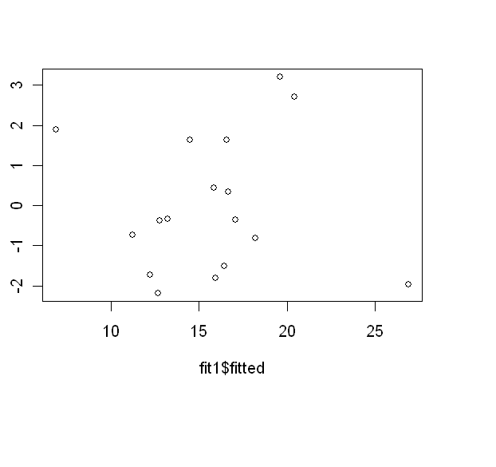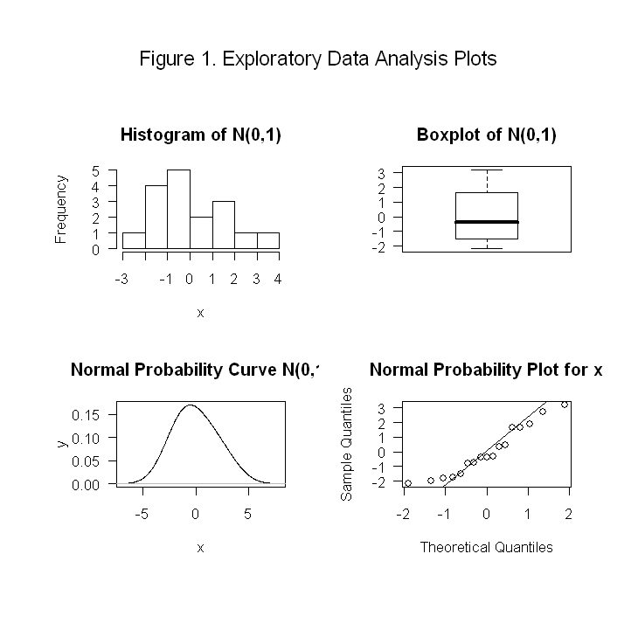

Without the intercept:
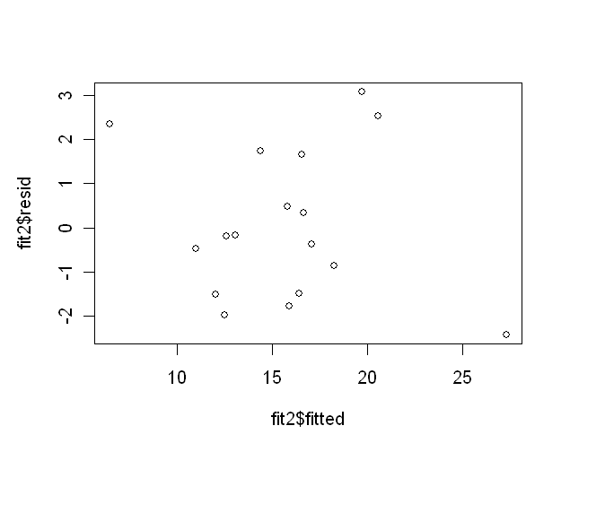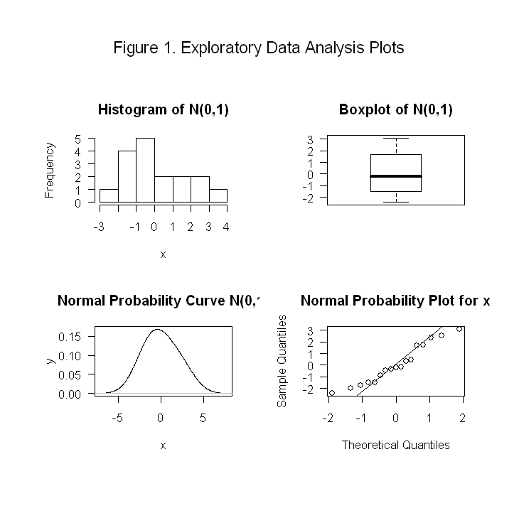

2.7 (R CODE)

install.packages("alr3")
library(alr3)
data(snake)
names(snake)
attach(snake)
fit2 = lm(Y ~ X-1)
fit2
summary(fit2)
sigma_sqhat = 1.7^2
sigma_sqhat
confint(fit2, level = 0.95)
#beta1hat = 0.520394
#sigma_sqhat = 2.89
fit1 = lm(Y ~ X)
fit1
summary(fit1)
#SOURCE EDA1TEXT
par(mfrow=c(1,1))
plot(fit1$fitted,fit1$resid)
par(mfrow=c(2,2))
eda1(fit1$resid)
par(mfrow=c(1,1))
plot(fit2$fitted,fit2$resid)
par(mfrow=c(2,2))
eda1(fit2$resid)

