Problem 2.1

Data: Height and Weight data.
2.1.1

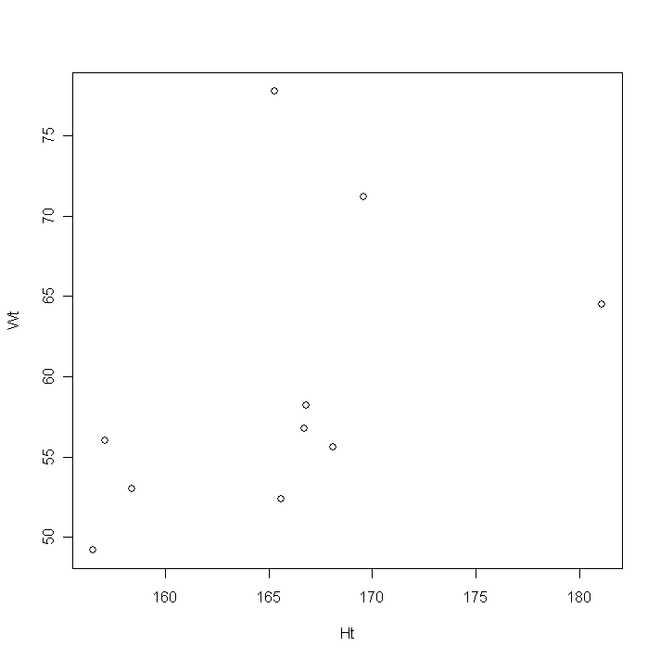

Comment: For this model, with the exception of one outlier, a simple linear regression model would make sense. Removal of one or two data points, may improve fit. Seems to be an increasing positive relationship between the variables.

One would expect, the taller a person is the more the individual weighed, on average.

2.1.2 (Output from R and see attached for computations by hand)

> mean(hw2prob2_1) > var(hw2prob2_1)*9
Ht Wt Ht Wt
165.52 59.47 Ht 472.076 274.786
Wt 274.786 731.961
> fit1 = lm(Wt~Ht, data = hw2prob2_1)
> coefficients(fit1)
(Intercept) Ht
-36.87588 0.58208

> plot(Ht, Wt)
> abline(fit1)
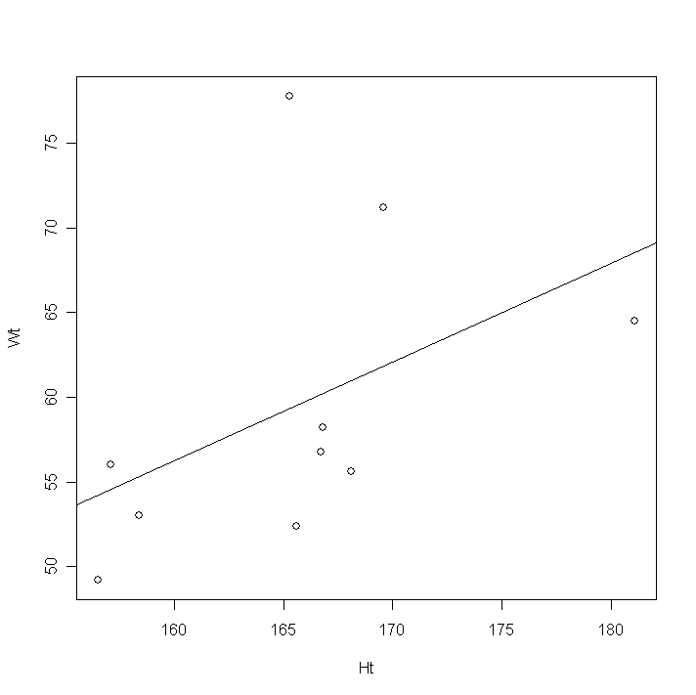
2.1.3 (Output from R and see attached for computations by hand)

> aov(fit1)
Call:
aov(formula = fit1)

Terms:
Ht Residuals
Sum of Squares 159.9474 572.0136
Deg. of Freedom 1 8

Residual standard error: 8.455868
Estimated effects may be unbalanced

> sigma = 572.0136/8
> sigma
[1] 71.5017

> summary(fit1)

Call:
lm(formula = Wt ~ Ht, data = hw2prob2_1)

Coefficients:
Estimate Std. Error t value Pr(>|t|)
(Intercept) -36.8759 64.4728 -0.572 0.583
Ht 0.5821 0.3892 1.496 0.173

Residual standard error: 8.456 on 8 degrees of freedom
Multiple R-Squared: 0.2185, Adjusted R-squared: 0.1208
F-statistic: 2.237 on 1 and 8 DF, p-value: 0.1731

> vcov(fit1)
(Intercept) Ht
(Intercept) 4156.74194 -25.0700325
Ht -25.07003 0.151462

2.1.4 (Output from R and see attached for computations by hand)

> anova(fit1)
Analysis of Variance Table

Response: Wt
Df Sum Sq Mean Sq F value Pr(>F)
Ht 1 159.95 159.95 2.237 0.1731
Residuals 8 572.01 71.50

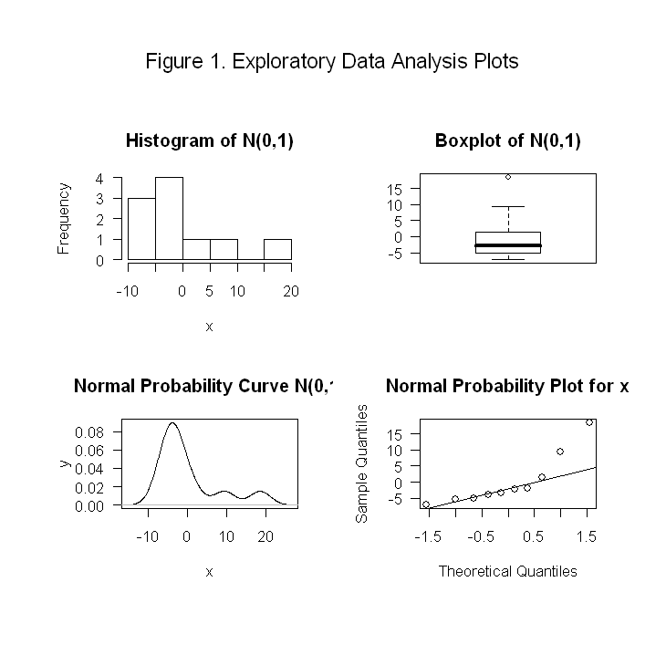

2.1 (R CODE)

hw2prob2_1 = read.table("E:\\FSU-school\\statapp2\\hw2_1.txt", header = TRUE)
attach(hw2prob2_1)
#parta
layout(matrix(c(1,1),2,2))
plot(Ht, Wt)
#partb
mean(hw2prob2_1)
var(hw2prob2_1)*9
fit1 = lm(Wt~Ht, data = hw2prob2_1)
coefficients(fit1)
plot(Ht, Wt)
abline(fit1)
#partc
aov(fit1)
sigma = 572.0136/8
sigma
summary(fit1)
vcov(fit1)
#partd
anova(fit1)

#source EDA
x1<-rnorm(1000,0,1)

eda1<-function(x){par(mfrow=c(2,2), oma=c(4,2,6,2), mar=c(5,5,4,2), hist(x,las=1, main = "Histogram of N(0,1)"),
boxplot(x,las=1, main = "Boxplot of N(0,1)"),iqr<-summary(x)[5]-summary(x)[2],
plot(density(x, width=2*iqr), xlab="x",ylab="y", type="l", las=1, main="Normal Probability Curve N(0,1)"),
qqnorm(x,las=1, main="Normal Probability Plot for x" ),qqline(x),par(mfrow=c(2,2),oma=c(4,2,6,2),mar=c(5,5,4,2)),
mtext(side=3,line=2,cex=1.2,outer=T, "Figure 1. Exploratory Data Analysis Plots" ))}

eda1(fit1$resid)

