Problem 5.1.1

Scatter plot for data Progeny Vs. Parent
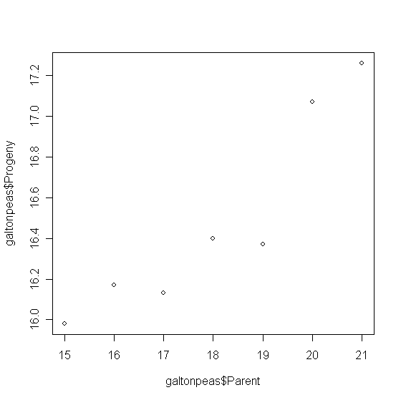

Comment:
From the scatter plot there seems to be positively correlated.

CODE: (R-Code)
#install.packages("alr3")
library(alr3)
data(galtonpeas)
attributes(galtonpeas)
plot(galtonpeas$Parent, galtonpeas$Progeny)

Problem 5.1.2

Fitting a weighted regression of Progeny on the Parent

Call:
lm(formula = Progeny ~ Parent, data = galtonpeas, weights = 1/(SD *
SD))

Residuals:
1 2 3 4 5 6 7
0.08187 0.09162 -0.16753 -0.04067 -0.08950 0.06071 0.06328

Coefficients:
Estimate Std. Error t value Pr(>|t|)
(Intercept) 12.79642 0.68112 18.787 7.87e-06 ***
Parent 0.20480 0.03815 5.368 0.00302 **
---
Signif. codes: 0 ‘***’ 0.001 ‘**’ 0.01 ‘*’ 0.05 ‘.’ 0.1 ‘ ’ 1

Residual standard error: 0.11 on 5 degrees of freedom
Multiple R-squared: 0.8521, Adjusted R-squared: 0.8225
F-statistic: 28.81 on 1 and 5 DF, p-value: 0.003021

Draw the fitted mean function
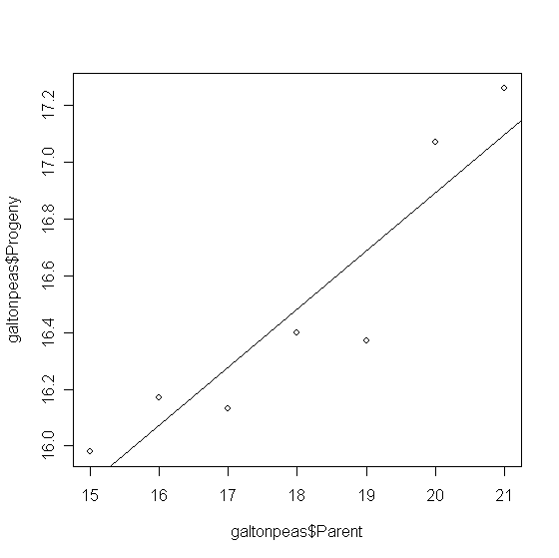

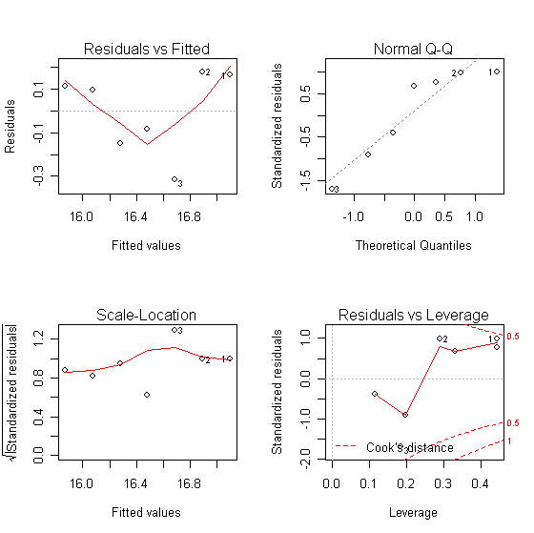

Comments: From above we have determined the weighted regression model.

CODE: (R-Code)
fit1 = lm(Progeny~Parent, galtonpeas,weights=1/(SD*SD))
summary(fit1)
plot(galtonpeas$Parent, galtonpeas$Progeny)
abline(fit1)
par(mfrow=c(2,2))
plot(fit1)

Problem 5.1.3

Testing β₁ = 1 versus β₁ < 1
From the null hypothesis, y – x = β₀ + error
Using a t-test
t = (0.2048 -1) / 0.03815 = -20.84403

The p-value is close to zero. The null hypothesis is rejected. Thus, we conclude the β₁ is less than one, which will suggest that the offspring are “reverting” toward what may be roughly and perhaps failry described as the average ancestral type.

Call:
lm(formula = Progenynew ~ +1, data = galtonpeasnew, weights = 1/(galtonpeas$SD *
galtonpeas$SD))

Residuals:
Min 1Q Median 3Q Max
-1.2216 -0.7653 -0.1416 0.5982 1.2998

Coefficients:
Estimate Std. Error t value Pr(>|t|)
(Intercept) -1.3115 0.6467 -2.028 0.0889 .
---
Signif. codes: 0 ‘***’ 0.001 ‘**’ 0.01 ‘*’ 0.05 ‘.’ 0.1 ‘ ’ 1
Residual standard error: 0.9414 on 6 degrees of freedom

RSS1 = 0.061 with DF1 = 5 and from anova of model above, RSS2 = 5.3179, with DF2 = 6

Now, with (RSS2 – RSS1)/(DF2 – DF1) / (RSS2/DF2) = 434.45 > F (1,5) . So reject the null hypothesis a

CODE: (R-Code)
Progenynew = galtonpeas$Progeny-galtonpeas$Parent
galtonpeasnew = data.frame(cbind(Progenynew , galtonpeas$Parent, galtonpeas$SD))
galtonpeas$SD
fit2 = lm(Progenynew ~+1, galtonpeasnew ,weights=1/(galtonpeas$SD*galtonpeas$SD))
summary(fit2)
anova(fit2)

