Problem 5.5.1

Draw Scatter plot matrix
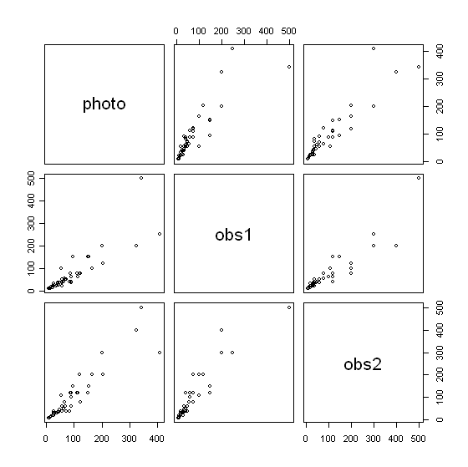

Comment:
From the scatter plot there seems to be
-high linear relationship between “photo vs obs1,” “photo vs obs2,” and “obs1 vs obs2”
-Obs1 and Obs2 have a high linear relationship which may suggest that the linear regression model might be appropriate for the regression of Photo on either one of the observer counts.

For simple regression model of Photo on Obs1, the error measures the count error of observer one.

In this problem, want to find out the linear relationship between the exact number of birds and the observations. The Photo gives the exact number of the snow geese. So it is appropriate to fit the regression of Photo on Obs1 rather than the regression of Obs1 on Photo.

CODE: (R-Code)
#install.packages("alr3")
library(alr3)
data(snowgeese)
attributes(snowgeese)
pairs(snowgeese)
Problem 5.5.2

Fitting a regression of Photo on obs1

Call:
lm(formula = photo ~ obs1, data = snowgeese)

Residuals:
Min 1Q Median 3Q Max
-125.928 -18.713 -9.033 11.699 161.711

Coefficients:
Estimate Std. Error t value Pr(>|t|)
(Intercept) 26.64957 8.61448 3.094 0.00347 **
obs1 0.88256 0.07764 11.367 1.54e-14 ***
---
Signif. codes: 0 ‘***’ 0.001 ‘**’ 0.01 ‘*’ 0.05 ‘.’ 0.1 ‘ ’ 1

Residual standard error: 44.41 on 43 degrees of freedom
Multiple R-squared: 0.7503, Adjusted R-squared: 0.7445
F-statistic: 129.2 on 1 and 43 DF, p-value: 1.537e-14

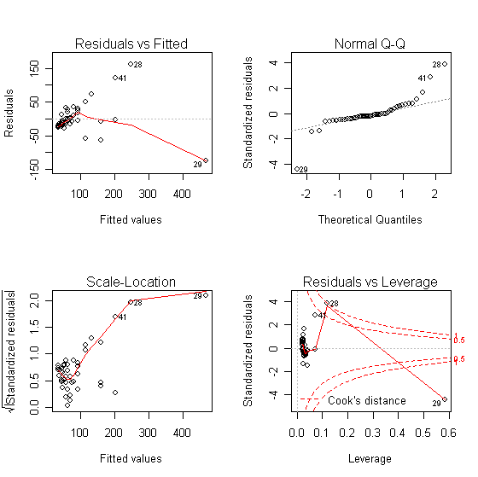

Testing

H₀: E(Y|X=x) = X (1)
H_{A}: E(Y|X=x) = β₀ + β₁ X (2)

Compute the RSS₁ = 104390 with df(1) = 45

RSS₂ = 84806.67 with df(2) = 43

Using F-test,
F= [(RSS₁- RSS₂)/ (45-43) ] / (RSS₂/43) = 4.96 > F_{0.05, 2,43}

Reject H₀ and conclude that reduced model is not adequate. The observer is not reliable. Reliable means that we can use the observer one’s counting as the actual number of the snow geese. In the null hypothesis, it can be interpreted as the photo method is similar to the old observation. The alternative has both outcomes are linearly correlated but one is consistently different (improve or not improve) than the other.

CODE: (R-Code)
fit1 = lm(photo~obs1, snowgeese)
summary(fit1)
par(mfrow=c(2,2))
plot(fit1)

Problem 5.5.3

Regression of the square root of Photo on square root of obs1

Call:
lm(formula = sqrt(photo) ~ sqrt(obs1), data = snowgeese)

Residuals:
Min 1Q Median 3Q Max
-3.9532 -0.7922 -0.1478 0.8080 3.8801

Coefficients:
Estimate Std. Error t value Pr(>|t|)
(Intercept) 1.61030 0.53529 3.008 0.00438 **
sqrt(obs1) 0.93182 0.06353 14.668 < 2e-16 ***
---
Signif. codes: 0 ‘***’ 0.001 ‘**’ 0.01 ‘*’ 0.05 ‘.’ 0.1 ‘ ’ 1

Residual standard error: 1.632 on 43 degrees of freedom
Multiple R-squared: 0.8334, Adjusted R-squared: 0.8296
F-statistic: 215.2 on 1 and 43 DF, p-value: < 2.2e-16

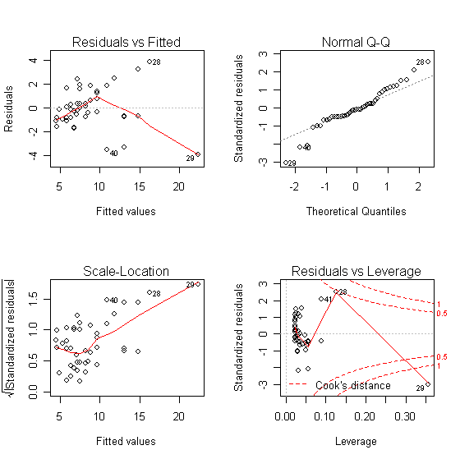

Testing

H₀: E(sqrt(Y)|sqrt(X)=x) = X (1)
H_{A}: E(sqrt(Y)|sqrt(X)=x) = β₀ + β₁ X (2)

Compute the RSS₁ = 171.8383 with df(1) = 45

RSS₂ = 114.52 with df(2) = 43

Using F-test,
F= [(RSS₁- RSS₂)/ (45-43) ] / (RSS₂/43) = 10.76 > F_{0.05, 2,43}

Reject H₀ and conclude that reduced model is not adequate. Interpretation of hypothesis are similar to previous, however, there is a transformation here. R-squared is better in this model than the previous and the normality plots assumptions seem to improve. The error from the variance has been significantly decreased.

CODE: (R-Code)
fit2 = lm(sqrt(photo)~sqrt(obs1), snowgeese)
summary(fit2)
par(mfrow=c(2,2))
plot(fit2)

Problem 5.5.4
Call:
lm(formula = photo ~ obs1, data = snowgeese, weights = 1/obs1)

Residuals:
Min 1Q Median 3Q Max
-10.3418 -2.1016 -0.1185 1.8679 7.4482

Coefficients:
Estimate Std. Error t value Pr(>|t|)
(Intercept) 9.21872 4.29810 2.145 0.0377 *
obs1 1.12806 0.09015 12.514 6.3e-16 ***
---
Signif. codes: 0 ‘***’ 0.001 ‘**’ 0.01 ‘*’ 0.05 ‘.’ 0.1 ‘ ’ 1

Residual standard error: 3.776 on 43 degrees of freedom
Multiple R-squared: 0.7846, Adjusted R-squared: 0.7796
F-statistic: 156.6 on 1 and 43 DF, p-value: 6.297e-16

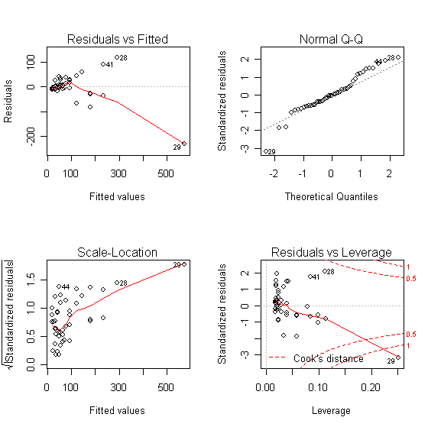

Testing

H₀: E(Y|X=x) = X (1)
H_{A}: E(Y|X=x) = β₀ + β₁ X (2)

Compute the RSS₁ = ∑(y_{i} – x_{i}) = 104390 with df(1) = 45

RSS₂ = 613.1 with df(2) = 43

Using F-test,
F= [(RSS₁- RSS₂)/ (45-43) ] / (RSS₂/43) = 3639.2 > F_{0.05, 2,43}

Reject H₀ and conclude that reduced model is not adequate. The reduced model is very bad for description of the problem. From previous problems, the RSS is decreasing and the F-statistic is becoming larger, showing more accuracy in results.

CODE: (R-Code)
fit3 = lm(photo~obs1,weights=1/obs1, snowgeese)
summary(fit3)
par(mfrow=c(2,2))
plot(fit3)

Problem 5.5.5
Apply OLS of average and difference of obs1 and obs2

Call:
lm(formula = photo ~ avg + diff, data = snowgeese)

Residuals:
Min 1Q Median 3Q Max
-69.917 -12.196 -1.831 8.239 159.884

Coefficients:
Estimate Std. Error t value Pr(>|t|)
(Intercept) 16.2227 6.8833 2.357 0.0232 *
avg 0.7914 0.0619 12.784 4.54e-16 ***
diff -0.3052 0.1378 -2.214 0.0323 *
---
Signif. codes: 0 ‘***’ 0.001 ‘**’ 0.01 ‘*’ 0.05 ‘.’ 0.1 ‘ ’ 1

Residual standard error: 34.13 on 42 degrees of freedom
Multiple R-squared: 0.8559, Adjusted R-squared: 0.849
F-statistic: 124.7 on 2 and 42 DF, p-value: < 2.2e-16

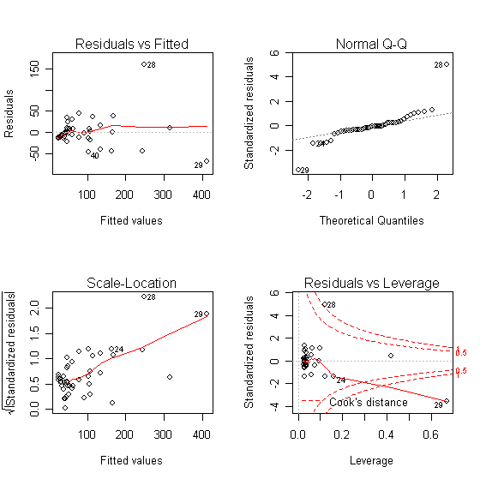

Testing

H₀: E(Y|X=x) = Average (1)
H_{A}: E(Y|X=x) = β₀ + β₁ avg + β₂ diff (2)

Compute the RSS₁ = 64532.75 with df(1) = 45

RSS₂ = 48924 with df(2) = 42

Using F-test,
F= 4.467 > F_{0.05, 2,42}

Reject H₀

CODE: (R-Code)
snowgeese$avg = (snowgeese$obs1+snowgeese$obs2)/2
snowgeese$diff = (snowgeese$obs1-snowgeese$obs2)

fit4 = lm(photo~avg+diff,snowgeese)
summary(fit4)
par(mfrow=c(2,2))
plot(fit4)

Apply WLS, using 1/average as weights

Call:
lm(formula = photo ~ avg + diff, data = snowgeese, weights = 1/avg)

Residuals:
Min 1Q Median 3Q Max
-5.9953 -1.3944 0.1673 1.2159 8.2148

Coefficients:
Estimate Std. Error t value Pr(>|t|)
(Intercept) 8.0352 3.3979 2.365 0.0227 *
avg 0.9361 0.0775 12.079 2.99e-15 ***
diff -0.1465 0.1486 -0.986 0.3299
---
Signif. codes: 0 ‘***’ 0.001 ‘**’ 0.01 ‘*’ 0.05 ‘.’ 0.1 ‘ ’ 1

Residual standard error: 2.825 on 42 degrees of freedom
Multiple R-squared: 0.8587, Adjusted R-squared: 0.852
F-statistic: 127.7 on 2 and 42 DF, p-value: < 2.2e-16

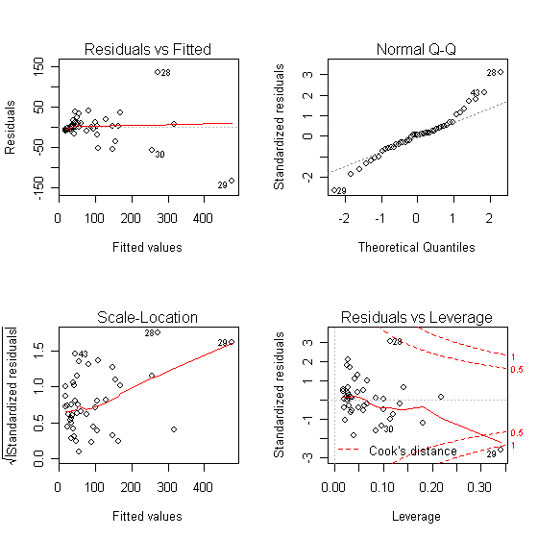

Comments

Testing

H₀: E(Y|X=x) = Average (1)
H_{A}: E(Y|X=x) = β₀ + β₁ avg + β₂ diff (2)

Compute the RSS₁ = 64532.75 with df(1) = 45

RSS₂ = 335.2 with df(2) = 42

Using F-test,
F= 2681 > F_{0.05, 2,42}

Reject H₀

Final comments:

From both tests above, both null hypotheses get rejected. Therefore, the model based on the combined predictor is not adequate to describe the problem. Even the combined observation of the two observers is not reliable for an estimate for the actual number of snowgeese.

Running several combinations of models illustrated that regressing photo on both observations did not improve significantly than just regression on observation2. Using the average and difference also did not show significant improve as both observations.

CODE: (R-Code)
fit6 = lm(photo~avg+diff, weights=1/avg, snowgeese)
summary(fit6)
plot(fit6)

