Problem 4.10.1

Scatter plot for data excluding Year
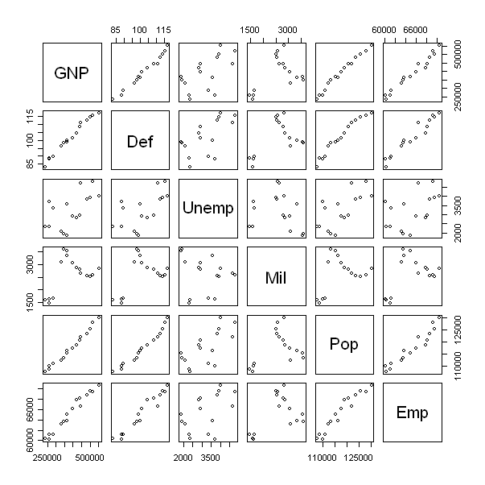
Comment:
From the scatter plot there seems to be highly positive correlated relationship between the variables.
The variables “Pop” vs. “GNP” and “Pop” vs. “Def” illustrate this. There may exist some numerical problems of regression programs.

CODE: (R-Code)
#install.packages("alr3")
library(alr3)
data(longley)
attributes(longley)
pairs(longley[,c(1,2,3,4,5,7)])

Problem 4.10.2

Fitting a regression of Employed on the others excluding Year

Call:
lm(formula = Emp ~ GNP + Def + Unemp + Mil + Pop, data = longley)

Residuals:
Min 1Q Median 3Q Max
-553.24 -364.78 61.06 205.50 933.59

Coefficients:
Estimate Std. Error t value Pr(>|t|)
(Intercept) 9.246e+04 3.517e+04 2.629 0.0252 *
GNP 7.200e-02 3.173e-02 2.269 0.0467 *
Def -4.846e+01 1.322e+02 -0.366 0.7217
Unemp -4.039e-01 4.385e-01 -0.921 0.3788
Mil -5.605e-01 2.838e-01 -1.975 0.0765 .
Pop -4.035e-01 3.303e-01 -1.222 0.2498
---
Signif. codes: 0 ‘***’ 0.001 ‘**’ 0.01 ‘*’ 0.05 ‘.’ 0.1 ‘ ’ 1

Residual standard error: 483.2 on 10 degrees of freedom
Multiple R-squared: 0.9874, Adjusted R-squared: 0.9811
F-statistic: 156.4 on 5 and 10 DF, p-value: 3.699e-09

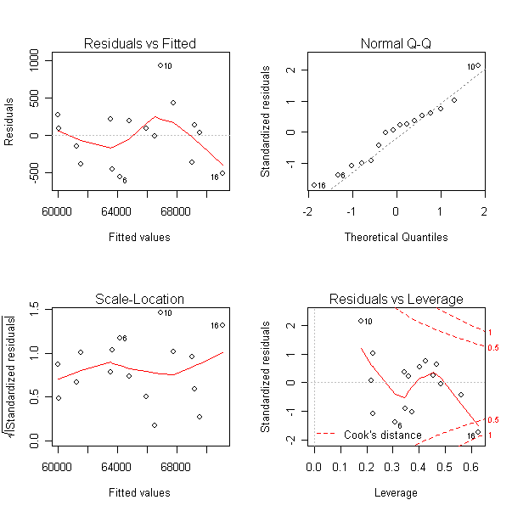

Comments: Evidence to reject that the coefficient of GNP is different than zero, but no the other hypothesis. The coefficient may be zero. The residual plots show some deviation from normality assumptions.

Model 2
Call:
lm(formula = Emp ~ GNP + Unemp, data = longley)

Residuals:
Min 1Q Median 3Q Max
-823.54 -256.36 -10.58 215.17 1146.89

Coefficients:
Estimate Std. Error t value Pr(>|t|)
(Intercept) 5.238e+04 5.735e+02 91.330 < 2e-16 ***
GNP 3.784e-02 1.711e-03 22.120 1.06e-11 ***
Unemp -5.436e-01 1.820e-01 -2.987 0.0105 *
---
Signif. codes: 0 ‘***’ 0.001 ‘**’ 0.01 ‘*’ 0.05 ‘.’ 0.1 ‘ ’ 1

Residual standard error: 524.7 on 13 degrees of freedom
Multiple R-squared: 0.9807, Adjusted R-squared: 0.9777
F-statistic: 329.5 on 2 and 13 DF, p-value: 7.29e-12

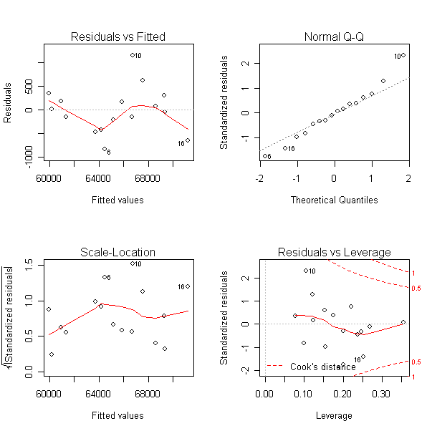

Comments:

Refit the line we different smaller variables. This was not required from the problem, however, Niu asked us to find a better fit with less variables. This fit has a higher Rsquared and normality assumptions seem to hold better than previous.

CODE: (R-Code)
fit1 = lm(Emp~GNP+Def+Unemp+Mil+Pop, data=longley)
summary(fit1)
par(mfrow=c(2,2))
plot(fit1)

fit4 = lm(Emp~GNP+Unemp, data=longley)
summary(fit4)
par(mfrow=c(2,2))
plot(fit4)

Problem 4.10.3

Used bootstrap by adding random variance on original data and formed a new data set.

[1] "Fitted summary of original trail"

Call:
lm(formula = Emp ~ GNP + Def + Unemp + Mil + Pop, data = original_data)

Residuals:
Min 1Q Median 3Q Max
-553.24 -364.78 61.06 205.50 933.59

Coefficients:
Estimate Std. Error t value Pr(>|t|)
(Intercept) 9.246e+04 3.517e+04 2.629 0.0252 *
GNP 7.200e-02 3.173e-02 2.269 0.0467 *
Def -4.846e+01 1.322e+02 -0.366 0.7217
Unemp -4.039e-01 4.385e-01 -0.921 0.3788
Mil -5.605e-01 2.838e-01 -1.975 0.0765 .
Pop -4.035e-01 3.303e-01 -1.222 0.2498
---
Signif. codes: 0 ‘***’ 0.001 ‘**’ 0.01 ‘*’ 0.05 ‘.’ 0.1 ‘ ’ 1

Residual standard error: 483.2 on 10 degrees of freedom
Multiple R-squared: 0.9874, Adjusted R-squared: 0.9811
F-statistic: 156.4 on 5 and 10 DF, p-value: 3.699e-09

Comments
From the function, obtain the following standard deviation of the coefficient estimates from the simulation. The standard deviations from the regression were given above, bolded. Since the standard deviations seem to be not as large or significantly different than the standard errors, not enough evidence that rounding would have important change.
[1] "Standard deviation of new data:"

(Intercept) GNP Def Unemp Mil
1.726088e+04 1.551637e-02 6.478070e+01 1.890745e-01 1.115003e-01

Pop
1.636748e-01

CODE: (R-Code)
source("C:\\Documents and Settings\\Jaime Frade\\Desktop\\HW4\\btstrp_4.10.txt")
btstrp_4.10(longley)

SOURCE code
btstrp_4.10 = function(original_data){

fit_original = lm(Emp~GNP+Def+Unemp+Mil+Pop, original_data);
print("Fitted summary of original trail");
print(summary(fit_original));

coef1 = NULL;

for (i in 1:1000){
GNP = original_data$GNP + runif(16, -500,500);
Pop = original_data$Pop + runif(16, -500,500);
Def_1 = original_data$Def[1:7]+runif(7,-0.5,0.5);
Def_2 = original_data$Def[8:16]+runif(9,-5,5);
Def = c(Def_1, Def_2);
Unemp = original_data$Unemp+runif(16,-5,5);
Mil = original_data$Mil+runif(16,-5,5);
Emp = original_data$Emp+runif(16,-50,50);

new_Data = data.frame(cbind(GNP, Pop, Def, Unemp, Mil, Emp));
temp_fit = lm(Emp~GNP+Def+Unemp+Mil+Pop, new_Data);
coef1 = cbind(coef1, temp_fit$coef);
}

print("Standard deviation of new data:");
apply(coef1, 1,sd);
}

