Calculation of confidence interval from original observation

fit lwr upr
[1,] 8.755197 8.609724 8.90067

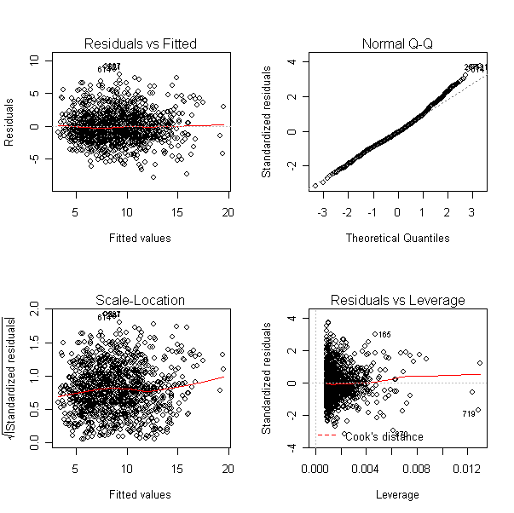

Used bootstrapping method to give the following confidence interval. Used a function that was sourced in R, and is listed in code below

2.5% 50% 97.5%
8.801703 9.013620 9.229341

CODE: (R-Code)
install.packages("alr3")
library(alr3)
data(wm1)
attributes(wm1)
fit1 = lm(CSpd~RSpd, data=wm1)
x1 = data.frame(RSpd = 7.4285)
predict(fit1, x1, interval="confidence")
par(mfrow=c(2,2))
plot(fit1)

SOURCE (R-code)
btstrp_4.6 = function(original_data){
total = length(original_data[,1]);
c1 = 1:total;
meanCSpd = NULL;

for(i in 1:999){
data_num = sample(c1,replace=T);
rearrange_data = original_data[data_num,];
temp_meanCSpd = mean(rearrange_data$CSpd);
meanCSpd = rbind(meanCSpd,temp_meanCSpd);
}

p1 = c(0.025,0.5, 0.975);
quantile(meanCSpd,p1);
}

