Problem 6.9.1

> MSE_long
[1] 1.527674

> MSE_short
[1] 0.8449973

As above, the mean square is 1.5276 for the long shoots and mean square is 0.845 or the short shoots. Th result shows the the estimate for the variance for shoots is nearly double the estimate of the variance for short shoots.

Variance test.
H₀: Variances for long and short shoots are equal.
H_{a}: Variances for long and short shoots are not equal.

> sum(longshoots$n-1)
[1] 167
> n1 = sum(longshoots$n-1)
> sum(shortshoots$n-1)
[1] 292
> n2 = sum(shortshoots$n-1)
> MSE_long/MSE_short
[1] 1.807904
> a = MSE_long/MSE_short
> 1-pf(a, n1, n2)
[1] 5.148344e-06
>

F = MSE_long/MSE_short = 1.8079 ~ F (167, 292)
Since the P-value is very small, reject the null hypothesis and conclude the variances are not equal

The pool estimate of the variance is
> #pool estimate
> ((n1-2)*MSE_long + (n2-2)*MSE_short)/(n1+n2-4)
[1] 1.092561

CODE: (R-Code)
library(alr3)
data(allshoots)
attributes(allshoots)
data(longshoots)
attributes(longshoots)
data(shortshoots)
attributes(shortshoots)

PE_long = (longshoots$n-1)*longshoots$SD^2
MSE_long = sum(PE_long)/sum(longshoots$n-1)
PE_short = (shortshoots$n-1)*shortshoots$SD^2
MSE_short = sum(PE_short)/sum(shortshoots$n-1)
MSE_long

MSE_short

sum(longshoots$n-1)
n1 = sum(longshoots$n-1)
sum(shortshoots$n-1)
n2 = sum(shortshoots$n-1)
MSE_long/MSE_short
a = MSE_long/MSE_short
1-pf(a, n1, n2)

#pool estimate
((n1-2)*MSE_long + (n2-2)*MSE_short)/(n1+n2-4)

Problem 6.9.2

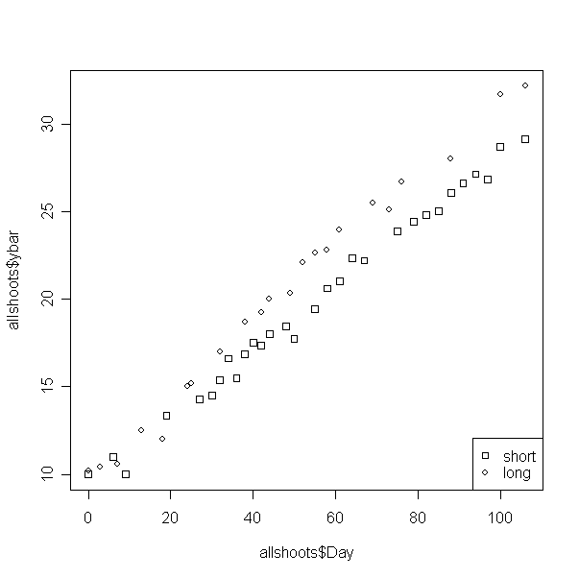

Comment:
From this plot we can that the the striaght-line mean functions are plausiable for both short and long shorts. Yet the two types of shoots are different.

CODE: (R-Code)

plot(allshoots$Day, allshoots$ybar, pch=allshoots$Type)
ex12 <- expression("short", "long")
utils::str(legend("bottomright", ex12, pch=22:1))

Problem 6.9.3

Model 1
> fit1 = lm(ybar~U1 + U2 + Z1 + Z2-1, weight= weights, allshoots_2)
> summary(fit1)

Call:
lm(formula = ybar ~ U1 + U2 + Z1 + Z2 - 1, data = allshoots_2,
weights = weights)

Residuals:
Min 1Q Median 3Q Max
-4.2703 -1.1737 0.1956 1.2911 4.6946

Coefficients:
Estimate Std. Error t value Pr(>|t|)
U1 9.973754 0.328298 30.38 <2e-16 ***
U2 9.488374 0.202988 46.74 <2e-16 ***
Z1 0.217330 0.005577 38.97 <2e-16 ***
Z2 0.187258 0.002965 63.15 <2e-16 ***
---
Signif. codes: 0 ‘***’ 0.001 ‘**’ 0.01 ‘*’ 0.05 ‘.’ 0.1 ‘ ’ 1

Residual standard error: 2.015 on 48 degrees of freedom
Multiple R-squared: 0.9995, Adjusted R-squared: 0.9995
F-statistic: 2.469e+04 on 4 and 48 DF, p-value: < 2.2e-16

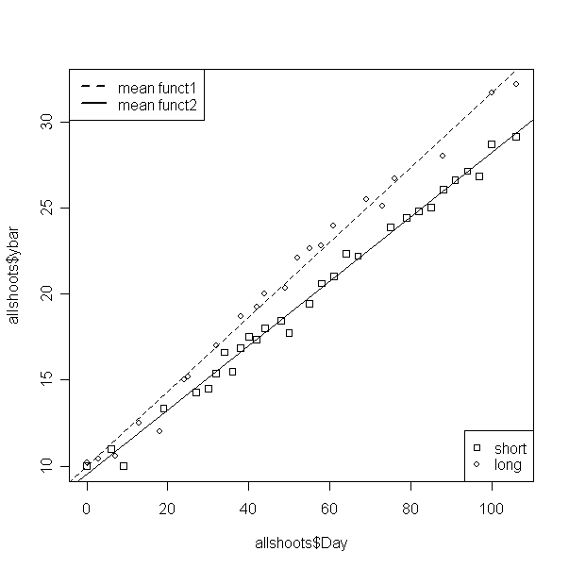
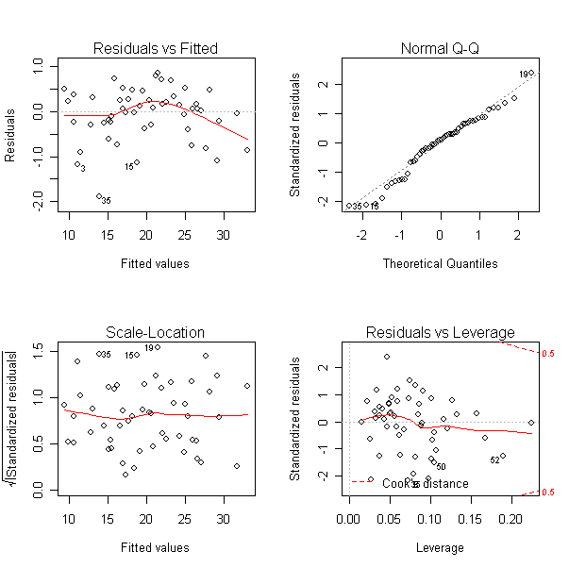

Model 2
> fit2 = lm(ybar~Z1 + Z2, weight= weights, allshoots_2)
> summary(fit2)

Call:
lm(formula = ybar ~ Z1 + Z2, data = allshoots_2, weights = weights)

Residuals:
Min 1Q Median 3Q Max
-4.4349 -1.0027 0.3431 1.1978 4.5920

Coefficients:
Estimate Std. Error t value Pr(>|t|)
(Intercept) 9.622614 0.173672 55.41 <2e-16 ***
Z1 0.222668 0.003639 61.19 <2e-16 ***
Z2 0.185453 0.002610 71.05 <2e-16 ***
---
Signif. codes: 0 ‘***’ 0.001 ‘**’ 0.01 ‘*’ 0.05 ‘.’ 0.1 ‘ ’ 1

Residual standard error: 2.027 on 49 degrees of freedom
Multiple R-squared: 0.9911, Adjusted R-squared: 0.9907
F-statistic: 2721 on 2 and 49 DF, p-value: < 2.2e-16
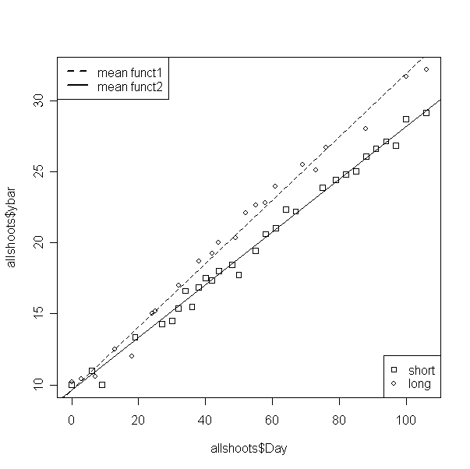

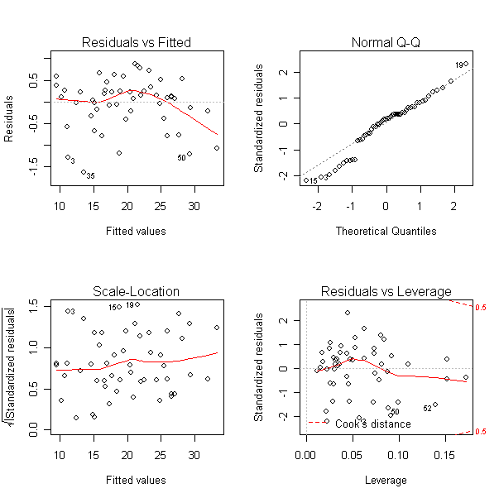

Model 3
> fit3 = lm(ybar~Day, weight= weights, allshoots_2)
> summary(fit3)

Call:
lm(formula = ybar ~ Day, data = allshoots_2, weights = weights)

Residuals:
Min 1Q Median 3Q Max
-6.5643 -2.5915 -0.3162 4.0970 9.5371

Coefficients:
Estimate Std. Error t value Pr(>|t|)
(Intercept) 9.877848 0.368850 26.78 <2e-16 ***
Day 0.188578 0.005555 33.95 <2e-16 ***
---
Signif. codes: 0 ‘***’ 0.001 ‘**’ 0.01 ‘*’ 0.05 ‘.’ 0.1 ‘ ’ 1

Residual standard error: 4.33 on 50 degrees of freedom
Multiple R-squared: 0.9584, Adjusted R-squared: 0.9576
F-statistic: 1153 on 1 and 50 DF, p-value: < 2.2e-16

Run ANOVA

> anova(fit1,fit2,fit3)
Analysis of Variance Table

Model 1: ybar ~ U1 + U2 + Z1 + Z2 - 1
Model 2: ybar ~ Z1 + Z2
Model 3: ybar ~ Day
Res.Df RSS Df Sum of Sq F Pr(>F)
1 48 194.83
2 49 201.25 -1 -6.42 1.5813 0.2147
3 50 937.60 -1 -736.35 181.4092 <2e-16 ***
---
Signif. codes: 0 ‘***’ 0.001 ‘**’ 0.01 ‘*’ 0.05 ‘.’ 0.1 ‘ ’ 1

> anova(fit1,fit3)
Analysis of Variance Table

Model 1: ybar ~ U1 + U2 + Z1 + Z2 - 1
Model 2: ybar ~ Day
Res.Df RSS Df Sum of Sq F Pr(>F)
1 48 194.83
2 50 937.60 -2 -742.77 91.495 < 2.2e-16 ***
---
Signif. codes: 0 ‘***’ 0.001 ‘**’ 0.01 ‘*’ 0.05 ‘.’ 0.1 ‘ ’ 1

Comment
From the p-value, accept the fit of the model 2 and reject model 3. Therefore long shoots and short shoots have some intercepts but different slopes, which can be shown from the plots.

CODE (R-code)
allshoots_2 = allshoots
allshoots_2$U1 = allshoots$Type
allshoots_2$U2 = 1- allshoots$Type

allshoots_2$Z1 = allshoots_2$U1*allshoots_2$Day
allshoots_2$Z2 = allshoots_2$U2*allshoots_2$Day

allshoots_2$weights[1:52] = allshoots$n[1:52]*2
allshoots_2$weights[31:52] = allshoots$n[31:52]

fit1 = lm(ybar~U1 + U2 + Z1 + Z2-1, weight= weights, allshoots_2)
summary(fit1)
anova(fit1)
par(mfrow=c(2,2))
plot(fit1)

x = 1:4
x = coef(fit1)
x
par(mfrow=c(1,1))
plot(allshoots$Day, allshoots$ybar, pch = allshoots$Type)
abline(x[1], x[3], lty=2)
abline(x[2], x[4], lty = "solid")
ex12 <- expression("short", "long")
utils::str(legend("bottomright", ex12, pch=22:1))

ex13 <- expression("mean funct1", "mean funct2")
utils::str(legend("topleft", ex13,lty=2:1, lwd=2))

fit2 = lm(ybar~Z1 + Z2, weight= weights, allshoots_2)
summary(fit2)
anova(fit2)
par(mfrow=c(2,2))
plot(fit2)

x = 1:3
x = coef(fit2)
x
par(mfrow=c(1,1))
plot(allshoots$Day, allshoots$ybar, pch = allshoots$Type)
abline(x[1], x[2],lty=2)
abline(x[1], x[3], lty="solid")
ex12 <- expression("short", "long")
utils::str(legend("bottomright", ex12, pch=22:1))
yb
ex13 <- expression("mean funct1", "mean funct2")
utils::str(legend("topleft", ex13,lty=2:1, lwd=2))

fit3 = lm(ybar~Day, weight= weights, allshoots_2)
summary(fit3)
anova(fit3)
par(mfrow=c(2,2))
plot(fit3)

par(mfrow=c(1,1))
ex12 <- expression("short", "long")
utils::str(legend("bottomright", ex12, pch=22:1))

ex13 <- expression("mean funct1", "mean funct2")
utils::str(legend("topleft", ex13,lty=2:1, lwd=2))

anova(fit1,fit2,fit3)
anova(fit1,fit3)

