Problem 8.3.1
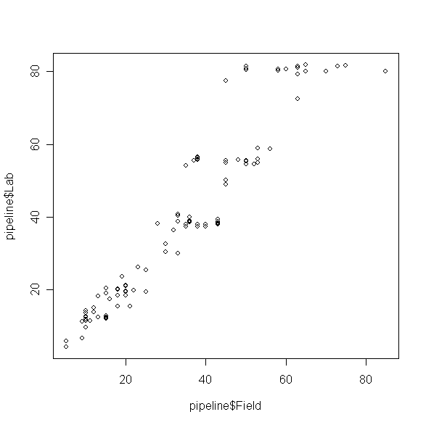

Comment
The plot above implies the is a positive linear relationship between Lab and Field. Try to fit a simple linear regression to determine a model.

CODE (R-CODE)
library(alr3)
data(pipeline)
attributes(pipeline)
plot(pipeline$Field, pipeline$Lab)

Problem 8.3.2
> fit1=(lm(Lab~Field, pipeline))
> summary(fit1)

Call:
lm(formula = Lab ~ Field, data = pipeline)

Residuals:
Min 1Q Median 3Q Max
-21.985 -4.072 -1.431 2.504 24.334

Coefficients:
Estimate Std. Error t value Pr(>|t|)
(Intercept) -1.96750 1.57479 -1.249 0.214
Field 1.22297 0.04107 29.778 <2e-16 ***
---
Signif. codes: 0 ‘***’ 0.001 ‘**’ 0.01 ‘*’ 0.05 ‘.’ 0.1 ‘ ’ 1

Residual standard error: 7.865 on 105 degrees of freedom
Multiple R-squared: 0.8941, Adjusted R-squared: 0.8931
F-statistic: 886.7 on 1 and 105 DF, p-value: < 2.2e-16

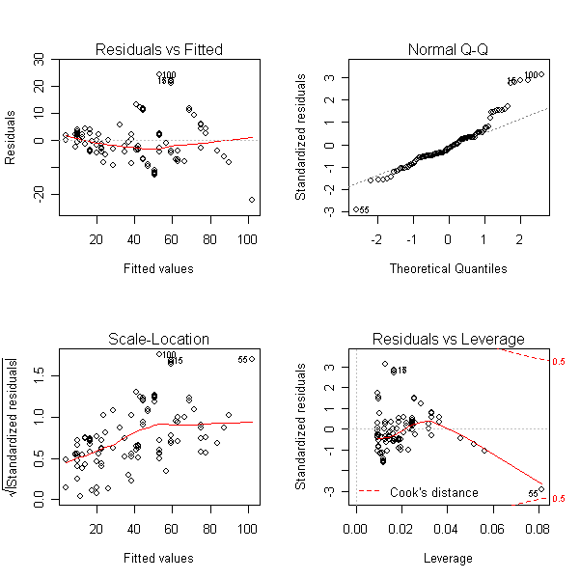

> ncv.test(fit1)
Non-constant Variance Score Test
Variance formula: ~ fitted.values
Chisquare = 29.58568 Df = 1 p = 5.349868e-08

Comment
The residual plot fails normality assumptions. This plot and the constant variance test illustrated that the model may not fit well to the data.

CODE (R-CODE)
#LOAD package CAR
fit1=(lm(Lab~Field, pipeline))
summary(fit1)
par(mfrow=c(2,2))
plot(fit1)
library(car)
ncv.test(fit1)

Problem 8.3.3

> ncv.test(fit1, ~pipeline$Field)
Non-constant Variance Score Test
Variance formula: ~ pipeline$Field
Chisquare = 29.58568 Df = 1 p = 5.349868e-08

> ncv.test(fit1, ~as.factor(pipeline$Batch))
Non-constant Variance Score Test
Variance formula: ~ as.factor(pipeline$Batch)
Chisquare = 8.6385 Df = 5 p = 0.1243814

Fitted model with weights as Field

> fit2= lm(Lab~Field, weights = Field, pipeline)
> summary(fit2)

Call:
lm(formula = Lab ~ Field, data = pipeline, weights = Field)

Residuals:
Min 1Q Median 3Q Max
-189.71 -23.77 -9.41 11.66 163.52

Coefficients:
Estimate Std. Error t value Pr(>|t|)
(Intercept) -0.47232 2.39210 -0.197 0.844
Field 1.18882 0.05061 23.490 <2e-16 ***
---
Signif. codes: 0 ‘***’ 0.001 ‘**’ 0.01 ‘*’ 0.05 ‘.’ 0.1 ‘ ’ 1

Residual standard error: 54 on 105 degrees of freedom
Multiple R-squared: 0.8401, Adjusted R-squared: 0.8386
F-statistic: 551.8 on 1 and 105 DF, p-value: < 2.2e-16

Fitted model with weights as Batch

> fit3= lm(Lab~Field, weights = Batch, pipeline)
> summary(fit3)
Call:
lm(formula = Lab ~ Field, data = pipeline, weights = Batch)

Residuals:
Min 1Q Median 3Q Max
-34.7887 -5.8973 -0.9805 5.2695 56.7496

Coefficients:
Estimate Std. Error t value Pr(>|t|)
(Intercept) -2.05168 1.40331 -1.462 0.147
Field 1.20161 0.03668 32.759 <2e-16 ***
---
Signif. codes: 0 ‘***’ 0.001 ‘**’ 0.01 ‘*’ 0.05 ‘.’ 0.1 ‘ ’ 1
Residual standard error: 12.81 on 105 degrees of freedom
Multiple R-squared: 0.9109, Adjusted R-squared: 0.91
F-statistic: 1073 on 1 and 105 DF, p-value: < 2.2e-16

Comment

From the constant variance test, choosing Batch as a weight gives more stable variance.

CODE (R-CODE)
#load library CAR
ncv.test(fit1, ~pipeline$Field)
ncv.test(fit1, ~as.factor(pipeline$Batch))
fit2= lm(Lab~Field, weights = Field, pipeline)
summary(fit2)
fit3= lm(Lab~Field, weights = Batch, pipeline)
summary(fit3)

Problem 8.3.4

> ncv.test(fit1, ~pipeline$Field^2)
Non-constant Variance Score Test
Variance formula: ~ pipeline$Field^2
Chisquare = 29.58568 Df = 1 p = 5.349868e-08

Comment: I used Field² as the weight, the p-value is small to be significant, however, there is still large variance. This weighted model is not a good choice.

CODE (R-CODE)
#load package
ncv.test(fit1, ~pipeline$Field^2)

