Problem 6.13.1

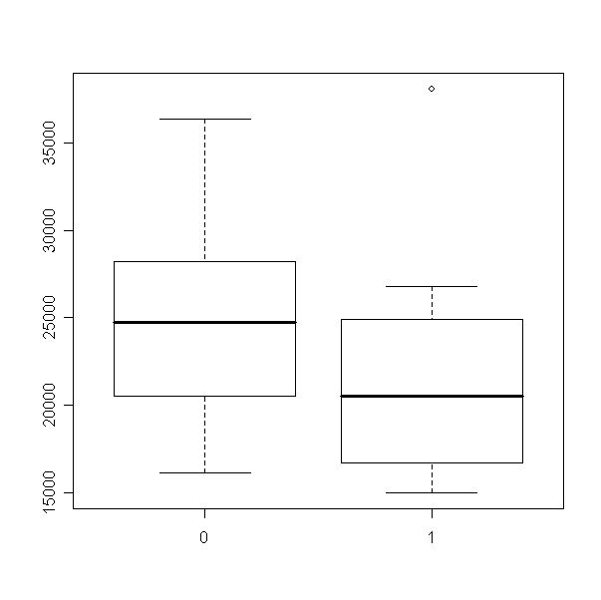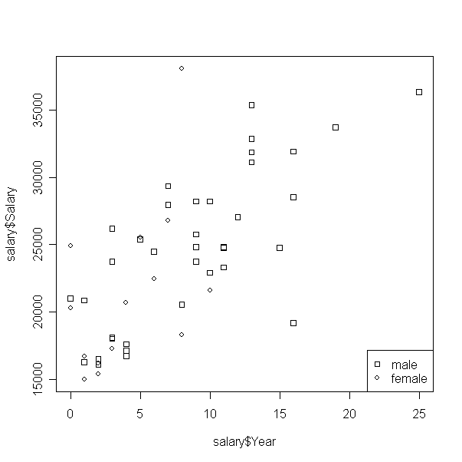

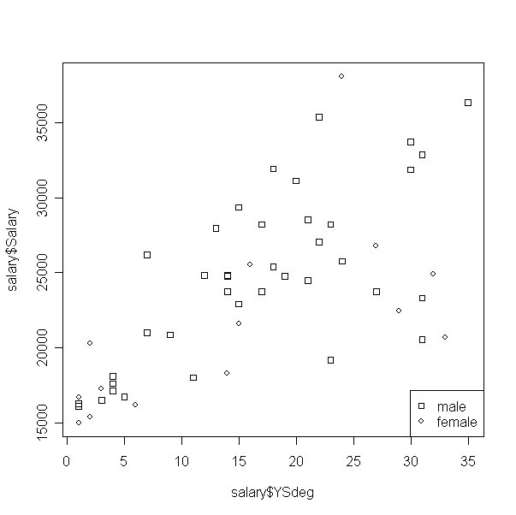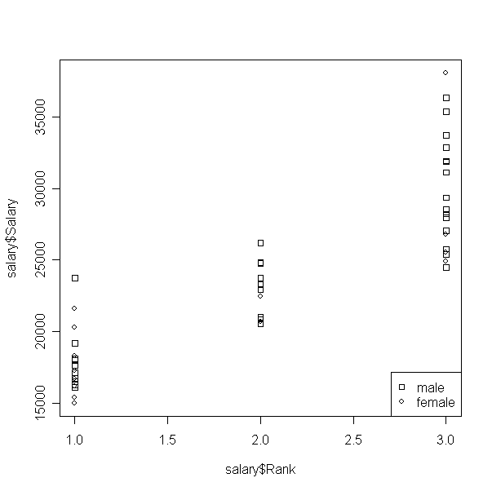

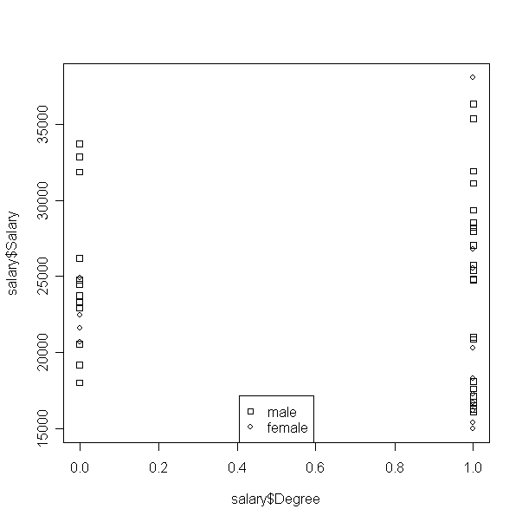

Comments
Used sex as the factor to analysis for the dataset. From the plots, we can see in the same rank, that females have less salary than that of male. Futhermore, at the same degree, females tend to have less salary than males.

The plot Salary vs. Ysdegree, shows males tend to get higher salary than females in the same period after reaching the highest degree. Females have a lower salary than males.

CODE: (R-Code)
plot(as.factor(salary$Sex),salary$Salary)

plot(salary$Year, salary$Salary, pch=salary$Sex)

ex12 <- expression("male", "female")
utils::str(legend("bottomright", ex12, pch=22:1))

plot(salary$YSdeg, salary$Salary, pch=salary$Sex)
ex12 <- expression("male", "female")
utils::str(legend("bottomright", ex12, pch=22:1))

plot(salary$Rank, salary$Salary, pch=salary$Sex)
ex12 <- expression("male", "female")
utils::str(legend("bottomright", ex12, pch=22:1))

plot(salary$Degree, salary$Salary, pch=salary$Sex)
ex12 <- expression("male", "female")
utils::str(legend("bottom", ex12, pch=22:1))
Problem 6.13.2
Fit the following model
> fit1 = lm(Salary~factor(Sex)+factor(Rank) + factor(Degree)+Year+YSdeg, salary)
> summary(fit1)
Call:
lm(formula = Salary ~ factor(Sex) + factor(Rank) + factor(Degree) +
Year + YSdeg, data = salary)
Residuals:
Min 1Q Median 3Q Max
-4045.2 -1094.7 -361.5 813.2 9193.1

Coefficients:
Estimate Std. Error t value Pr(>|t|)
(Intercept) 17134.66 1197.70 14.306 < 2e-16 ***
factor(Sex)1 1166.37 925.57 1.260 0.214
factor(Rank)2 5292.36 1145.40 4.621 3.22e-05 ***
factor(Rank)3 11118.76 1351.77 8.225 1.62e-10 ***
factor(Degree)1 -1388.61 1018.75 -1.363 0.180
Year 476.31 94.91 5.018 8.65e-06 ***
YSdeg -124.57 77.49 -1.608 0.115
---
Signif. codes: 0 ‘***’ 0.001 ‘**’ 0.01 ‘*’ 0.05 ‘.’ 0.1 ‘ ’ 1

Residual standard error: 2398 on 45 degrees of freedom
Multiple R-squared: 0.855, Adjusted R-squared: 0.8357
F-statistic: 44.24 on 6 and 45 DF, p-value: < 2.2e-16
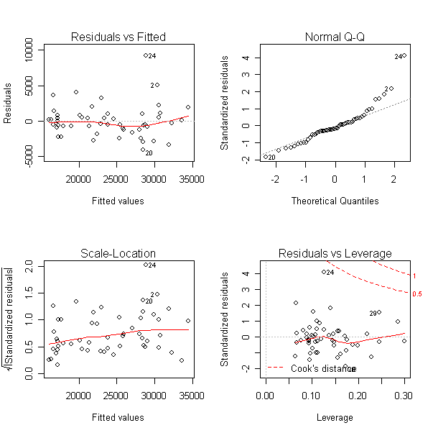

Test the following
H₀: Salaries of males and females are the same
H_{a}: Salaries are not the same

The p-value is 0.214. Sex is not significant factor so we can reject the null hypothesis.

CODE
fit1 = lm(Salary~factor(Sex)+factor(Rank) + factor(Degree)+Year+YSdeg, salary)
summary(fit1)
anova(fit1)
par(mfrow=c(2,2))
plot(fit1)

Problem 6.13.3

Test 1:

H₀: Salaries adjusted for years in current rank, highest degree, and years since the highest degree is the same for each of the three ranks
H_{a}: Salaries are not the same

Compare the following models to see if reduced model can be used
Model 1: Salary ~ Rank + Degreee + Years + YSdeg
Model 2: Salary ~ Degree + Years + YSdeg

If model 1 can be reduced to model 2, then fail to reject null hypothesis.

> fit2 = lm(Salary~factor(Rank) + factor(Degree) + Year + YSdeg, salary)
> summary(fit2)

Call:
lm(formula = Salary ~ factor(Rank) + factor(Degree) + Year +
YSdeg, data = salary)

Residuals:
Min 1Q Median 3Q Max
-4226.9 -972.1 -293.1 612.5 9840.8

Coefficients:
Estimate Std. Error t value Pr(>|t|)
(Intercept) 17373.45 1190.15 14.598 < 2e-16 ***
factor(Rank)2 4713.92 1056.09 4.464 5.18e-05 ***
factor(Rank)3 10509.62 1270.43 8.272 1.18e-10 ***
factor(Degree)1 -1062.12 991.53 -1.071 0.290
Year 416.56 82.75 5.034 7.84e-06 ***
YSdeg -81.22 69.87 -1.162 0.251
---
Signif. codes: 0 ‘***’ 0.001 ‘**’ 0.01 ‘*’ 0.05 ‘.’ 0.1 ‘ ’ 1

Residual standard error: 2414 on 46 degrees of freedom
Multiple R-squared: 0.8499, Adjusted R-squared: 0.8336
F-statistic: 52.1 on 5 and 46 DF, p-value: < 2.2e-16

> fit3 = lm(Salary~factor(Degree) + Year + YSdeg, salary)
> summary(fit3)

Call:
lm(formula = Salary ~ factor(Degree) + Year + YSdeg, data = salary)

Residuals:
Min 1Q Median 3Q Max
-8320.0 -2182.8 -769.6 2241.9 10452.4

Coefficients:
Estimate Std. Error t value Pr(>|t|)
(Intercept) 13548.73 1603.01 8.452 4.61e-11 ***
factor(Degree)1 3092.11 1284.69 2.407 0.019985 *
Year 414.10 127.54 3.247 0.002131 **
YSdeg 318.29 77.66 4.099 0.000159 ***
---
Signif. codes: 0 ‘***’ 0.001 ‘**’ 0.01 ‘*’ 0.05 ‘.’ 0.1 ‘ ’ 1

Residual standard error: 3742 on 48 degrees of freedom
Multiple R-squared: 0.6236, Adjusted R-squared: 0.6001
F-statistic: 26.51 on 3 and 48 DF, p-value: 2.929e-10

Run ANOVA on both models
> anova(fit2,fit3)
Analysis of Variance Table

Model 1: Salary ~ factor(Rank) + factor(Degree) + Year + YSdeg
Model 2: Salary ~ factor(Degree) + Year + YSdeg

Res.Df RSS Df Sum of Sq F Pr(>F)
1 46 267993336
2 48 672102002 -2 -404108665 34.682 6.544e-10 ***
---
Signif. codes: 0 ‘***’ 0.001 ‘**’ 0.01 ‘*’ 0.05 ‘.’ 0.1 ‘ ’ 1

Comments:
From the ANOVA, we can NOT reduce model 1 to model2, thus the Rank is a significant factor again the salaries are not the same.

Test 2
H₀: The sex differential in salary is the same for each rank
H_{a}: The sex differential in salary is not the same for each rank

Compare the following models to see if reduced model can be used
Model 1: Salary ~ Degreee + Year + YSdeg +
Model 2: Salary ~ Degree + Year + YSdeg

If model 1 can be reduced to model 2, then fail to reject null hypothesis.

> fit4 = lm(Salary~factor(Degree) + Year + YSdeg + factor(Sex)+factor(Rank):factor(Sex), salary)
> fit5 = lm(Salary~factor(Degree) + Year + YSdeg + factor(Sex), salary)

> anova(fit4,fit5)
Analysis of Variance Table

Model 1: Salary ~ factor(Degree) + Year + YSdeg + factor(Sex) + factor(Rank):factor(Sex)
Model 2: Salary ~ factor(Degree) + Year + YSdeg + factor(Sex)

Res.Df RSS Df Sum of Sq F Pr(>F)
1 43 248070090
2 47 658649047 -4 -410578957 17.792 1.098e-08 ***
---
Signif. codes: 0 ‘***’ 0.001 ‘**’ 0.01 ‘*’ 0.05 ‘.’ 0.1 ‘ ’ 1

Comments
From the ANOVA above, we can not reject, cannot more reduce model 1 to model 2. Sex is significant facto and H₀ gets rejected. Sex differential in salary may NOT be the same in each rank.

R-code
#test1
fit2 = lm(Salary~factor(Rank) + factor(Degree) + Year + YSdeg, salary)
summary(fit2)
fit3 = lm(Salary~factor(Degree) + Year + YSdeg, salary)
summary(fit3)
anova(fit2,fit3)

#test2
fit4 = lm(Salary~factor(Degree) + Year + YSdeg + factor(Sex)+factor(Rank), salary)
summary(fit4)
fit5 = lm(Salary~factor(Degree) + Year + YSdeg + factor(Sex), salary)
summary(fit5)
anova(fit4,fit5)

Problem 6.13.4

Fitting model with no Rank

> fit6 = lm(Salary~factor(Sex) + factor(Degree)+ Year + YSdeg, salary)
> summary(fit6)

Call:
lm(formula = Salary ~ factor(Sex) + factor(Degree) + Year + YSdeg,
data = salary)

Residuals:
Min 1Q Median 3Q Max
-8146.9 -2186.9 -491.5 2279.1 11186.6

Coefficients:
Estimate Std. Error t value Pr(>|t|)
(Intercept) 13884.22 1639.82 8.467 5.17e-11 ***
factor(Sex)1 -1286.54 1313.09 -0.980 0.332209
factor(Degree)1 3299.35 1302.52 2.533 0.014704 *
Year 351.97 142.48 2.470 0.017185 *
YSdeg 339.40 80.62 4.210 I see 0.000114 ***
d
Signif. codes: 0 ‘***’ 0.001 ‘**’ 0.01 ‘*’ 0.05 ‘.’ 0.1 ‘ ’ 1

Residual standard error: 3744 on 47 degrees of freedom
Multiple R-squared: 0.6312, Adjusted R-squared: 0.5998
F-statistic: 20.11 on 4 and 47 DF, p-value: 1.048e-09

Fitted model with Rank

> fit7 = lm(Salary~factor(Sex) + factor(Degree)+ Year + YSdeg + factor(Rank), salary)
> summary(fit7)

Call:
lm(formula = Salary ~ factor(Sex) + factor(Degree) + Year + YSdeg +
factor(Rank), data = salary)

Residuals:
Min 1Q Median 3Q Max
-4045.2 -1094.7 -361.5 813.2 9193.1

Coefficients:
Estimate Std. Error t value Pr(>|t|)
(Intercept) 17134.66 1197.70 14.306 < 2e-16 ***
factor(Sex)1 1166.37 925.57 1.260 0.214
factor(Degree)1 -1388.61 1018.75 -1.363 0.180
Year 476.31 94.91 5.018 8.65e-06 ***
YSdeg -124.57 77.49 -1.608 0.115
factor(Rank)2 5292.36 1145.40 4.621 3.22e-05 ***
factor(Rank)3 11118.76 1351.77 8.225 1.62e-10 ***
---
Signif. codes: 0 ‘***’ 0.001 ‘**’ 0.01 ‘*’ 0.05 ‘.’ 0.1 ‘ ’ 1

Residual standard error: 2398 on 45 degrees of freedom
Multiple R-squared: 0.855, Adjusted R-squared: 0.8357
F-statistic: 44.24 on 6 and 45 DF, p-value: < 2.2e-16

Comment
From above, with and without the factor weights, the factor Sex is significant. Thus, no salary discrimination based on Sex

CODE (R-code)
fit6 = lm(Salary~factor(Sex) + factor(Degree)+ Year + YSdeg, salary)
summary(fit6)
fit7 = lm(Salary~factor(Sex) + factor(Degree)+ Year + YSdeg + factor(Rank), salary)
summary(fit7)

