Problem 7.3.1
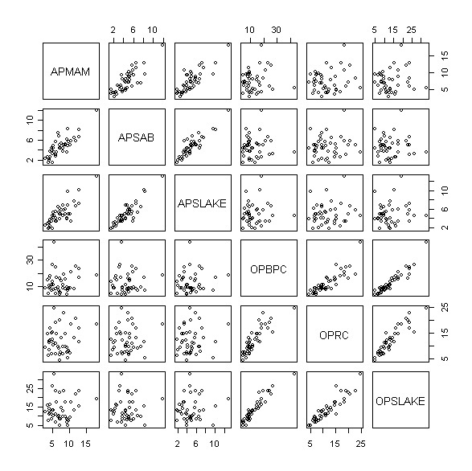

> trans = bctrans(BSAAM~APMAM + APSAB + APSLAKE + OPBPC + OPRC + OPSLAKE, water)
> summary(trans)
box.cox Transformations to Multinormality

Est.Power Std.Err. Wald(Power=0) Wald(Power=1)
APMAM 0.0982 0.2861 0.3434 -3.1522
APSAB 0.3450 0.2032 1.6977 -3.2238
APSLAKE 0.0818 0.2185 0.3741 -4.2020
OPBPC 0.0982 0.1577 0.6227 -5.7180
OPRC 0.2536 0.2445 1.0375 -3.0531
OPSLAKE 0.2534 0.1763 1.4374 -4.2361

LRT df p.value
LR test, all lambda equal 0 5.452999 6 4.871556e-01
LR test, all lambda equal 1 61.203125 6 2.562905e-11

Test:

H₀: All lambdas equal to 0
H_{a}: Not all lambdas equal to 0
The p-value is (0.4871556) greater than 0.05. Fail to reject, lambdas all equal to zero. Do a log transformation.

logAPMAM = log(water$APMAM)
logAPSAB = log(water$APSAB)
logAPSLAKE = log(water$APSLAKE)
logOPBPC = log(water$OPBPC)
logOPRC = log(water$OPRC)
logOPSLAKE = log(water$OPSLAKE)

Log_water = data.frame(logAPMAM,logAPSAB ,logAPSLAKE, logOPBPC , logOPRC ,logOPSLAKE )
pairs(Log_water)

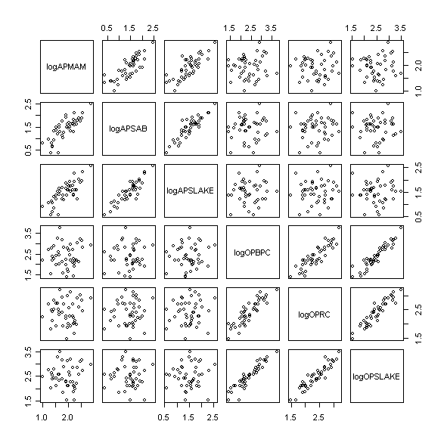

Comment
Studying the scatter plots, this illustates that the transfomation give us more more linear improvement.

Code (R-CODE)
pairs(water[,c(2,3,4,5,6,7)])
trans = bctrans(BSAAM~APMAM + APSAB + APSLAKE + OPBPC + OPRC + OPSLAKE, water)
summary(trans)
logAPMAM = log(water$APMAM)
logAPSAB = log(water$APSAB)
logAPSLAKE = log(water$APSLAKE)
logOPBPC = log(water$OPBPC)
logOPRC = log(water$OPRC)
logOPSLAKE = log(water$OPSLAKE)

Log_water = data.frame(logAPMAM,logAPSAB ,logAPSLAKE, logOPBPC , logOPRC ,logOPSLAKE )

pairs(Log_water)

Problem 7.3.2

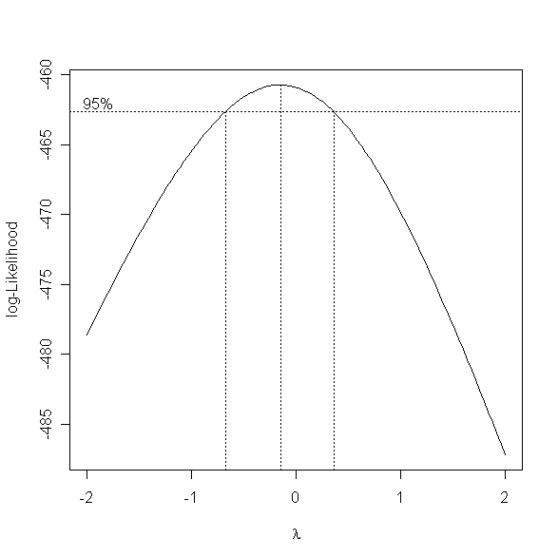
Comment
From the Box-Cox plot above, we choose lambda =0, this we choose to use the log transformations.

CODE(R-CODE)
library(MASS)
fit1 = lm(BSAAM ~ logAPMAM+ logAPSAB + logAPSLAKE + logOPBPC + logOPRC + logOPSLAKE, water )
boxcox(fit1)

Problem 7.3.3

> fit2 = lm(logBSAAM ~ logAPMAM+ logAPSAB + logAPSLAKE + logOPBPC + logOPRC + logOPSLAKE, water )
> summary(fit2)

Call:
lm(formula = logBSAAM ~ logAPMAM + logAPSAB + logAPSLAKE + logOPBPC +
logOPRC + logOPSLAKE, data = water)

Residuals:
Min 1Q Median 3Q Max
-0.18671 -0.05264 -0.00693 0.06130 0.17698

Coefficients:
Estimate Std. Error t value Pr(>|t|)
(Intercept) 9.46675 0.12354 76.626 < 2e-16 ***
logAPMAM -0.02033 0.06596 -0.308 0.75975
logAPSAB -0.10303 0.08939 -1.153 0.25667
logAPSLAKE 0.22060 0.08955 2.463 0.01868 *
logOPBPC 0.11135 0.08169 1.363 0.18134
logOPRC 0.36165 0.10926 3.310 0.00213 **
logOPSLAKE 0.18613 0.13141 1.416 0.16524
---
Signif. codes: 0 ‘***’ 0.001 ‘**’ 0.01 ‘*’ 0.05 ‘.’ 0.1 ‘ ’ 1

Residual standard error: 0.1017 on 36 degrees of freedom
Multiple R-squared: 0.9098, Adjusted R-squared: 0.8948
F-statistic: 60.54 on 6 and 36 DF, p-value: < 2.2e-16

Comment
LogAPMAM and logAPSAB are negative, caused by the linear dependence amount the “A” predictors. They both have very large p-values, which means they can be elminiated from the model

CODE (R-CODE)
logBSAAM = log(water$BSAAM)

fit2 = lm(logBSAAM ~ logAPMAM+ logAPSAB + logAPSLAKE + logOPBPC + logOPRC + logOPSLAKE, water )
summary(fit2)

Problem 7.3.4
> combine_OP = logOPBPC + logOPRC + logOPSLAKE
> fit3 = lm(logBSAAM ~ logAPMAM+ logAPSAB + logAPSLAKE + combine_OP, water )
> summary(fit3)
Call:
lm(formula = logBSAAM ~ logAPMAM + logAPSAB + logAPSLAKE + combine_OP,
data = water)

Residuals:
Min 1Q Median 3Q Max
-0.224695 -0.060140 -0.003566 0.065240 0.208606

Coefficients:
Estimate Std. Error t value Pr(>|t|)
(Intercept) 9.55181 0.11070 86.284 <2e-16 ***
logAPMAM -0.02954 0.06669 -0.443 0.6603
logAPSAB -0.07484 0.08427 -0.888 0.3801
logAPSLAKE 0.19931 0.08649 2.304 0.0268 *
combine_OP 0.20879 0.01156 18.059 <2e-16 ***
---
Signif. codes: 0 ‘***’ 0.001 ‘**’ 0.01 ‘*’ 0.05 ‘.’ 0.1 ‘ ’ 1

Residual standard error: 0.1033 on 38 degrees of freedom
Multiple R-squared: 0.9019, Adjusted R-squared: 0.8915
F-statistic: 87.3 on 4 and 38 DF, p-value: < 2.2e-16

Run ANOVA
Analysis of Variance Table

Model 1: logBSAAM ~ logAPMAM + logAPSAB + logAPSLAKE + logOPBPC + logOPRC +
logOPSLAKE
Model 2: logBSAAM ~ logAPMAM + logAPSAB + logAPSLAKE + combine_OP

Res.Df RSS Df Sum of Sq F Pr(>F)
1 36 0.37243
2 38 0.40536 -2 -0.03293 1.5915 0.2176

Comment
By combining “O” predictors, the new combination predictor is very significant. The ANOVA to compare the models, determined a p-value (0.2176) greater 0.05, which suggests that we can reduce the model to only 4 predictors including the combined predictor.

CODE (R-CODE)
combine_OP = logOPBPC + logOPRC + logOPSLAKE
fit3 = lm(logBSAAM ~ logAPMAM+ logAPSAB + logAPSLAKE + combine_OP, water )
summary(fit3)
anova(fit2,fit3)

Problem 7.3.5

From the previous question, will form a model using logAPSLAKE and the combination of “O” predictor as predictors.

>newtrail = data.frame(logBSAAM, logAPSLAKE, combine_OP)
>pairs(newtrail)

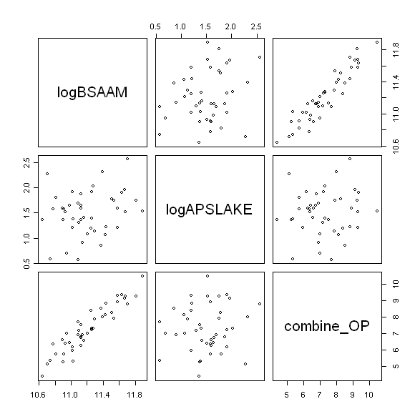
> fit4 = lm(logBSAAM~logAPSLAKE + combine_OP, water)
> summary(fit4)

Call:
lm(formula = logBSAAM ~ logAPSLAKE + combine_OP, data = water)

Residuals:
Min 1Q Median 3Q Max
-0.243096 -0.064886 0.008562 0.060307 0.233416

Coefficients:
Estimate Std. Error t value Pr(>|t|)
(Intercept) 9.52446 0.09722 97.965 < 2e-16 ***
logAPSLAKE 0.10634 0.03624 2.935 0.00551 **
combine_OP 0.20918 0.01147 18.240 < 2e-16 ***
---
Signif. codes: 0 ‘***’ 0.001 ‘**’ 0.01 ‘*’ 0.05 ‘.’ 0.1 ‘ ’ 1

Residual standard error: 0.1025 on 40 degrees of freedom
Multiple R-squared: 0.8982, Adjusted R-squared: 0.8931
F-statistic: 176.4 on 2 and 40 DF, p-value: < 2.2e-16

Run ANOVA

Model 1: logBSAAM ~ logAPMAM + logAPSAB + logAPSLAKE + combine_OP

Model 2: logBSAAM ~ logAPSLAKE + combine_OP
Res.Df RSS Df Sum of Sq F Pr(>F)
1 38 0.40536
2 40 0.42050 -2 -0.01513 0.7094 0.4983

Comment
Can conclude from the ANOVA, the p-value help states that the model works we..

CODE (R-CODE)
fit4 = lm(logBSAAM~logAPSLAKE + combine_OP, water)
summary(fit4)
anova(fit3,fit4)

