Problem 7.6.1
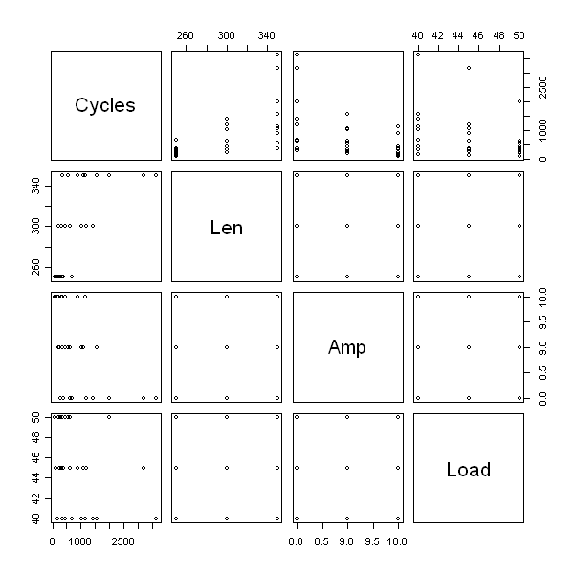

Comment
From the plot matrix, there exists independence among Len, Amp, and Load. Also, find when there is an increase in the relationship between Cycles and Len, a decreasing relationship between Cycles and Amp, and decreasing between Cycles and Load.

CODE (R-CODE)
library(alr3)
data(wool)
attributes(wool)

pairs(wool[c(4,1,2,3)])

Problem 7.6.2

Since some of the factors were indicators, needed to change to factors to use R. After this, the following was full model was fitted.

> fit_full = lm(Cycles~Lenf+Ampf+Loadf + Lenf:Ampf+ Lenf:Loadf+ Ampf:Loadf, wool)
> summary(fit_full)

Call:
lm(formula = Cycles ~ Lenf + Ampf + Loadf + Lenf:Ampf + Lenf:Loadf +
Ampf:Loadf, data = wool)

Residuals:
Min 1Q Median 3Q Max
-127.593 -39.148 -9.037 58.074 117.074

Coefficients:
Estimate Std. Error t value Pr(>|t|)
(Intercept) 6.826e+02 9.237e+01 7.390 7.69e-05 ***
Lenf300 7.809e+02 1.161e+02 6.728 0.000148 ***
Lenf350 2.895e+03 1.161e+02 24.946 7.13e-09 ***
Ampf9 -2.944e+02 1.161e+02 -2.537 0.034879 *
Ampf10 -5.713e+02 1.161e+02 -4.923 0.001160 **
Loadf45 -2.041e+02 1.161e+02 -1.759 0.116697
Loadf50 -5.077e+02 1.161e+02 -4.374 0.002368 **
Lenf300:Ampf9 -2.147e+02 1.271e+02 -1.688 0.129813 ←←←←
Lenf350:Ampf9 -1.698e+03 1.271e+02 -13.355 9.45e-07 ***
Lenf300:Ampf10 -4.310e+02 1.271e+02 -3.390 0.009502 **
Lenf350:Ampf10 -1.826e+03 1.271e+02 -14.362 5.40e-07 ***
Lenf300:Loadf45 -1.003e+02 1.271e+02 -0.789 0.452782 ←←←←
Lenf350:Loadf45 -2.593e+02 1.271e+02 -2.040 0.075709 .
Lenf300:Loadf50 -3.323e+02 1.271e+02 -2.614 0.030944 *
Lenf350:Loadf50 -9.427e+02 1.271e+02 -7.414 7.52e-05 ***
Ampf9:Loadf45 -2.127e-13 1.271e+02 -1.67e-15 1.000000 ←←←←
Ampf10:Loadf45 1.843e+02 1.271e+02 1.450 0.185155 ←←←←
Ampf9:Loadf50 3.613e+02 1.271e+02 2.842 0.021747 *
Ampf10:Loadf50 5.717e+02 1.271e+02 4.496 0.002012 **
---
Signif. codes: 0 ‘***’ 0.001 ‘**’ 0.01 ‘*’ 0.05 ‘.’ 0.1 ‘ ’ 1

Residual standard error: 110.1 on 8 degrees of freedom
Multiple R-squared: 0.9952, Adjusted R-squared: 0.9844
F-statistic: 92.25 on 18 and 8 DF, p-value: 2.537e-07

Comment
Most of the factors were signifcant, from the p-values, therefore cannot be eliminated. However, there are some interactions terms, labeled above by arrows, that are insignificant.

CODE (R-CODE)
Lenf = as.factor(wool$Len)
Ampf = as.factor(wool$Amp)
Loadf = as.factor(wool$Load)
fit_full = lm(Cycles~Lenf+Ampf+Loadf + Lenf:Ampf+ Lenf:Loadf+ Ampf:Loadf, wool)
summary(fit_full)
Problem 7.6.3

Main effects fitted model
> fit_main = lm(Cycles~Lenf+Ampf+Loadf,wool)
> summary(fit_main)

Call:
lm(formula = Cycles ~ Lenf + Ampf + Loadf, data = wool)

Residuals:
Min 1Q Median 3Q Max
-570.81 -308.43 -53.81 227.57 1112.63

Coefficients:
Estimate Std. Error t value Pr(>|t|)
(Intercept) 1203.4 246.0 4.891 8.83e-05 ***
Lenf300 421.4 227.8 1.850 0.079096 .
Lenf350 1320.0 227.8 5.795 1.14e-05 ***
Ampf9 -811.6 227.8 -3.563 0.001948 **
Ampf10 -1071.7 227.8 -4.705 0.000136 ***
Loadf45 -262.6 227.8 -1.153 0.262611
Loadf50 -621.7 227.8 -2.729 0.012918 *
---
Signif. codes: 0 ‘***’ 0.001 ‘**’ 0.01 ‘*’ 0.05 ‘.’ 0.1 ‘ ’ 1

Residual standard error: 483.2 on 20 degrees of freedom
Multiple R-squared: 0.7692, Adjusted R-squared: 0.6999
F-statistic: 11.11 on 6 and 20 DF, p-value: 1.769e-05

> inv.tran.plot(wool$Cycles, predict(fit_main), lambda = c(-1,-0.5,0,0.5,1), key = "bottomright")
lambda RSS
1 0.1452334 1340826
2 -1.0000000 5544947
3 -0.5000000 2973307
4 0.0000000 1429311
5 0.5000000 1823385
6 1.0000000 3591351

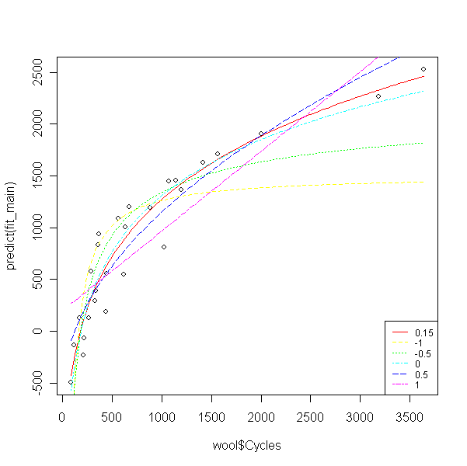

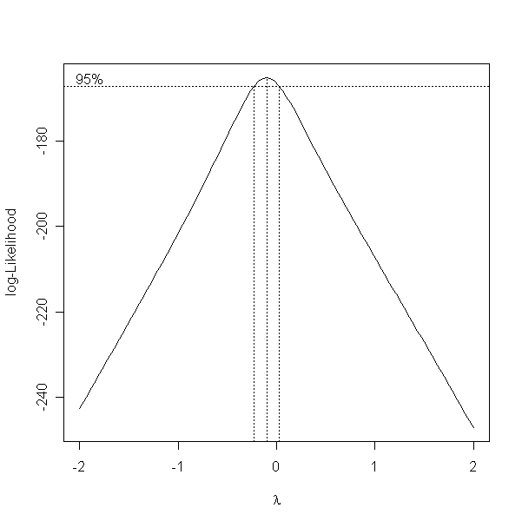

Comment
Obtained a λ = 0.1452334 from the inverse fitted plot, and a λ ≈ 0.1 from the boxcox plot. Both are near to zero, thus we use log transformation.

CODE (R-CODE)
fit_main = lm(Cycles~Lenf+Ampf+Loadf,wool)
summary(fit_main)
inv.tran.plot(wool$Cycles, predict(fit_main), lambda = c(-1,-0.5,0,0.5,1), key = "bottomright")
boxcox(fit_main)

Problem 7.6.4

> logCycles = log(wool$Cycles)
> fit_trans = lm(logCycles~Lenf + Ampf+ Loadf+ Lenf:Ampf+ Lenf:Loadf+ Ampf:Loadf, wool)
> summary(fit_trans)

Call:
lm(formula = logCycles ~ Lenf + Ampf + Loadf + Lenf:Ampf + Lenf:Loadf +
Ampf:Loadf, data = wool)

Residuals:
Min 1Q Median 3Q Max
-0.12779 -0.05537 -0.01802 0.06325 0.15780

Coefficients:
Estimate Std. Error t value Pr(>|t|)
(Intercept) 6.362917 0.120807 52.670 1.87e-11 ***
Lenf300 0.913780 0.151801 6.020 0.000316 ***
Lenf350 1.963516 0.151801 12.935 1.21e-06 ***
Ampf9 -0.413379 0.151801 -2.723 0.026121 *
Ampf10 -1.203298 0.151801 -7.927 4.67e-05 ***
Loadf45 -0.375588 0.151801 -2.474 0.038457 *
Loadf50 -0.609676 0.151801 -4.016 0.003861 **
Lenf300:Ampf9 -0.001114 0.166290 -0.007 0.994817
Lenf350:Ampf9 -0.614678 0.166290 -3.696 0.006074 **
Lenf300:Ampf10 0.064964 0.166290 0.391 0.706242
Lenf350:Ampf10 -0.152966 0.166290 -0.920 0.384537
Lenf300:Loadf45 0.083463 0.166290 0.502 0.629248
Lenf350:Loadf45 0.145059 0.166290 0.872 0.408448
Lenf300:Loadf50 -0.133655 0.166290 -0.804 0.444766
Lenf350:Loadf50 -0.273658 0.166290 -1.646 0.138450
Ampf9:Loadf45 -0.074416 0.166290 -0.448 0.666379
Ampf10:Loadf45 -0.003211 0.166290 -0.019 0.985067
Ampf9:Loadf50 -0.035285 0.166290 -0.212 0.837264
Ampf10:Loadf50 -0.084089 0.166290 -0.506 0.626717
---
Signif. codes: 0 ‘***’ 0.001 ‘**’ 0.01 ‘*’ 0.05 ‘.’ 0.1 ‘ ’ 1

Residual standard error: 0.144 on 8 degrees of freedom
Multiple R-squared: 0.9928, Adjusted R-squared: 0.9768
F-statistic: 61.71 on 18 and 8 DF, p-value: 1.236e-06

Run an ANOVA
Analysis of Variance Table

Response: logCycles
Df Sum Sq Mean Sq F value Pr(>F)
Lenf 2 12.5159 6.2579 301.7441 2.930e-08 ***
Ampf 2 7.1674 3.5837 172.7986 2.620e-07 ***
Loadf 2 2.8019 1.4010 67.5509 9.767e-06 ***
Lenf:Ampf 4 0.4012 0.1003 4.8357 0.02806 *
Lenf:Loadf 4 0.1358 0.0339 1.6364 0.25620
Ampf:Loadf 4 0.0146 0.0036 0.1760 0.94456
Residuals 8 0.1659 0.0207
---
Signif. codes: 0 ‘***’ 0.001 ‘**’ 0.01 ‘*’ 0.05 ‘.’ 0.1 ‘ ’ 1
> anova(fit_full)
Analysis of Variance Table

Response: Cycles
Df Sum Sq Mean Sq F value Pr(>F)
Lenf 2 8182253 4091126 337.4408 1.884e-08 ***
Ampf 2 5624249 2812124 231.9473 8.260e-08 ***
Loadf 2 1753097 876548 72.2987 7.554e-06 ***
Lenf:Ampf 4 3555537 888884 73.3162 2.433e-06 ***
Lenf:Loadf 4 732881 183220 15.1122 0.0008457 ***
Ampf:Loadf 4 283609 70902 5.8481 0.0167886 *
Residuals 8 96992 12124
---
Signif. codes: 0 ‘***’ 0.001 ‘**’ 0.01 ‘*’ 0.05 ‘.’ 0.1 ‘ ’ 1

Comment
All intereractions are significant, except Lenf350:Amp9. The transformation gives a reduced model with no interactions.

CODE (R-CODE)
logCycles = log(wool$Cycles)
fit_trans = lm(logCycles~Lenf + Ampf+ Loadf+ Lenf:Ampf+ Lenf:Loadf+ Ampf:Loadf, wool)
summary(fit_trans)
anova(fit_trans)
anova(fit_full)

