3.1.1
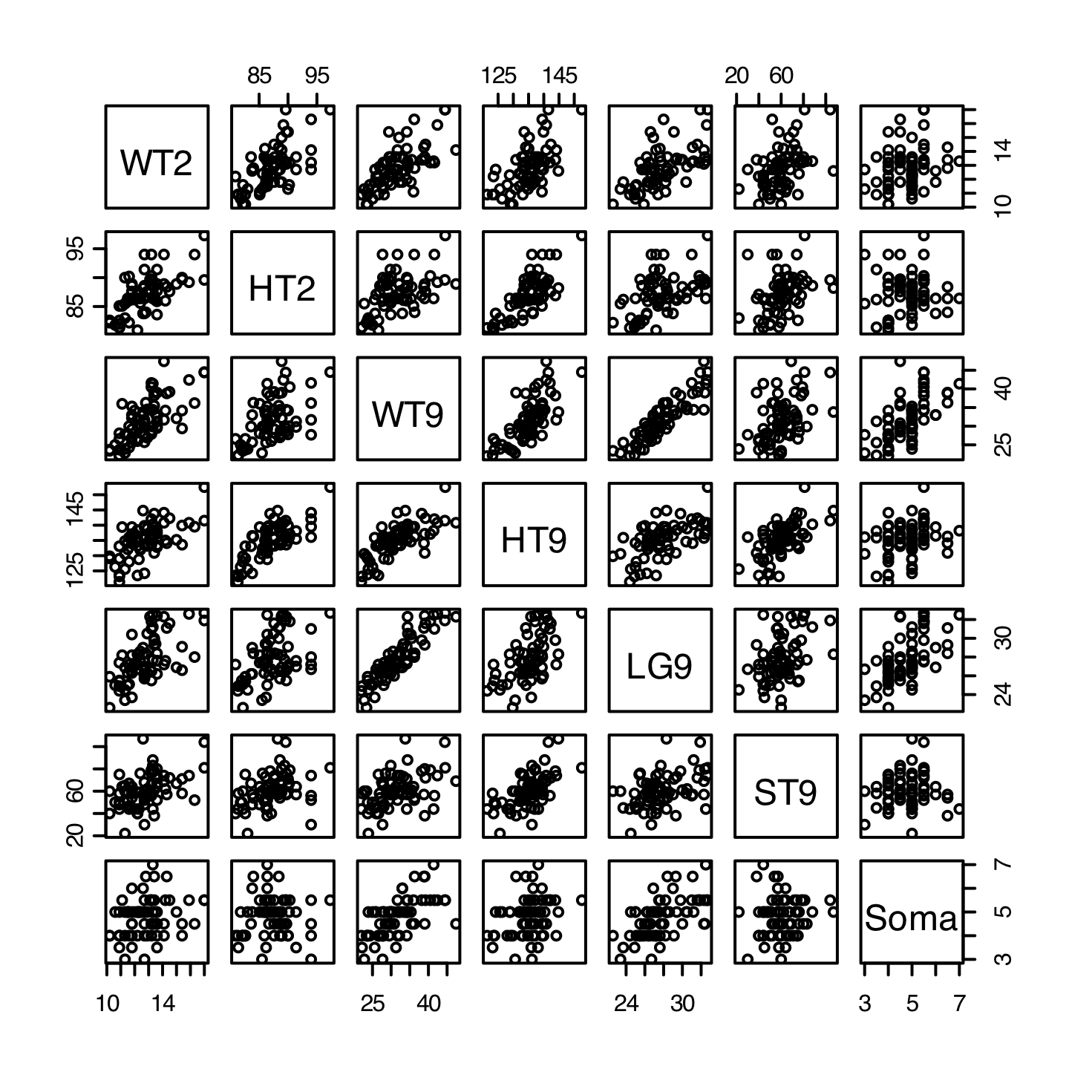
WT2 HT2 WT9 HT9 LG9 ST9 Soma
WT2 1.0000000 0.64454954 0.6925390 0.6071247 0.6164399 0.4515812 0.27151816
HT2 0.6445495 1.00000000 0.5229277 0.7383562 0.4687710 0.3617241 0.03978899
WT9 0.6925390 0.52292768 1.0000000 0.7276123 0.9044433 0.4530041 0.61807611
HT9 0.6071247 0.73835617 0.7276123 1.0000000 0.5981001 0.6033681 0.27396202
LG9 0.6164399 0.46877101 0.9044433 0.5981001 1.0000000 0.4129353 0.57944119
ST9 0.4515812 0.36172415 0.4530041 0.6033681 0.4129353 1.0000000 0.08867531
Soma 0.2715182 0.03978899 0.6180761 0.2739620 0.5794412 0.0886753 1.00000000

Comment:
Appears to be an positive correlation in most of the graphs. In almost all of graphs exist positive correlated.

CODE: (R-Code)
install.packages("alr3")
library(alr3)
data(BGSgirls)
attributes(BGSgirls)
attach(BGSgirls)
plot(BGSgirls)
x = data.frame(WT2,HT2, WT9, HT9, LG9, ST9,Soma)
cor(x)

Problem 3.1.2

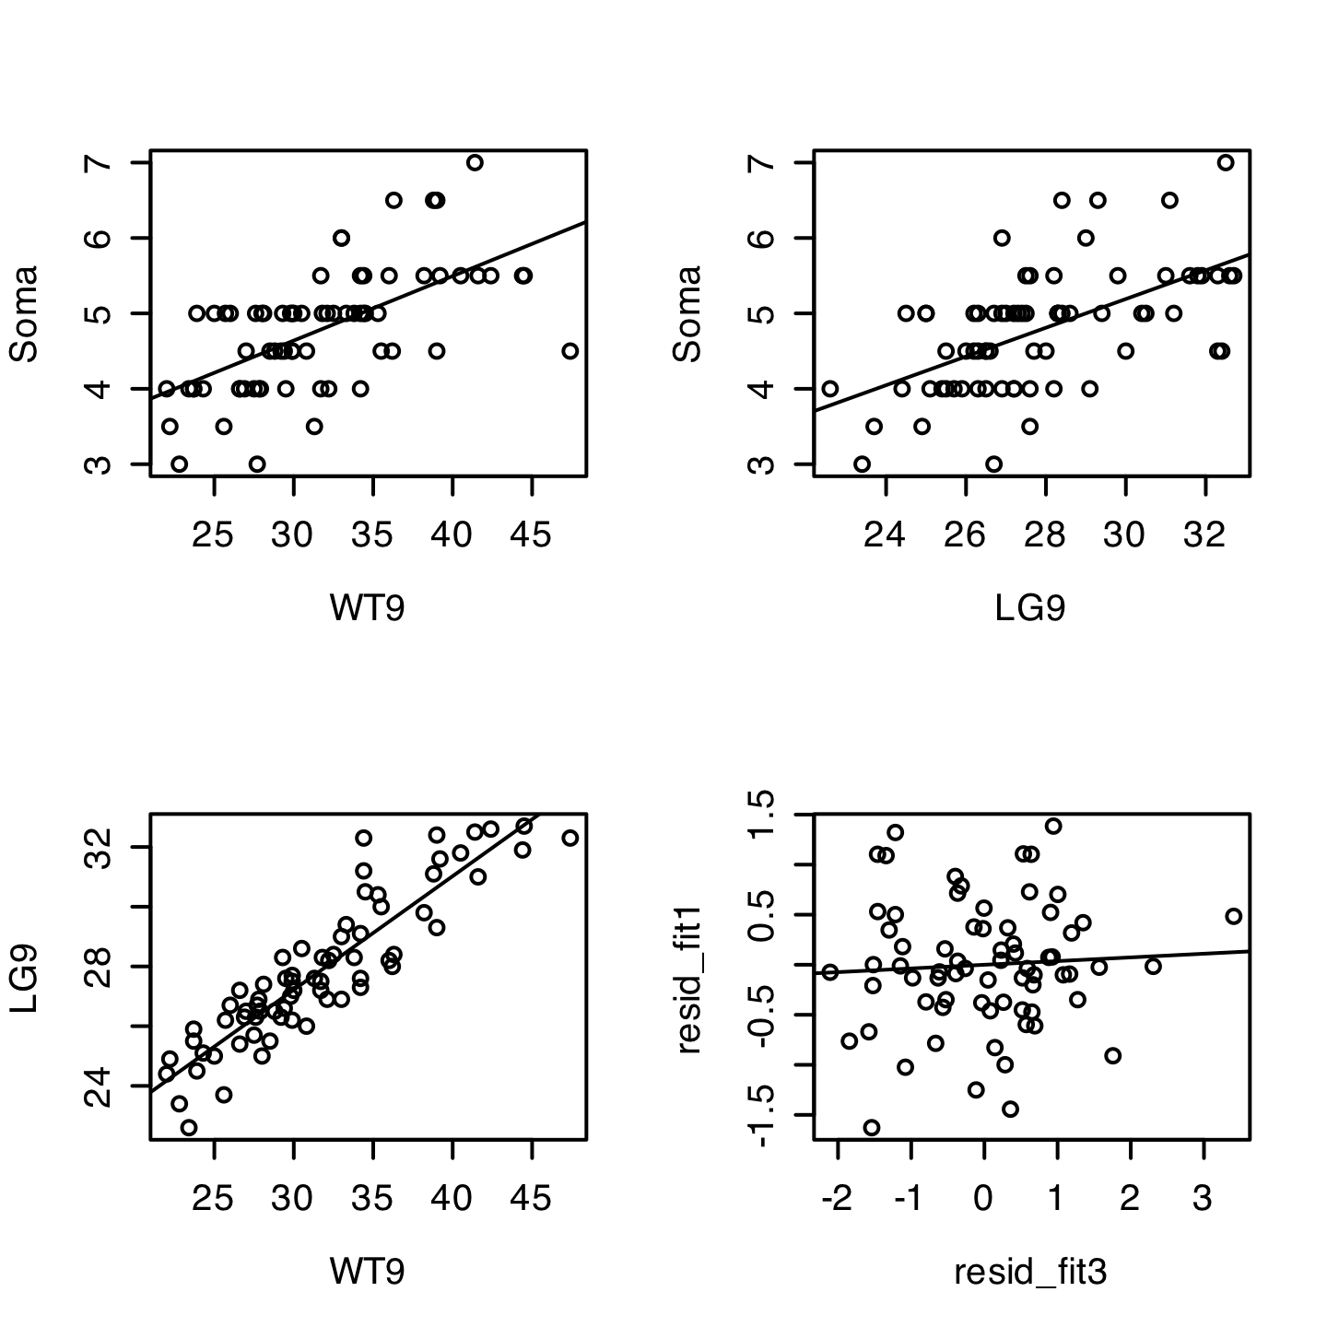

Call:
lm(formula = Soma ~ WT9, data = BGSgirls)

Residuals:
Min 1Q Median 3Q Max
-1.62809 -0.37394 -0.03102 0.37507 1.38508

Coefficients:
Estimate Std. Error t value Pr(>|t|)
(Intercept) 2.07405 0.42406 4.891 6.45e-06 ***
WT9 0.08553 0.01319 6.483 1.19e-08 ***
---
Signif. codes: 0 '***' 0.001 '**' 0.01 '*' 0.05 '.' 0.1 ' ' 1

Residual standard error: 0.6382 on 68 degrees of freedom
Multiple R-Squared: 0.382, Adjusted R-squared: 0.3729
F-statistic: 42.04 on 1 and 68 DF, p-value: 1.193e-08

Call:
lm(formula = Soma ~ LG9, data = BGSgirls)

Residuals:
Min 1Q Median 3Q Max
-1.5621 -0.4001 -0.0240 0.3459 1.6139

Coefficients:
Estimate Std. Error t value Pr(>|t|)
(Intercept) -0.52661 0.90835 -0.580 0.564
LG9 0.19059 0.03251 5.863 1.47e-07 ***
---
Signif. codes: 0 '***' 0.001 '**' 0.01 '*' 0.05 '.' 0.1 ' ' 1

Residual standard error: 0.6617 on 68 degrees of freedom
Multiple R-Squared: 0.3358, Adjusted R-squared: 0.326
F-statistic: 34.37 on 1 and 68 DF, p-value: 1.475e-07

Call:
lm(formula = LG9 ~ WT9, data = BGSgirls)

Residuals:
Min 1Q Median 3Q Max
-2.10742 -0.65736 0.06522 0.64682 3.40703

Coefficients:
Estimate Std. Error t value Pr(>|t|)
(Intercept) 15.80360 0.69962 22.59 <2e-16 ***
WT9 0.38051 0.02176 17.48 <2e-16 ***
---
Signif. codes: 0 '***' 0.001 '**' 0.01 '*' 0.05 '.' 0.1 ' ' 1

Residual standard error: 1.053 on 68 degrees of freedom
Multiple R-Squared: 0.818, Adjusted R-squared: 0.8153
F-statistic: 305.7 on 1 and 68 DF, p-value: < 2.2e-16

Call:
lm(formula = resid_fit1 ~ resid_fit3)

Residuals:
Min 1Q Median 3Q Max
-1.57125 -0.38297 -0.03819 0.36787 1.36617

Coefficients:
Estimate Std. Error t value Pr(>|t|)
(Intercept) 8.077e-18 7.614e-02 1.06e-16 1.000
resid_fit3 3.692e-02 7.337e-02 0.503 0.616

Residual standard error: 0.637 on 68 degrees of freedom
Multiple R-Squared: 0.00371, Adjusted R-squared: -0.01094
F-statistic: 0.2532 on 1 and 68 DF, p-value: 0.6164

Comment
The graphs illustrate a positive relationship on Soma with either WT9 or LG9 as predictor. There is also a positive relationship between WT9 and LG9. The added variable shows little improvement in estimating Soma by adding LG9 after we control for Wt9. The relationship in the second plot is weaker than the added variable plot. The total total explained variability is less than the additive amount.

CODE: (R-Code)
par(mfrow=c(2,2))
fit1 = lm(Soma~WT9, data=BGSgirls)
plot(Soma~WT9, data=BGSgirls)
abline(fit1)
fit2 = lm(Soma~LG9, data=BGSgirls)
plot(Soma~LG9, data=BGSgirls)
abline(fit2)
fit3 = lm(LG9~WT9, data=BGSgirls)
plot(LG9~WT9, data=BGSgirls)
abline(fit3)
resid_fit1 = fit1$resid
resid_fit3= fit3$resid
plot(resid_fit1~resid_fit3)
resid_fit = lm(resid_fit1~resid_fit3)
abline(resid_fit)

Problem 3.1.3

Call:
lm(formula = Soma ~ HT2 + WT2 + HT9 + WT9 + ST9, data = BGSgirls)

Residuals:
Min 1Q Median 3Q Max
-2.03132 -0.34062 0.01917 0.43939 0.97266

Coefficients:
Estimate Std. Error t value Pr(>|t|)
(Intercept) 8.8590417 2.3764431 3.728 0.000411 ***
HT2 -0.0792535 0.0354034 -2.239 0.028668 *
WT2 -0.0409358 0.0754343 -0.543 0.589244
HT9 -0.0009613 0.0260735 -0.037 0.970704
WT9 0.1280506 0.0203544 6.291 3.2e-08 ***
ST9 -0.0092629 0.0060130 -1.540 0.128373
---
Signif. codes: 0 ‘***’ 0.001 ‘**’ 0.01 ‘*’ 0.05 ‘.’ 0.1 ‘ ’ 1

Residual standard error: 0.5791 on 64 degrees of freedom
Multiple R-squared: 0.5211, Adjusted R-squared: 0.4837
F-statistic: 13.93 on 5 and 64 DF, p-value: 3.309e-09

H₀: β = 0 H_{a}: β ≠ 0

σ² = 0.3353 R² = 0.5211 F_{5,64}= 13.93 p-value< 0.001
For each β_{j}, the t-statistic is calculated above by
t = (bhat - 0)/(se(bhat))

CODE: (R-Code)
soma_fit1= lm(Soma~HT2 + WT2 + HT9 + WT9 + ST9, data=BGSgirls)
summary(soma_fit1)

Problem 3.1.4
Analysis of Variance Table

Response: Soma
Df Sum Sq Mean Sq F value Pr(>F)
HT2 1 0.0710 0.0710 0.2116 0.6470887
WT2 1 4.6349 4.6349 13.8212 0.0004252 ***
HT9 1 3.7792 3.7792 11.2695 0.0013299 **
WT9 1 14.0746 14.0746 41.9700 1.516e-08 ***
ST9 1 0.7958 0.7958 2.3731 0.1283728
Residuals 64 21.4623 0.3353
---
Signif. codes: 0 ‘***’ 0.001 ‘**’ 0.01 ‘*’ 0.05 ‘.’ 0.1 ‘ ’ 1

H₀: β_{j} = 0 H_{a}: β_{j} ≠ 0

Comments:
From the table above, HT2 and ST9 are not significant, p-value> 0.05. Also, other variable are significant with α = 0.05.

CODE: (R-Code)
anova_soma = anova(soma_fit1)
anova_soma

Problem 3.1.5

Analysis of Variance Table

Response: Soma
Df Sum Sq Mean Sq F value Pr(>F)
ST9 1 0.3524 0.3524 1.0509 0.30916
WT9 1 18.8328 18.8328 56.1587 2.516e-10 ***
HT9 1 1.4375 1.4375 4.2867 0.04245 *
WT2 1 1.0523 1.0523 3.1379 0.08125 .
HT2 1 1.6805 1.6805 5.0112 0.02867 *
Residuals 64 21.4623 0.3353
---
Signif. codes: 0 ‘***’ 0.001 ‘**’ 0.01 ‘*’ 0.05 ‘.’ 0.1 ‘ ’ 1

Comment:
The values obtained in the table above were different then the previous table in the last question. Matrix scatter plots may help to explain the issue above. There may exist correlation in the variables since time dependent because of aging pattern, so order may matter.

CODE: (R-Code)
soma_fit2= lm(Soma~ ST9 + WT9 + HT9 +WT2 + HT2, data=BGSgirls)
anova_soma2 = anova(soma_fit2)
anova_soma2

