Interest rate modeling

Abstract
In this paper, three models were used to forecast short term interest rates for the 3 month LIBOR. Each of the models, regression time series, GARCH, and Cox, Ingersoll, and Ross (CIR) model, have different assumptions and forecasts. To access the validity of these forecasts, each was used to price a European call option on the 3 month LIBOR data. Each of the models, predicted the value of the rate and was used to calculate the value of rate.

Introduction
The purpose of this paper was to access the different models that are possible for short rates. Each model involves topics of statistic and mathematical finance. To the interest of the writer of this paper, the goal was to create a model for the short rate. Bond prices, option prices, and other derivative prices depend only on the process followed by r in a risk-neutral world. To obtain a model for would have many applications both in forecasting as well as in analysis of trends.
This paper will present background information for the reader in all the models and a short introduction the finance related to the applications of the model. Each model will be presented and the assumptions will be checked. A forecast for each model, with a certain confidence interval, will be used to determine the price of a call option.
The goal of this paper is to learn more about different application of statistics in finance, specifically regression. The main model of this paper is to determine a regression model, access the model with diagnostics, and obtain a forecast with a certain degree of error. To the writer of this paper, this is the first time for this area of statistics, multiple regressions, to be applied to finance. The writer was interested in ascertaining how well the regression results measured in comparison to the models used in finance, what level of ease in obtaining a regression model, and the validity of the model in comparisons to others.

Background information
There are two non-mathematical or statistical topic of this paper is when the writer provided an application for the results, the call option and the topic of interest rates. The writer provides a brief discussion on call options, an example, and a brief review of the properties of short rates.
There exist many different models for pricing interest rate options. Each have different assumptions on the process being modeled. There are models that make assumptions on the probability distribution of the interest rate, such as the regression time series that is presented. These models have limitations because the do not how the rate evolve over time. Therefore this cannot be used to model more complicated options, such as SWAPS.
Interest rate behavior is similar to stock movements; however rates appear to be pulled back to some long-run average over time. This mean-reverting property causes a positive drift when the current rate is high and a negative drift when rates are low.

“There are compelling economic arguments in favor of mean reversion. When rates are high, the economy tends to slow down and there is low demand for funds from borrowers. As a result, rates decline. When rates are low, there tends to be a high demands for funds on the part of borrowers and rates tend to rise.” (Hull 328).

The call option is a contract that is between two parties where there exists a buyer and a seller of the option. The buyer has the right to buy at an agreed value, the contract; however, there exists no obligation. The seller is obligated to sell the contract, if the buyer chooses to exercise the option to buy at the agreed time period. For ease, a European call option was modeled, because the agreement can only be exercised on the option expiration date.

In this paper, a CAP, a certain type of European call option, was chosen specially for short rate models. A 3 month CAP was setup as a contract and can be purchased for a given price. This price will be obtained from the forecasts of each of the three models.

An example is illustrated to present a possible application of the purchase of the CAP option on the 3 month Libor rate. For instance, a bank offers to lend money to another party that is based on the LIBOR interest rate. This rate is an index that is used to set various variable-rate loans that are currently offered in the market.

The party paying back the loan at this variable rate is highly motivated and paying attention to the movement of the rate. If the loan was opened today, April 22, 2008, the current 3 month LIBOR rate would be set at 2.90%. Under the belief that interest rates are mean reverting, then since the current rate is lower then some long term average, the party would seek the hedge themselves against the potential exposure of a fluctuation in the interest rate of the loan.

The party would be interested in covering the risk by purchasing a CAP call option where they would exercise the option at 3 months when they must pay back the loan. The call option would cover the difference if interest rates were to go above the rate set in the loan, anything below the set rate, the call option would be worth zero and the party would be responsible for.

From the above example, setting the price of this call option is dependent upon the possible forecasted rates. Obtaining a model for the rate can help the seller of the option to set a base price to the value of the option.
The forecasted rate will be used produce a value where a price for a European call option, with S, spot rate and, K, strike price can be set. Therefore for the buyer of this CAP call, the expected payoff is max((S – K), 0). All the formulas for valuing this call option are provided in the appendix. However, the main goal is still to obtain a value for r, the short rate.
The main purpose a call option is discussed, instead of a put, is because the short rate process holds mean reverting properties. The current rate as of today, April 20, 2004, is lower the long term average of the data of the time span (2 years) that was used for this research. Therefore, it is “believed,” since interest rates, unlike common stocks, hold this property, that will not only converge to a mean number, but will move toward this number, a call option must be purchased.

Methodology

To model the short rate, the following models were used, Regression Time series, GARCH model, and the Cox-Ingersoll-Ross Model. Each model will be presented with a discussion of the assumptions and limitations when applying to the model of the short-rate process.

Data
The data was collected from the Federal Reserve Statistical Release. Daily rates from each business day were obtained from April 2006 to April 15, 2008.
- 3 month LIBOR
- 3 month Treasury rates (short rate)
- 30 day Treasury rates (long rate)

Each of the above rates is used as indexes for several different financial products. To see how the rates fluctuate and also have similar behavior over the same time period, graphs 1-3 are provided in the Appendix.

Regression Time Series
A time series may be analyzes using this method of regression. There are other methods that are available, such as building an ARIMA. However these were not implemented due to the limitations or either the data or the process in the modeling involved ARIMAS. Furthermore, there exist advantages to using regression over ARIMA, such as the ability to handle larger number of predictor variables, as well as, the flexibility and ease in determining, using, and programming regression models.
In time series analysis, there is one point that differentiates from most other statistical problems, observations are not mutually independent. There may exist a high correlation within the dataset, which may lead to the discussion of the limitation of this method, multicollinearity. A random spike in the process may affect all later data points in the series.

Model
Regressing on time series to predict the time series raised issues of multicollinearity between the predictors as well as the response. The correlations between the data were all above 0.70. Please see table below.

mon3LIB_ts yr30_ts mon3_ts
mon3LIB_ts 1.0000000 0.6231833 0.8850851
yr30_ts 0.6231833 1.0000000 0.7123295
mon3_ts 0.8850851 0.7123295 1.0000000

After fitting several different models, the following was obtained.

$Y_{t}=β_{0}+β_{1}∗X_{t−1}$

In this model, there significant contribution from the predictor of a one time step lag in the 3 month Treasury rate. The coefficient was determined to be significant and have lower correlation between the response and the predictor. Other models were chosen and compared with ANOVA, however, this was determined to be significant and created diagnostic plots that violated the normality assumptions to a lesser degree than all the rest. Please see results below.

Coefficients:
Estimate Std. Error t value Pr(>|t|)
(Intercept) 2.30781 0.06836 33.76 <2e-16 ***
lag(mon3_ts, -1) 0.62671 0.01528 41.03 <2e-16 ***
---
Signif. codes: 0 ‘***’ 0.001 ‘**’ 0.01 ‘*’ 0.05 ‘.’ 0.1 ‘ ’ 1

Residual standard error: 0.3695 on 503 degrees of freedom
Multiple R-squared: 0.7699, Adjusted R-squared: 0.7695
F-statistic: 1683 on 1 and 503 DF, p-value: < 2.2e-16

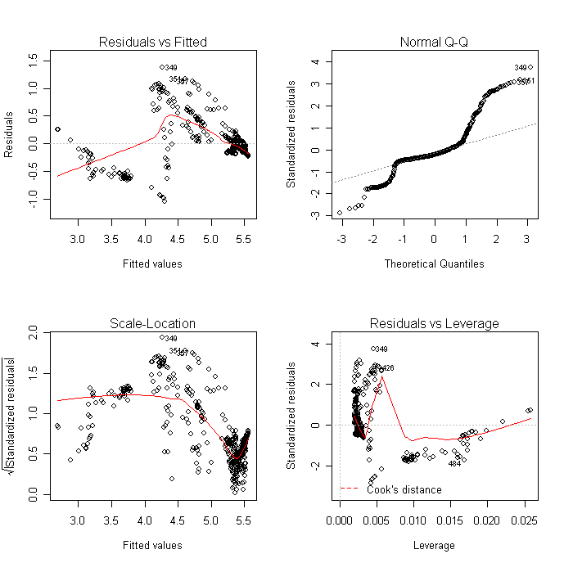
There were several attempts to make the process stationary, by applying logs or analyzing the difference, however, did not produces significant results. I chose a one time step lag in the data, because I looked at the differences in the dependent variable as well as each predictor. Analyzing the autocorrelations, it was determined that because of the more recent “spikes” in the ACF, that series depended more on recent data.

One model that was first attempted and to be found not significant as in other studies, was trying to predict the change in the short rate by taking the difference in the long rate and short rate. By looking at the spread (or daily change) between the 30 year T-rate rate and 3 month T-rate, the attempt was to predict the change in the LIBOR 3 month data. I found this model to insignificant and produce a very low adjust R². Again, this corroborated much of the analysis that has already been done in past studies. See results below.
Call:
lm(formula = dyn(LIBchange ~ Spread))

Coefficients:
Estimate Std. Error t value Pr(>|t|)
(Intercept) 0.02033 0.00695 2.924 0.00360 **
Spread 0.05788 0.01042 5.556 4.46e-08 ***
---
Signif. codes: 0 ‘***’ 0.001 ‘**’ 0.01 ‘*’ 0.05 ‘.’ 0.1 ‘ ’ 1

Residual standard error: 0.09011 on 510 degrees of freedom
Multiple R-squared: 0.05707, Adjusted R-squared: 0.05522
F-statistic: 30.87 on 1 and 510 DF, p-value: 4.458e-08
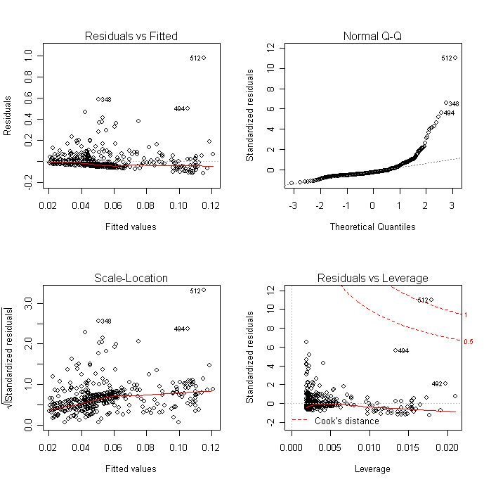

The model was chosen after regression several other factors and finding less significant p-values for predictors and/or critical F-values when using ANOVA to compare to different fit. There was also a great need to avoid multicollinearity when choosing predictors in each model.

GARCH Model

The writer of this paper will not go in details of the GARCH model, however, a discussion of how the model for this paper is derived and the limitations will follow. The generalized autoregressive conditional heteroscedasticity (GARCH) model is an important type of time series model for heteroscedastic data, random variables with different variances. It explicitly models a time-varying conditional variance as a linear function of past squared residuals and of its past values.

This model was chosen because it takes into account excess kurtosis and volatility clustering, two important characteristics of financial time series. It also provides an accurate forecast of variances and covariances. This is why the writer of this paper chose to generate a model of rates to build a term structure.

The series of 3 month LIBOR data from March 2006 to April 2008, was taken and a GARCH model was produced. The writer used steps outlined in the Hull book that carefully worked out each procedure to produce a GARCH model of possible interest rate paths as well as possible forecasts of the data.
The challenge is to specify how the information is used to forecast the mean and variance of the rate, conditional on the past information. The GARCH(1,1) model is successful in forecasting as well as predicting conditional variances. This can be interpreted as the volatility of the data being measured; furthermore, this volatility is a factor that is measure on the risk management level. Applications of the GARCH approach are used in situations where volatility is a central importance of the portfolio’s risk management. Many banks and other financial institutions use the idea of “value at risk” as a way to measure the risks faced by their portfolios
The GARCH(1,1) model contains notation, (1,1), in parentheses which is a standard to display how many autoregressive lags appear in the equation, while the second number refers to how many lags are included in the moving average component of a variable. Thus, a GARCH (1, 1) model for variance looks like this:

.

This model forecasts the variance of date t return as a weighted average of a constant, yesterday’s forecast, and yesterday’s squared error. Of course, if the mean is zero, then from the surprise is simply .
All calculations of the GARCH(1,1) was done in using Microsoft Excel. However, much time was spent to determine a simulation and predict outcomes using R. Provided in the appendix is a snapshot of the sheet used to simulate the rates.

Limitation of the GARCH model

GARCH models are parametric specifications that operate best under relatively stable market conditions and underlying assumptions, such as risk-neutral and arbitrage free. GARCH models often fail to capture highly irregular phenomena. These include wild market fluctuations, such as crashes and subsequent rebounds, and other highly unanticipated events that can lead to significant structural change. This can be found in the sudden Subprime rate decline in the Federal rates. It is highly evident in the process; however, the GARCH model may not capture this event.

CIR model
The Cox-Ingersoll-Ross Model is used to model the evolution of short interest rates. This particular model is an extension of another model, Vasicek, which also models the short rate. However, in the CIR model, the rate will always be nonnegative. The model provides a closed-form solution for the instantaneous rate of change. The CIR model can model the risk neutral process, r, by a stochastic differential equation,

$$\text{dr}=a⋅(b−r)⋅\text{dt}+σ⋅\sqrt{r}⋅\text{dz}$$

The model accounts for the mean reverting drift property of interest rates in the first group of terms. This term provides that the path will drift towards the long run average of b. The rate at which the path will converge toward the long run average, is a. However, where the difference between CIR and Vasicek, is found where the standard deviation of the change in the short rate in a short period of time is proportional to$\sqrt{r}$. This can simulated and observed when the short rate decreases, the standard deviation decreases.
How the CIR model avoids negative rates is encompassed in the last term. At lower values of the simulated rate, the variance between the terms is close to zero, this eliminating the assumed standard normal shock term, dz.
The model was created using simulations in VBA and Excel. A Monte Carlo simulated 10,000 paths of the CIR model given above with initial conditions and assumptions. The average of these simulations was calculated and this is the estimate for the forecasted short rate.

Analysis and Conclusions
Each of the models produced forecasts for the short rate, and furthermore, when possible with a certain confidence interval.

Results

Model | Predicted value | Forecasted value | Error  Current: (3.10%) | 95% Confidence interval
Regression time series | 1.1% | 3.227971% | 0.13% | (3.19940, 3.25653)
GARCH | N/A | 3.266101861548% | 0.17% | N/A
CIR | N/A | 3.256349951995% | 0.16% | N/A

Calculation of the value of a $1 CAP option.

Model | Forecasted value | CAP option price
Regression time series | 3.227971% | 0.033152
GARCH | 3.266101861548% | 0.03351
CIR | 3.256349951995% | 0.033419

Conclusions and Recommendations
From the diagnostic plots, the regression time may have violated normality assumptions. However, many transformations, differences, and lagging the data was attempted to make the process stationary but with no success. However, the forecasted value was within a certain degree to the other forecasted values of other models.
The assumptions in the CIR model must be validated on current market data. In the financial market, the CIR results would have been accepted because of the properties the stochastic equation. From the three models, however, the CIR value of the CAP option would be accepted. This is largely due to the fact that much of the properties that encompass the CIR are displayed in the interest rate model.

Appendix

Graph 1: 3 month LIBOR rates from March 31, 2006 until April 22, 2008.
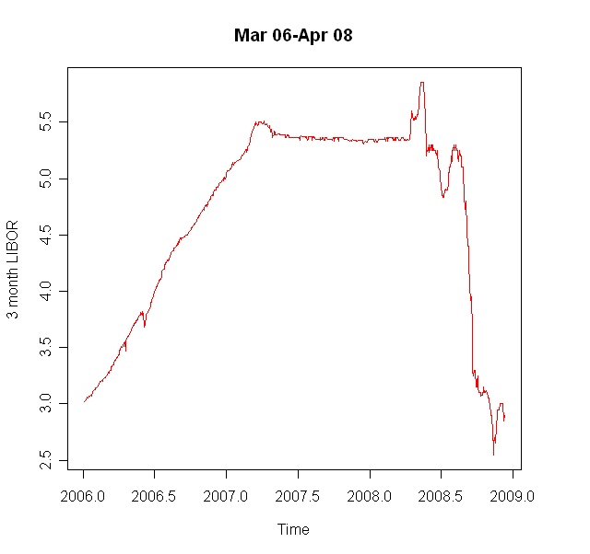

Graph 2: 3 month Treasury rates from March 31, 2006 until April 22, 2008.
Graph 3: 30 year Treasury rates from March 31, 2006 until April 22, 2008.

Formulas for valuing a CAP call option.

The value at time $t$of an interest rate derivative that provides a payoff of $f_{T}$at time $T$ is
$\hat{E}\left[e^{−\overline{r}(T−t)}f_{T}\right]$ (A.1)

Where $\overline{r}$ is the average value of $r$ in the time interval between $t$and $T$, and $\hat{E}$denotes expected value in the traditional risk-neutral world.

As usual we define $P(t,T)$as the price at time $t$ of a zero-coupon bond that pays off $1 at time T. From equation (A.1),

$$P(t,T)=\hat{E}\left[e^{−\overline{r}(T−t)}\right]$$

If $R(t,T)$ is the continuously compounded interest rate at time $t$for a term (or tenor) of $T−t$, then

$$P(t,T)=e^{−R(t,T)⋅(T−t)}$$

So that

$$R(t,T)=−\frac{1}{T−t}\text{ln}P(t,T)$$

This equation enables the term structure of interest rates at any given time to be obtained from the value of $r$ at that time and the risk-neutral process for$r$. It shows that once we have fully defined the process for$r$, we have fully defined everything about the initial zero curve and its evolution through time.

